**Group 3**

**Milestone 3**

Truman Forey

Arely Gil

Elizabeth Hinz

Lea Trueworthy

Megan Wheeler

**Supplier Deliveries:**

Purpose: To check whether all suppliers are delivering on time, and to identify any delays in supply deliveries.

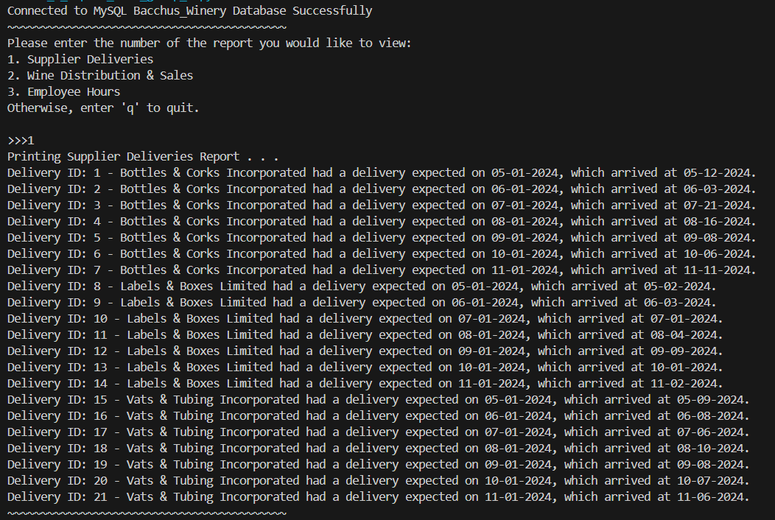

**Wine Distribution & Sales:**

Purpose: To analyze which wines are performing well and identify and low-performing wines.

**Employee Hours:**

Purpose: To track the number of hours worked by each employee in the past year.

