Lea Trueworthy

Module 5.2 Assignment: MySQL Functions

UPPER() Function

The UPPER() function is used to convert a string to uppercase. This can be useful when you need to standardize data for case-insensitive comparisons or for presentation purposes.

* When to use: Use this function when you need to convert text data to uppercase, such as displaying names, addresses, or any text where case consistency is required.
* Alias: UppercaseName

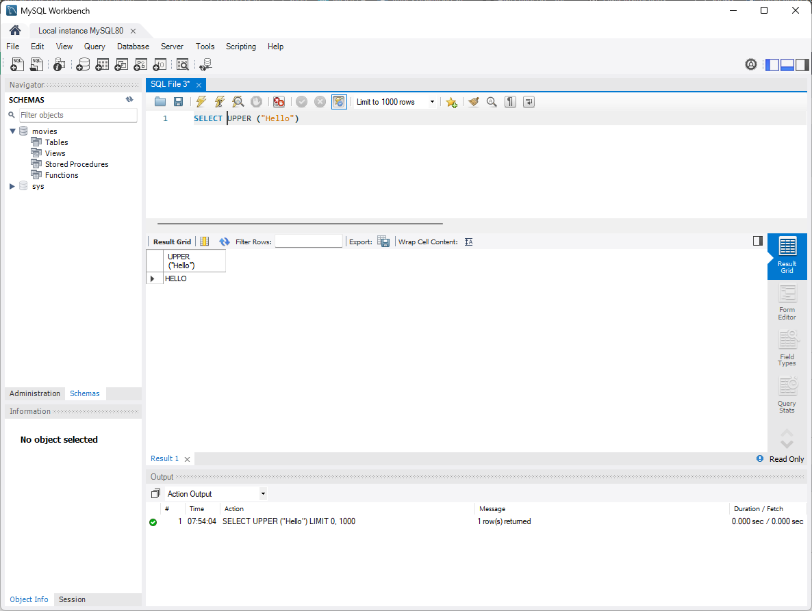

ROUND() Function

The ROUND() function is used to round a numeric value to a specified number of decimal places. This function is particularly useful when you need to present numerical results in a clean, readable format, such as rounding financial figures or measurements.

* When to use: Use this function when you need to round numeric data to a certain precision, such as rounding prices, quantities, or averages.
* Alias: RoundedSalary

NOW() Function

The NOW() function returns the current date and time in the format YYYY-MM-DD HH:MM:SS. This function can be used when you need to capture the current timestamp in your queries, such as when tracking records that are added or updated.

* When to use: Use it when you need the current date and time in your queries, like recording the time a record was inserted or last updated.
* Alias: CurrentDateTime

