Lea Trueworthy

Module 4.2 Assignment: High/Low Temperatures

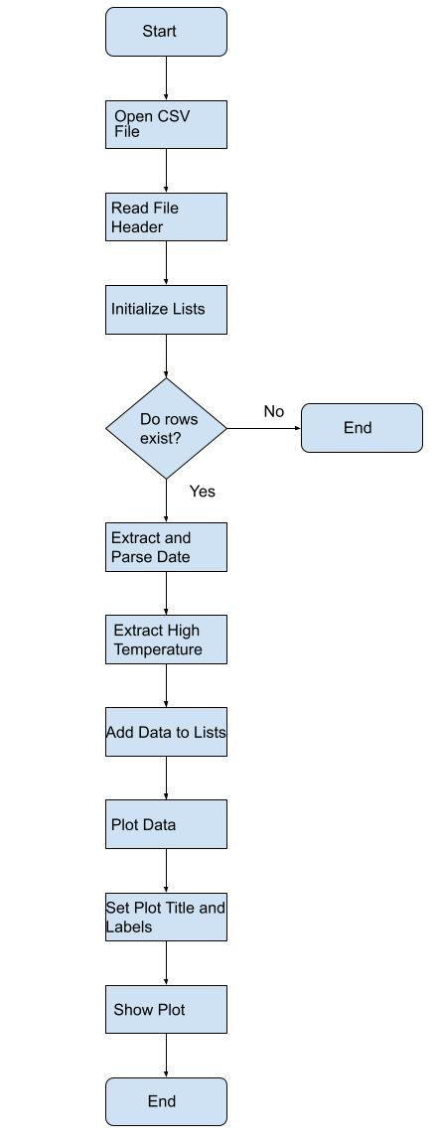

Revised flowchart

