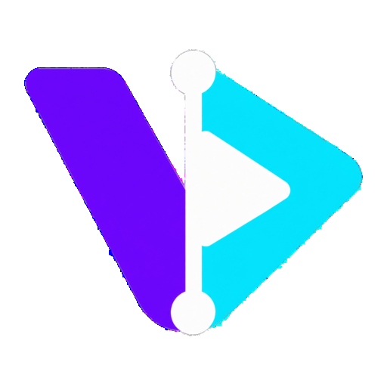

VDODesk 1.5.0 User Guide
Installation Editing Audio Layers 3D Photo Motion Export
For macOS including Apple M4 and Windows 10 or 11
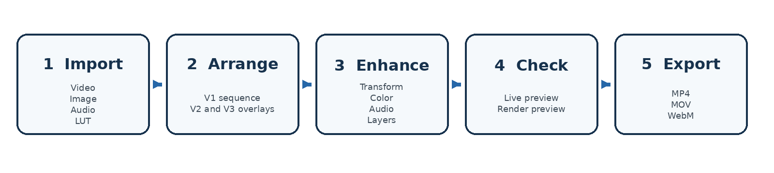
The standard VDODesk editing workflow
Local first browser editor powered by Python and FFmpeg

About this guide
This guide explains how to install VDODesk, create and edit a project, manage separate video and audio layers, add titles and stickers, generate 3D photo movement, render a reliable preview and export the finished video. It covers the controls available in VDODesk 1.5.0 beta 1 and identifies the practical boundaries of the current beta.
Privacy and source safety. VDODesk works locally on your computer. Its browser interface connects only to a Python service on 127.0.0.1, while FFmpeg and FFprobe perform media analysis, preview rendering and final export. Imported source files are copied into the project workspace and are never modified.

Guide contents
1 Install and start VDODesk
2 Understand the workspace
3 Create a first project
4 Manage media and proxies
5 Edit and sequence the timeline
6 Apply transitions, transforms, color and filters
7 Add titles, watermarks, stickers and emoji
8 Control, unlink and replace audio
9 Use subject tracking and 3D Photo Motion
10 Save, recover, relink, preview and export
11 Troubleshoot common problems
12 Use shortcuts and reference tables

Release status
The original 0.4.0 roadmap and the later requested features are implemented in this release. The application is a feature-complete beta. It is distributed as a portable local application rather than a signed Windows installer or notarized macOS app. The final appendix separates implemented capabilities from current limitations and future expansion areas.

1 Install and start VDODesk

System requirements
Component | Requirement | Purpose
Operating system | macOS or Windows 10 or 11 | Runs the local editor and browser
Python | Version 3.10 or newer | Runs the local VDODesk service
FFmpeg and FFprobe | Required and available on PATH | Media analysis, preview and export
Web browser | Current Chrome, Edge or Safari | Editor interface and live playback
OpenCV | Optional | Improves subject detection, tracking and segmentation

Architecture note. Node.js, a database, a C++ compiler and a C++ runtime are not required.

Install on macOS including Apple M4
1. Install Homebrew if it is not already available.
2. Open Terminal and run brew install python ffmpeg.
3. Extract the VDODesk ZIP into a writable folder. Do not run the application from inside the ZIP preview.
4. Run START_MAC.command. You can also open Terminal in the VDODesk folder and run ./START_MAC.command.
5. Keep the Terminal window open. The editor opens at http://127.0.0.1:8765.
First launch. If macOS blocks the launcher, right-click START_MAC.command and choose Open, or allow it in Privacy and Security. The M4 release uses the existing Python and FFmpeg architecture and does not require Rosetta.

Optional advanced analysis on macOS
1. Run INSTALL_ADVANCED_MAC.command once.
2. The installer creates a private .venv inside the VDODesk folder and installs OpenCV.
3. Restart VDODesk. Automatic subject tracking and segmentation will use OpenCV when available.

Install on Windows 10 or 11
1. Extract the complete ZIP to a writable folder such as C:\VDODesk. Do not run from inside the ZIP window.
2. Double-click SETUP_WINDOWS.bat once. It installs or confirms Python 3.12 and FFmpeg through Windows Package Manager.
3. Close the setup window after installation so Windows refreshes PATH.
4. Double-click START_WINDOWS.bat and keep its terminal window open.
5. The default browser opens at http://127.0.0.1:8765.
Advanced tracking. For optional OpenCV analysis, run INSTALL_ADVANCED_WINDOWS.bat. VDODesk editing, manual tracking, audio tools and export work without this optional component.

Manual Windows prerequisite check
If Windows Package Manager is unavailable, install Python from python.org and enable Add python.exe to PATH. Install an FFmpeg Windows build and add its bin folder to PATH. Open a new Command Prompt and confirm:
- python --version reports Python 3.10 or newer.
- ffmpeg -version returns build information.
- ffprobe -version returns build information.

Confirm a healthy startup
- The terminal displays VDODesk 1.5.0-beta.1 ready at http://127.0.0.1:8765.
- The browser shows the VDODesk header, Media panel, viewer, timeline and Inspector.
- Leave the terminal open throughout the editing session.
- Press Ctrl+C once in the terminal to stop VDODesk cleanly.

2 Understand the workspace
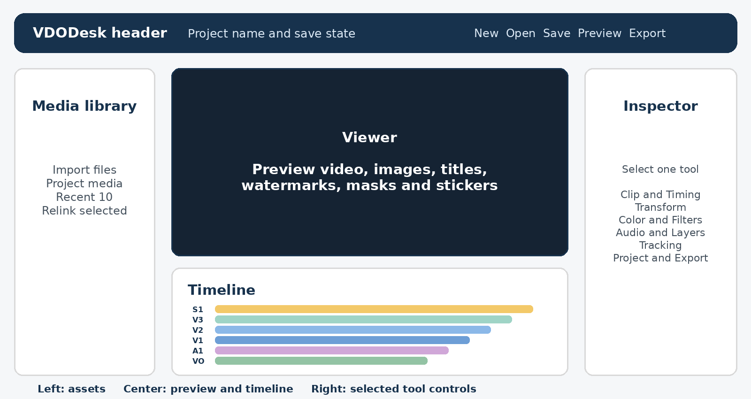
VDODesk workspace layout
Area | What it does
Header | Names the project and provides New, Open project, Save project, Render preview and Export.
Media | Imports video, audio, images and LUT files; shows project assets and Recent 10; relinks missing media.
Viewer | Shows the selected clip and approximates edits, titles, masks, watermarks, stickers and photo motion.
Transport | Moves to timeline or clip boundaries, steps by frame, plays and pauses, shows timecode and changes timeline zoom.
Timeline | Arranges V1 to V3, S1, A1 and VO tracks; supports selection, drag, trim, split and playhead positioning.
Inspector | Shows one categorized tool at a time for the selected clip, layer or project.

Inspector tool menu
Group | Tools
Clip | Clip and Timing; Transform; Color; Filters; Motion Keyframes; 3D Photo Motion; Audio
Layers and Analysis | Stickers and Emoji; Subject Tracking
Project | Project Settings; Export Settings

Selection matters. Select an item on the timeline before choosing a clip-specific tool. If no suitable item is selected, the Inspector displays Select a timeline clip.

3 Create a first project

A complete first edit
1. Choose Import or drop media into the Media panel.
2. Press the plus button on each video or image you want to place on the timeline.
3. Drag V1 clips left or right to change their sequence. The visible insertion marker shows the new position.
4. Drag a clip edge to trim it. Place the playhead and choose Split to divide a clip.
5. Select a clip and choose an Inspector tool such as Transform, Color, Filters or Audio.
6. Choose Project Settings to select the aspect ratio, frame rate, title, watermark and safe-area guides.
7. Choose Render preview to verify the complete FFmpeg result.
8. Choose Export, select a container and codec, and start the export.
Output location. Completed previews and exports are retained below the extracted application folder in projects/exports/.

Choose the project format early
Setting | Available choices | Guidance
Aspect ratio | 16:9, 9:16, 4:3, 3:4, 1:1 | Choose the target screen before positioning overlays and text.
Frame rate | 24, 25, 30, 50, 60 fps | Match the primary source when practical. Higher rates require more processing.
Safe-area guides | On or off | Use for titles and graphics that must remain visible on different displays.

Start a photo-only project
1. Import an image and press its plus button. When the project has no primary clip, the image enters V1.
2. Select the image clip and set its still duration in Clip and Timing.
3. Use 3D Photo Motion, Transform, Filters, titles, stickers and audio as required.

4 Manage media and proxies

Import supported project assets
Asset | How VDODesk uses it
Video | Primary V1 sequence, V2 or V3 overlay, linked audio, freeze frames and tracking source
Image | Still clip, image watermark, image sticker or custom grayscale depth map
Audio | Independent A1 music or replacement audio
3D LUT | Selected-clip color lookup table in .cube format

Project and Recent 10. The Project tab shows assets in the current workspace. Recent 10 remembers the ten most recently imported files across New project operations. Select an asset card to highlight it; press its plus button to add it to the appropriate track.

Browser-compatible preview proxies
Some camera files, especially HEVC video in MOV containers, may be valid for FFmpeg but unsupported by the browser. VDODesk detects the codec, creates an H.264 and AAC preview proxy, switches the selected clip to it and retries playback. Large files can also receive a lower-resolution proxy in the background.
- Keep Proxy playback enabled for responsive editing.
- The proxy affects browser playback only. Final rendering uses the authoritative project renderer.
- A media card can show preparing preview while a proxy job is running.

Relink missing or moved media
1. Select the missing or outdated item in Media.
2. Choose Relink selected.
3. Select the correct replacement file.
4. VDODesk updates all matching references, including clips, depth maps, stickers, audio, voiceovers and watermarks.
Workspace rediscovery. VDODesk also rediscovers assets stored under the project workspace when it starts, even if they no longer appear in Recent 10.

5 Edit and sequence the timeline
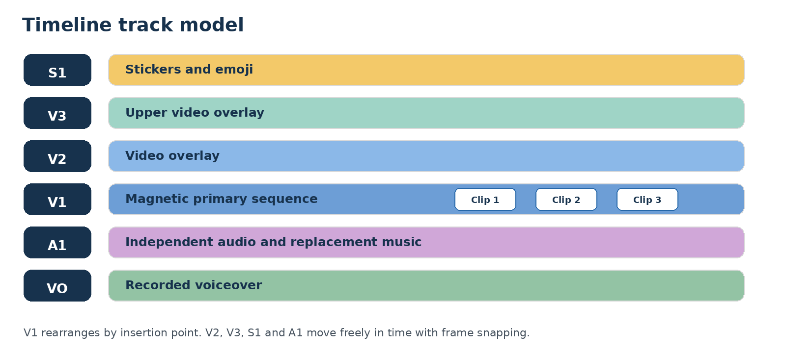
VDODesk uses six purpose-specific tracks

Sequence V1 clips
1. Select a V1 clip and drag it horizontally.
2. Move the pointer to the desired insertion point. The lane highlights and an insertion marker appears.
3. Release the clip. V1 closes gaps automatically and renumbers the sequence.

Alternative controls. You can also select a V1 clip and use Earlier or Later in the timeline toolbar or Clip and Timing Inspector.

Position overlays and independent layers
- V2 and V3 video clips move freely in time and can be dragged between those two tracks.
- S1 stickers move freely and their edges define when they appear.
- A1 independent audio moves and trims without changing the picture.
- VO items are positioned at the playhead when recording begins.
- Frame snapping and edge auto-scroll assist long-timeline moves.

Trim, split and duplicate
Action | Method | Result
Trim | Drag either edge of a clip, sticker or independent A1 item | Changes the included duration or layer timing
Split | Place the playhead, select a clip and choose Split | Creates two independently editable clips
Duplicate | Select a clip and choose Duplicate | Creates a copy for reuse or variation
Delete | Select the item and choose Delete or press Delete | Removes the selected clip, sticker or A1 item
Freeze frame | Place the playhead in a video and choose Freeze frame | Creates a still image clip suitable for extended display or 3D motion

Timeline navigation and playback
Control | Purpose
Timeline start and timeline end | Jump to the first or last frame of the whole edit.
Clip start and clip end | Jump to the first or last frame of the selected clip.
Previous and next frame | Move exactly one output frame.
Play | Play or pause the timeline from the current playhead.
Timeline ruler and playhead | Click or drag to position the edit point.
Timeline Zoom | Changes the horizontal timeline scale without changing the project.

Clip timing controls
Control | Range or behavior
Source in and Source out | Choose the portion of the source media used by the clip.
Still duration | Sets the timeline length of an image or freeze-frame clip.
Speed | Constant playback from 0.25x to 4x.
Reverse clip | Plays the selected clip backwards.
Video track | Places a clip on V1, V2 or V3.
Timeline start | Positions V2 or V3 overlays on the project timeline.

Undo safety. Use Undo and Redo after timeline or Inspector changes. Command or Ctrl+Z reverses a change; Command or Ctrl+Shift+Z reapplies it.

6 Transitions, transforms, color and filters

Transitions
Choose Clip and Timing, select a Transition in, and set its duration from 0.04 to 3 seconds. The transition belongs to the selected clip and affects how it enters.
Transition | Visual result
None | A direct cut
Dissolve | The incoming clip blends with the previous image
Fade | A fade transition around the clip boundary
Wipe | The incoming frame replaces the earlier frame across the picture
Slide | The incoming picture slides into view
Zoom | The boundary uses a zoom-based transition

Transform and framing
- Zoom and Focus X or Y define framing for all clips.
- V2 and V3 add Overlay scale and Position X or Y.
- Rotation, horizontal mirror, vertical mirror and opacity alter the selected clip.
- Crop uses normalized Left, Top, Width and Height controls.
- Stabilization can be enabled with adjustable strength from 4 to 32.

Color correction and LUTs
Control group | Controls
Primary correction | Brightness, contrast, saturation and gamma
Color balance | Temperature, tint, hue, shadows and highlights
Lookup table | One imported .cube 3D LUT applied to the selected clip

Reset and verify. Use Reset color to return the selected clip to its default correction. Render preview is the authoritative check for final color behavior.

Selected-clip filters
Preset | General character
None | No creative filter
Cinematic | Film-oriented contrast and color
Warm | Warmer color balance
Cool | Cooler color balance
Vintage | Faded retro treatment
Mono | Neutral monochrome
Noir | High-contrast monochrome
Vivid | Stronger color and contrast
Soft | Gentler contrast and detail
Teal and Orange | Cool shadows and warmer skin-oriented highlights

Filter strength. Filters apply only to the selected clip. Adjust Intensity from 0 to 1 or choose Remove filter.

Motion keyframes
Start values come from Transform and Color. Motion Keyframes defines linear end values for zoom, focus X and Y, brightness, contrast, saturation and gamma. Audio provides a separate End level control. Choose Clear keyframes to remove the selected clip animation.

7 Titles, watermarks, stickers and emoji

Opening title and text watermark
1. Choose Project Settings.
2. Enter the Opening title and optional Text watermark.
3. Set Watermark opacity and enable safe-area guides if required.
4. Render preview before export to confirm placement and timing.
Reliable export. VDODesk detects available FFmpeg text rendering. It uses drawtext when available, otherwise libass, and finally its own transparent-image text renderer. This avoids the No such filter drawtext failure on minimal FFmpeg builds.

Image watermark
1. Import the watermark image.
2. Choose Project Settings and select it under Image watermark.
3. Adjust scale, opacity and X or Y position, or drag the watermark in the viewer.

Add an emoji sticker
1. Place the playhead where the sticker should begin.
2. Choose Stickers and Emoji in the Inspector.
3. Select one of the twelve built-in emoji buttons. VDODesk converts the native color emoji to a portable transparent PNG.
4. Drag the sticker in the viewer to position it, or adjust X and Y in the Inspector.
5. Drag the sticker on S1 to change its start time and drag either edge to trim its visible duration.

Add an image sticker
1. Import a PNG, JPEG or WebP image.
2. Click the image card so it is highlighted in Media.
3. Choose Stickers and Emoji and select Add highlighted image to S1.
4. Adjust timeline start, duration, position, scale, rotation and opacity.
Persistence. Stickers persist through save, recovery, relinking, undo and redo, preview and export.

8 Control, unlink and replace audio

Adjust linked clip audio
1. Select the video clip on V1, V2 or V3.
2. Choose Audio in the Inspector.
3. Set Level from 0 to 4x, enable Mute clip audio if required, and optionally set an animated End level.
Linked behavior. The A1 lane shows linked source audio with a link indicator. It follows the video until it is unlinked.

Unlink audio and video
1. Select the video clip and choose Audio.
2. Select Unlink audio to A1.
3. The video becomes silent and an independent audio item appears on A1 at the same timeline position.
4. Drag or trim the A1 item without changing the video. Adjust Level, Mute audio, Timeline start and Duration in the Inspector.

Delete audio only
1. Select the independent item on A1.
2. Choose Delete audio only or press Delete.
3. The video clip remains on its video track.

Replace original audio with music
1. Import the music file and click its Media card so it is highlighted.
2. Select the video clip with linked audio, or select its already unlinked A1 audio item.
3. Choose Audio and select Replace with highlighted music.
4. VDODesk unlinks the original source audio if needed and places the selected music on A1 without changing the video.
5. Trim, move, mute or change the level of the replacement on A1.
Undo replacement. If the detached A1 item still belongs to a video clip, Restore original audio removes the detached replacement and reconnects the original source sound.

Record a voiceover and duck music
1. Move the playhead to the intended voiceover start.
2. Select Voiceover and allow browser microphone access.
3. Record, then select Stop recording. The new item appears on VO.
4. Select the voiceover to adjust its level and timeline start or to remove it.
5. Leave Duck A1 audio under voiceover enabled to lower background audio while narration is active.
Preview behavior. Timeline Play synchronizes independent A1 audio with the playhead. Render preview and export remain the definitive audio mix.

9 Subject tracking and 3D Photo Motion

Track a subject
1. Select a video clip and choose Subject Tracking.
2. Choose Track subject for automatic sampled analysis, or Use manual box when the subject must be defined directly.
3. Correct Box X, Box Y, Box width and Box height as needed.
4. Enable Draw tracked object outline, choose Smart reframe or enter Anchored text.
5. If a segmentation mask is available, enable Preview segmentation mask to inspect it.
OpenCV behavior. With OpenCV installed, VDODesk uses automatic detection, template tracking and GrabCut segmentation. Without OpenCV, manual and focal-region workflows remain available.

Generate 3D movement from a still image
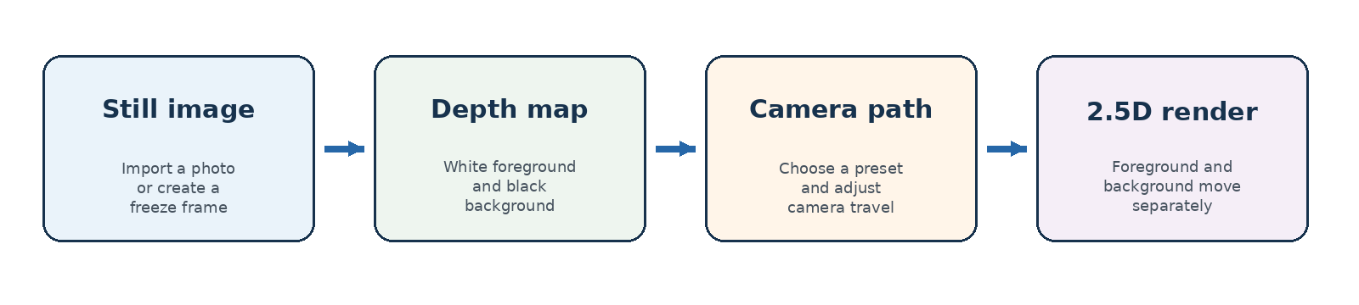
Single-image 3D Photo Motion is a local 2.5D depth workflow
1. Import an image or create a freeze frame and select it on V1.
2. Choose 3D Photo Motion.
3. Place Focus X and Focus Y over the principal subject and adjust Subject radius.
4. Choose Cinematic Push-In, Pull-Out, Orbit Left, Orbit Right or Floating Portrait.
5. Select Generate depth and motion. VDODesk creates a reusable local depth map and enables the effect.
6. Adjust Depth strength, Camera travel, Edge fill and Easing.
7. Use Render preview to evaluate the final depth-separated compositor.

Use a custom depth map
1. Create or obtain a grayscale image at the same composition as the source image.
2. Use white for areas nearest the viewer and black for the background, with smooth gray transitions around edges.
3. Import the depth image and select it from the Depth map list in 3D Photo Motion.
4. Use moderate Camera travel and adjust Edge fill to control exposed borders.
Important limitation. This feature creates 2.5D parallax from one photograph. It cannot reconstruct genuinely hidden surfaces. Large orbit values can reveal stretched or duplicated background detail; reduce travel, refine the depth map or use a stronger edge fill.

10 Save, recover, relink, preview and export

Save and open projects
- Save project downloads a portable .vdodesk.json project manifest.
- Open project restores a previously saved manifest and its edit decisions.
- Media remains under projects/media and is referenced by the project manifest.
- Relink selected replaces missing or moved files without rebuilding the edit.

Autosave and recovery
VDODesk stores an autosave in browser local storage after edits. Starting a new project also preserves one previous-project snapshot.
1. After a browser or process interruption, restart VDODesk in the same browser profile.
2. Choose Project Settings.
3. Select Restore last autosave, or Restore previous project when New project replaced the active edit.
4. Save a .vdodesk.json manifest after recovery.
Caution. Clear recovery removes the saved recovery state. Use it only after confirming the current project has been saved.

Live preview versus Render preview
Preview type | Best use | Authority
Live browser preview | Fast editing, placement, scrubbing and approximate effects | Responsive approximation
Render preview | Transitions, text, composite layers, color, tracking, photo motion and audio mix | Same FFmpeg project renderer as export
Final export | Delivery file | Authoritative finished output

Export settings
Setting | Choices and guidance
Container | MP4, MOV or WebM
Codec | H.264, H.265 or HEVC, or VP9; choose a codec compatible with the selected container
Dimensions | Custom even-numbered width from 240 to 7680 and height from 240 to 4320, or leave blank for the project preset
Quality | 14 to 45; lower values produce higher quality and larger files; 20 is the default
Hardware encode | Uses Apple VideoToolbox when available, with software fallback
PCM audio | Optional uncompressed audio for MOV

1. Choose Render preview and inspect the output.
2. Choose Export or Inspector, Export Settings, Open export settings.
3. Select the container, codec, dimensions, quality and optional hardware or PCM settings.
4. Choose Start export and leave VDODesk running until the background job completes.
5. Open projects/exports to find the completed file.

11 Troubleshooting
Problem | What to do
FFmpeg is required | Install FFmpeg and FFprobe, open a new terminal so PATH refreshes, and restart VDODesk.
Browser does not open | Visit http://127.0.0.1:8765 manually. Confirm the terminal still shows the ready message.
Port 8765 is in use | On Windows run START_WINDOWS.bat --port 8877. On macOS run ./START_MAC.command --port 8877, then open that address.
Preview is blank or video will not play | Keep Proxy playback enabled and wait while the H.264 preview proxy is prepared. HEVC MOV files commonly require this.
Imported A1 audio is silent | Use timeline Play, confirm the A1 item overlaps the playhead, clear Mute audio, raise Level and test with Render preview.
Replace with highlighted music is disabled | Import an audio file and click its Media card before selecting the video or A1 item to replace.
No such filter drawtext | Version 1.5.0 should automatically use libass or built-in image text. Confirm you are using the current package and retry Render preview.
Title or text is missing from export | Render preview first, confirm the text is entered in Project Settings or Anchored text, and use the current 1.5.0 package.
Sticker does not appear | Confirm its S1 timing overlaps the playhead, opacity is above zero and the sticker asset has not been moved.
3D motion shows stretched edges | Reduce Camera travel, adjust the focal area, increase Edge fill or import a corrected depth map.
Microphone is unavailable | Allow microphone access for 127.0.0.1 in browser settings, reload the editor and record again.
OpenCV features are limited | Run the platform advanced installer, restart VDODesk and repeat the analysis.
Media is missing after moving the folder | Select the missing Media item and use Relink selected. VDODesk updates matching project references.
Windows still reports missing Python or FFmpeg | Close all Command Prompt windows after setup, reopen START_WINDOWS.bat and verify python --version, ffmpeg -version and ffprobe -version.

Collect useful diagnostic information
- Save the project manifest before changing files.
- Record the exact error shown in the terminal or export status.
- Note the source container and codec, such as MOV with HEVC.
- Confirm whether the issue appears in live preview, Render preview, final export or all three.
- Keep a copy of the source file that reproduces the problem.

12 Keyboard shortcuts and reference
Shortcut | Action
Space | Play or pause
Left Arrow or Right Arrow | Move one output frame
Home or End | Move to the timeline start or end
[ or ] | Move to the selected clip start or end
Delete or Backspace | Delete the selected video clip or independent A1 item
Command or Ctrl+Z | Undo
Command or Ctrl+Shift+Z | Redo

Project storage
Location | Contents
projects/media | Imported media, generated assets, proxies and depth maps
projects/exports | Rendered previews and final exports
projects/recent-files.json | Persistent Recent 10 list
Downloaded .vdodesk.json | Portable project edit manifest
Browser local storage | Autosave and one previous-project snapshot

Recommended quality workflow
1. Keep original media outside the VDODesk application folder as the source archive.
2. Save a named project manifest at important milestones.
3. Use proxies for responsive editing but rely on Render preview for composite decisions.
4. Check titles, stickers, tracking, photo motion and audio with Render preview.
5. Export a short test when using a new codec, aspect ratio or custom dimension.
6. Retain the project manifest and source media until the final video has been reviewed.

Appendix A Implemented feature status
The following capability groups are implemented in VDODesk 1.5.0 beta 1. Automated validation covers workspace persistence, depth generation, all five photo-motion presets, animated 2.5D export, waveforms, proxies, freeze frames, tracking fallbacks, filters, color and effects, stickers, audio replacement, transitions, titles, watermarks and export compatibility.
Capability group | Status
Timeline, sequencing and layers | Implemented: V1 magnetic ordering; V2 and V3 overlays; S1, A1 and VO; drag, trim, split, duplicate and freeze frame
Transforms, transitions, color and filters | Implemented: five transitions, crop, position, scale, rotation, mirror, opacity, stabilization, full color controls, LUTs and ten filter choices
Titles, watermarks, stickers and emoji | Implemented with export and text-rendering fallbacks
Audio editing | Implemented: linked level and mute, unlink, independent A1 editing, delete audio only, music replacement, restore original, voiceover and ducking
Tracking and reframing | Implemented with optional OpenCV automation and manual fallback
3D Photo Motion | Implemented as local 2.5D parallax with five presets and custom depth maps
Project protection | Implemented: autosave, previous project, manifests, Recent 10, workspace rediscovery and relinking
Preview and export | Implemented: proxy playback, background jobs, MP4, MOV, WebM, H.264, H.265 and VP9
Platform packaging | Implemented as portable macOS and Windows 10 or 11 packages with launchers and setup helpers

Appendix B Current limitations and future expansion
Area | Current boundary
Photo movement | 2.5D parallax rather than complete 3D reconstruction, NeRF, Gaussian splatting or generative video.
Keyframes | Linear start-to-end animation rather than arbitrary multi-point keyframes or Bezier curves.
Speed | Constant speed and reverse; no variable speed ramp.
Tracks | Fixed V1 to V3, S1, A1 and VO rather than unlimited tracks, nested sequences or multicamera editing.
Masks and keying | No chroma key, freehand animated mask painting or frame-by-frame rotoscoping.
Captions | No dedicated subtitle editor or SRT and VTT import or export.
Audio processing | No advanced EQ, compressor, noise reduction, reverb or bus mixer.
Hardware encoding | Apple VideoToolbox selection is available; Windows NVENC, Quick Sync and AMD AMF selection is not.
Native packaging | No signed MSI or EXE, notarized macOS bundle or automatic updater.
Architecture | No native C++ or Qt build. The retained design is browser UI, Python server and FFmpeg.
Collaboration | No account, cloud storage, cloud rendering, real-time collaboration or analytics.
Scale limit | A single render supports up to 120 clips and 120 stickers.

Distribution note
Before public commercial distribution, complete an independent review of FFmpeg codec and patent licensing, third-party component licenses, security hardening, code signing and Apple notarization requirements.

Version reference
Item | Value
Application | VDODesk
Guide version | 1.5.0 beta 1
Architecture | Browser UI, Python standard-library server, FFmpeg and FFprobe
Local address | http://127.0.0.1:8765
Supported desktop systems | macOS including Apple M4; Windows 10 or 11

Final pre-export checklist
- Save a named .vdodesk.json project manifest.
- Render a preview and check the complete video from start to finish.
- Confirm titles, watermarks, stickers and tracked labels are visible.
- Listen to linked clip audio, A1 replacement music and VO voiceover levels.
- Verify the chosen aspect ratio, dimensions, container and codec.
- Keep VDODesk and its terminal open until the export job completes.

