Embeded Systems Homework 2

Due on 10/2, submit in hard copy

1. (15%)

Gcc defines integer types in stdint.h and bool type in stdbool.h.

1. Report the folders of the two header files in avr-gcc and xc16 respectively.

Avr-gcc location:

﻿C:\Program Files (x86)\Atmel\Studio\7.0\toolchain\avr8\avr8-gnu-toolchain\lib\gcc\avr\5.4.0\include\stdint.h

Avr-gcc location:

﻿C:\Program Files (x86)\Atmel\Studio\7.0\toolchain\avr8\avr8-gnu-toolchain\lib\gcc\avr\5.4.0\include\stdbool.h

Xc16 location:

﻿C:\Program Files (x86)\Microchip\xc16\v1.35\include\stdint.h

Xc16 Location:

﻿C:\Program Files (x86)\Microchip\xc16\v1.35\include\stdbool.h

1. Report the type definitions of int8_t, uint8_t, int16_t, uint16_t, int32_t, uint32_t, int64_t, uint64_t.





1. Report the type definition of bool, and the values of true and false.



2. (20%)

Define a union data struct WORD_T for a uint16_t integer so that a value can be assigned to a WORD_T integer in three ways:

a) Show the code of defining the union data struct WORD_T.

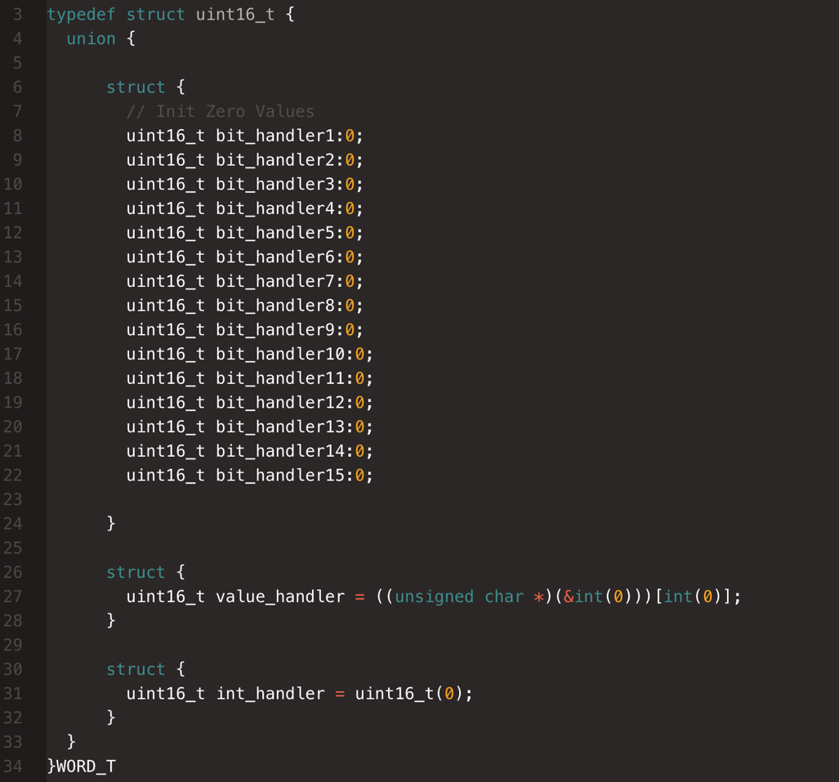

b) Show the code to assign the value 16 to the integer in the three ways.

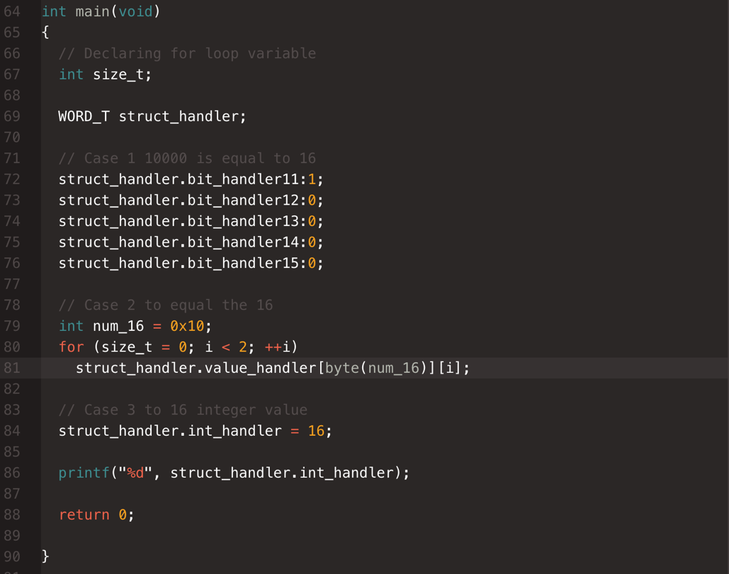

Hint: You may refer to the source file ${xc16}/support/PIC24E/h/p24EP512GU810.h. ${xc16} is where you installed the xc16 compiler.

3. (10%) Please read the following code.

(a) Add one line of C code that defines a macro, so that "main()" will call "foowithdebug()".

#define argv foowithdebug() // Allows for the argument to be referenced in main’s original function call.

(b) Read gcc command options about macro at https://gcc.gnu.org/onlinedocs/gcc/Preprocessor-Options.html

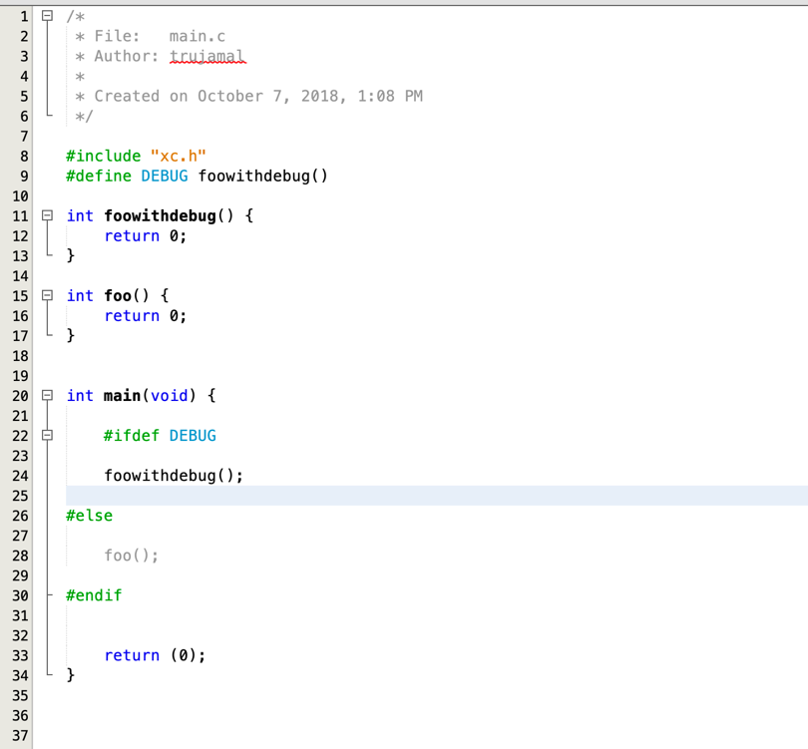

4. (20%)

Read the reference at http://www.nongnu.org/avr-libc/user-manual/pgmspace.html and http://www.nongnu.org/avr-libc/user-manual/group__util__crc.html

Make a program to calculate CRC-16 of the code in program memory. Assume the code size is always 4KBytes.

1. Copy & paste your code in report.c

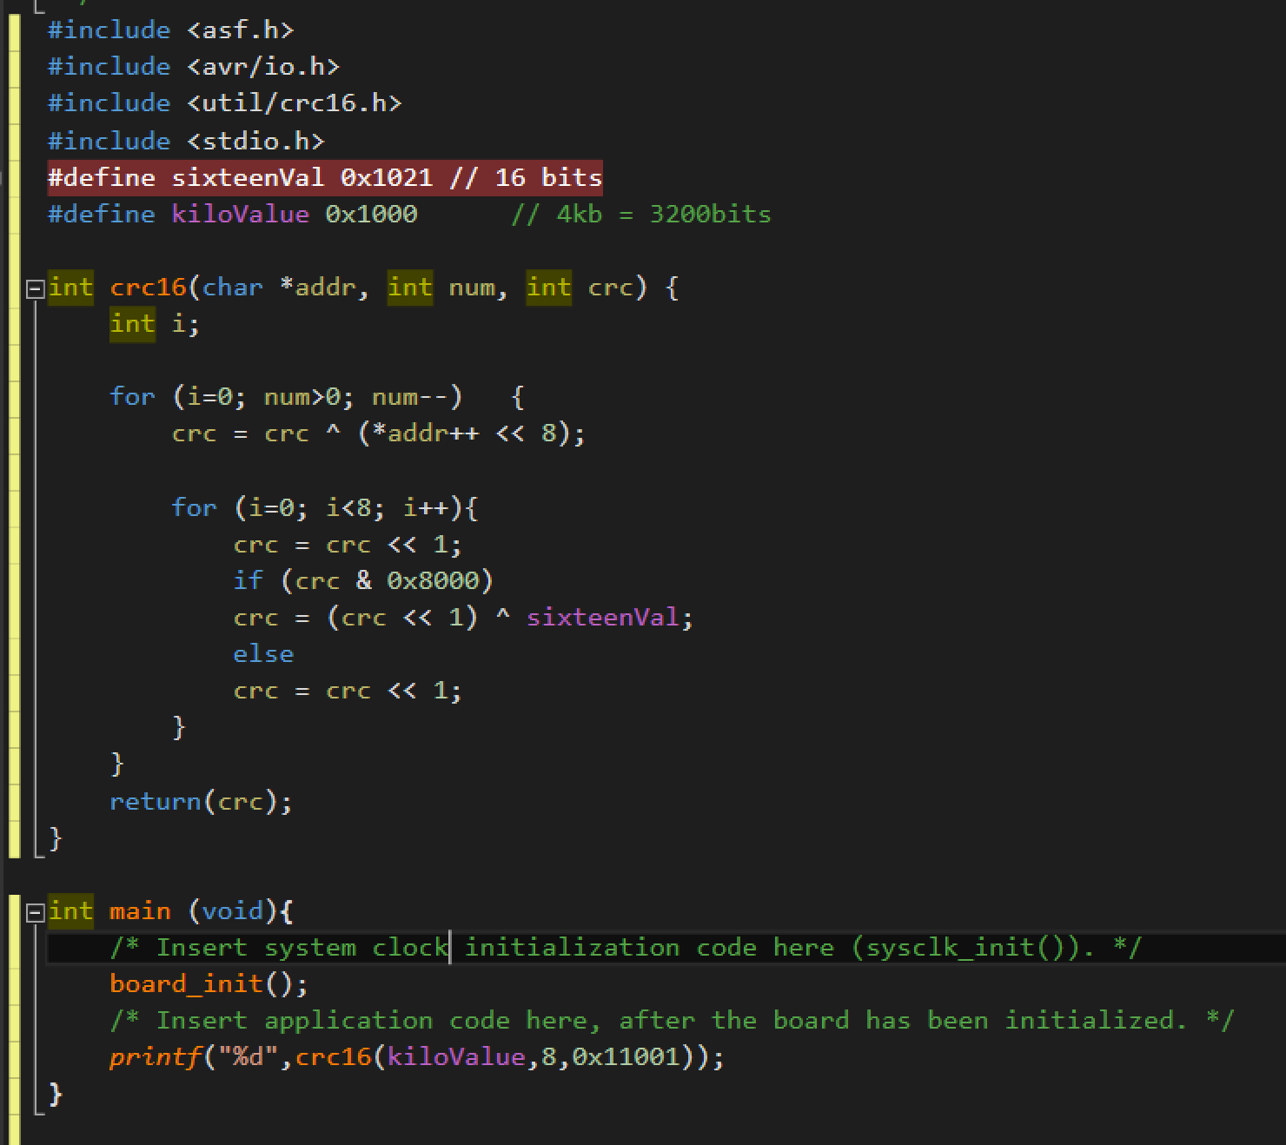

b) Run your program in AVR Studio and show the CRC value of your program in a screen shot of AVR Studio.

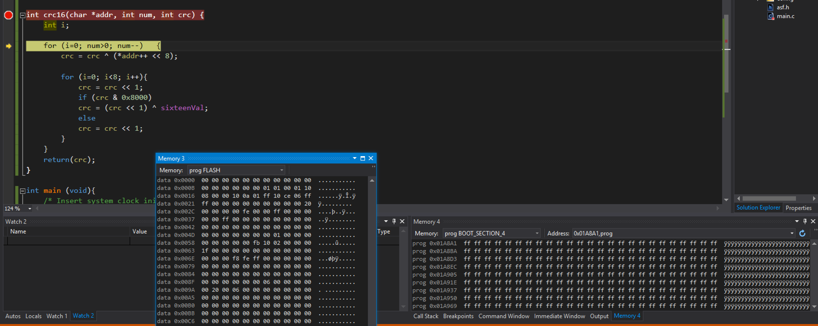

5. (35%)

Read the schematics and datasheets of Atmega128 and Pic24e chips. The two schematic pdfs are included in hw2's package, and the datasheets are in tracs.

Find three types of pins: (i) reset, (ii) clock and (iii) the IO pins in ports A and B.

1. Document the three types of pins of Atmega128 in a table. The example table is included in hw2's package.

|  |  |  |  |
| --- | --- | --- | --- |
| **Atmega128** | | | |
| **Pin#** | **Description** | | **Label** |
| **In Datasheet** | **In Schematic** |
| Reset | | | |
| 20 | ~RESET | RST | RSTN |
| Clock | | | |
| 24 | XTAL1 | XTAL1 |  |
| 23 | XTAL2 | XTAL2 |  |
|  |  |  |  |
|  |  |  |  |
| IO Pins | | | |
| 51 | PA0 (AD0) | PA0/AD0 | LED3 |
| 50 | PA1 (AD1) | PA1/AD1 | LED2 |
| 49 | PA2 (AD2) | PA2/AD2 | LED1 |
| 48 | PA3 (AD3) | PA3/AD3 | FLASH_CS |
| 47 | PA4 (AD4) | PA4/AD4 | SERIAL_ID |
| 46 | PA5 (AD5) | PA5/AD5 | BAT_ON |
| 45 | PA6 (AD6) | PA6/AD6 | CHP_OUT |
| 44 | PA7 (AD7) | PA7/AD7 | THERM_PWR |
| 10 | PB0 (SS) | PB0/SS |  |
| 11 | PB1 (SCK) | PB1/SCK | SPI_SCK |
| 12 | PB2 (MOSI) | PB2/MOSI | SPI_MOSI |
| 13 | PB3 (MISO) | PB3/MISO | SPI_MISO |
| 14 | PB4 (OC0) | PB4/OC0 | PWM0 |
| 15 | PB5 (OC1A) | PB5/OC1A | PWM1A |
| 16 | PB6 (OC1B) | PB6/OC1B | PWM1B |
| 17 | PB7 (OC1C) | PB7/OC1C | SPI_SCK |

b) Document the three types of pins of Pic24e in a table. The example table is included in hw2's package.

Add rows to the example tables if necessary. Group IO pins according to their ports and sort them in ascending order.

|  |  |  |  |
| --- | --- | --- | --- |
| **Pic24ep512gu810** | | | |
| **Pin#** | **Description** | | **Label** |
| **In Datasheet** | **In Schematic** |
| Reset | | | |
| 13 | ~MCLR | ~MCLR | ICSP_~MCLR_VPP_TARGET |
| Clock | | | |
|  | T2CK | RPINR3 | Timmer 2 External Clock |
|  | T3CK | RPINR3 | Timmer 3 External Clock |
|  | T4CK | RPINR4 | Timmer 4 External Clock |
|  | T5CK | RPINR4 | Timmer 5 External Clock |
|  | T6CK | RPINR5 | Timmer 6 External Clock |
|  | T7CK | RPINR5 | Timmer 7 External Clock |
|  | T8CK | RPINR6 | Timmer 8 External Clock |
|  | T9CK | RPINR6 | Timmer 9 External Clock |
| IO Pins | | | |
| 17 | TMS/RPI16/RA0 | TMS/RA0 | TMS/RA0 |
| 38 | TCK/RPI17/RA1 | TCK/RA1 | TCK/RA1 |
| 58 | ASCL2/RPI18/RA2 | ASCL2/RA2 | SCL2/RA2 |
| 59 | ASDA2/RPI19/RA3 | ASDA2/RA3 | SDA2/RA3 |
| 60 | TDI/RPI20/RA4 | TDI/RPIA4 | TDI/RA4 |
| 61 | TDO/RPI21/RA5 | TDO/RPIA5 | TDO/RA5 |
| 91 | AN22/RPI22/RA6 | RPIA6 | TRCLK/RA6 |
| 92 | AN23/RPI23/RA7 | RPIA7 | TRD3/RA7 |
| 28 | VREF-/RA9 | VREF-/RA9 | PMPA7/VREF-/RA9 |
| 29 | VREF+/RA10 | VREF+/RA10 | PMPA6/VREF+/RA10 |
| 66 | RPI30/RA14 | RA14 | INT3/SCL1/RA14 |
| 67 | RPI31/RA15 | RA15 | INT4/SCA1/RA15 |
| 25 | PGED3/AN0/RPI32/RB0 | PGED3/RB0 | PGD1/AN0/CN2/RB0 |
| 24 | PGEC3/AN1/RPI33/RB1 | PGEC3/RB1 | PGC1/AN1/CN3/RB1 |
| 23 | AN2/C2IN2-/VMIO/RPI34/RB2 | C2INB/RB2 | C2IN-/AN2/CN4/RB2 |
| 22 | AN3/C2IN1+/VPIO/RPI35/RB3 | C21INA/RB3 | C2IN+/AN3/CNS/RB3 |
| 21 | AN4/C1IN2-USBOEN/RPI36/RB4 | C1INB/USBOE/RB4 | USBOEN/C1IN-/AN4/CN6/RB4 |
| 20 | AN5/C1IN1+/VBUSON/VBUSST/RPI37/RB5 | C1INA/VBUSST/RB5 | VBUSON/C1IN+/AN5/CN7/RB5 |
| 26 | PGEC1/AN6/RPI38/RB6 | PGEC2/RB6 | ICSP_PGEC_TARGET |
| 27 | PGED1/AN7/RCV/RPI39/RB7 | PGED2/RB7 | ICSP_PGED_TARGET |
| 32 | AN8/PMA6/RPI40/RB8 | PMPA6/RB8 | C1OUT/AN8/RB8 |
| 33 | AN9/PMA7/RPI41/RB9 | PMPA7/RB9 | C2OUT/AN9/RB9 |
| 34 | AN10/CVREF/PMA13/RPI42/RPI42/RB11 | CVREF/PMPA13/RB10 | PMPA13/CVREF/AN10 |
| 35 | AN11/PMA12/RPI43/RB11 | PMPA12/RB11 | PMAPA12/AN11/RB11 |
| 41 | AN12/PMA11/RPI44/RB12 | PMPA11/RB12 | PMPA11/AN12/RB12 |
| 42 | AN12/PMA10/RPI45/RB13 | PMPA10/RB13 | PMPA10/AN13/RB13 |
| 43 | AN12/PMA1/RPI46/RB14 | PMPA1/RB14 | PMPA1/AN14/RB14 |
| 44 | AN12/PMA0/RPI47/RB15 | PMPA0/RB15 | PMPA0/AN15/OCFB/CN12 |