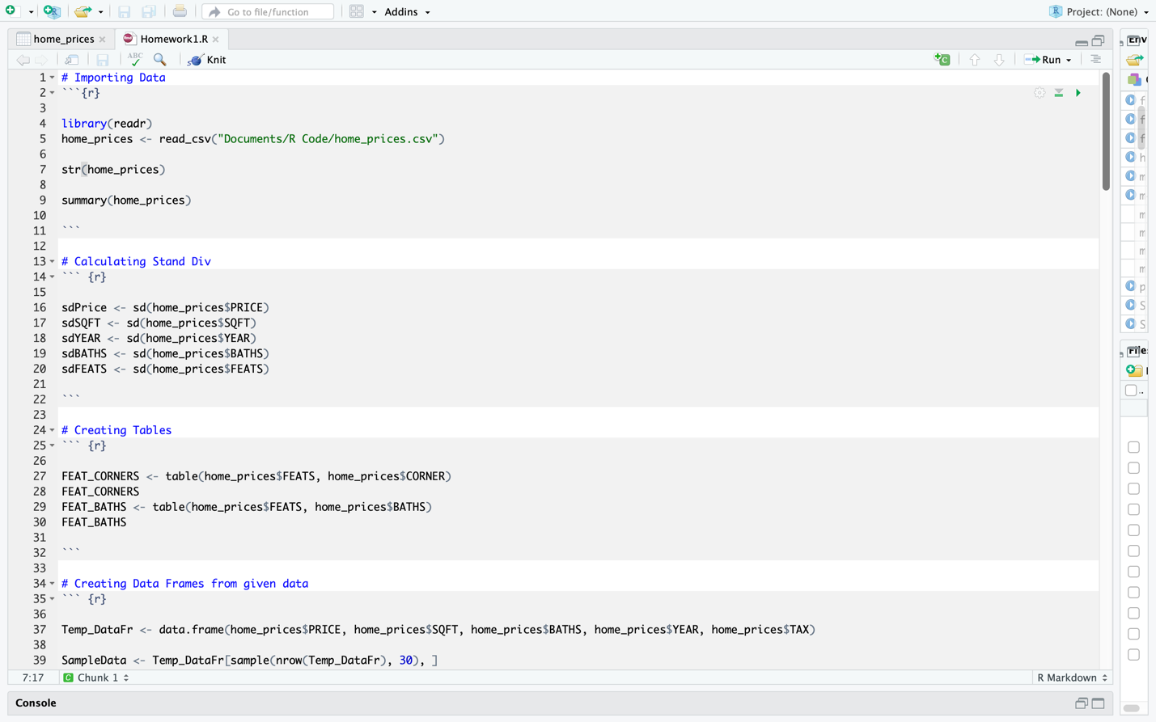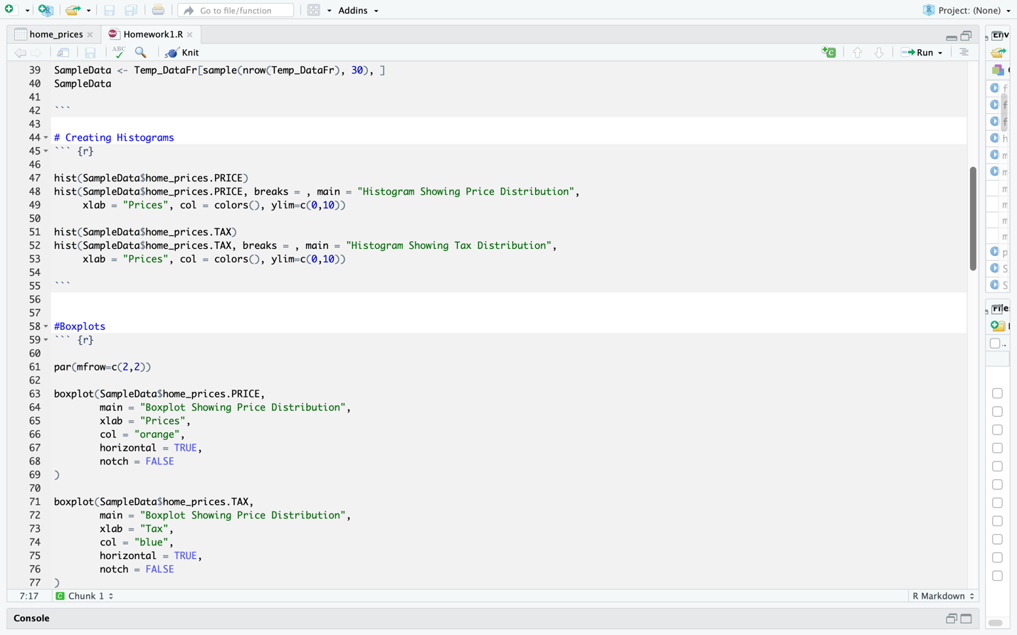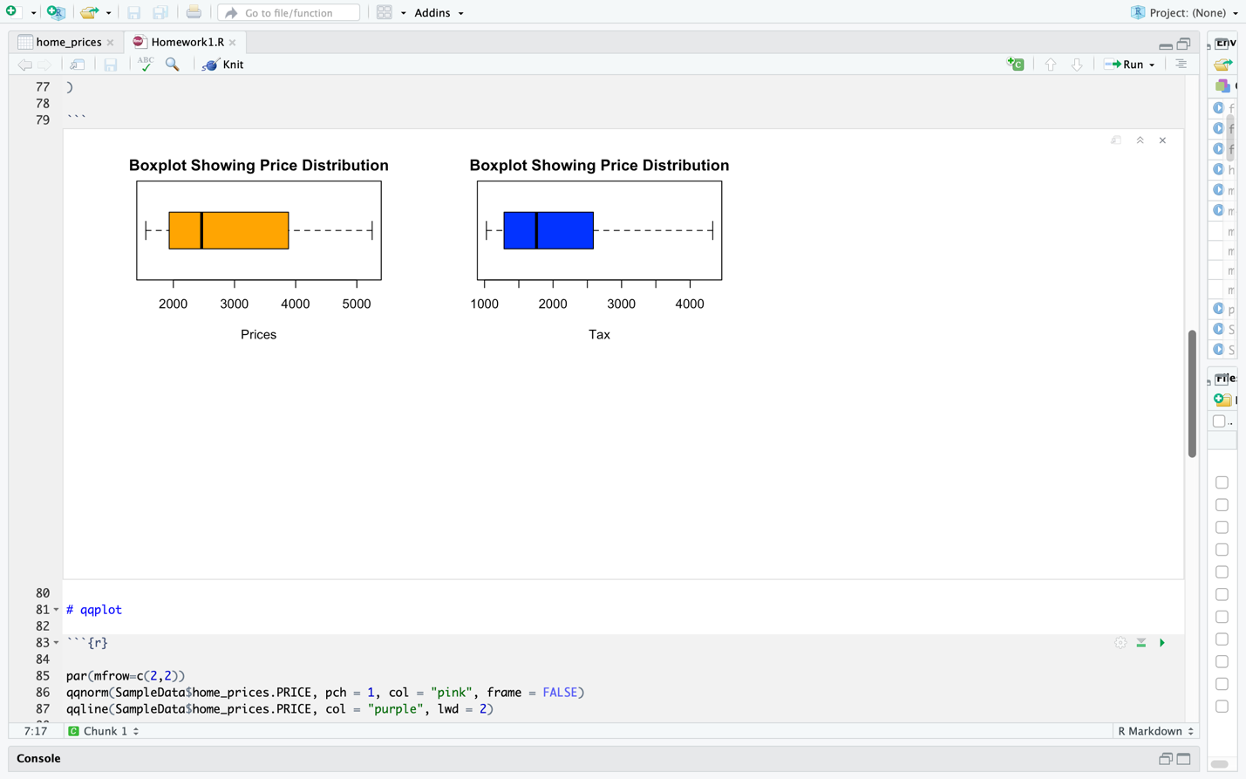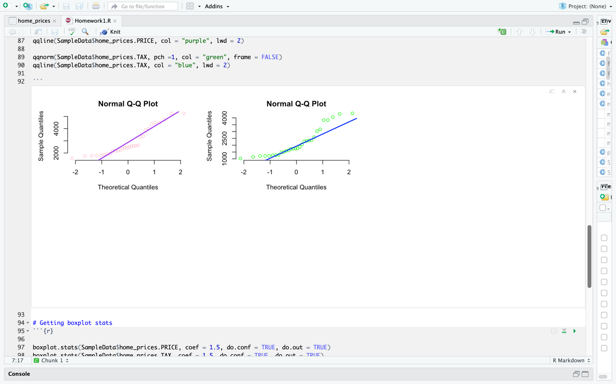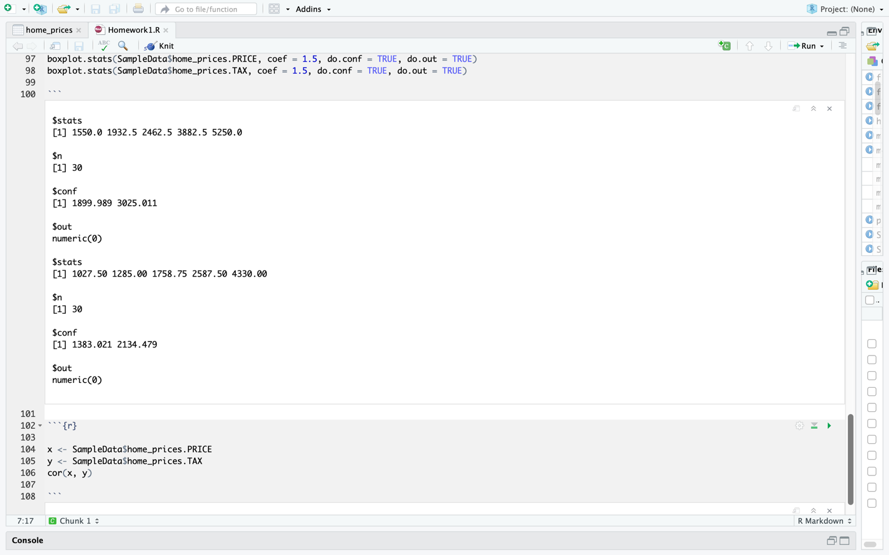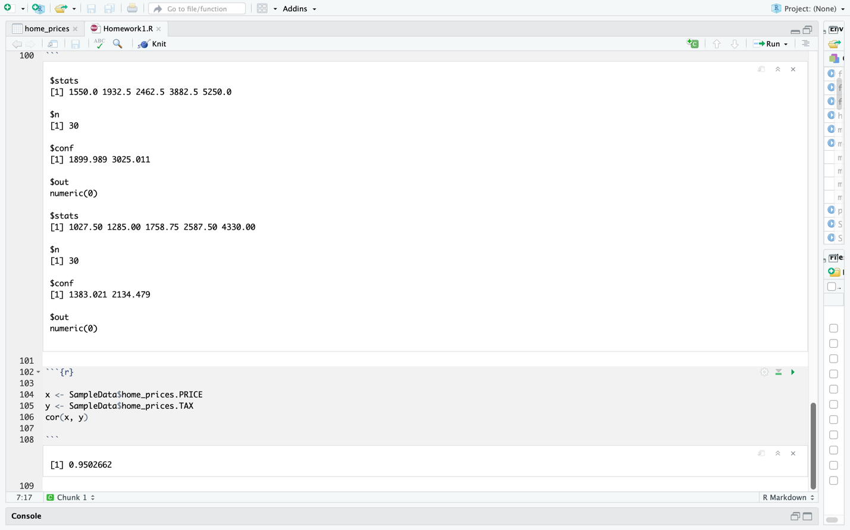

**STEP 6**

Here we examine the boxplot stat function, from this we can identify that out of the 30 samples we analyzed a vector of length 5, containing:

**PRICE**:

{the extreme of the lower whisker: 1550.0, the lower ‘hinge’: 1932.5, the median: 2462.5, the upper ‘hinge’: 3882.5 and the extreme of the upper whisker: 5250.0. We determine the lower extreme: 1899.989 and the upper extreme: 3025.011}

**The outliers are: numeric (0)**

**TAX**:

{the extreme of the lower whisker: 1027.50, the lower ‘hinge’: 1285.00, the median: 178.75, the upper ‘hinge’: 2587.50 and the extreme of the upper whisker: 4330.00. We determine the lower extreme: 1383.021 and the upper extreme: 2134.479}

**The outliers are: numeric (0)**

**STEP 7**

**Since both outliers are numeric(0) I predict that this is due to our random sample function selecting elements that are not beyond the average extreme to that specific sample size of 30.**

**Step 8**

After running cor(price,tax) we can conclude that there does exist a correlation between the variable Price and Tax, since the function returned the value of 0.9502662, a confidence high enough to make this claim. The data is most likely effected by abnormal points rather than outliers. I suggest this because our boxplot.stat didn’t indicate any major outliers, whereas in the qqplots there was a strong indication in abnormal points.