**Dataset Description:** An investigator provides data from the Professional Bowlers Association. The PBA (Professional Bowlers Association) includes many women professional bowlers as members. This dataset includes the following bowlers from their list of 15 women bowlers: (a) 9=Stephanie Nation, (b) 11=Amanda Fagan, and (c) 14=Shannon O’Keefe. The dataset contains 3 columns, Bowler, GameNum, Score.

**Case studies:**

1. We want to know if the 3 bowlers have different average bowling scores.
2. We want to know f there they have some type of spread on their potential scores.

**All decisions made using α = 0.05.**

**Model Statement:**

*Y = $β_{0}+β_{1}\left(Nation\right)+β_{2}\left(Fagan\right)+β_{3}\left(O^{'}Keefe\right)+ε_{i}$*

**Summary Statistic per Bowler:**

*Nation Fagan*

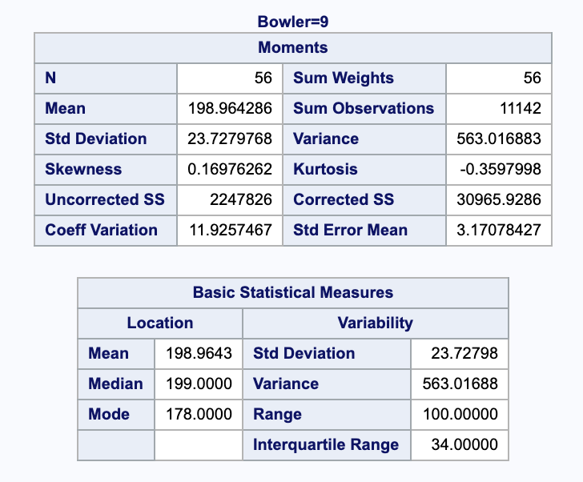 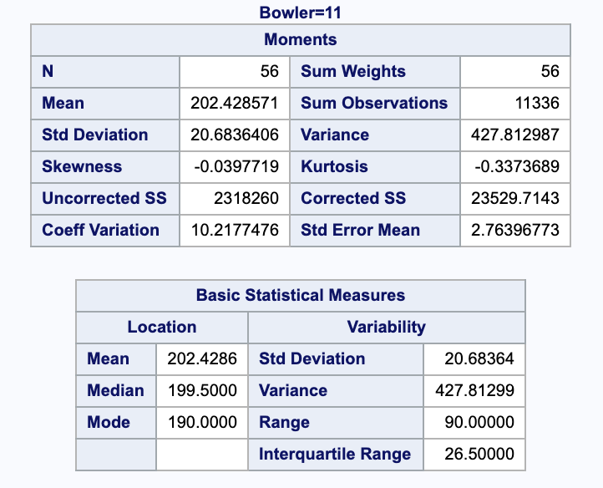

*O’Keefe*

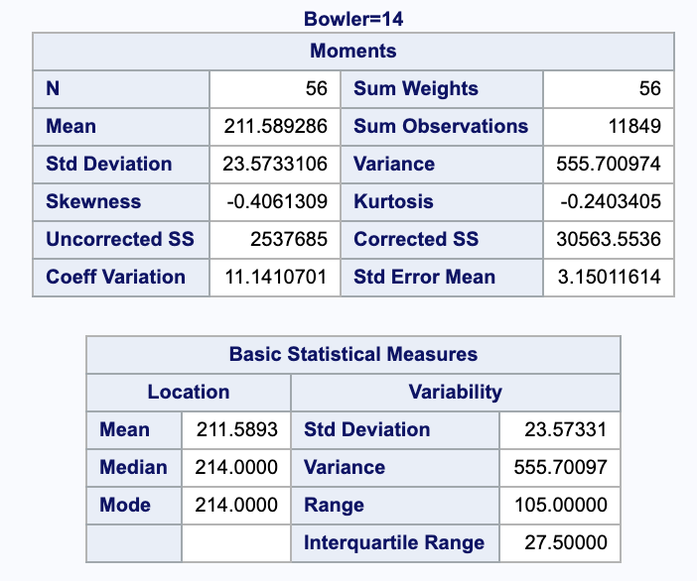

For this data set we are studying the scores of Professional Bowlers: Stephanie Nation, 1Amanda Fagan, and Shannon O’Keefe. The summary statistics above show sample size, minimum value, median, mean, variance, standard deviation, and maximum value for the data set of bowlers.

**Normality of Errors:**

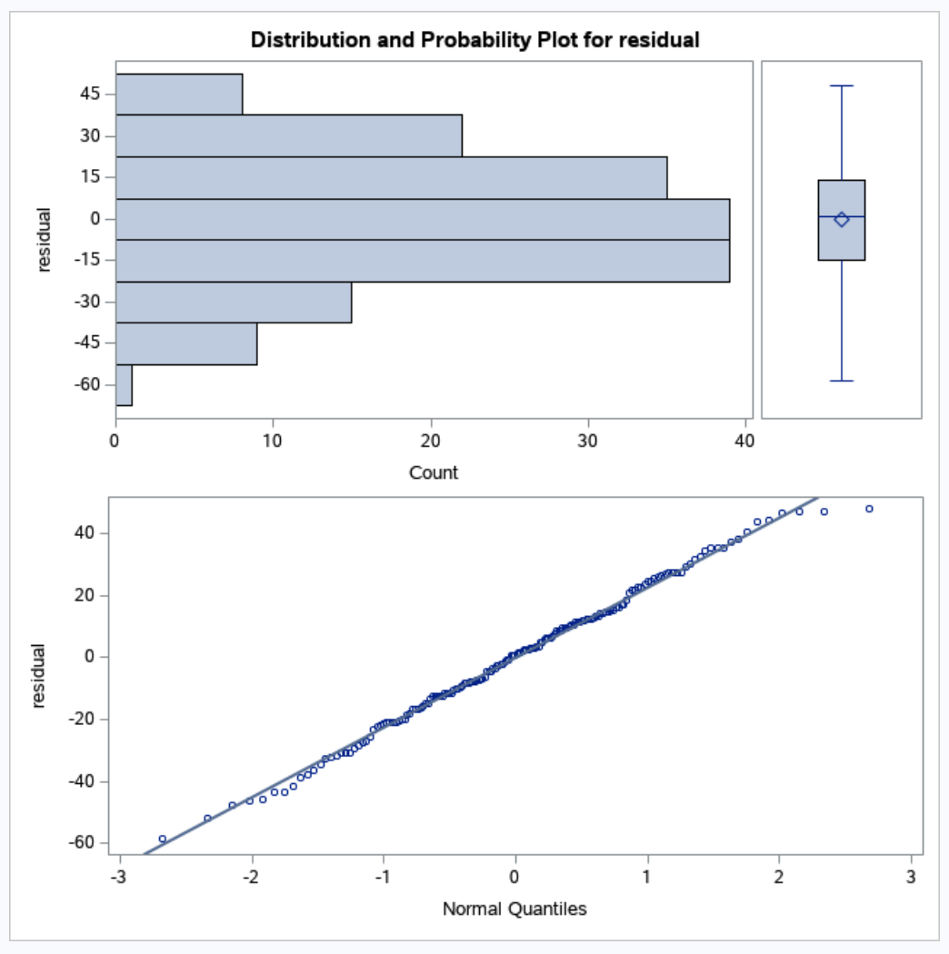

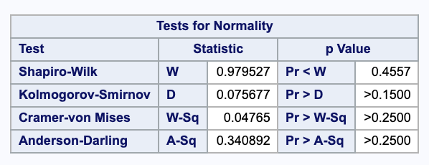

Normality assumptions are met based of the graphs generated since there seems to be linearity. Shapiro-Wilk test it gives us enough evidence that the residuals are normally distributes.

**Equal Variance of Errors:**

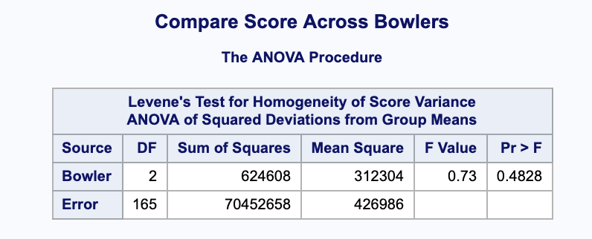

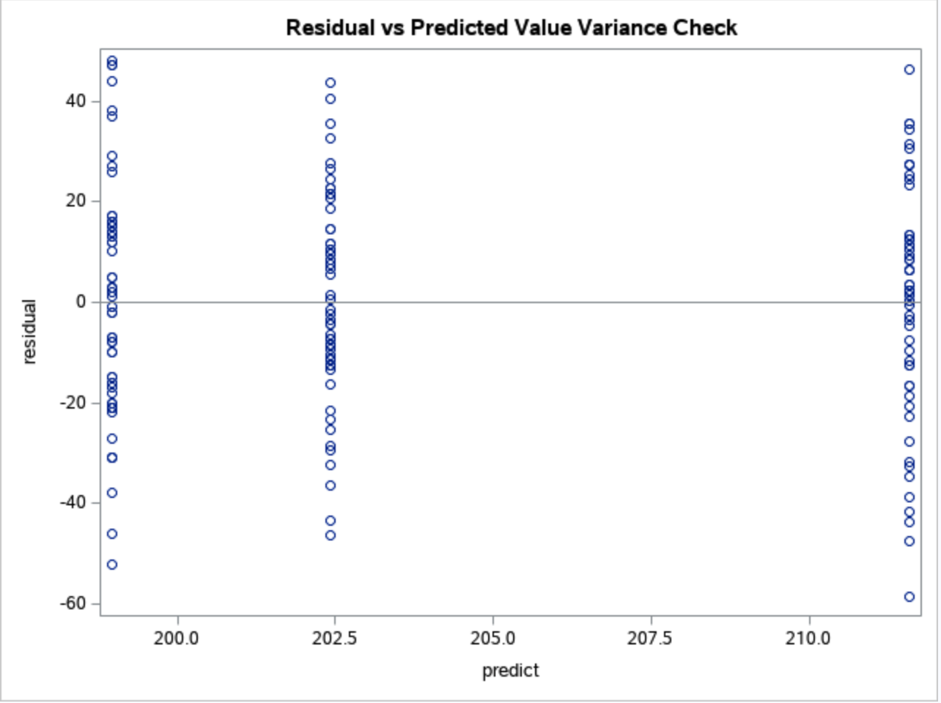

Based on the p-value being less than alpha (0.05) and the residual plot against predicted values, there appear not to be patterns, so the assumption of equal variance is met.

**Anova:**

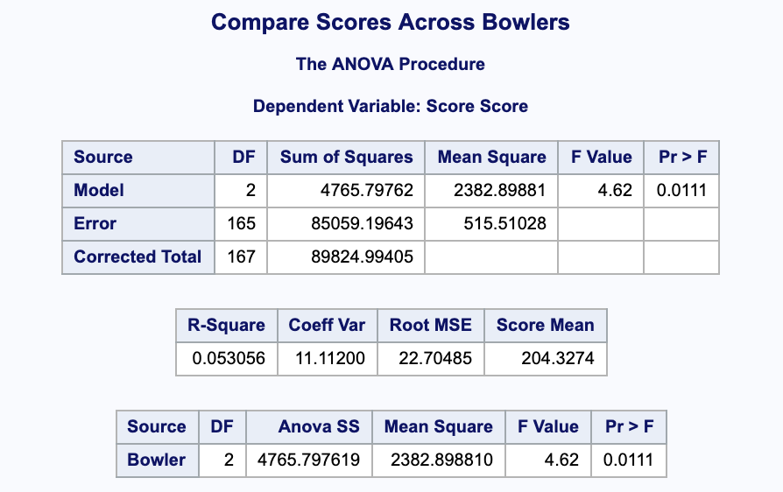

**Investigator Questions:**

**1**. Do the 3 bowlers in the provided dataset have different average bowling scores? If

there are different average bowling scores, which bowlers are different from each

other?

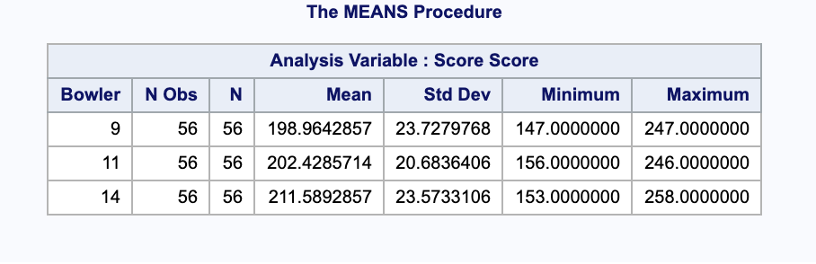

Here we clearly see that each bowler has a different average bowling score. Nation has an average score of 198.9643, Fagan of 202.4286, and O’Keefe that 211.5893. Each consecutively larger than the other.

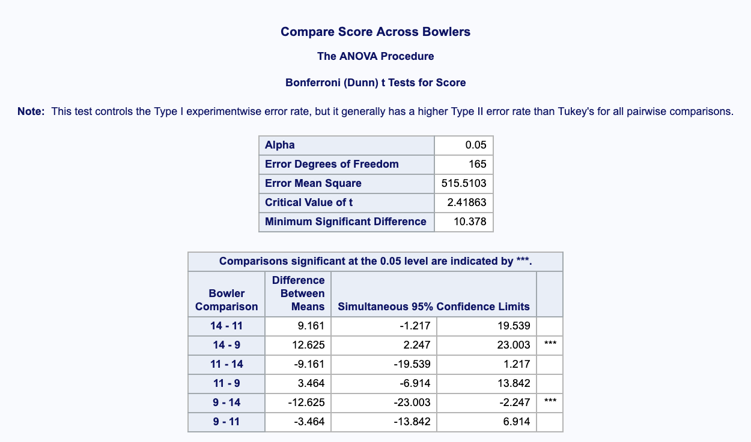

The difference of means between O’Keefe and Fagan is 9.161, 12.625 for O’Keefe and Nation, and 3.464 for Fagan and Nation. Bonferroni was used to reduce the chances of obtaining false-positive results (type I errors) when multiple pair wise tests are performed on a single set of data.

* **Hypotheses:**

*H*0 : 1 = 2 = 3 = 4 *H*1 : at least one  *I*, , *i*=1, 2, …, n is not the same

* **Test statistic:**

*F* = 4.62

* ***P*-value:**

*p*-value < 0.011162

* **Decision (Reject H0 or Do Not Reject H0):**

Since *p*-value < α = 0.05, Reject H0.

* **Conclusion:** There is enough evidence that there is a difference in treatment means within the bowlers scores. We notice that there are significance differences between Nation and O’Keefe (14-9 & 9-14), but no significance differences between Fagan and O’Keefe (14-11 & 11-14), and Nation and Fagan (11-9 & 9-11) since there confidence intervals include the value of zero. (This comes from the confidence table above).

**2**. How much variability do bowlers in general have within their scores? In other words,are their scores approximately the same every time, or do they have some type of

spread on their potential scores? If there is evidence of significant variability, what is

this value?

* **Hypotheses:**

*H*0 : 1 =  2 =  3 =  4 = 0 *H*1 : at least one  *i* ≠ 0, *i*=1, 2, …, n

* **Test statistic:**

*F* = 4.62

* ***P*-value:**

*p*-value < 0.011162

* **Decision (Reject H0 or Do Not Reject H0):**

Since *p*-value < α = 0.05, Reject H0.

* **Conclusion:** There is enough evidence that there is of significant variability within the bowlers scores.

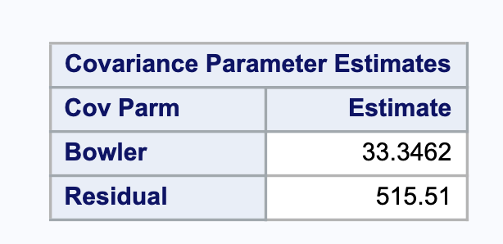

From the table above we see that each player has a variability of approximately 33.35 units. Showing that there is some type of spread on their potential scores.

**Summary:** We were able to determine that the 3 bowlers have different average bowling scores, and evidence of differences in means between the bowlers by testing with Bonferroni, where Fagan and Nation were different from each other. We were also able to identify that there was some type of spread on their potential scores thus, there was evidence that there is a significant variability of 33.35 units within the bowlers scores.