[Config config1]

description = "Podpovprecna obremenjenost"

sim-time-limit = 20min

\*\*.standardHost{..23}.numTcpApps = 1

\*\*.standardHost{..23}.tcpApp[0].numRequestsPerSession = 1 *# number of requests sent per session*

\*\*.standardHost{..23}.tcpApp[0].requestLength = 200B *# length of a request*

\*\*.standardHost{..23}.tcpApp[0].replyLength = 1MiB *# length of a reply*

\*\*.standardHost{..23}.tcpApp[0].thinkTime = truncnormal(2s,3s) *# time gap between requests*

\*\*.standardHost{..23}.tcpApp[0].idleInterval = truncnormal(3s,12s) *# time gap between sessions*

\*\*.standardHost{..23}.tcpApp[0].reconnectInterval = 30s *# if connection breaks, waits this much before trying to reconnect*

\*\*.standardHost{24..}.numTcpApps = 1

\*\*.standardHost{24..}.tcpApp[\*].replyDelay = 0

<datasets name="Potovalni čas">

<items xsi:type="scave:Add" filterPattern="endToEndDelay:histogram:mean"/>

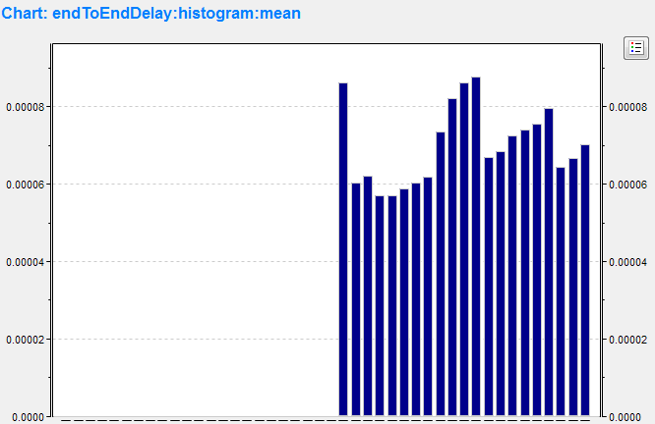

<datasets name="Število izgubljenih paketov">

<items xsi:type="scave:Add" filterPattern="dropPk:count"/>

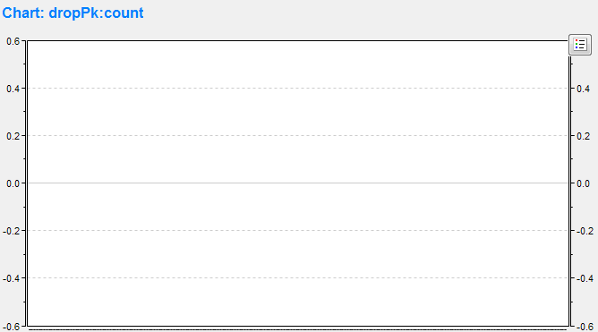

<datasets name="Number of sessions">

<items xsi:type="scave:Add" filterPattern="numSessions:last"/>

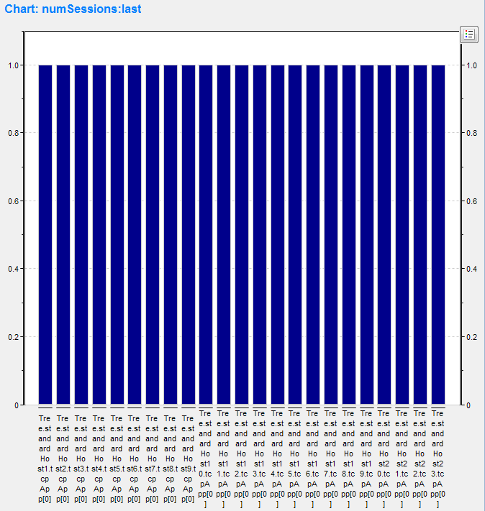

<datasets name="RTT">

<items xsi:type="scave:Add" filterPattern="&quot;measured RTT&quot;" type="VECTOR"/>

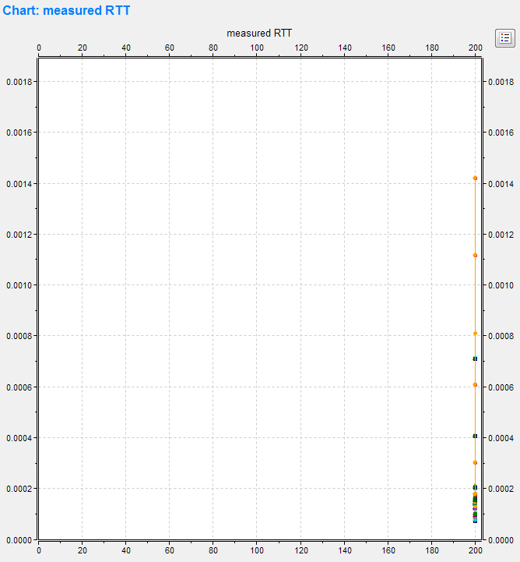

[Config config2]

description = "Srednja obremenjenost"

sim-time-limit = 20min

\*\*.standardHost{..23}.numTcpApps = 10

\*\*.standardHost{..23}.tcpApp[\*].numRequestsPerSession = 10 *# number of requests sent per session*

\*\*.standardHost{..23}.tcpApp[\*].requestLength = 200B *# length of a request*

\*\*.standardHost{..23}.tcpApp[\*].replyLength = 1MiB *# length of a reply*

\*\*.standardHost{..23}.tcpApp[\*].thinkTime = truncnormal(2s,3s) *# time gap between requests*

\*\*.standardHost{..23}.tcpApp[\*].idleInterval = truncnormal(3s,12s) *# time gap between sessions*

\*\*.standardHost{..23}.tcpApp[\*].reconnectInterval = 15s *# if connection breaks, waits this much before trying to reconnect*

\*\*.standardHost{24..}.numTcpApps = 1

\*\*.standardHost{24..}.tcpApp[\*].replyDelay = 0

<datasets name="Potovalni čas">

<items xsi:type="scave:Add" filterPattern="endToEndDelay:histogram:mean"/>

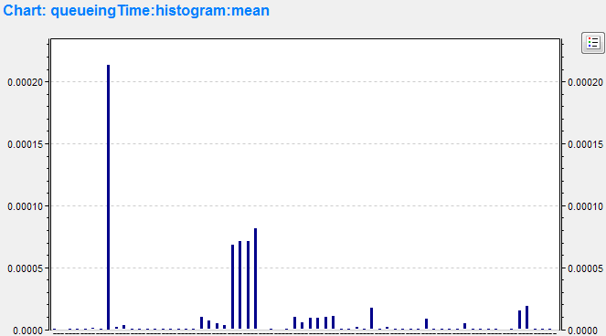

<datasets name="Število izgubljenih paketov">

<items xsi:type="scave:Add" filterPattern="dropPk:count"/>

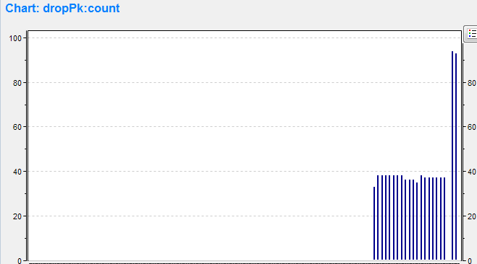

<datasets name="Number of sessions">

<items xsi:type="scave:Add" filterPattern="numSessions:last"/>

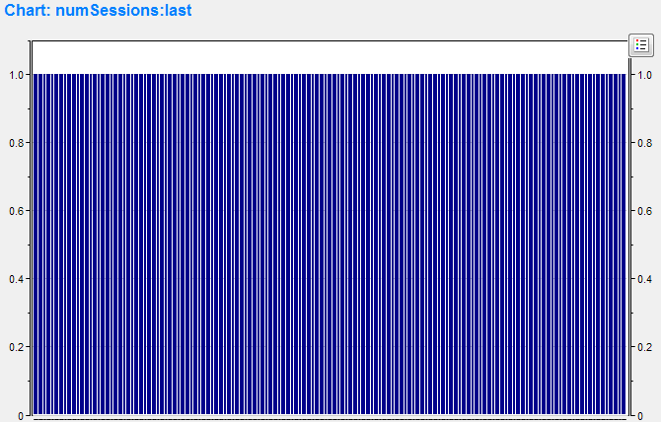

RTT (round-trip delay

time), which is the length of time it takes for a signal to be sent plus the

length of time it takes for an acknowledgment of that signal to be received (in

this simulation, ping).

<datasets name="RTT">

<items xsi:type="scave:Add" filterPattern="&quot;measured RTT&quot;" type="VECTOR"/>

