# Outline of steps taken to prepare the data to be visualized

1. Wrote an SQL query to join data from two tables (city_data and global_data) in the temperatures database.

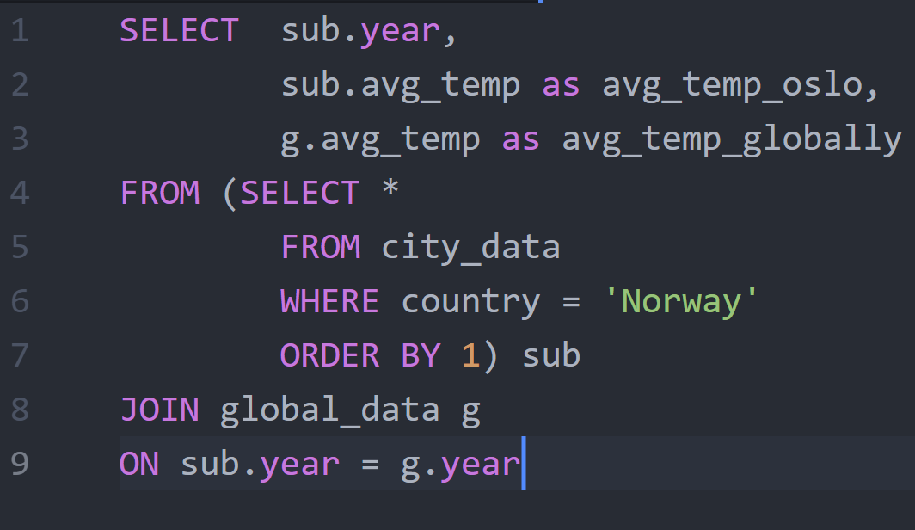

Used an inner join for this in order to only keep data from years available in both. The query was nested once allowing the inner query on city_data to be filtered on my city, Oslo. Used the feature in the learning module for downloading the resulting table as a .csv file. At this point the resulting consisted of three columns:

* year
* avg_temp_oslo
* avg_temp_globally

1. Opened the .csv file in Excel and added three columns:

* ma_oslo (used the AVERAGE function to calculate moving averages)
* ma_globally (used the AVERAGE function to calculate moving averages)
* ma_difference

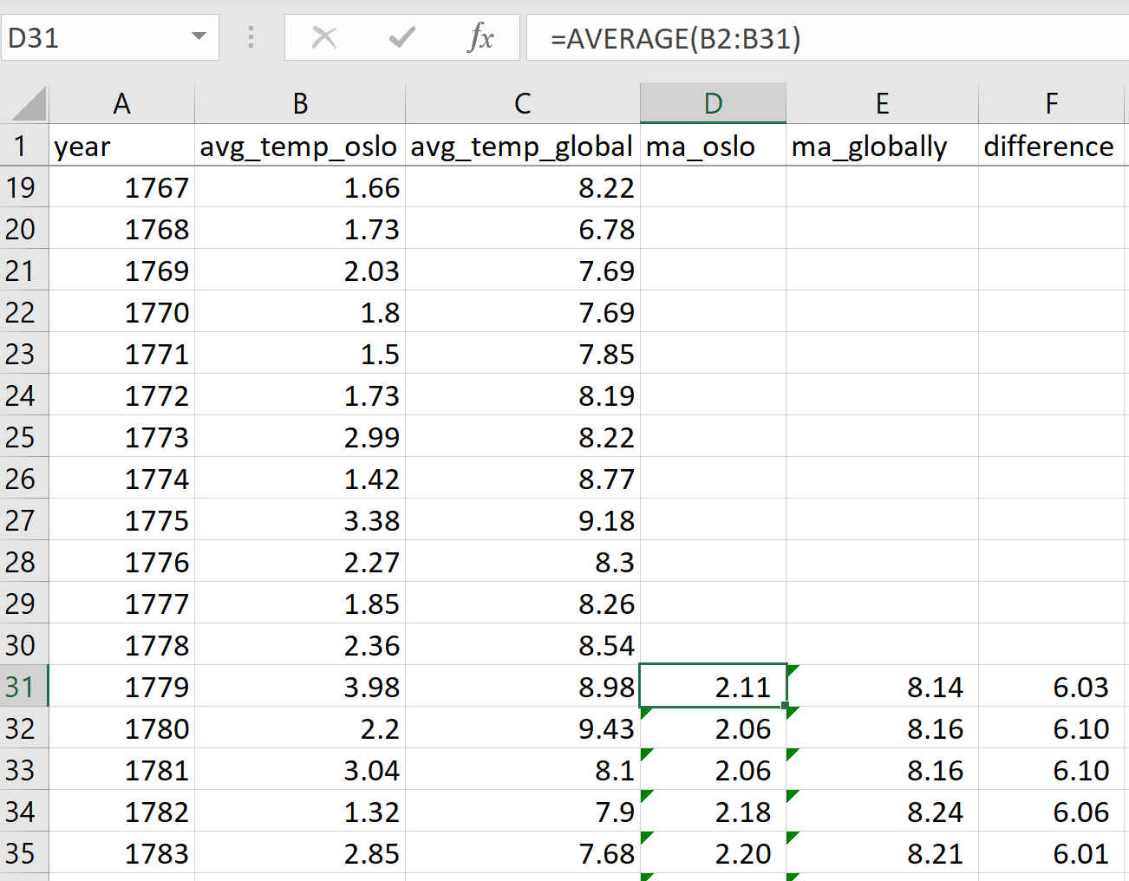

# Visualization

After taking mentioned steps I used an Excel line chart to visualize the data. This helped in considering different degrees of smoothing, and I ended up choosing a 30-year moving average for my plot.

# Observations

1. Over the course of more than 200 years the temperature trend is up, both for Oslo and globally. In Oslo it was quite flat around 2.1 degrees until around 1905 and since then it has increased to about 3.2 degrees, so an increase of around 1.1 degrees. Globally, the trend was quite similar, with an increase from around 8.0 degrees to around 9.2 degrees, so a slightly higher increase of around 1.2 degrees.
2. Both for Oslo and globally the uptrend has sharpened in the last 30 years leading up to 2013, and it appears that most of the increase has happened in recent years. This could indicate an accelerating increase in temperature, which would be much more alarming than a linear increase.
3. Around 1830-1840, however, we see a difference. In this period there is a clear dip in the global average temperature, while there is no such dip for Oslo.
4. Looking at the long-term difference (separate line graph in the chart) it is relatively stable around 6 degrees difference. This shows that Oslo follows the rest of the world when it comes to average temperature. It’s colder than the global average, as one would expect, and the difference is pretty much constant.