# **Workbook**

# **For**

# **MicroStrategy**

# **Truman Ng, PMP, HCIE**

**Learning Objectives**

By the end of this lab series, you will:

1. Understand how to set up and configure the MicroStrategy One environment.
2. Connect various data sources to MicroStrategy for analysis and visualization.
3. Create and customize basic and advanced visualizations.
4. Utilize key MicroStrategy features, including filtering, interlinking visualizations, creating metrics, and exporting data.

### **Lab 1: Setting Up of MicroStrategy One Environment**

**Objective**: Learn how to install and configure the MicroStrategy environment.

1. **Step 1**: Registration in MicroStrategy One.
   * <https://microStrategy.com>
2. **Step 2**: Launch MicroStrategy.
   * Navigate through the initial setup wizard.
   * Familiarize yourself with the user interface.
3. **Step 3**: Set up your workspace.
   * Click on (+) to create New Project

**Lab 2: Data Preparation - Connecting Your Data to MicroStrategy**

**Objective**: Learn how to import and connect data sources.

Source of Dataset:

<https://github.com/trumanng10/microstrtegyDatasets>

1. **Step 1**: Import data from a file (Excel, CSV).
   * Click on “Add Data.”
   * Upload file: ‘100000_Sales_Records.csv’

**Lab 3: Basic Visualization in MicroStrategy**

**Lab 3.1: Grid Visualization: The Basics**

**Objective**: Learn to create and customize a basic grid visualization in MicroStrategy.

**Step 1: Drag Dataset Fields into Rows and Columns**

1. **Open the MicroStrategy Project**:
   * Start MicroStrategy Web or Desktop and open your existing project where you have your dataset prepared.
2. **Select the Dossier or Create a New One**:
   * If you already have a dossier (report), open it. Otherwise, create a new one by clicking on **Create** → **New Dossier**.
3. **Add a New Grid Visualization**:
   * In the visualization panel on the right, click on **Grid** to add a grid layout to your dossier.
4. **Drag Dataset Fields**:
   * In the **Data Panel** on the left side:
     + Drag one or more **Attributes** (e.g., Product, Category) to the **Rows** section.
     + Drag one or more **Metrics** (e.g., Sales, Revenue) to the **Columns** section.

***Tip****: Attributes define how data will be grouped (rows), while metrics show the numerical data in columns.*

1. **Instant Grid Generation**:
   * Once you’ve added the fields, MicroStrategy automatically generates a grid visualization based on your dataset. You should now see data displayed in a tabular format.

**Step 2: Format the Grid**

Now that the basic grid has been created, you can format it to enhance readability and visual appeal.

1. **Adjust Column Widths**:
   * Hover over the column headers in the grid.
   * Click and drag the edge of a column header to resize the column width, making it fit the content better.
2. **Style the Headers**:
   * Right-click on any column header and select **Format Header**.
   * In the **Formatting Options** panel, you can:
     + Change the font style (bold, italics).
     + Adjust font size and color.
     + Change the background color of the header.
3. **Apply Conditional Formatting** (Optional):
   * To make the grid more dynamic, you can apply **conditional formatting** to cells.
   * Right-click on a metric value, select **Conditional Formatting**, and apply rules based on thresholds (e.g., Sales over $10,000 in green, below $5,000 in red).
4. **Customize Row and Column Borders**:
   * Right-click anywhere inside the grid and select **Format Grid**.
   * Under **Grid Properties**, you can adjust the border styles (solid, dashed) and colors around the cells.

**Step 3: Save the Grid and Review the Data**

1. **Save the Visualization**:
   * After formatting, click **Save** to store the changes in your dossier.
   * Enter a suitable name for your dossier if this is your first time saving it (e.g., **“Sales Performance Grid”**).

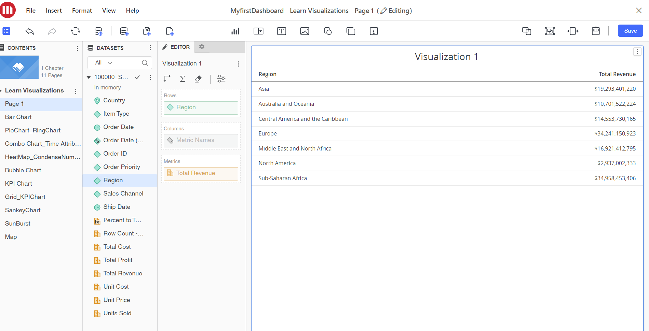

**Lab 3.2: Grid Visualization: Other Basic Options**

**Objective**: Explore additional options for grid customization.

1. **Step 1**: Add conditional formatting to grid cells.
2. **Step 2**: Customize headers, borders, and gridlines.

**Lab 3.3: Bar Chart**

**Objective**: Create and customize a bar chart.

1. **Step 1**: Add measures to the Y-axis and attributes to the X-axis.
2. **Step 2**: Format bars (color, width) and adjust axis labels.
3. **Step 3**: Save and preview the chart.

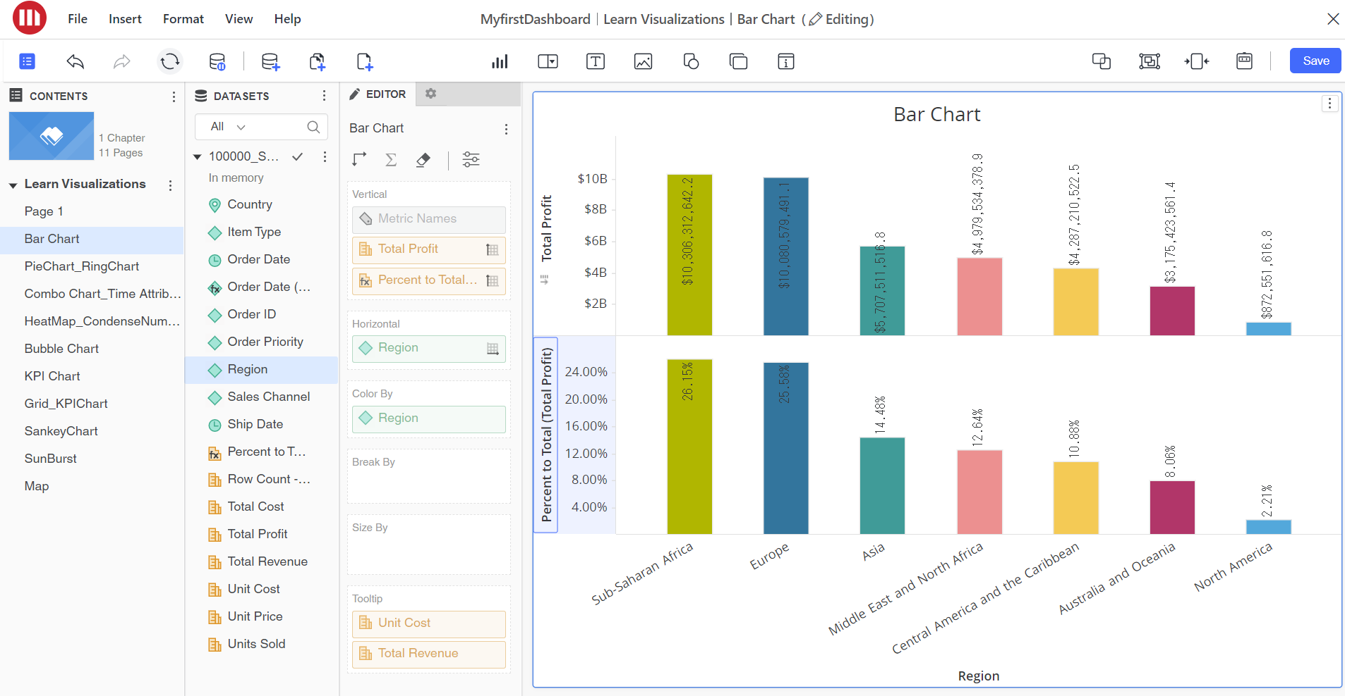

**Lab 3.4: Pie Chart vs Ring Chart**

**Objective**: Understand the difference between pie charts and ring charts.

1. **Step 1**: Create a pie chart.
   * Add attributes and measures.
2. **Step 2**: Switch to a ring chart and compare.
   * Discuss use cases for each type.

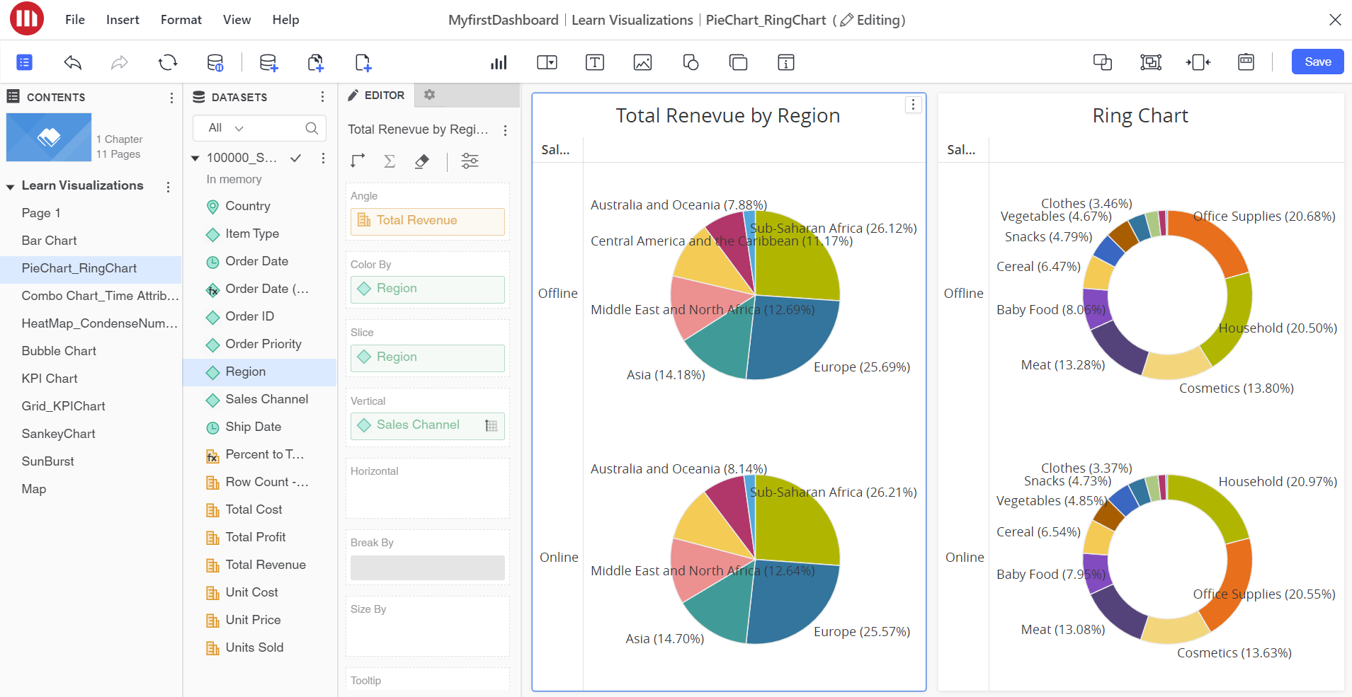

**Lab 4: Advanced Visualization**

**Lab 4.1: Combo Chart and Time Attributes**

**Objective**: Create combo charts combining line and bar visualizations.

1. **Step 1**: Add a time-based attribute to the X-axis.
2. **Step 2**: Add multiple measures (bars and lines) to visualize trends over time.

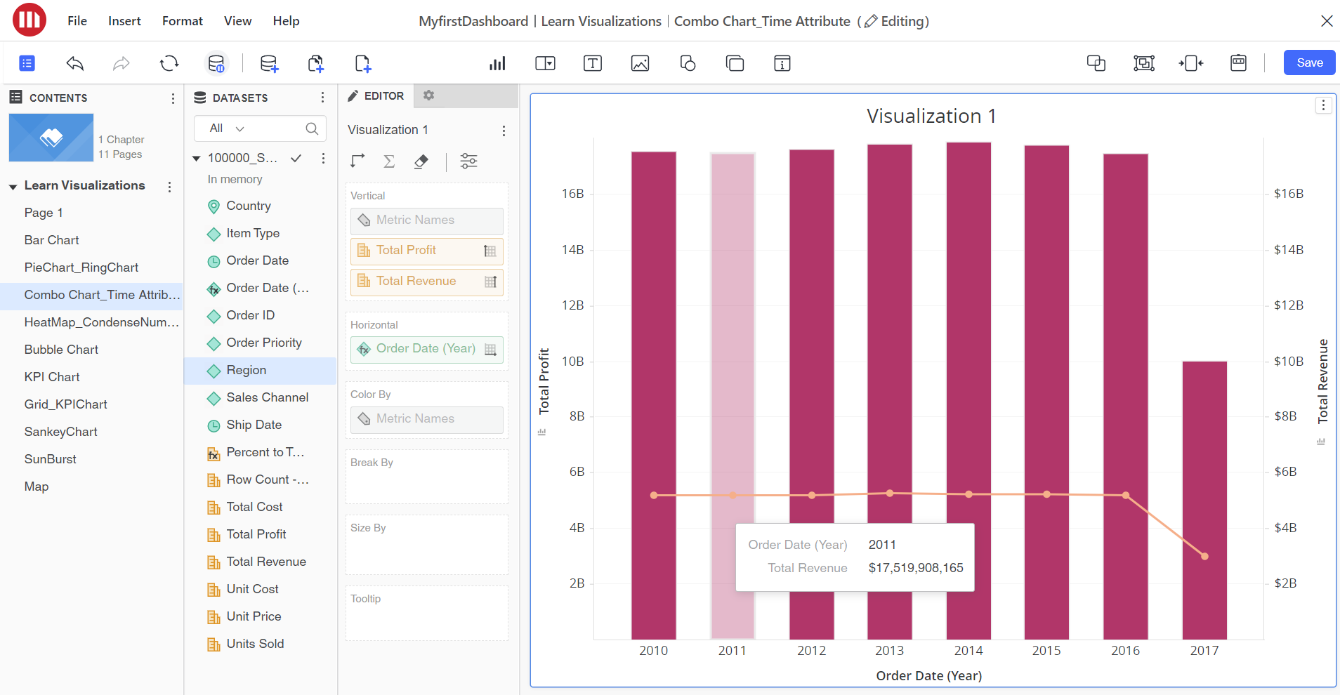

**Lab 4.2: Heatmaps and Condensed Number Feature**

**Objective**: Create heatmaps with condensed number formats.

1. **Step 1**: Add attributes and metrics to the heatmap.
2. **Step 2**: Apply the **Condensed Number** feature to simplify numeric display.

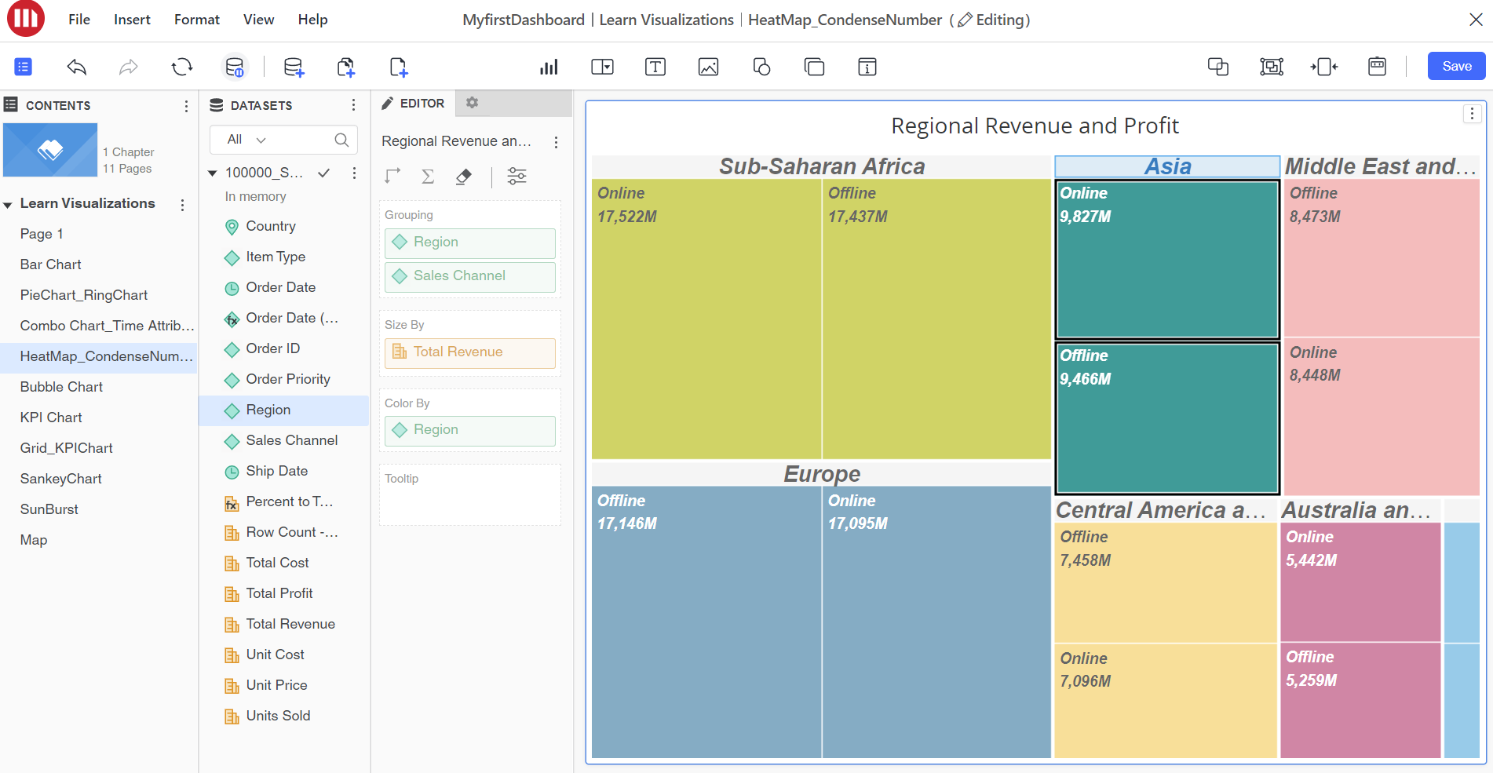

**Lab 4.3: Bubble Charts**

**Objective**: Learn how to build bubble charts for multi-dimensional analysis.

1. **Step 1**: Add measures for bubble size and color.
2. **Step 2**: Adjust transparency and labels for clarity.

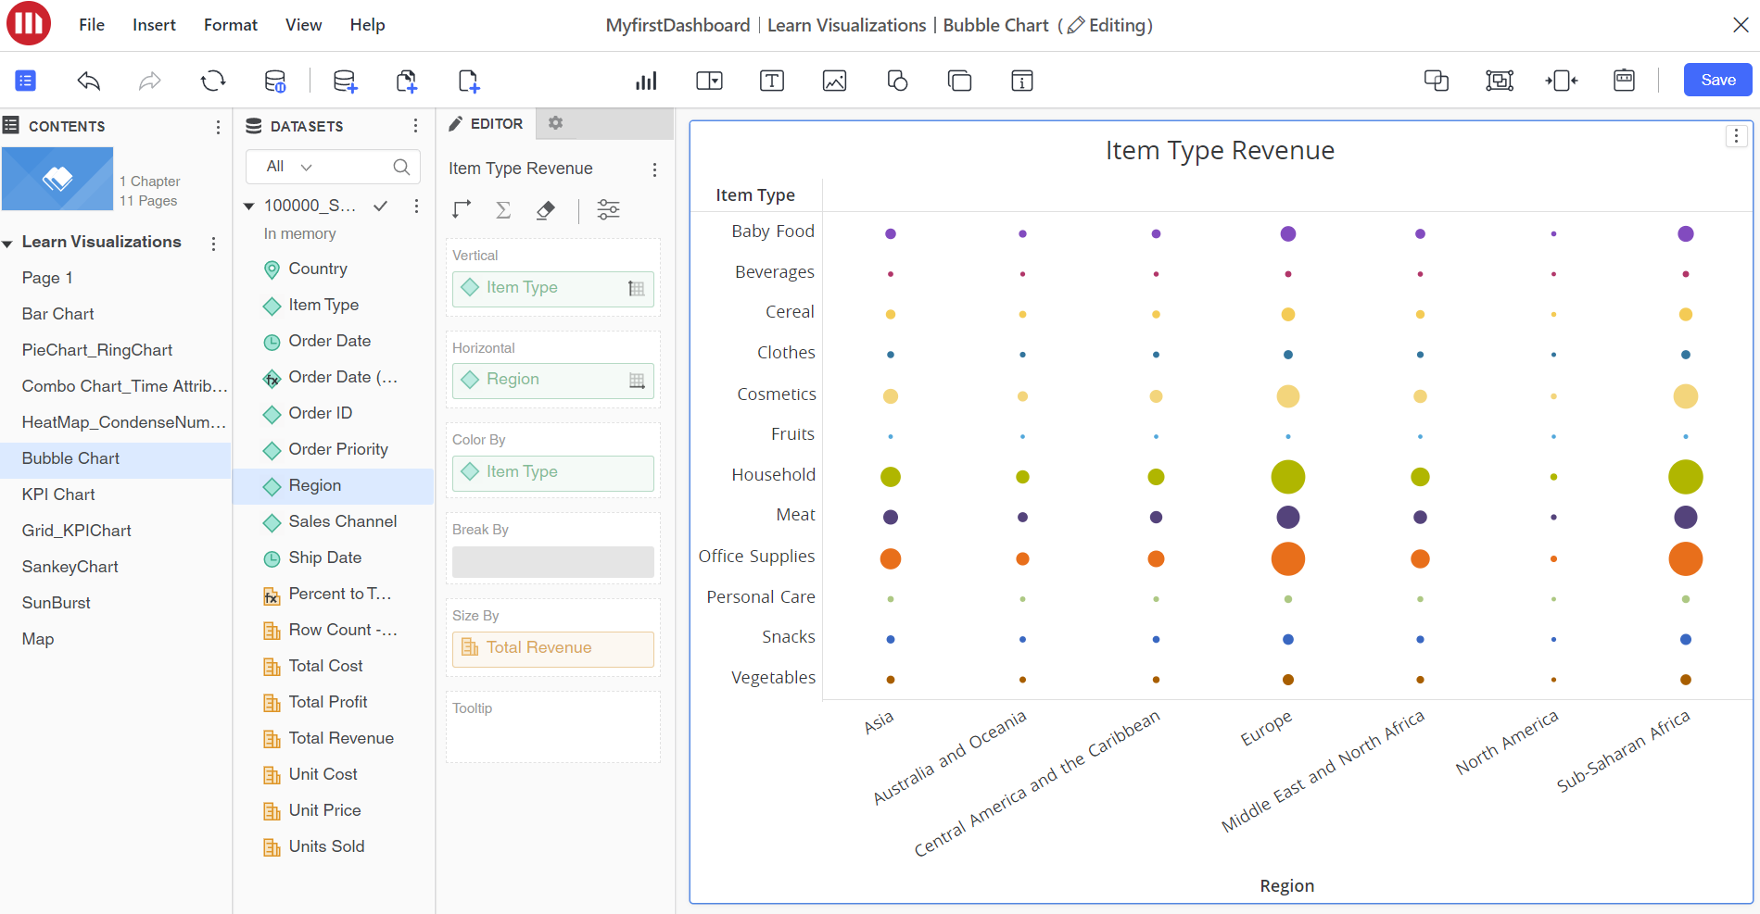

**Lab 4.4: KPI Charts - YoY Comparison**

**Objective**: Create KPI charts for year-over-year comparison.

1. **Step 1**: Set up time series data (e.g., Sales YoY).
2. **Step 2**: Customize KPI visualization using thresholds and colors.

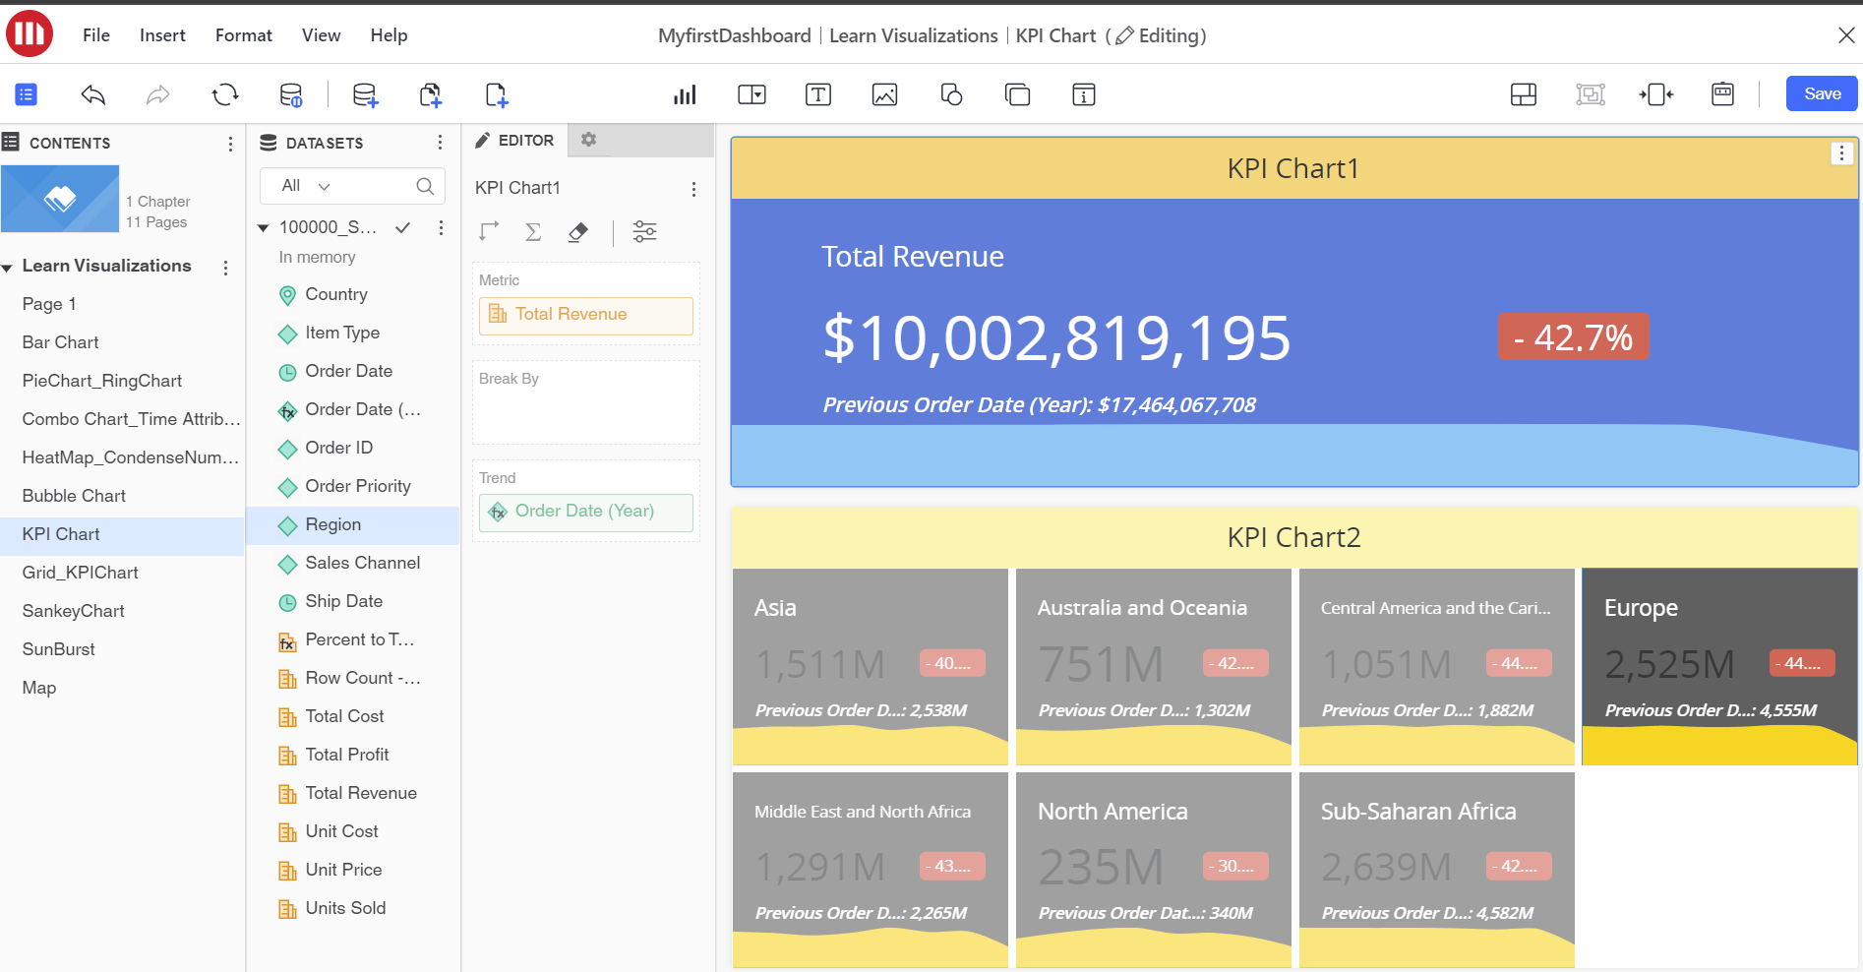

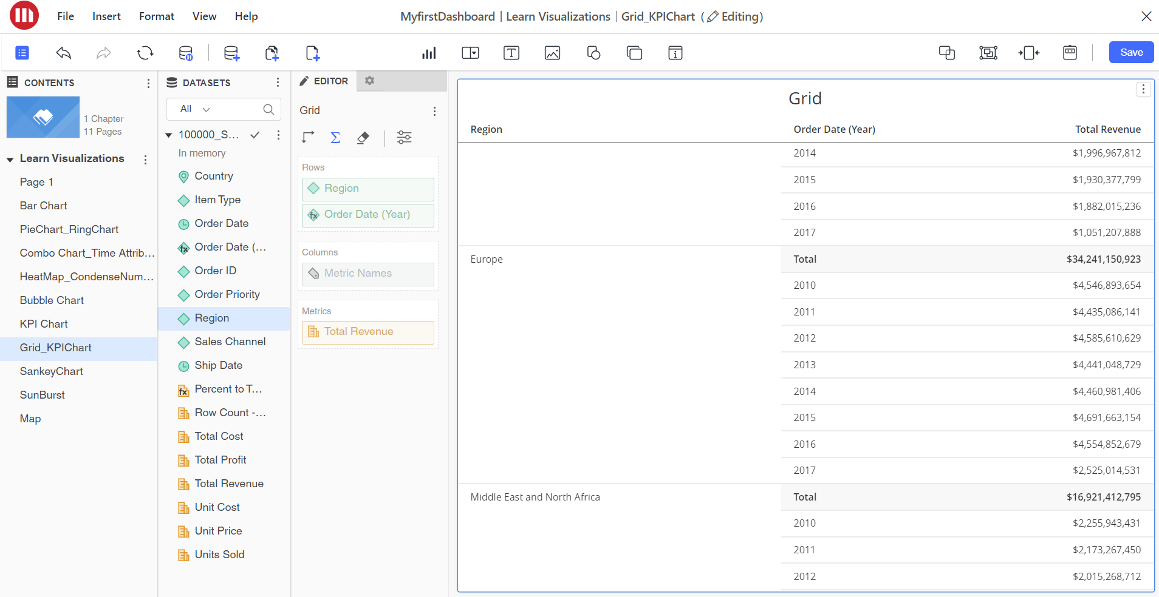

**Lab 4.6: Sankey Diagram**

**Objective**: Create a Sankey diagram for flow visualization.

1. **Step 1**: Add source and target fields.
2. **Step 2**: Customize flow connections and color coding.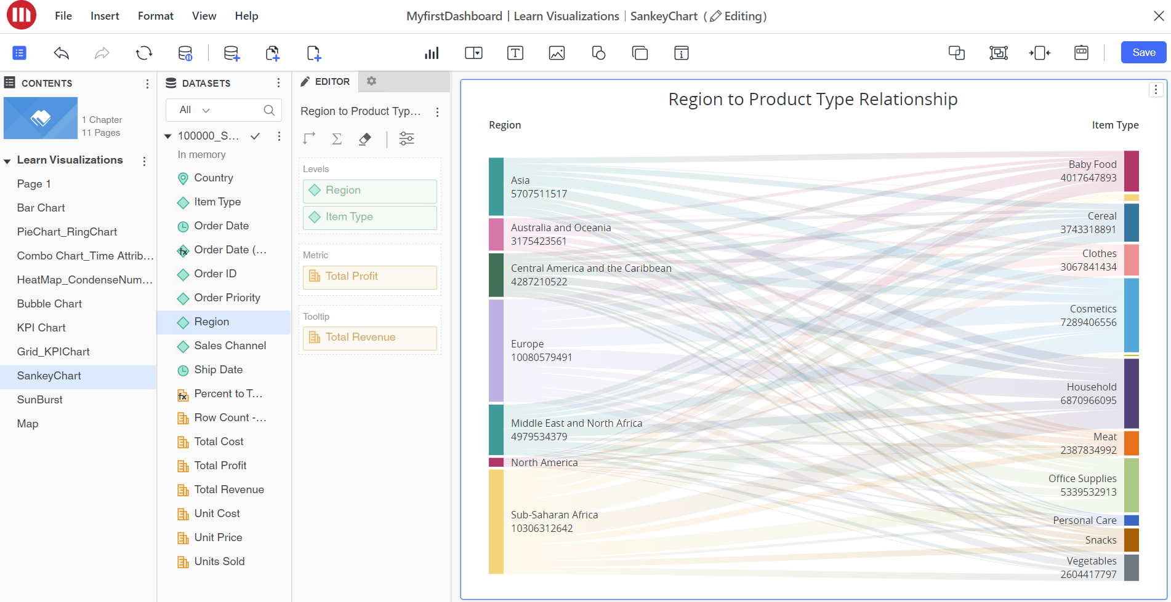

**Lab 4.7: SunBurst Chart**

**Objective**: Create a SunBurst chart to visualize hierarchical data.

1. **Step 1**: Add multiple layers of attributes to the chart.
2. **Step 2**: Format color and outer ring spacing.

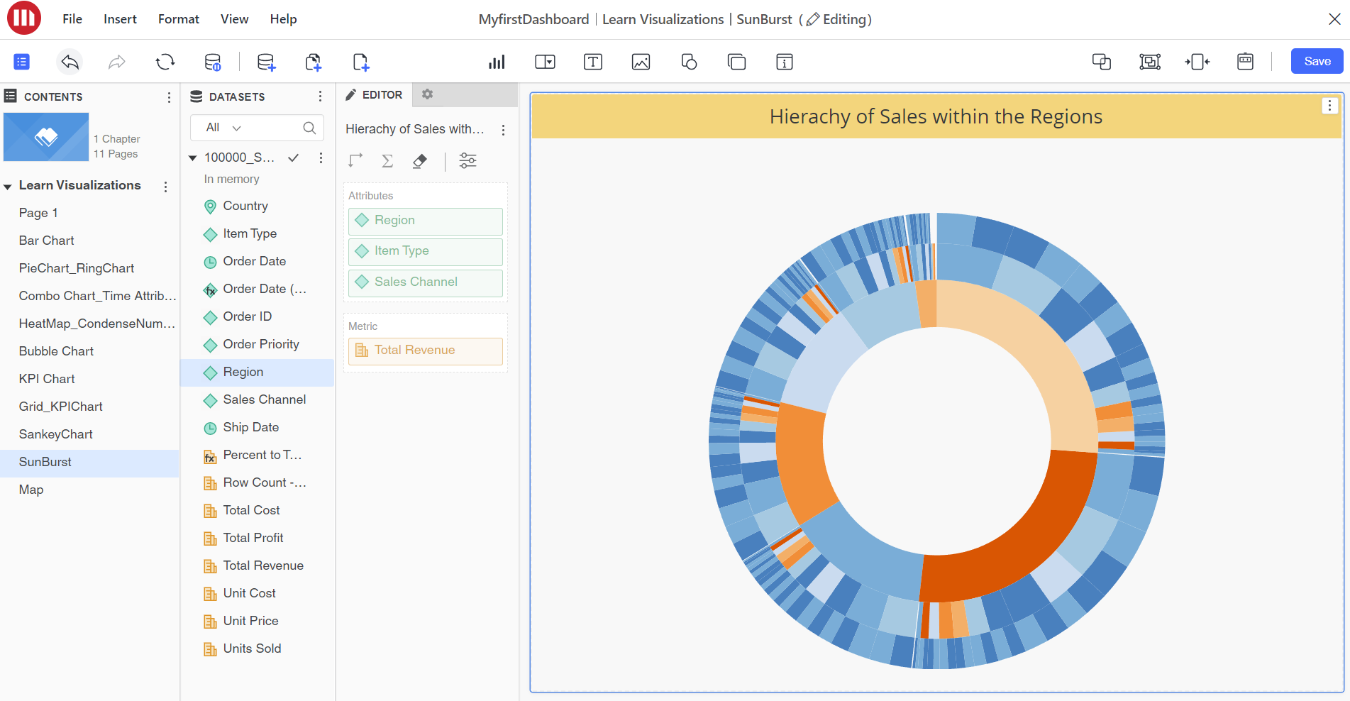

**Practice of the Day:**

Load Sample Dataset from the MicroStrategy and Build your own Visualization