WoMat Documentation

First of all, thanks for purchasing this theme. I hope you will love the design of theme. Now it’s turn to see WoMat live in action.

The process of activating the theme is very simple. In some case, you don’t know about theme installation, you can follow the simple steps below.

* First of all, download the theme file which you have purchased.
* Now extract the zip file with the help of ‘WinRar’ or ‘7-zip’. The zip file contains the following files and folders.

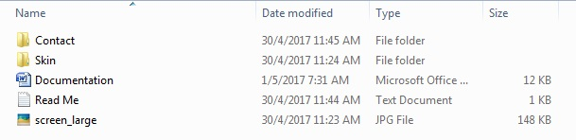

* The main theme is in the **Skin** folder.
* Now Copy the **womat** folder and upload it to your website by FTP or with the help of cPanel in the themes directory of your website.

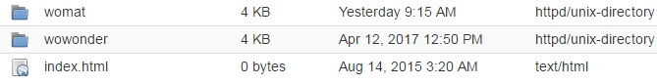

* It’s time to activate the theme via admin panel. To do so, visit the admin panel of your site and choose Theme option from the left sidebar. Now click on **Active** to activate the theme.

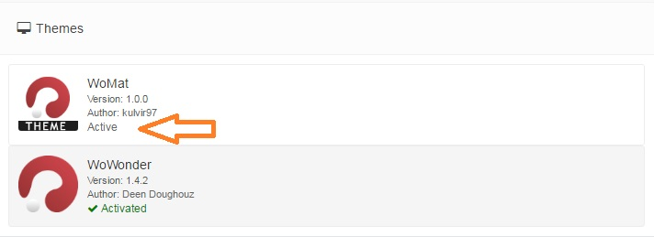

* Now the theme will be activated.

Once again, thanks for purchasing this theme.

If you like it, don’t forget to give it 5 stars. ☺