# Lab 1 Pre-lab Example

## Team Information

**Lab number:** 1

**Date:** 2/7/2016

**Team Members:** Brett Bushnell, Ryan Trumpinski, Sydney Clark, Matt Dzurick**Team Number/Name:** 217/ WeDidTheThing

Team Member Responsibilities

**Software Design:** Ryan Trumpinski

**Hardware Design:** Brett Bushnell

**Quality Assurance:** Sydney Clark

**Systems Integrator:** Matt Dzurick

# Hardware

### Responsibility (2 pts)

Fill in the table below based on your responsibilities provided in the procedures and grading rubric. This will be what determines your individual grade for the lab.

|  |  |  |
| --- | --- | --- |
| Part 1 | Part 2 | Part 3 |
| The circuit diagram is complete. Appropriate colors are chosen for the wire-Wrapping Portion | Pin numbers on the LCD and microcontroller are included. Appropriate colors are used for each wire | Same as part 1 |

### Part 1 (1 pts)

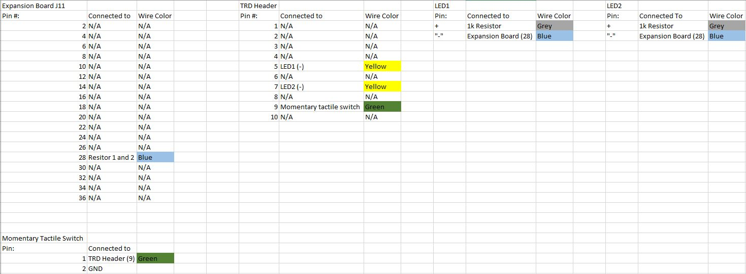Draw the schematics or create a table detailing the connections for Part 1 of Lab 1.

### Part 2 (1 pts)

Draw the schematics or create a table detailing the connections for Part 2 of Lab 1. You can choose to use a table or use a diagram.

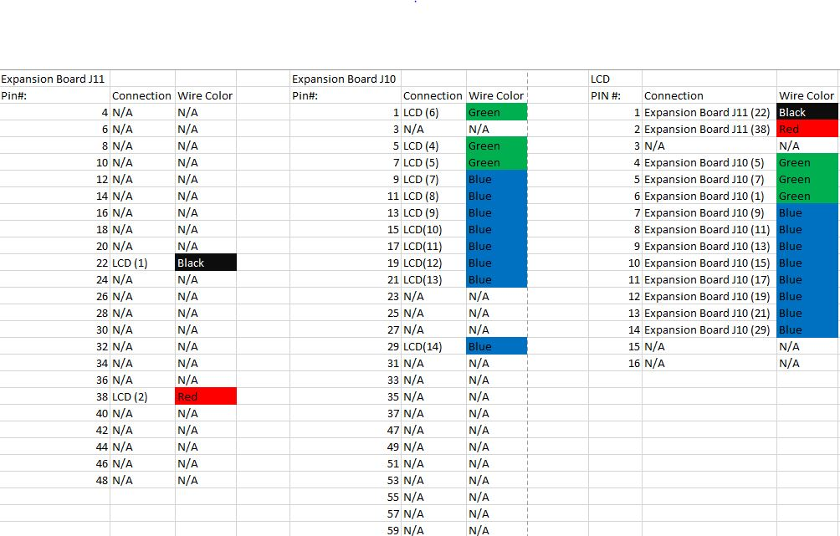

### Part 3 (1 pts)

Draw the schematics or create a table detailing the connections for Part 3 of Lab 1. You can choose to use a table or use a diagram.

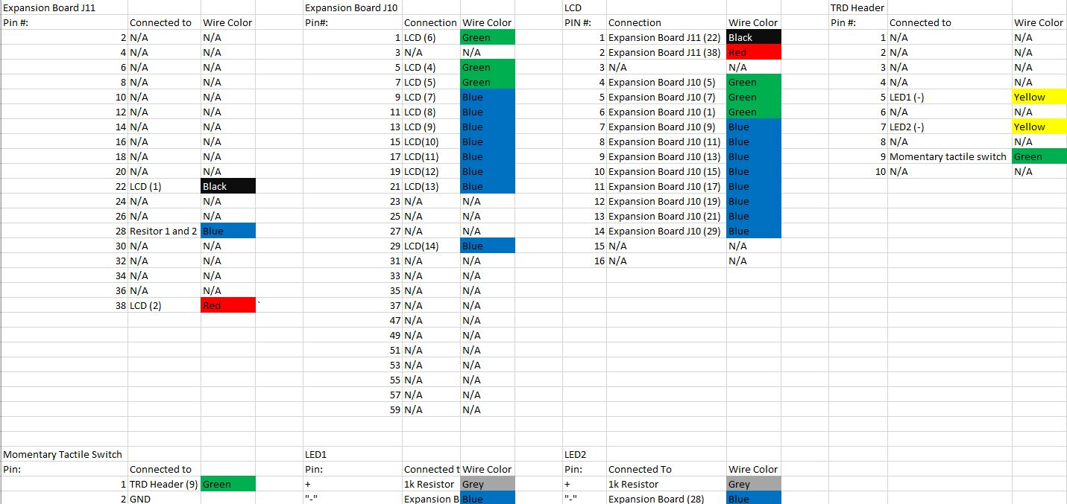

# Quality Assurance

### Responsibility (2 pts)

Fill in the table below based on your responsibilities provided in the procedures and grading rubric. This will be what determines your individual grade for the lab.

|  |  |  |
| --- | --- | --- |
| Part 1 | Part 2 | Part 3 |
|  |  |  |

### Part 1 (1 pts)

List the tests that you intend to do based on the Lab 1 procedures. Describe the name of the test, the tool you intend to use, and a description of the test. Do this for each part in Lab 1.

|  |  |  |
| --- | --- | --- |
| Test Name | Tool | Description |
| Continuity Test | Digital Multi-meter | Test all wire connectors, solder joints, and wire-wraps for continuity |
| Power Test | Digital Multi-meter | Test that any created circuits have power correctly flowing |
| Grounding Test | Digital Multi-meter | Test that any switches connected to ground actually ground a powered circuit |
| Component Test | Digital Multi-meter | Test that appropriate pins on the switch are connected |

You may also include any software tests that you intend to make.

|  |  |  |
| --- | --- | --- |
| Test Name | Input | Description |
| timerTick Test |  | Test that timerTick indeed ticks at the correct interval |
| displayTime Test | “10000” | Test that this function assigned the appropriate register to “10:00:00.” |
| Register Test |  | Test that the register configurations for the timer work. |

### Part 2 (1 pts)

### Part 3 (1 pts)

# Software

### Responsibility (2 pts)

Fill in the table below based on your responsibilities provided in the procedures and grading rubric. This will be what determines your individual grade for the lab.

|  |  |  |
| --- | --- | --- |
| Part 1 | Part 2 | Part 3 |
| Debounce buttons  Clear code  RUN LED is initially on | Functionality works  LCD displays any string input  Supporting functions work | Interrupts are used  State machine is correct  Time is formatted correctly with new function |

### Part 1 (1 pts)

List the relevant control registers for controlling the LEDs in Part 1 of Lab 1.

|  |  |
| --- | --- |
| Device: | Register(s): |
| Digital I/O | LATGbits.LATG14, LATGbits.LATG12 |

Also describe the function of the microcontroller software as a finite-state machine.

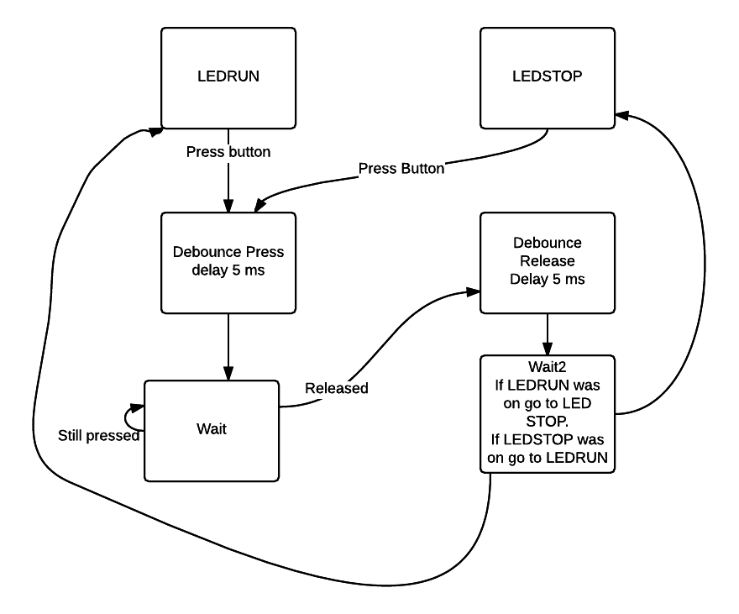

### Part 2 (1 pts)

List the relevant control registers for controlling the LCD in Part 2 of Lab 1.

|  |  |
| --- | --- |
| Device: | Register(s): |
| Timer | Pins 1-14 on the expansion board: RG15,RE5,RE6,RE7,RC1,RC2,RC3,RC4,RG6,RG7,RG8,RG9,P32C1, P32R1 |

### Part 3 (1 pts)

Also describe the function of the microcontroller software as a finite-state machine in Part 3 of Lab 1.

