POI Manager
v0.6

(c) Steve Clarke

Introduction
POI Manager is an application to manage of interest and Garmin GPX track files. It has the following features:
- Graphical map editing / placement.
- Map overlays for satellite and footpaths.
- Geocoding of points of interest.
- Import and export of TomTom OV2 files.
- Import and export of Garmin GPX files.
- Import of points of interest from photos with lat/lon.
- Reverse engineering track from photos with lat/lon and timestamps.
- Upload / download from Garmin GPS device.
- Automatically creates a tracks.gpx and tracks.ov2 file containing the starting point of each track.
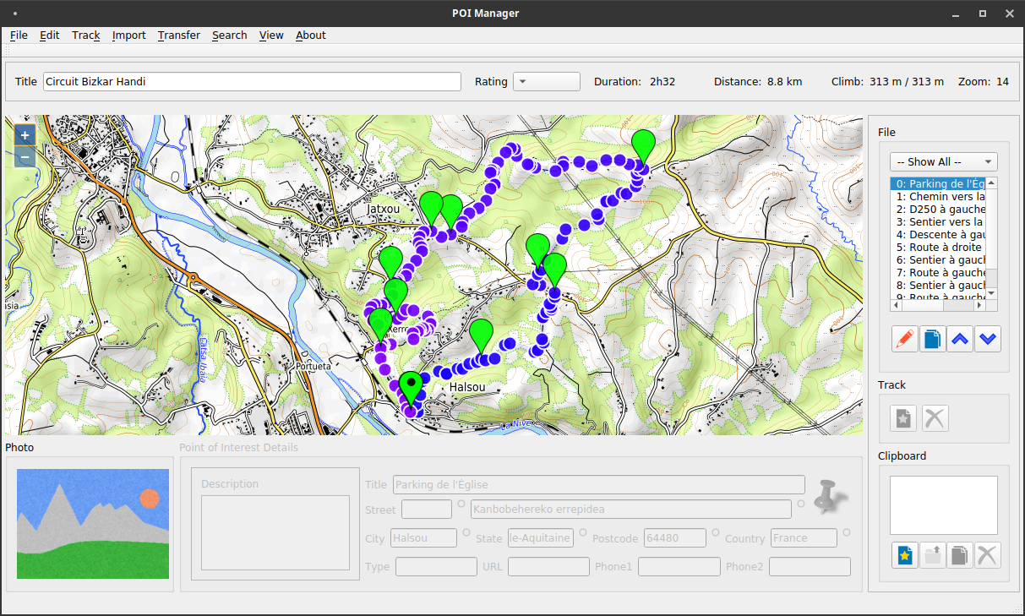

Configuration
The application requires a POI.ini file to work fully. When you first launch the application, you will be reminded that a POI.ini file could not be found.
In File/Settings, you will be able to add a default POI.ini file, in addition to setting up default folders for other POI Manager features.
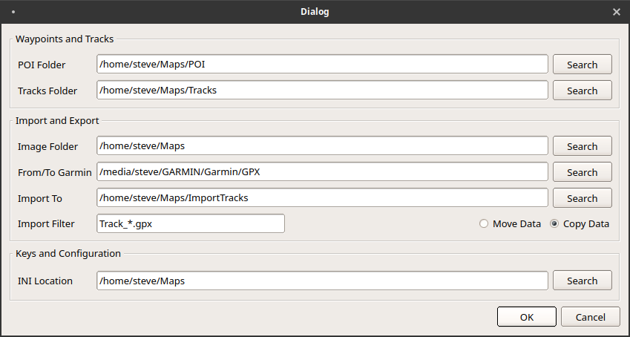

POI Folder | This folder is where the Points of Interest files are stored.  They are stored in two formats: GPX and OV2. The OV2 file is generated from the GPX file to allow upload to TomTom MyDrive.
Tracks Folder | The Tracks folder is where the GPS track files are stored. These are similar to POI files, except the markers are linked together into a navigable track. Track files are stored in GPX format, and whenever a track file is saved, the tracks.gpx and tracks.ov2 file in the POI folder is automatically updated.
Image Folder | This folder is where photographs associated with tracks are stored.
From/To Garmin | This is the folder in which a connected Garmin device (which is connected via USB) appears. This folder is used to import and export tracks.
Import To | This is the folder that is used to transfer track from a Garmin device.
Import Filter | This is the file name format for new import tracks.
INI Location | This is the location of the POI.ini file, which is used to configure keys and additional map services (such as satellite overlays).

INI Configuration
To set up a POI.ini file, simply select the INI Location search button, and pick a folder where you would like it to live. A default POI.ini file will be created. You should edit this file with a text edit application such as Mousepad or Notepad++.
The file is setup in several sections:
[keys] | This section contains access keys, which are used for various services.  The Bing key is required for Bing maps display.  The Here id and code is required for here.com gecoding.  The googleid and googlesecret are required to perform Google contacts synchronisation.  Other keys can be added for convenience, and in any url in the following section {keyname} is automatically replaced with the appropriate key.
[geocode] | This section is used to select the service used for geocoding.  Due to the way each service returns geocode results in a slightly different format, the code for the interpretation is built-in, and currently only two geocoding services are supported.  type=”OSM”  This is the open streetmap service.  type=”Here”  This is the here.com service. Note that this service requires a hereid and herecode in the keys section.
[map] | This section is used to select the service used for the base map view.  zoom=<zoomlevel>  url=”OSM”  The default URL of OSM indicates that Open Streetmap is to be used.  url=”<custom>”  A custom URL for map tiles. This url includes variable substitutions – see next section.
[aerial] | This section is used to select the service used for the aerial map view.  zoom=<zoomlevel>  url=”Bing”  This view uses Bing maps, and a bing key is required.  url=”<custom>”  A custom URL for map tiles. This url includes variable substitutions – see next section.
[contour] | This section is used to select the service used for the contour map view.  zoom=<zoomlevel>  url=”<custom>”  A custom URL for map tiles. This url includes variable substitutions – see next section.
[aerialoverlay] | This section is used to select the service used for the aerial overlay.  zoom=<zoomlevel>  url=”Bing”  This view uses Bing maps, and a bing key is required.  url=”<custom>”  A custom URL for map tiles. This url includes variable substitutions – see next section.
[tracksoverlay] | This section is used to select the service used for the tracks overlay.  zoom=<zoomlevel>  url=”<custom>”  A custom URL for map tiles. This url includes variable substitutions – see next section.

URL Variable Substitution
The following variable substitutions in the URL are supported:

{1-4}  {a-c} | This is used for load-balancing – i.e. the application will, for example. select server number 1, 2, 3 or server number 4 on different requests. Not all service providers have multiple servers, so the need for this is on a case by case basis.
{z} | The current zoom level (required)
{x} | The X tile coordinate (required)
{y} | The Y tile coordinate (required)
{anything else} | The contents of the matching key in the [keys] section.

Example:

https://{1-4}.aerial.maps.ls.hereapi.com/maptile/2.1/maptile/newest/
hybrid.day/{z}/{x}/{y}/256/png?apiKey={hereapi}

- Access one of 4 different servers at hereapi.com
- Return tile at {x}/{y} coordinates in png format at zoom level {z}
- Using the key ‘hereapi’ from the [keys] sections

Following a change to the POI.ini file, you will need to re-start the application.

Obtaining a Google ID and Secret

In order to use Google to synchronise contacts, there are two steps which must be taken.
Firstly, the application itself needs to be registered with Google. It is impractical to do this in an open-source application, as the resulting authentication secret (which is normally compiled / buried into the executable binary) would need to be published.
Secondly, the user needs to authenticate with Google using the application.
The first step’s data is stored in the POI.ini file, and the second step’s data is stored in the user’s profile.

1. Visit https://console.cloud.google.com/apis/credentials
2. In the dashboard page, create a new project, and set the Project Name, e.g.: MyPeopleApiOauth2 | 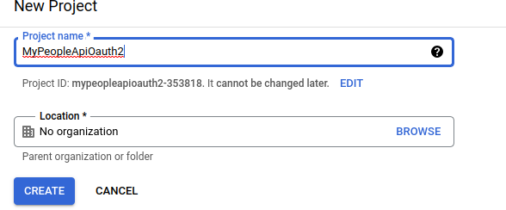
3. In the drop-down project selector, select the project you have just created. | 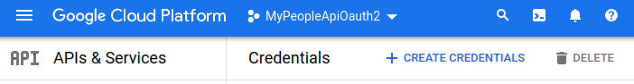
4. Select Configure Consent  Select the user type (for most users, only one option will be available).  user type: external  Select ‘Create’ | 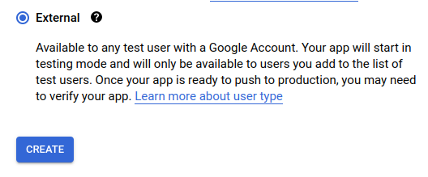
4. Add the following application information:  app name: MyPeopleApiOauth2  user support email: your email address  developer contact info: your email address  Note that other fields can be left blank.  Select ‘Save and Continue’ | 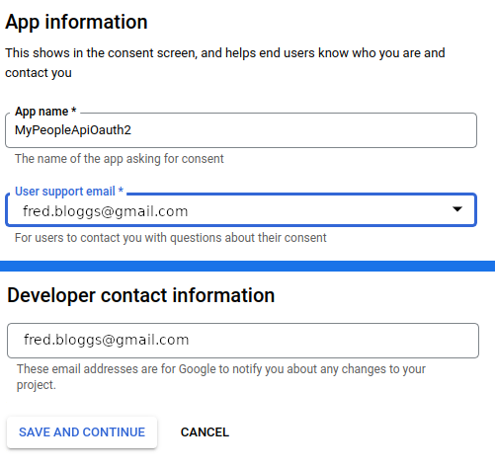
5. When prompted for the scopes, ensure that the following three scopes are selected:  - https://www.googleapis.com/auth/userinfo.profile  - https://www.googleapis.com/auth/userinfo.email  - https://www.googleapis.com/auth/contacts  If the scopes are not listed in the table, they can be manually added.  Select ‘Update’ to continue  Select ‘Save and Continue’ | 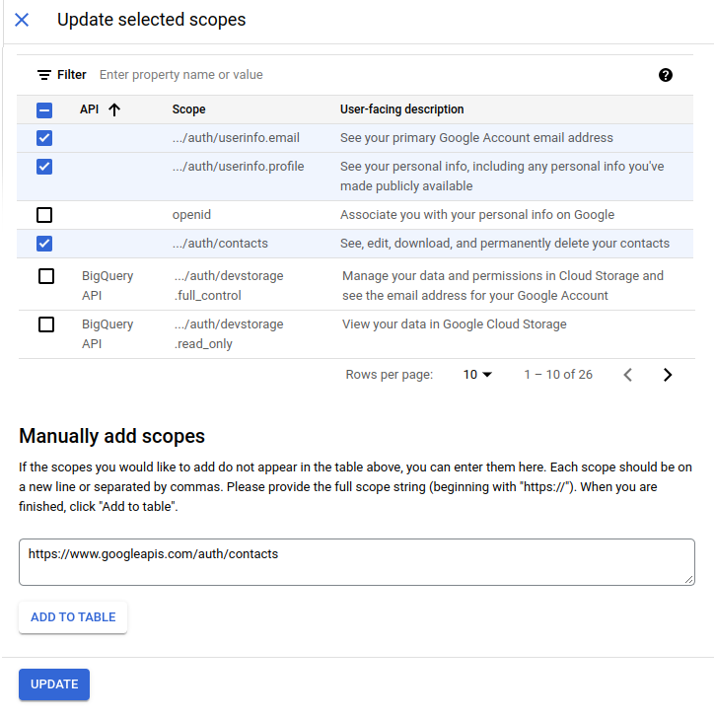
6. When presented with the Test users screen, select ‘Add Users’, and ensure that your google email address is in the list.  test users: your google email address  Select ‘Save and Continue’  And go ‘Back to Dashboard’ | 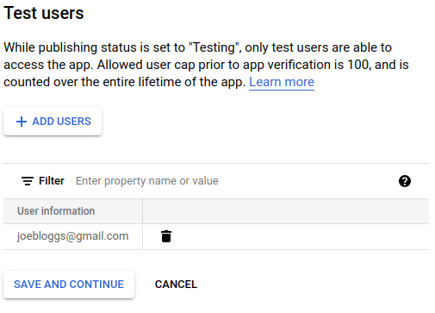
7. In the main screen for the project, select ‘Credentials’ and ‘Oauth client ID’ | 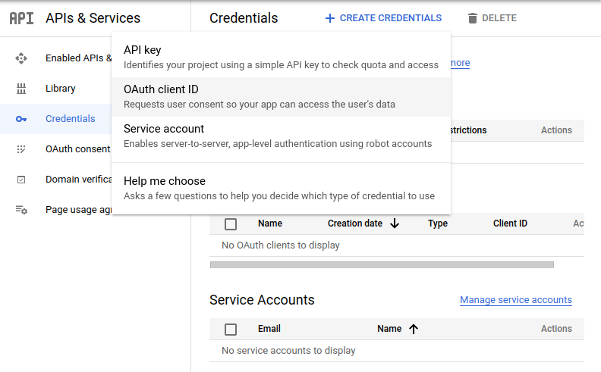
8. Select “TV and Limited Input devices” for the Application type, and give the application a name.  It is suggested that you use ‘MyPeopleApiOAuth2’ for your application name.  You can set up different credentials for different instances of the application or different applications if you desire. | 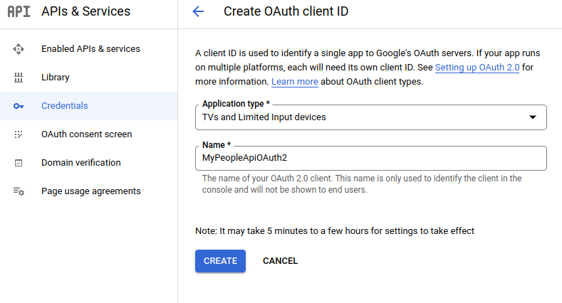
9. Copy the clientid and the client secret – these are the two entries you need to put in your POI.ini file for the googleouth2clientid and the googleoauth2secret entries.  These details should not be shared with others / published etc. as any interactions with the Google Contacts data is subject to quota restrictions. | 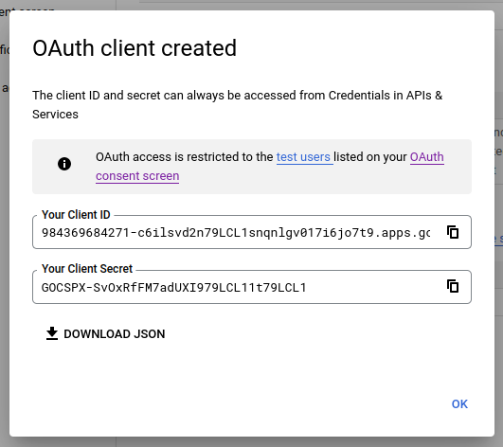

Screen Layout

The screen is split in to 7 areas:

1. File Summary

2. Map Display

3. File Contents

4. Track Edit Controls

5. Clipboard

6. Point of Interest Details

7. Photograph
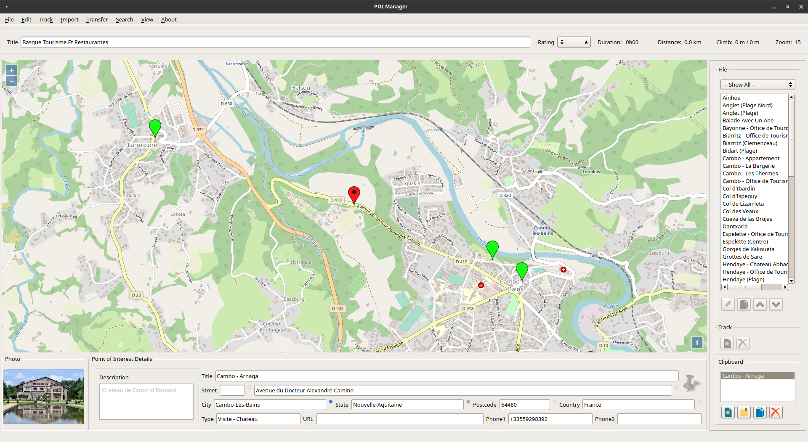
1
2
3
4
5
6
7

File Summary
The File Summary (1) displays information associated with the entire file. The title is used to generate the initial filename itself, and in addition, is used in the automatically generated POI entries for tracks in the tracks.gpx file, along with the Rating, Duration, Distance and Climb.

Map Display
The main map display (2) shows points of interest and track points as follows:
Point of interest marker in the current file.
Currently selected point of interest marker in the current file. This marker may be dragged / moved as desired.
Point of interest marker on the clipboard. These markers are not saved.
Currently selected point of interest marker on the clipboard. In addition to being movable, the points of interest details (6) may also be modified.
Track point in the current file. These points gradually change in colour along the track.
Currently selected track point in the current file. This marker may be dragged / moved / removed as desired.

File Contents
The File Contents (3) displays the points of interest contents of the current file. If the file is a track, the points of interest represent waypoints, and are numbered.
There is a drop-down selection box, which can be used to filter the entries in the list. The selection list is automatically populated from the rating of the entry (applicable to tracks.gpx) and the contents of the type field in the points of interest details area (6).
The currently selected entry on the map is highlighted here, and similarly, if an entry is selected here, it is zoomed to and selected on the map.
There are four actions which may be performed on a selected entry:
 | Edit | Move the entry to the clipboard so that the points of interest details may be edited.
 | Copy | Copy the entry to the clipboard so that the a duplicate of the points of interest details may be edited.
 | Up | Move the entry up in the list – note that this only applies to track waypoint entries.
 | Down | Move the entry down in the list – note that this only applies to track waypoint entries.

Track Edit Controls
The Track Edit Controls (4) is enabled when a track point is selected, there are two edit operations which may be used:
 | New | Create a new track point half way between the selected point and the next point along the track.  Note that this is not applicable if the selected point is the last one on the track.
 | Delete | Remove the selected track point.

Clipboard
The Clipboard (5) contains a list of editable entries. Markers associated with the clipboard entries are shown on the map in red.
It should be noted that the clipboard entries are not cleared when a new file is opened, so the clipboard may be used to move or copy entries between files.
Entries may be selected in the clipboard, and the corresponding marker on the map will be zoomed to.
There are four edit options associated with the clipboard:
 | New | Create a new point of interest in the centre of the current map.
 | Save | Save the current point of interest back into the File Contents (6).
 | Delete | Remove the selected point of interest from the clipboard.
 | Copy | Duplicate the current clipboard entry.

Point of Interest Details
The Points of Interest Details (6) shows details when an entry in the file or clipboard is selected. These are automatically updated through reverse geocoding whenever an entry is created or moved.
If the entry is in the clipboard, the details may also be manually edited. A blue marker associated with each entry shows which entries have been overridden. Future geocoding will not affect these entries.
Title | The title of the POI entry.
Street | This is split into two parts, the first being the house name / number, and the second being the street address. Often, the reverse geocoding doesn’t find the exact house number, so it is recommended that this is overridden manually.  This number is automatically appended to the end of the title when saving / exporting the data as TomTom OV2 format.
City  State  Postcode  Country | These are fields of the address which are saved in the gpx file, and are useful on garmin devices, but are not exported to TomTom, or to Google.
Type | The type is a custom free-text entry field which can be useful when filtering entries. This could be something like ‘Parking’ or ‘Restaurant’. Multiple words are also allowed, so ‘Tourism – Museum’ would appear under both ‘Tourism’ and ‘Museum’.
URL | URL for the website of the entry.
Phone 1 | Phone number for the entry – this is passed forward into the TomTom OV2 file, and is accessible on some devices.
Phone 2 | Alternative phone number for the entry – this is passed forward into the TomTom OV2 file, and is accessible on some devices.
Description | Free-text description.

Photograph

Photographs (7) may be associated with waypoints. Photographs may reside anywhere on the device, however it is recommended that if a photograph is to remain associated with a point of interest or waypoint, it is saved in the photographs folder (as defined in the setup). Photographs are not exported to TomTom (OV2) mydrive, Garmin (GPX) devices or synchronised with Google contacts.

Photographs can be useful methods of creating tracks. With modern mobile phones, the GPS coordinates and time/date can be stored in the image itself. These images can be imported into the POI Manager and a track automatically generated.

Menus

File Menu
The File Menu has seven options:
New | Close the current file, and clear out the current file points of interest and waypoints.
Open | Open a new (GPX) points of interest or track file.
Save | Save the current file.
Save As | Save the current file as a new name / in a new folder.
Setup | Access the setup menu (see Configuration section)
Clear Cookies | Clear any cookies which have been stored by the map tile web access.
Exit | Exit the application.

Edit Menu
The Edit Menu has three options:
Edit All | Transfer all file options to the clipboard.
Empty Clipboard | Remove all entries from the clipboard.
Undo | Undo the last operation.

Track Menu
The Track Menu has five options:
Resort | This option re-sorts all of the waypoints in the list by date.
Track from Waypoints | This option creates a track which links the points of interest together (effectively turning the points of interest into waypoints).
Snap | This option ensures that track markers dropped close to waypoints are automatically snapped to them.
Reduce Points | This option reduces the number of points in the track (removing every other point).
Delete Points | There are two options here, the first deletes all points in the track before the current selection, and the second deletes all points in the track after the current selection.

Import Menu
The Import menu has six options:
Photos / GPS | This option imports a set of photos into the track list, extracting the embedded GPS location and placing them appropriately on the map.
Photos / Time | This option imports a set of photos into the track list, using the embedded time, comparing against the current track to determine their GPS location.
TomTom POI | This option imports a TomTom OV2 file into the track list.
Garmin GPX | This option imports a Garmin GPX file into the track list.
Garmin to Clipboard | This option imports a Garmin GPX file into the clipboard.
Auto Geocode | This option attempts to geocode all entries in the current file.

Transfer Menu
The Transfer Menu has three Options:
Load Tracks | This option loads new tracks from an attached Garmin device and stores them in the import folder.
Save Tracks | This option saves track files to an attached Garmin device.
Eject Garmin | Eject Garmin device.
Launch TomTom | This option launches the TomTom mydrive website to enable OV2 files to be uploaded.
Upload to Google | This option uploads all of the current points of interest as contacts in Google such that they can be found in Android Auto. Note that the full address is not uploaded as this is less accurate than the lat/lon identified by the marker.
Purge Google Entries | This option removes all contact entries in Google which have been uploaded by POI Manager. Note that any Google contacts which have not been managed with POI Manager are left unaffected.

Search Menu
The Search Menu has one Option:
Find Location | This option prompts for a location, and uses geocoding databases to provide the most likely match.

View Menu
There are three different view styles, two types of overlay supported. In addition, two options area available when displaying a track:
Standard Map | This option shows the standard map. It is associated with the [map] section in the POI.ini file. The default standard map is from Open Streetmaps.
Aerial Map | This option shows an aerial overview. It is associated with the [aerial] section of the POI.ini file. At the time of writing, there are no sources of aerial tiles that can be accessed without a password. There are, however, free resources (e.g. Bing) that can be used once a password / key is acquired.
Contour Map | This option shows a terrain map (i.e. with contours). It is associated with the [terrain] section of the POI.ini file.
Satellite Overlay | This option places a satellite image as an overlay onto the standard or terrain map. It is associated with the [satelliteoverlay] section of the POI.ini file. As with the Aerial Map, a key is required to enable this feature.
Trails Overlay | This option places a trails overlay onto the map. It is associated with the [trailsoverlay] section of the POI.ini file.
Track | This option enables the drawing of a line between points on a track.
Actual Duration | By default, the duration for the distance travelled is estimated using the Naismith formula. The actual duration (from the GPS timestamps) travelled on a walk can be displayed instead if this option is selected.

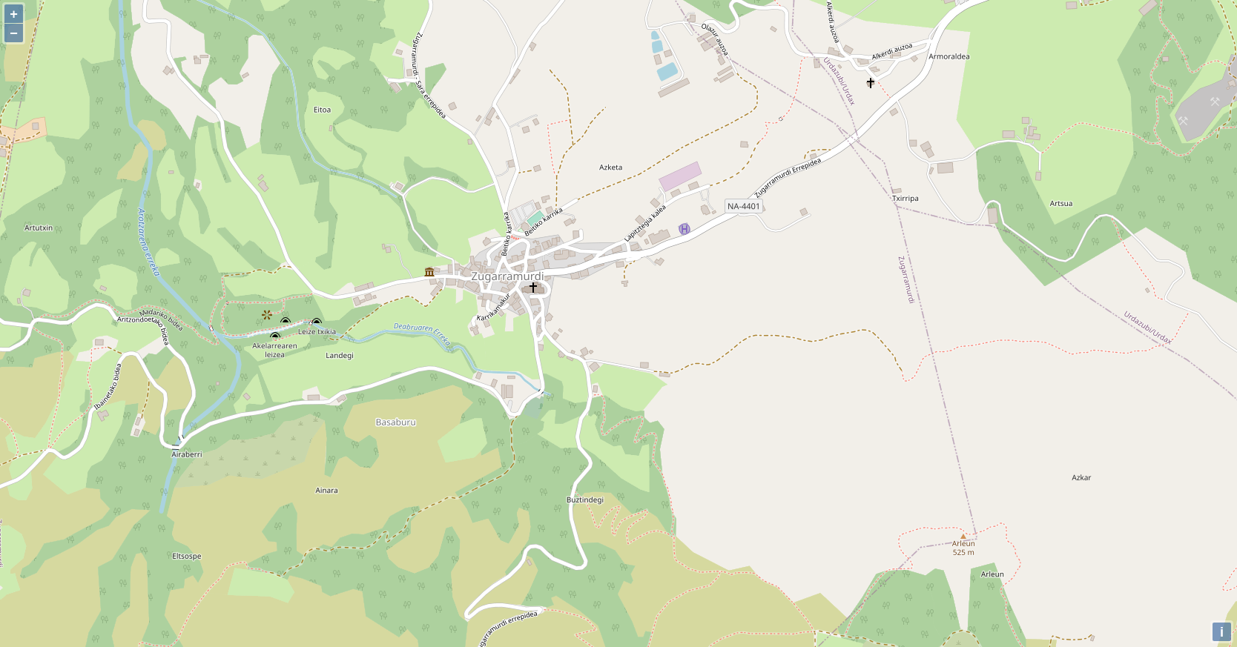  Standard View | 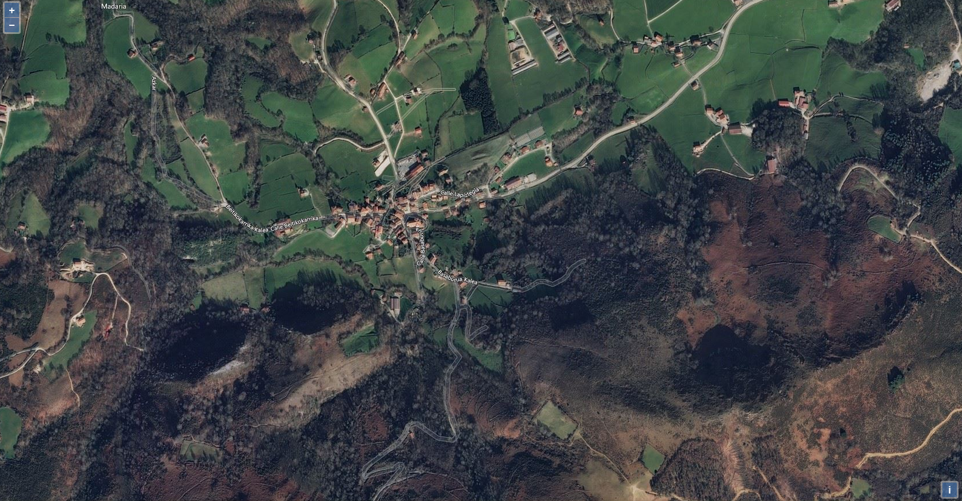  Aerial View | 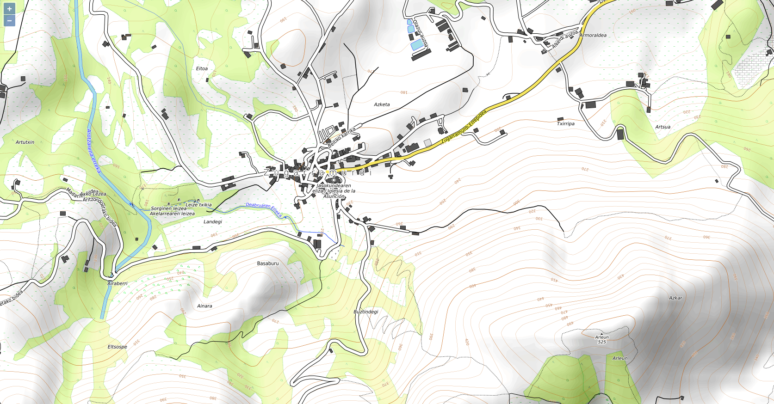  Contour View

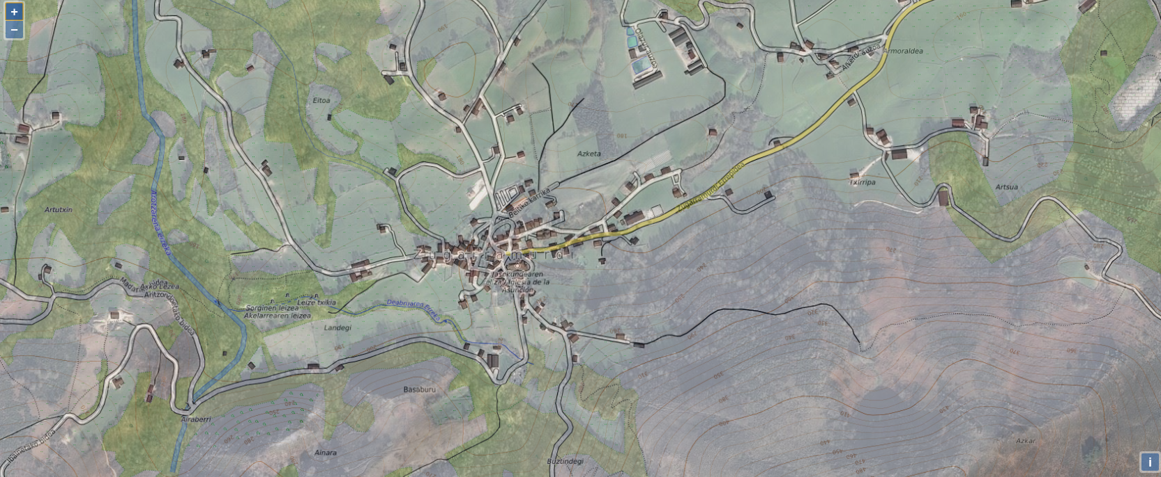  Contour View with Aerial Overlay | 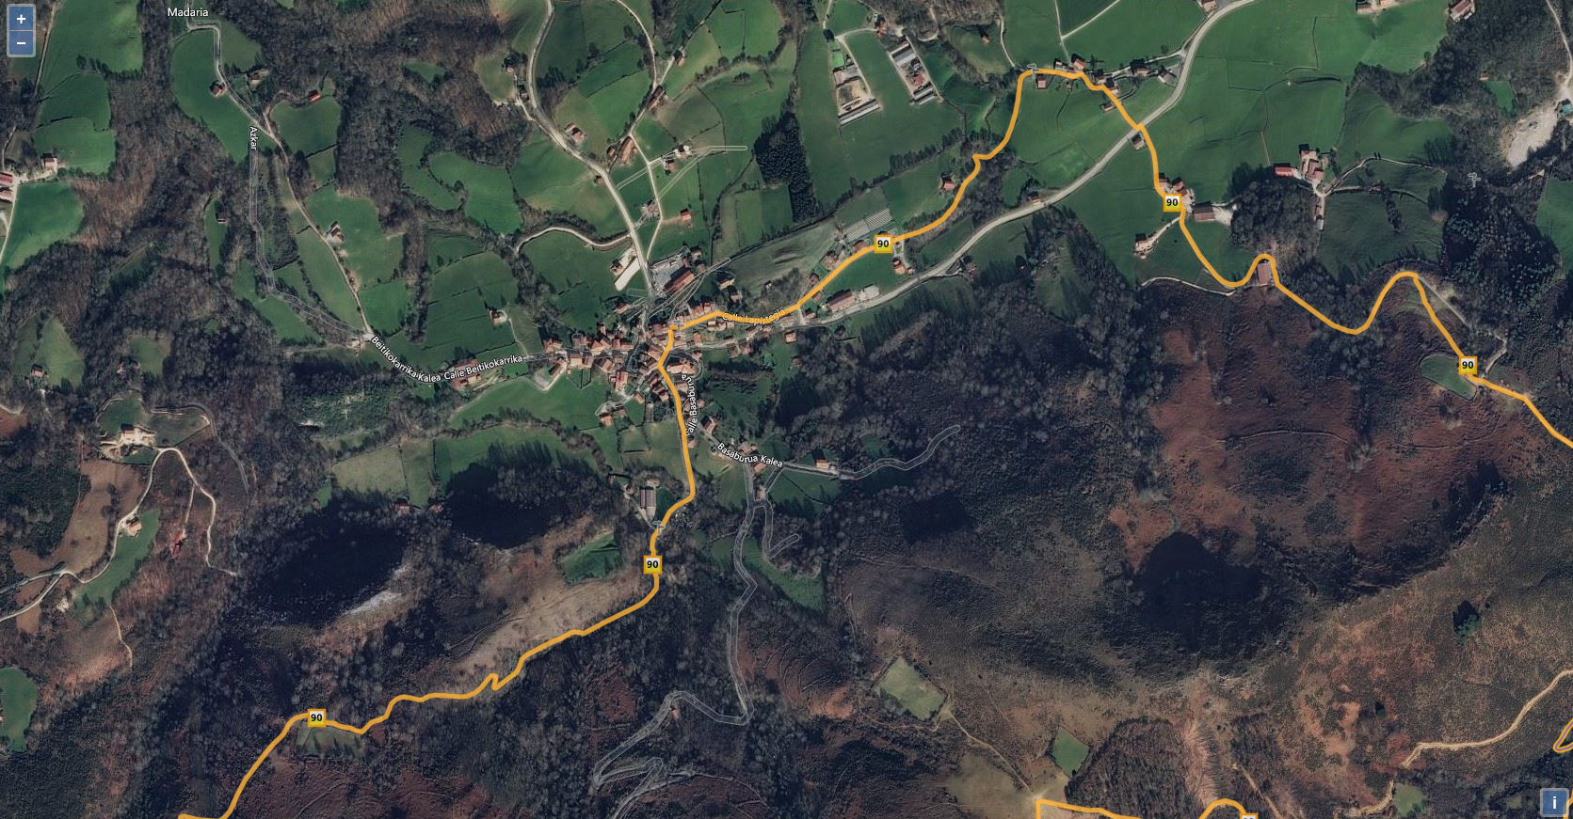  Aerial View with Trails Overlay

Performing Tasks – Worked Examples

Creating and Exporting a Points of Interest File
Start by creating a new file with File / New (Control-N).
Set the File Description by entering London Places of Interest into the File field.
Search for a place with Search / Find (Control-F).

Enter 221B Baker Street, London into the dialog and select OK.

An icon will be added to the clipboard, a marker will be dropped onto the map, and the marker will be geocoded.

Edit the Type field and insert Travel – Museum.

Press Save to save the entry to the file – the marker will turn from red to green, and the entry will be transferred to the File section.

Now save the file by selecting File / Save (Control-S).

Pan across the map to Gloucester Place near to number 8.

Create a New marker in the middle of the road outside number 8.

Edit the first field, and insert the number 8 – the blue indicator will be set.

Set the name to Embassy of El Salvador

Edit the Type field and insert Travel – Embassy.

Press Save to save the entry to the file – the marker will turn from red to green, and the entry will be transferred to the File section.
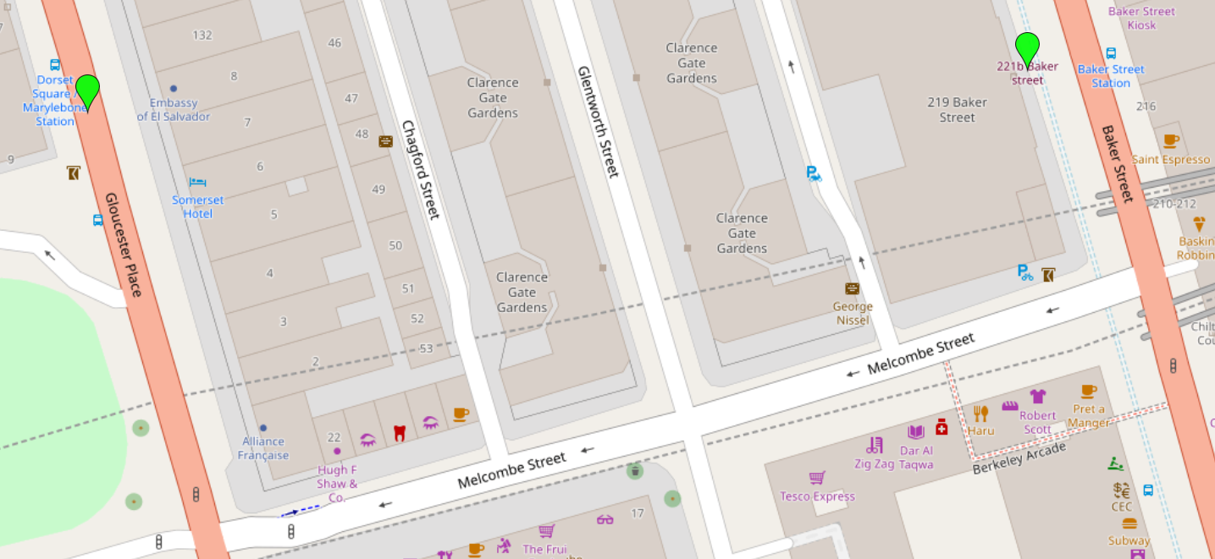

That’s it, you’ve created a Points of Interest file containing two entries. When the save occurred, two files will have been produced: a GPX file, which is in Garmin format and contains all of the information provided; and also an OV2 file, which is in TomTom format, and contains a subset of the information which is supported by the TomTom GPS devices.

Creating a Track From Points of Interest
Start with the London Places of Interest file created in the previous section.
Select Track / Create Track from Waypoints, and each waypoint will also be marked with a blue track marker point.
Select the first track point (at 221B Baker Street), and press the New track button twice, to create two new track points.
Drag the first track point to the intersection between Baker Street and Melcombe Street, and the second track point to the intersection between Melcombe Street and Gloucester Place.
Select View / Track to display the track lines between points.
Change the Title to Baker Street to Embassy
Set the rating to two stars
Save the file with File / Save As, and you will be prompted to save the file in the Tracks folder.
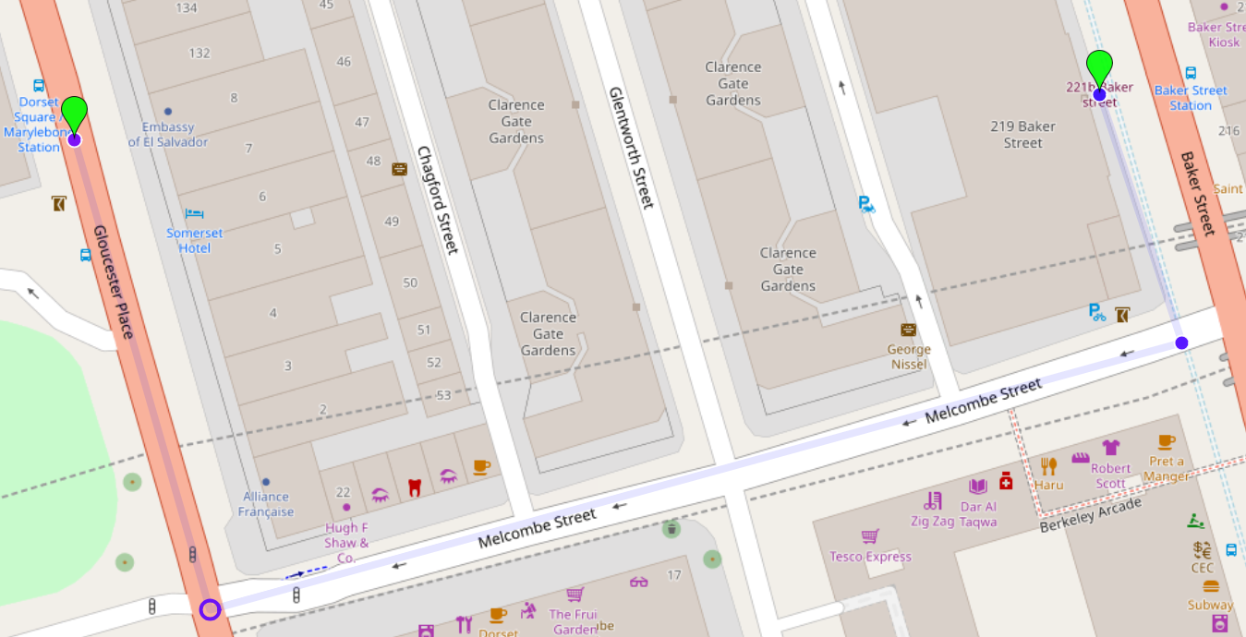

Select File / Open and open the newly created tracks.gpx file, which has been placed in the POI folder.

You will see a single entry which is called: “★★ Baker Street To Embassy 0h03 0.3km”.

This file (and a corresponding OV2 file) will be automatically refreshed each time you save a track.

Creating POI Entries from Photographs
On a walk, take several photographs with a GPS-enabled camera or phone.
If you wish to retain the association between the track and the photos, it is recommended that you transfer the photographs to the Image Folder (see the Configuration section for information on how to set this up).
Select Import / Photos Using Embedded GPS Coordinates, and search for the photographs.
A point of interest entry will be created from each photograph, and as long as the photograph remains in the same relative location to the gpx file, it will be displayed when the point of interest is selected.

Using this method, it is possible to record a track using a mobile phone camera, and then manually create the gpx file using this application.

Note: A feature is identified in the photographs from Samsung S8 phones, which means that some images are incorrectly tagged with their GPS coordinates. This has been verified by using other software applications to view the GPS location.

Importing Tracks from Garmin GPS
Connect a Garmin GPS to the computer, and ensure that it is automatically mounted.
Select Transfer / Load Tracks from Garmin, and the tracks on the device will be transferred to the Garmin Import folder (as defined in the setup).

Exporting Tracks to Garmin GPS
Connect a Garmin GPS to the computer, and ensure that it is automatically mounted.
Select Transfer / Save Tracks to Garmin, and the tracks in the tracks folder (as defined in the setup) will be transferred to the Garmin device.

Exporting Points of Interest to TomTom MyDrive
In order to upload to TomTom MyDrive, an external web browser must be used. Select Transfer / Launch TomTom, and the MyDrive page will be opened in your preferred browser. The default (current) folder will be set to the POI folder (as defined in the setup) to simplify searching for the OV2 files.

Export Points of Interest to Google
In order to upload points of interest to Google, you must first have installed the clientid and secret in the POI.ini file; and also logged in using the configuration menu.
In order to synchronise a POI file with Google, ensure that a file is open, and select Transfer / Upload to Google.
The program will upload new entries, modify those which have been changed locally, and remove any remote entries that no longer exist in the current file.
These entries are stored as pseudo-contacts, and the Surname is the name of the gpx file (e.g. Tracks), and the first name is the Title of the point of entry.
Note that this synchronisation is one-way, and you cannot download entries from Google that were not originally created with the local instance of POI Manager – i.e. your gpx files should be considered the ‘master files’.
Note also that the program stores a unique ID with each entry on Google so that entries associated with each file can be identified. The transfer does not affect any of your contacts, or any entries associated with a different POI file.
If you wish to remove all of the POI entries that have been uploaded by POI Manager, select Transfer / Purge all Google Entries. Following this step, you will need to re-upload each file in turn (as required).

Latest Version
For the latest version of POI_Manager, visit: www.vizier.uk/poi

Licenses
The program uses a number of applications, each of which has its own license requirements:
POI - www.vizier.uk/poi
Copyright (c) 2021 www.vizier.uk/poi Steve Clarke
Program licensed under GPLv3 - Any modification to the code must be contributed back to the community.
Redistribution and use in binary or source form with or without modification is permitted provided that the following conditions are met:
Clause 7b - attribution for the original author shall be provided with the inclusion of the above Copyright statement in its entirity, which must be clearly visible in each application source file, in any documentation and also in a pop-up window in the application itself. It is requested that the charity donation link to Guide Dogs for the Blind remain within the program, and any derivitive thereof.

OpenLayers - openlayers.org
Code licensed under the 2-Clause BSD. All documentation CC BY 3.0

QT - www.qt.io
Code licensed under the LGPL - any modification to a Qt component covered by the GNU Lesser General Public License must be contributed back to the community. This is the primary open source Qt license, which covers the majority of Qt modules.
Qt contains some code that is not provided under the GNU Lesser General Public License (LGPL) or the Qt Commercial License, but rather under specific licenses from the original authors.

LinuxDeploy - github.com/linuxdeploy
Linuxdeploy is used to generate AppImages. Linuxdeploy itself is licensed under the MIT License.

EasyExif - github.com/mayanklahiri/easyexif
Copyright (c) 2010-2015 Mayank Lahiri - mlahiri@gmail.com
Code licensed under the BSD License.

Data Providers
The POI Manager flexibly supports map data providers through the POI.ini file. A number of providers, however, are embedded in the POI Manager code, and these are presented below:

Openstreetmap - www.openstreetmap.org/copyright
Openstreetmap is used for geocoding, and sharing of map tiles.
Licensed under the Open Data Commons Open Database License

Here – www.here.com
Here.com offers paid subscription, for geocoding. It also has a free tier.
Terms and conditions are presented here

Bing – bing.com/maps
Microsft Bing may be used to access satellite images and map tiles. Paid subscriptions are available, and also a free tier.
Terms and conditions are presented here

Intentionally Blank

v0.6

20th June 2022

