MiniDLNA Database Construction
Database has a DETAILS table, which stores all of the details about the media item
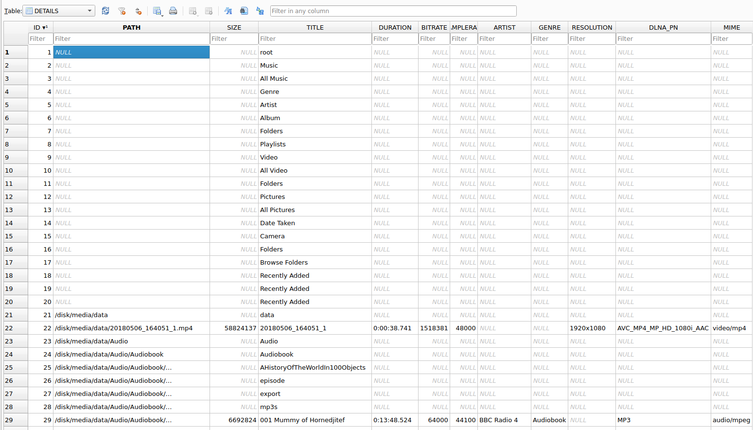
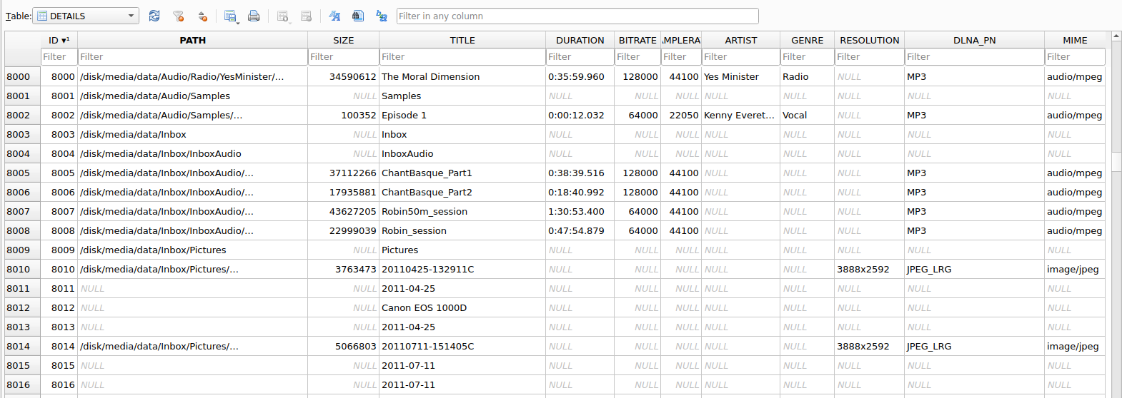
- Records with no PATH are created by the minidlna CreateDatabase function.
- Folders have a PATH and TITLE – all other fields are NULL.
- Videos have metadata extracted and have a MIME type of video/x.
- Audio files have metadata extracted and have a MIME type of audio/x.
- Photos have metadata extracted and have a MIME type of image/x.
The management and use of metadata within photos is poor at best.
Next, there is the OBJECTS table, which stores the hierarchical information which is presented to the user.
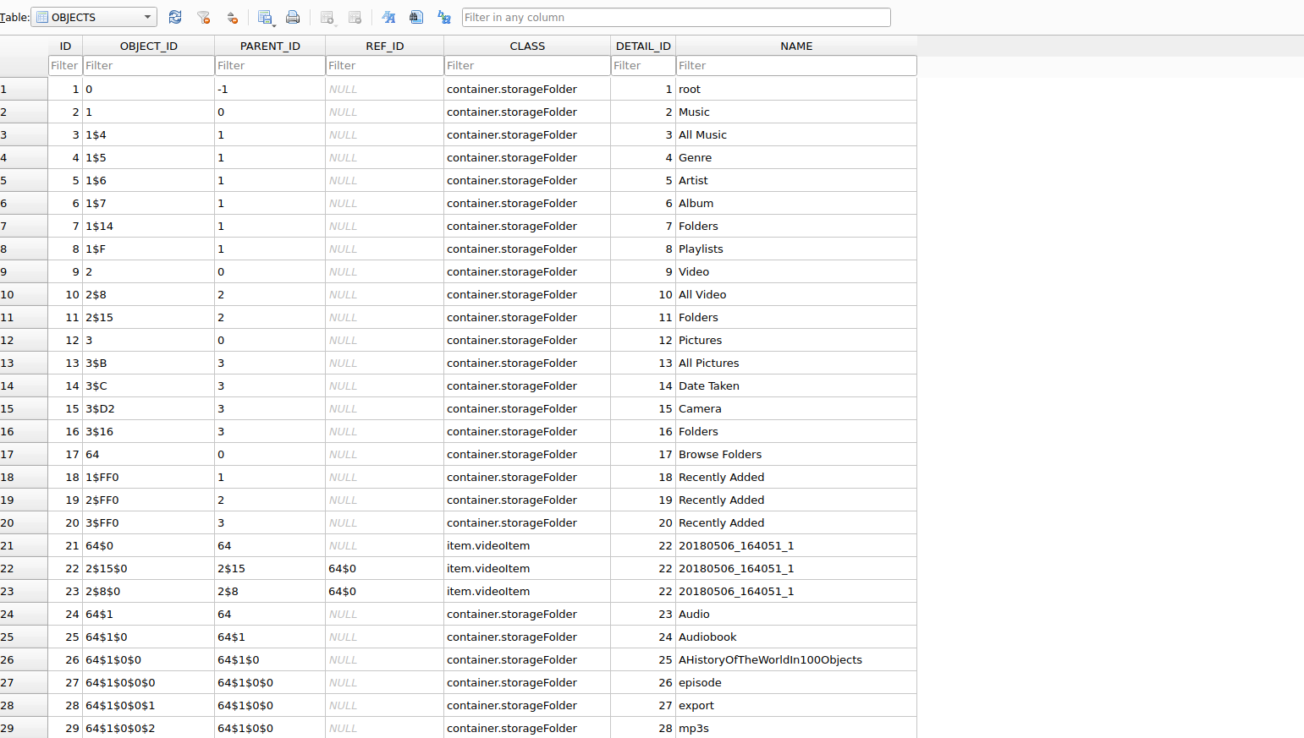
Each item has an OBJECT_ID, which contains the hierarchical path to the item.

For example, entry 21 has a path of 64$0
entry 17 has an OBJECT_ID of 64 and a DETAIL_ID of 17
The DETAILS table has entry 17 with the text “Browse Folders”
The NAME in this table is also “Browse Folders”
entry 21 has a DETAIL_ID of 22
The DETAILS table for entry 22 has a 38 minute mp4 video file called 20180506_164051_1

And entry 22 has a path of 2$15$0
Entry 9 has an object ID of 2 and a DETAIL_ID of 9
The DETAILS table has entry 9 with the text “Video”
The NAME in this table is also “Video”
Entry 11 has an object ID of 2$15 and a DETAIL_ID of 11
The DETAILS table has entry 11 with the text “Folders”
The NAME in this table is also “Folders”
entry 22 has a DETAIL_ID of 22
The DETAILS table for entry 22 has a 38 minute mp4 video file called 20180506_164051_1

And entry 23 has a path of 2$8$0
Entry 9 has an object ID of 2 and a DETAIL_ID of 9
The DETAILS table has entry 9 with the text “Video”
The NAME in this table is also “Video”
Entry 10 has an object ID of 2$8 and a DETAIL_ID of 10
The DETAILS table has an entry 10 with the text “All Video”
The NAME in this table is also “All Video”
entry 23 has a DETAIL_ID of 22
The DETAILS table for entry 22 has a 38 minute mp4 video file called 20180506_164051_1

So this same video file can be accessed through any of the following three paths
“Browse Folders / 20180506_164051_1”
“Video / Folders / 20180506_164051_1”
“Video / All Video / 20180506_164051_1”

Note that the names for the elements of the path, and the file itself come from the OBJECTS table – it is only when you arrive at a file and interrogate it will you be given the details from the DETAILS table.
It is not clear as to why the folder names are required in the DETAILS table at all.
It is not clear as to whether there is any ‘magic’ in the selection of the OBJECT_IDs at the top of the tree – i.e. why does “Browse Folders” have an ID of 64 and not 4; and why does the “Recently Added” have and ID ending in FF0.

The resulting browser view of the database is as follows:

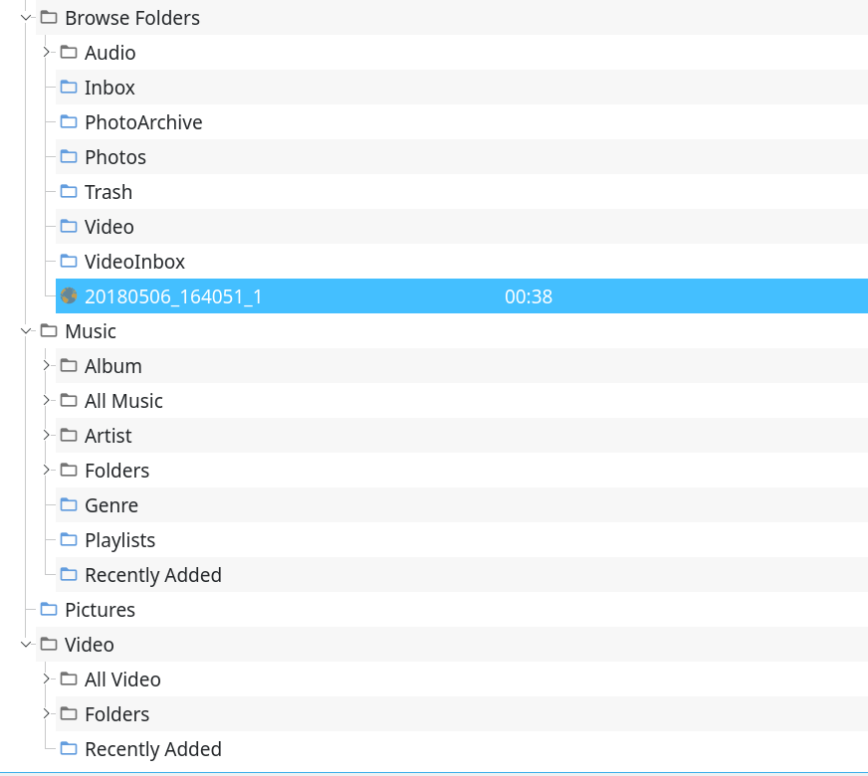

Scanner Process
The scanner process follows this basic approach

scanner.c - CreateDatabase()
Create some tables
Populate the OBJECTS table with some top-level folders
Create some indexes

scanner.c – ScanDirectory()
Step through files / folders in a directory
If entry is a folder, insert_directory into the database, and recurse
If entry is a file, insert_file into the database

scanner.c – insert_directory()
Add folder and parent folders to OBJECTS table until done or folder was already there

scanner.c - insert_file()
If the entry is a playlist, insert_playlist into the database
Otherwise, use GetImageMetadata, GetVideoMetadata, GetAudioMetadata to extract information, and an entry to the DETAILS table
Add the file in its hierarchical place in the OBJECTS table, along with the name

scanner.c – insert_playlist()
Open playlist file
For each entry in the playlist file, add it to the PLAYLISTS table
(note: no evidence that there are any checks to determine that the actual file in the playlist exists or not).

metadata.c – GetImageMetadata()
Identify image type and extract metadata from file:
SIZE, TIMESTAMP, DATE, RESOLUTION, ROTATION, THUMBNAIL, CREATOR
Add entry into DETAILS table
Return identifier for entry in DETAILS table

metadata.c – GetVideoMetadata()
Identify image type, and assess audio and video codecs and extract metadata from file:
SIZE, TIMESTAMP, DURATION, DATE, CHANNELS, BITRATE, SAMPLERATE, RESOLUTION, TITLE, CREATOR, ARTIST, GENRE, COMMENT, ALBUM_ART, DISC, TRACK
Add entry into DETAILS table
Return identifier for entry in DETAILS table

metadata.c – GetAudioMetadata()
Identify media type, and extract metadata from file:
SIZE, TIMESTAMP, DURATION, CHANNELS, BITRATE, SAMPLERATE, DATE,TITLE, CREATOR, ARTIST, ALBUM, GENRE, COMMENT, DISC, TRACK
Tidy up metadata
Add entry into DETAILS table
Return identifier for entry in DETAILS table

Scanner Enhancements

Layout
Having better control over how entries are added to the OBJECTS table will allow for:
Better sorting – e.g. splitting audio books from music, or playing multiple albums and sorting in album then track order
More control – e.g. not having shuffle options on audio book chapters
Better searching – e.g. Artist / Album, Artist / Year, Album / Artist, Year / Album etc…
Support for searching with a remote, e.g. Album / [stu] / t[stu] / su[jkl] / Tusk

Metadata Override
Support for some global corrections when parsing metadata, for example replacing Pop/Rock with Pop-Rock so that only one genre is used when a mix of different similar genres are present.

Better Metadata Collection for Photos
Support for extracting better metadata from photos – i.e. photos could be tagged with names of locations; people; scene; weather etc. and searching could be:
Photos / Person / Search / [abc] / b[ghi] / bi[jkl] / Bill / And Person / - All - / Jean
Photos / Person / Search / [abc] / b[ghi] / bi[jkl] / Bill / Year / 60s

Proposed Layout Management
Add a set of layout management functions, which take the input from a configuration file e.g. /etc/minidlna/minidlna-layout.conf
The layout configuration file has the following format:

[config] section
unknown=Unknown
searchdepth=8
strippath=/disk/media/data
unknown:
searchdepth:
strippath:

[template] section

[comments] section

[replace] section
genre=rock/pop=rock-pop
Replace

[rule] section
chainset=music
mediatype=audio
There may be multiple [rule] sections, each of which has 1 or 2 entries:
The chainset is a unique name that refers to a section elsewhere in the configuration file which contains the parsing rules for the chain.
The mediatype is either ‘audio’, ‘video’ or ‘image’. If the mediatype is missing, the entry is treated as a catch-all. Only the first entry of each type is processed, and all others are ignored.

[chainset] sections
[music]
chain=/Folder/$PATH/$FILENAME
chain=/Music/All Music/$TITLE
chain=/Music/Search/Artist/$SEARCHARTIST/All
chain=/Music/Search/Artist/$SEARCHARTIST/$ARTIST ($ALBUM)
chain=/Music/Genre/$GENRE/$TITLE
chain=/Music/Artist/$ARTIST/$TITLE
chain=/Music/Album/$ALBUM/$TRACKNUM. $TITLE
chain=/Music/Folders/$PATH/$FILENAME
The title of the section must match one of the chainsets in a [rule] section.
This section contains a number of paths, within the database the same file can be accessed, for example, the above example will place the same music file in 8 different parts of the tree.
The section contains variables which are expanded based on information extracted from the file’s metadata:
$0TRACKNUM | Track number zero padded
$ABCALBUM | First letter of the album expanded to [abc], [def] etc.
$ABCALBUMARTIST
$ABCARTIST
$ABCCOMPOSER
$ABCTITLE
$ABCTRACKARTIST
$ALBUMARTIST
$ARTIST
$BITRATE
$COMMENT
$COMPOSER
$DATE
$DECADE | This is the decade, e.g. 60s
$DISC
$FILENAME | This is the name of the file
$GENRE
$LOCATION
$PATH | This is the path to the file with the prefix identified in strippath removed
$RESOLUTION
$RND | Replace with a zero padded random 3 digit number
$SALBUM | Replace with the initial letters of the album, e.g. “War of the Worlds” becomes WOTW
$SARTIST | Replace with the initial letters of the artist, e.g. “Karen Carpenter” becomes KC
$SEARCHALBUM | Expands Album to [d]/[da]/[dat]/[data] format
$SEARCHALBUMARTIST | Expands Album Artist to [d]/[da]/[dat]/[data] format
$SEARCHARTIST | Expands Artist to [d]/[da]/[dat]/[data] format
$SEARCHCOMPOSER | Expands Composer to [d]/[da]/[dat]/[data] format
$SEARCHTITLE | Expands Title to [d]/[da]/[dat]/[data] format
$SEARCHTRACKARTIST | Expands Track Artist to [d]/[da]/[dat]/[data] format
$TITLE | Replace with the title of the file (TITLE field from the DETAILS table)
$TRACKARTIST
$TRACKNUM
$YEAR

Modifications

Modifying the Make Process to Include the New Files

Makefile.am:
Update the file to include the following to the bottom of the sources list:
layout/mstring/mstring.c layout/mstring/mcharacter.c \
layout/mstring/municodetables.c layout/layout.c
Then run automake

Including and Initialising the Layout Function

upnpglobalvars.h:
Include the layout.h file, and modify the version to ensure it is different to the default minidlna – this file is included by everything, so everything will have access to the layout functions.
#include "layout/layout.h"
#define MINIDLNA_VERSION "1.3.3-lo"

options.c and options.h
Add an entry to the end of the list of optionids in options.c
{ LAYOUT, "layout" }, // LAYOUT
And an entry to the end of the upnoconfigoptions enum in options.h
LAYOUT, /* LAYOUT configuration file */

minidlna.c
Add a new variable in the init() functions:
const char * layoutfile = NULL; // LAYOUT
And a new case option in the options parsing switch:
switch (ary_options[i].id)
{
case LAYOUT:
layoutfile = ary_options[i].value ;
break ;
Finally, further down in the init() function, add code to initialise the layout:
set_startup_time();
if (layoutfile)
lo=layout_newfrom((char *)layoutfile) ;
else
lo=NULL ;

