When Does Attention Topology Know the Model Is Wrong? Mapping the Narrow Regime Where Persistent Homology Beats Confidence
Eduardo Trunci
All numbers in this document are generated by `src/write_paper.py` from machine-checked statistics JSONs; no value is hand-typed. Code, stats JSONs, and per-experiment verdict files: https://github.com/trunci/topo.

Abstract—Topological data analysis (TDA) of transformer attention is increasingly proposed for interpretability and hallucination detection, but is rarely benchmarked against the trivial baselines that could explain it away. We conduct an adversarial audit — a spike study and fifteen follow-up experiments — of H1 persistent homology on attention graphs, testing every proposed use against the cheapest available competitor. Three claims survive. (1) H1 persistence carries signal about induction circuits that first-order attention statistics do not — a suppression effect invisible to marginal correlation (ΔR² = 0.074, nested-F p = 0.00044; replicated in a second model) — and ablating cycle edges causally damages induction behaviour at budget-matched controls, though the effect is budget-sensitive and not universal across scale. (2) As a failure predictor, topology is regime-conditional, and the regime is narrow: clean, template-generated reasoning at a model's capability ceiling — it does not include naturalistic QA. Within that regime topology is near-perfect where confidence fails (accuracy 0.525: topology AUC 0.930 vs confidence 0.681; at five hops 1.000 vs 0.617; replicated across three seeds and a second model); on easy tasks (accuracy 0.77–0.85) it is fully redundant with confidence. (3) The mechanism is scale-dependent — and deflates the headline number: at 0.5B parameters (the scale of the 1.000-vs-0.617 result) topology proxies attention entropy (r = 0.925, adding ΔAUC = 0.000 beyond first-order controls), while at 1.5B it adds ΔAUC = 0.216 beyond those controls (item-level bootstrap 95% CI [0.147, 0.285]). Everything else falls. Topology loses to raw attention magnitude as a circuit attributor (AUC 0.501 vs 0.976 on induction; 0.458 vs 0.963 on IOI), adds nothing as a pruning criterion, and its apparent "information-flow" signal decomposes first into graph connectivity and then into a sequence-length artifact. Critically, the failure-prediction result does not transfer to real QA: on the benchmark and model family of the concurrent TOHA method (Mistral-7B-Instruct / HotpotQA), the identical features sit at chance (AUC 0.494, vs TOHA's engineered 0.71), remain at chance after length residualization (0.545), and remain at chance with supervised head selection on distractor-free gold contexts (0.499). Nor is the boundary merely our featurization: reimplementing TOHA's own MTop-Div (generation-time answer-to-prompt divergence) on the same items also fails to beat chance under fold-internal head selection (0.560 distractor / 0.504 gold). We offer the audit methodology — control first-order statistics, verify instruments, benchmark against magnitude and confidence — as the durable contribution.

1. Introduction
The attention matrices of a transformer induce, at every head, a weighted directed graph over token positions. A growing literature applies topological data analysis to these graphs — persistent homology, discrete Morse theory, sheaf Laplacians — and reports that the resulting descriptors track linguistic structure, reasoning, and hallucination. The appeal is clear: topology promises a principled, coordinate-free summary of how attention is organized, beyond what any single edge weight conveys.
The risk is equally clear. Attention graphs come with extremely cheap covariates — the raw magnitude of an edge, the entropy of a row, the distance between attended positions, the length of the sequence — and topological statistics are functions of the same graph, so they are correlated with all of these by construction. A topological feature that "predicts reasoning" may be a sequence-length meter; a cycle score that "localizes a circuit" may be a noisy copy of edge magnitude. Most TDA-for- interpretability papers do not run these controls. This paper is the audit we wished existed: a single H1-persistence pipeline, held fixed, pushed through every use it has been proposed for — description, attribution, pruning, causal ablation, and failure prediction — with each claim required to beat the strongest trivial baseline we could construct, under pre-registered verdict rules.
The audit produces one positive result we believe is new, one mechanistic decomposition, and a catalogue of instructive failures:
1. A regime-conditional failure-prediction claim, with its limit mapped. Per-example H1 features predict whether the model's answer will be wrong, beyond the model's own confidence — but only when the model is at its capability ceiling (accuracy near 0.5) on clean, template-generated multi-hop reasoning. On easy tasks the signal is fully redundant with confidence; on naturalistic multi-hop QA at the same ~0.5 accuracy it vanishes entirely, surviving neither length residualization, nor supervised head selection, nor replacement of our features by TOHA-style generation-time divergence. The regime is real, replicable (three seeds, two model scales) — and narrow.
2. A mechanism that changes with scale. In the regime where topology works, why it works differs by model size: at 0.5B parameters the topological features are an attention-entropy proxy; at 1.5B they carry structural information that entropy and the other first-order statistics do not.
3. Calibrated negatives for the rest of the design space. Against attention magnitude, topology is not competitive as a circuit attributor (induction and IOI); under a verified causal instrument, neither beats random at small budgets; as a pruning criterion discrete-Morse retention loses to magnitude; and a sheaf "information-flow" signal over the residual stream decomposes, in two controlled steps, into graph connectivity and then into sequence length.
We state what does survive baseline control precisely because so much does not: H1 persistence is a genuine, non-redundant correlate of induction-circuit strength (a textbook suppression effect — the marginal correlation is near zero), and gap-constrained cycle edges are causally load-bearing for induction behaviour under a directed, budget-matched ablation. Topology is not decorative; it is simply much narrower than proposed.

2. Related work
Topological probes of attention. Closest to our failure-prediction experiments is TOHA (Bazarova et al., ACL 2026; arXiv:2504.10063v3), which engineers topological features of attention maps for hallucination detection and reports AUROC 0.71 on HotpotQA with Mistral-7B-Instruct-v0.1 (a result added in the v3 revision) — the setting our Experiments 14–16 target, using v0.3 of the same model (§7). TOHA validates the direction; our contribution relative to it is the regime map (when topology adds beyond confidence and when it cannot), head-to-head nulls on their own benchmark for both hand-specified H1 features and a reimplementation of their MTop-Div metric (Experiment 16), and the scale-dependent mechanism. Attention-based uncertainty probes more broadly include KL-divergence attention probes (van Dijk, 2026) and semantic-entropy methods (Farquhar et al., 2024), which our confidence baseline proxies in spirit: any topology claim must beat what the model already tells us for free.
Mechanistic interpretability circuits. We use the induction circuit (Olsson et al., 2022; Elhage et al., 2021) and the indirect-object-identification (IOI) circuit (Wang et al., 2023) as ground truth for attribution and causal tests, precisely because both are independently characterized.
TDA machinery. Persistent homology on flag (clique) complexes of weighted graphs (Edelsbrunner & Harer, 2010; GUDHI), discrete Morse theory (Forman, 1998), and cellular sheaves with spectral Laplacians (Hansen & Ghrist, 2019; cf. Neural Sheaf Diffusion, Bodnar et al., 2022). We use these as fixed, non-learned descriptors; no component of the pipeline is trained on the labels except where explicitly stated (the supervised head-selection probe of §5.3, which is fold-internal).

3. Methods
Topology pipeline (held fixed throughout). For each (layer, head) attention matrix A: max-symmetrize, sparsify to the top-k entries per row (k = 8 unless stated), build the flag complex of the resulting weighted graph, and compute H1 persistent homology over the edge-weight filtration. Per-head scalars: total and maximum H1 persistence; per-example pooled features: mean persistence, max persistence, and the fraction of heads with non-trivial H1 (topo_frac_nontrivial).
First-order controls. Every regression or classifier that credits topology must beat the same model with only cheap attention statistics: mean attention distance, off-diagonal mass, row entropy, and KL-from-uniform — plus, where relevant, sequence length and entity count. The confidence baseline is the answer-token logit margin.
Verdict rules. Each experiment pre-registers a GREEN/PARTIAL/RED rule before the run (e.g., "GREEN iff ΔR² ≥ 0.02 and nested-F p < 0.05"; "GREEN iff topology adds AUC beyond confidence at paired-Wilcoxon p < 0.05"). All verdicts are machine-checked fields in per-experiment JSON files, from which this document is generated. Pre-registration is verifiable in the repository history (https://github.com/trunci/topo).
Models and tasks. Qwen2.5-0.5B/1.5B-Instruct (synthetic kinship/ordering reasoning, 1–5 hops), GPT-2 small/medium and distilgpt2 (induction, previous-token, duplicate-token, IOI circuits), Mistral-7B-Instruct-v0.3 (HotpotQA bridge questions, full-distractor and gold-only contexts). Statistical tests are paired and non-parametric throughout (Wilcoxon, Mann-Whitney, BH correction where multiple heads are tested); failure-prediction AUCs are 5-fold cross-validated logistic probes. ΔAUC significance is a one-sided Wilcoxon signed-rank test over the five fold-wise deltas; note that with five folds the smallest attainable p-value is 1/32 ≈ 0.031, reached exactly when all five folds move in the predicted direction — reported p-values at that value are at the test's resolution floor. For the headline ΔAUC claims we therefore also report an item-level paired bootstrap (B = 10,000) over pooled out-of-fold predictions from the same probes (§5.3).

4. What survives

4.1 Topology tracks attempted reasoning (spike study)
On 60 matched 1-hop/2-hop prompt pairs (Qwen2.5-0.5B, 336 heads), 55.9% of head-observations carry a persistent H1 cycle, and 196/336 heads discriminate hop count (paired Wilcoxon, BH-corrected). The effect is two-sided (129 heads increase persistence with hops, 67 decrease) and survives an exactly length-matched prompt family — an early warning that length control matters, which §5 vindicates.

4.2 A non-redundant correlate of induction — the suppression effect (Experiments 2–4)
Marginally, H1 persistence barely correlates with independently-measured induction strength across GPT-2's 144 heads (Spearman ρ = 0.114, p = 0.172); the trivial attention-distance scalar does better (0.446). A naive reading kills the topology story here. The nested test reverses it: adding H1 persistence to an OLS of induction strength on the first-order controls raises R² from 0.137 to 0.211 (ΔR² = 0.074, F p = 0.00044), and the partial Spearman is 0.372 — an order of magnitude above the marginal. H1's correlation with the controls had masked its unique signal. Generalizing over 2 models × 3 circuits:
model | circuit | ΔR² | nested-F p | partial ρ | verdict
gpt2 | induction | 0.074 | 0.00044 | 0.372 | GREEN
gpt2 | previous-token | 0.001 | 0.31897 | -0.119 | RED
gpt2 | duplicate-token | 0.000 | 0.90999 | 0.237 | RED
distilgpt2 | induction | 0.119 | 0.00113 | 0.443 | GREEN
distilgpt2 | previous-token | 0.011 | 0.05266 | -0.033 | RED
distilgpt2 | duplicate-token | 0.001 | 0.79379 | 0.095 | RED

2 of 6 cells are GREEN — induction in both models, neither positional circuit. Topology earns its keep exactly where the circuit has multi-position relational structure, and nowhere simpler.
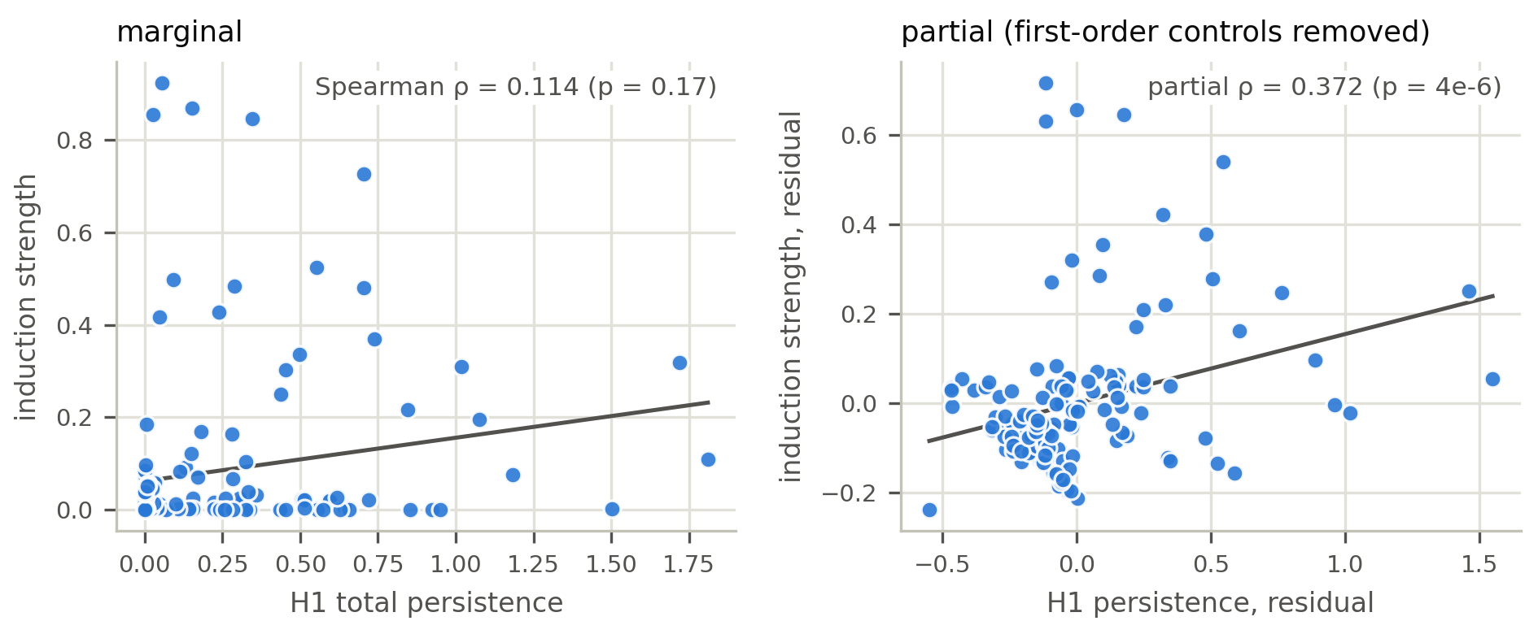
- Figure 1: The suppression effect (GPT-2, 144 heads; Experiment 3). Marginally, per-head H1 persistence is uncorrelated with independently-measured induction strength (left). Residualizing both variables on the first-order attention controls reveals the relationship (right): topology carries signal the cheap statistics mask.

4.3 Cycle edges are causally load-bearing — at adequate budget (Experiments 5–6)
Descriptively, the H1 cycle edges of induction heads concentrate at the induction copy distance S (the offset between the two occurrences of the repeated subsequence): the fraction of cycle edges at gap ≈ S is 0.233 in induction heads vs 0.013 elsewhere (Mann-Whitney p = 0.00043). Causally, a directed, edge-exact, budget-matched ablation (equal edge counts for cycle / magnitude / random conditions) damages induction behaviour more than both controls in distilgpt2 (median damage 0.0043, vs-random p = 0.0017). In gpt2 the verdict tracks the treatment budget:
top_k | edges ablated/seq | cycle median damage | vs random p | verdict
8 | 2.5 | 0.0000 | 0.5000 | INCONCLUSIVE
16 | 7.8 | 0.0001 | 0.5452 | RED
24 | 24.5 | 0.0600 | 0.0024 | GREEN

gpt2-medium remains negative at adequate budget (damage 0.0113, p = 0.0757): more heads spread the circuit, increasing redundancy. The causal claim is real but budget-sensitive and not universal across scale — the honest version of "cycles matter".

5. What falls

5.1 Attribution: attention magnitude wins, twice (Experiments 9–11)
If topology is useful for explainability it should at least localize known circuit edges. It does not. ROC-AUC at recovering the ground-truth copy edge within induction heads: magnitude 0.976, cycle participation 0.501 (chance), sheaf discord 0.581. On IOI name-mover heads — chosen specifically because attention there is diffuse, handicapping magnitude — magnitude still scores 0.963, against cycle participation 0.458 (below chance) and sheaf discord 0.606. With a verified causal instrument (ablating the known END→IO edge produces median damage 0.513, p = 0.000050; n = 48), no saliency beats random at small budgets — median damage: cycle 0.028 (p = 0.276), magnitude -0.132, sheaf -0.187, the latter two negative (ablating their top edges mildly helps). The instrument works; the saliencies don't.

5.2 "Information flow" collapses to shape, then to length (Experiments 8, 9a, 9b)
A cellular sheaf over the residual stream (PCA stalks, Procrustes restriction maps) initially appeared to add ΔR² = 0.051 beyond H1 at predicting hop count — the project's most exciting intermediate result. Decomposition killed it in two steps. First, the added signal was carried entirely by the Fiedler value (graph algebraic connectivity — shape), ΔR² = 0.0436; the genuinely flow-valued discord feature added 0.0076 (p = 0.0875) once Fiedler was controlled. Second, Fiedler itself died under length control: token count and entity count alone explain R² = 0.773 of hop variance, and Fiedler's contribution beyond a length-augmented baseline is ΔR² = 0.0092, below the pre-registered 0.02 floor. Both the "flow beats shape" and "better shape statistic" readings were withdrawn.

5.3 Failure prediction does not survive real QA (Experiments 7, 12–16)
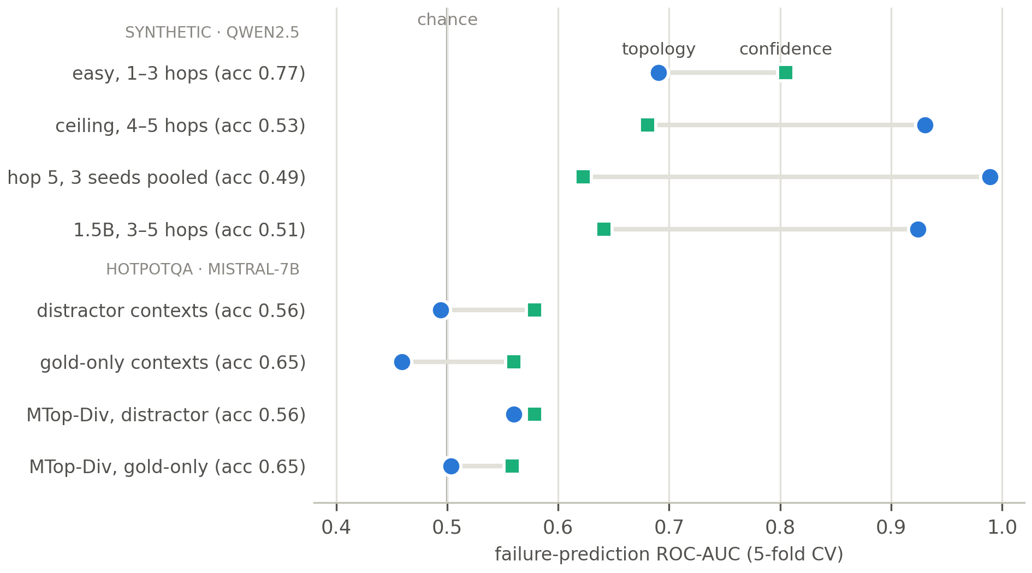
- Figure 2: The regime map. Failure-prediction AUC of topology (blue circles) vs the model's own confidence (green squares) across the eight evaluation regimes, each labeled with task accuracy. Topology decisively beats confidence only on synthetic multi-hop reasoning at the capability ceiling (middle rows); on easy tasks it is redundant, and on naturalistic HotpotQA (bottom group) it collapses to chance — for our H1 features and for the TOHA-style MTop-Div reimplementation alike (bottom two rows).
This is the audit's sharpest arc. On easy synthetic reasoning (accuracy 0.772), topology predicts errors above chance (AUC 0.690) but adds nothing beyond confidence (0.805) — and contradictory distractors do not change this (they raised accuracy from 0.796 to 0.850, the model resolving explicit contradictions correctly). At the capability ceiling the picture inverts: on 4–5-hop problems (accuracy 0.525), topology reaches AUC 0.930 against confidence's 0.681 (ΔAUC = 0.245, p = 0.0312 — every fold positive, the floor of the five-fold test, §3); at five hops, 1.000 vs 0.617. Replication: three seeds pooled (n = 360, accuracy 0.508), hop-5 topology 0.989 vs confidence 0.623; a second model (1.5B, accuracy 0.506) gives topology 0.924 vs confidence 0.641. The item-level bootstrap (§3) removes any fold-count worry: pooled across seeds (n = 360), topology beyond confidence gives ΔAUC = 0.212, 95% CI [0.163, 0.264]; the 1.5B model's topology-beyond-controls ΔAUC = 0.214, CI [0.147, 0.285] — neither interval approaches zero.
Mechanism, by scale. For the 0.5B model the explanation is deflationary: at hop 5 the first-order controls alone reach AUC 0.991, matching topology's 0.989; r(topology, attention entropy) = 0.925; topology adds ΔAUC = 0.000 beyond the controls. Topology is an entropy meter here. For the 1.5B model it is not: controls reach 0.734, adding topology lifts it to 0.948 (ΔAUC = 0.216, p = 0.0312) — a structural signal beyond entropy, appearing only at the larger scale.
The boundary. On TOHA's benchmark and model family — Mistral-7B-Instruct on HotpotQA bridge questions, full 10-paragraph distractor contexts, n = 200, accuracy 0.565 (inside the miscalibration band) — the identical features are at chance: topology AUC 0.494, confidence 0.579, TOHA's engineered features 0.71. Diagnosis: the prompts span 210–3739 tokens and the pooled H1 features track length almost perfectly (ρ = 0.947 with sequence length) while length is uninformative about correctness (ρ = 0.004) — the features are length meters on a dataset where length is noise. But the obvious rescue fails. Residualizing length lifts topology only to 0.545; and re-running the entire experiment with gold-only contexts (the two supporting paragraphs; length std 88 tokens, no distractors, accuracy 0.650) leaves pooled (0.459), length-residualized (0.478), and per-head supervised head-selected (0.499) topology all at chance against confidence (0.560). Geometry control does not rescue the features; the boundary is the move from template-generated to naturalistic tasks itself.
Engineered features do not cross it either. The remaining hypothesis was that the boundary is feature construction: our features summarize prompt-encoding persistence, while TOHA scores how the generated answer's tokens attach to the prompt. Experiment 16 tests this by reimplementing TOHA's MTop-Div (the minimal spanning forest cost attaching answer tokens to the prompt in generation-time attention, per head, length-normalized) on the same 200 items, with the TOHA protocol's top-10 head selection made fold-internal. Pre-registered verdict: RED in both geometries. Head-selected MTop-Div reaches AUC 0.560 (95% CI [0.479, 0.641]) on distractor contexts and 0.504 (CI [0.417, 0.589]) on gold-only contexts — chance in both, adding nothing beyond confidence or response-entropy controls, and far from TOHA's reported 0.71 (pooled variants: 0.558 / 0.541). Whatever separates our setting from TOHA's reported result, it is not the choice between hand-specified persistence and their divergence metric.

5.4 Pruning (Experiment 1)
At equal per-head edge budget, retaining discrete-Morse critical cells loses to plain magnitude retention on WikiText-2 perplexity:
method | mean PPL
unpruned | 51.3
magnitude | 123.4
window | 12252.7
dmt | 70365.6
random | 189756.6

The paired per-example loss test agrees (DMT worse than magnitude, p < 0.001). Topology does not tell you which edges to keep.

6. Discussion
For the TDA-for-interpretability literature. Three controls did all the killing in this audit, and we recommend them as a minimum standard: (i) benchmark against attention magnitude — it is nearly free and was a near-perfect attributor in both of our circuit settings; (ii) benchmark against model confidence — any failure predictor must add to what the logit margin already encodes; (iii) control sequence length explicitly — two of our own intermediate positives (Fiedler, and implicitly the real-QA features) were length artifacts, and H1 statistics on naturalistic text correlate with length at ρ > 0.9. Where instruments are causal, verify them with a ground-truth condition before interpreting a null or a positive.
What topology is for, on this evidence. Not attribution, not pruning, not flow. The defensible uses are (a) as a descriptive, non-redundant correlate of relational circuit structure — the suppression effect of §4.2 means topology sees something first-order statistics genuinely miss, even though that something is not practically extractable by our hand-specified features outside controlled settings; and (b) as a failure signal in the narrow regime: clean task geometry, model at its capability ceiling, where it can be dramatically better than confidence (1.000 vs 0.617 at hop 5). We conjectured that TOHA's 0.71 on naturalistic QA meant engineered features could cross the boundary our hand-specified ones cannot — that the gap was feature construction. Experiment 16 falsified that conjecture in our setting: TOHA's own MTop-Div metric, reimplemented on our items, is also at chance (0.560 / 0.504). On our evidence, no attention-topology featurization tested — hand-specified or engineered — survives naturalistic QA. Reconciling this with TOHA's reported result now requires diagnosis rather than assertion: candidate explanations are protocol differences (annotation-based hallucination labels vs our substring-match correctness, their item mix vs our bridge-only slice, sampling vs greedy decoding, their probe-set head-selection budget, and the model revision — TOHA evaluates Mistral-7B-Instruct-v0.1, we v0.3). TOHA's released implementation makes an artifact-level comparison on our items feasible, and adjudicating these axes is the natural next experiment.
Scale. The mechanistic split — entropy proxy at 0.5B, entropy-orthogonal signal at 1.5B — cautions against extrapolating any single-model topology result in either direction. What topology measures appears to change with capacity.

7. Limitations
Runs are small and CPU/single-GPU scale: circuits on GPT-2-class models (n_seqs ≤ 12, single seeds for the causal budget sweeps), synthetic reasoning on 0.5B/1.5B models, and n = 200 items for each HotpotQA condition. The confidence baseline is a logit margin, not a calibrated probability or a sampling-based measure such as semantic entropy (Farquhar et al., 2024). On naturalistic QA this only makes our null conservative — topology is at chance even against the weak baseline — but in the synthetic regime where topology wins, a stronger sampled baseline could narrow the reported margins; we have not tested one. The sheaf construction is non-learned. Gold-only accuracy (0.650) sits above the deep-miscalibration band where the synthetic effect is strongest, so Experiment 15 jointly tests "real task + easier regime"; its supervised head-selection probe is far simpler than TOHA's featurization. Experiment 16 closes part of that gap — it scores TOHA's own metric — but is still not a full replication of their protocol: we use greedy decoding, substring-match correctness labels rather than annotated hallucination labels, bridge questions only, and fold-internal head selection on ≤160 training items; and our runs use Mistral-7B-Instruct-v0.3 where TOHA's published numbers are for v0.1. Experiment 16 is a from-paper reimplementation of the MTop-Div metric — built to the paper's definition with unit-tested MST equivalence, so that feature extraction ran inside the same audited pipeline as Experiments 14–15 — rather than a run of TOHA's released artifact; a null here bounds MTop-Div under our evaluation, not TOHA's published result, and the artifact-level comparison is the follow-up flagged in §6. All synthetic results use two task families (kinship, ordering) and template prompts. The fold-level Wilcoxon p-values (0.0312) sit at the resolution floor of a five-fold test (§3); the item-level bootstrap CIs of §5.3, whose lower bounds stay well clear of zero, carry the statistical weight of the ΔAUC claims.

8. Conclusion
Attention-graph topology, audited adversarially, is neither decorative nor a panacea. It carries genuine signal that first-order statistics miss — visible only under suppression-aware controls — and in one sharply bounded regime it is a far better failure detector than the model's own confidence. Outside that regime, every proposed use we tested is matched or beaten by a baseline costing nothing. We offer the regime map, the scale-dependent mechanism, and above all the audit methodology as the contributions, and we encourage the field to treat "beats magnitude, confidence, and length" as the entry bar for topological claims about transformers.

References
[1] Bazarova, A., et al. (2026). Hallucination Detection in LLMs with Topological Divergence on Attention Graphs. ACL 2026. arXiv:2504.10063 (v3; the HotpotQA results cited here appear from v3 onward).
[2] Bodnar, C., et al. (2022). Neural Sheaf Diffusion: A topological perspective on heterophily and oversmoothing in GNNs. NeurIPS 2022.
[3] Edelsbrunner, H., & Harer, J. (2010). Computational Topology: An Introduction. AMS.
[4] Elhage, N., et al. (2021). A Mathematical Framework for Transformer Circuits. Transformer Circuits Thread.
[5] Farquhar, S., et al. (2024). Detecting hallucinations in large language models using semantic entropy. Nature 630.
[6] Forman, R. (1998). Morse theory for cell complexes. Advances in Mathematics 134.
[7] Hansen, J., & Ghrist, R. (2019). Toward a spectral theory of cellular sheaves. Journal of Applied and Computational Topology 3.
[8] Olsson, C., et al. (2022). In-context Learning and Induction Heads. Transformer Circuits Thread.
[9] The GUDHI Project. GUDHI User and Reference Manual.
[10] van Dijk, G. (2026). Detecting Hallucinations in Large Language Models via Internal Attention Divergence Signals. arXiv:2605.05025.
[11] Wang, K., et al. (2023). Interpretability in the Wild: A Circuit for Indirect Object Identification in GPT-2 small. ICLR 2023.
[12] Yang, Z., et al. (2018). HotpotQA: A Dataset for Diverse, Explainable Multi-hop Question Answering. EMNLP 2018.

