## Sơ đồ phân rã chức năng

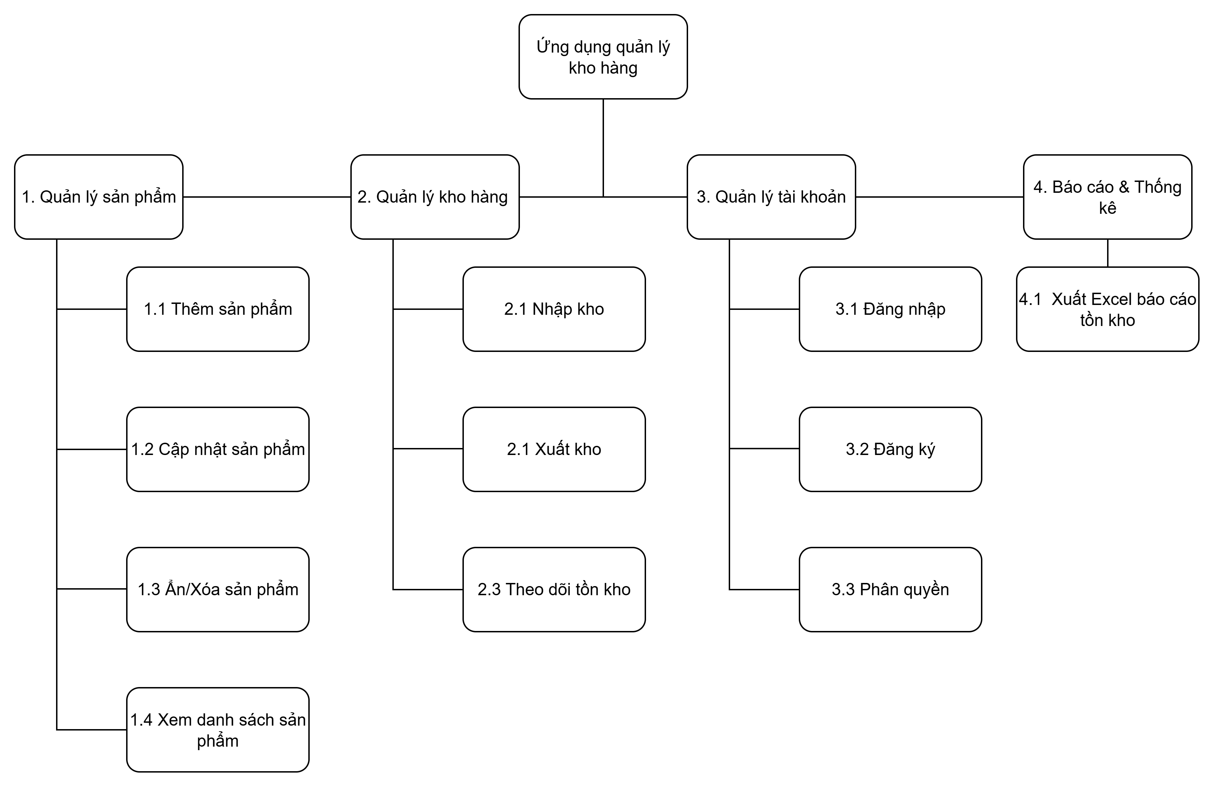

1. DFD mức đỉnh

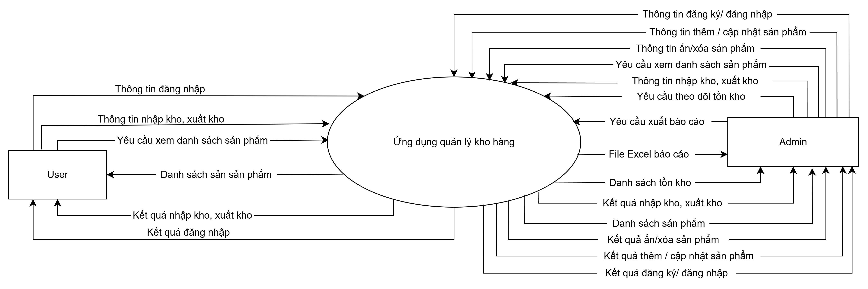

1. DFD mức dưới đỉnh

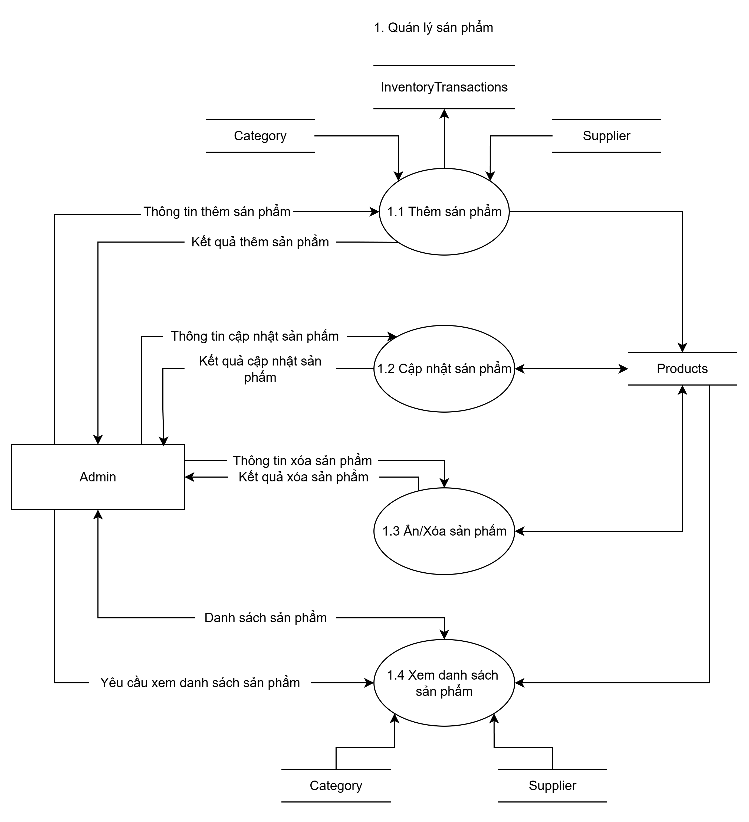

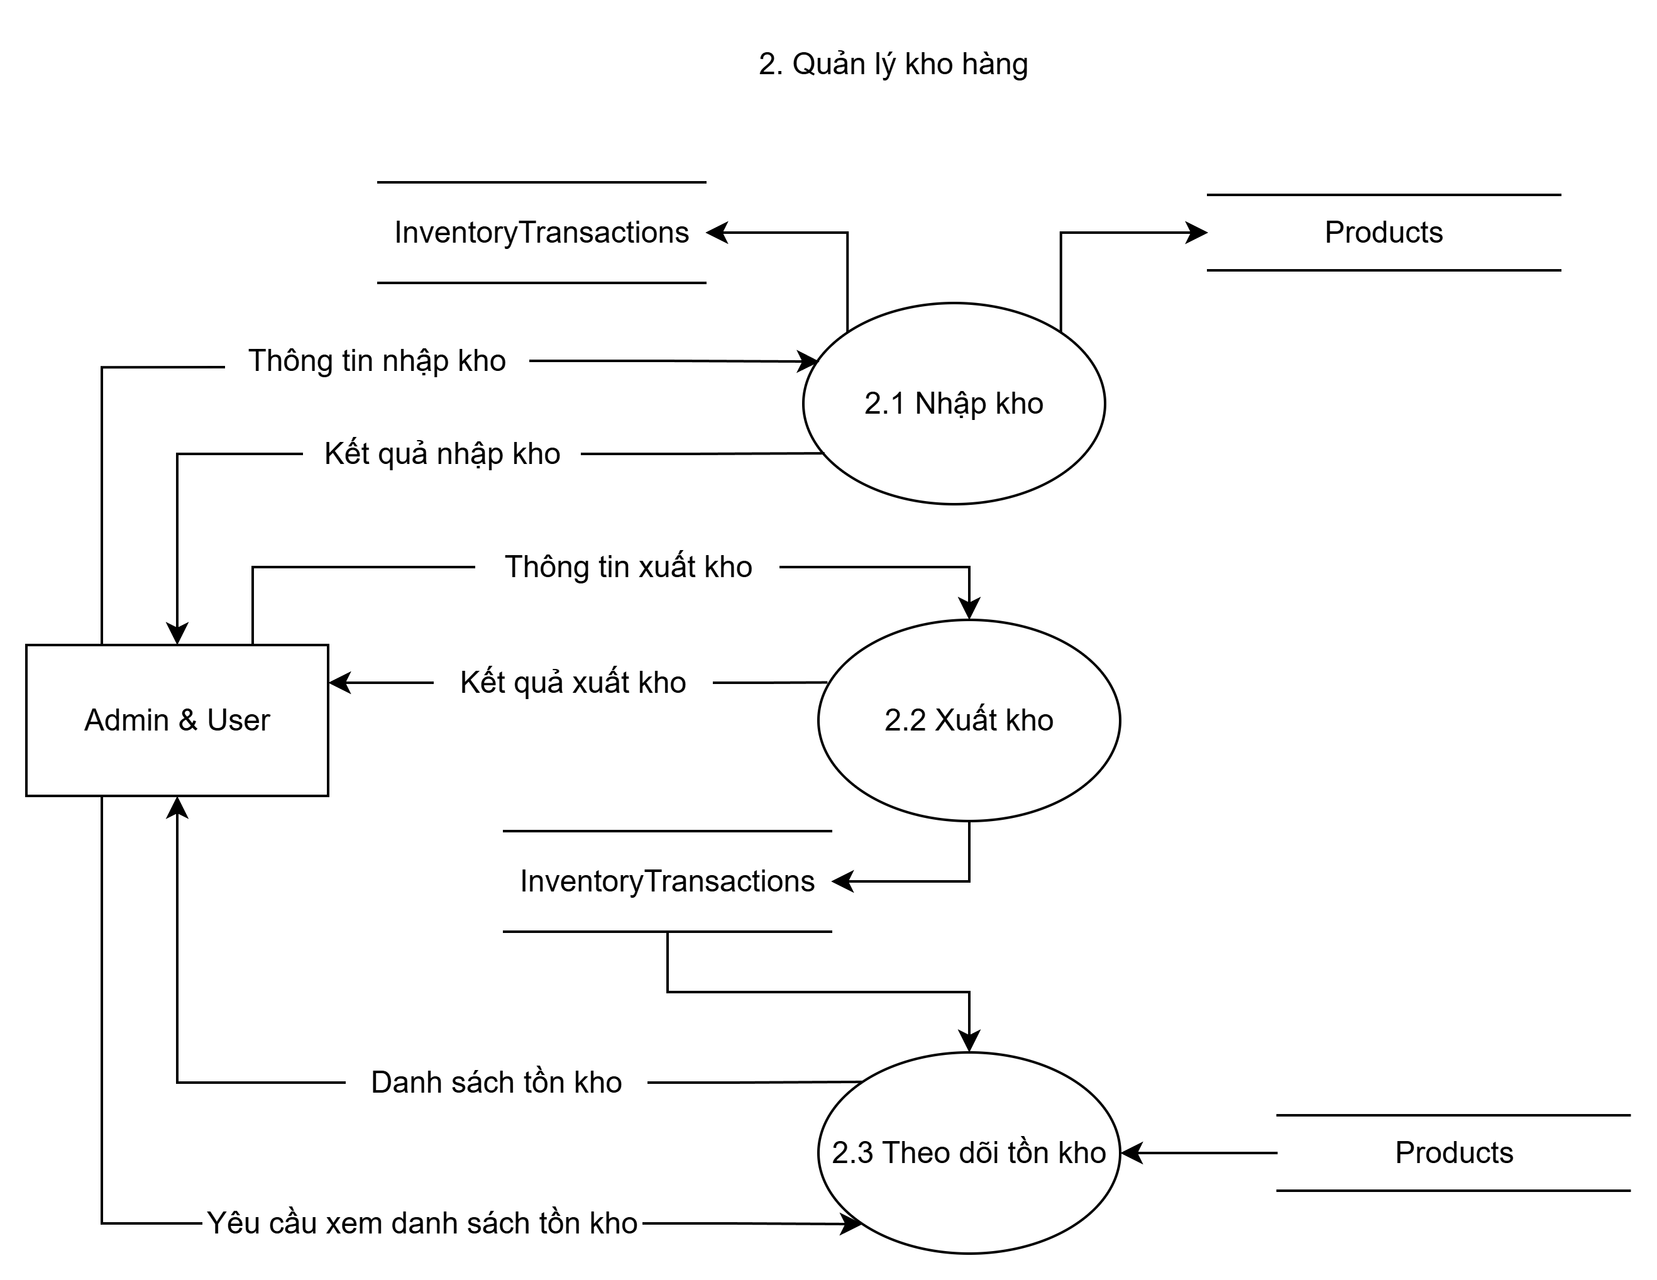

## 

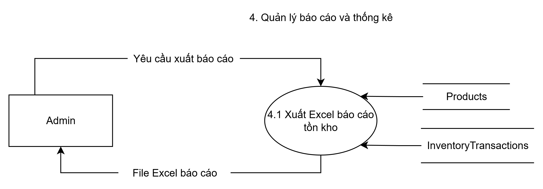

## DATABASE

## Table: Roles

|  |  |
| --- | --- |
| Column Name | Data Type & Constraints |
| RoleId | INT, PRIMARY KEY, AUTO_INCREMENT |
| RoleName | VARCHAR(50), NOT NULL, UNIQUE |

## Table: Users

|  |  |
| --- | --- |
| Column Name | Data Type & Constraints |
| UserId | INT, PRIMARY KEY, AUTO_INCREMENT |
| Username | VARCHAR(50), NOT NULL, UNIQUE |
| PasswordHash | VARCHAR(255), NOT NULL |
| Email | VARCHAR(100) |
| RoleId | INT, NOT NULL, FK -> Roles(RoleId) |
| CreatedAt | DATETIME, DEFAULT CURRENT_TIMESTAMP |

## Table: Categories

|  |  |
| --- | --- |
| Column Name | Data Type & Constraints |
| CategoryId | INT, PRIMARY KEY, AUTO_INCREMENT |
| CategoryName | VARCHAR(100), NOT NULL, UNIQUE |
| Description | TEXT |

## Table: Products

|  |  |
| --- | --- |
| Column Name | Data Type & Constraints |
| ProductId | INT, PRIMARY KEY, AUTO_INCREMENT |
| ProductName | VARCHAR(150), NOT NULL |
| Description | TEXT |
| Unit | VARCHAR(20), DEFAULT 'Chiếc' |
| Price | DECIMAL(10,2), NOT NULL |
| Quantity | INT, DEFAULT 0 |
| MinStockLevel | INT, DEFAULT 0 |
| IsActive | BOOLEAN, DEFAULT TRUE |
| CategoryId | INT, NOT NULL, FK -> Categories(CategoryId) |
| CreatedBy | INT, FK -> Users(UserId) |
| CreatedAt | DATETIME, DEFAULT CURRENT_TIMESTAMP |

## Table: InventoryTransactions

|  |  |
| --- | --- |
| Column Name | Data Type & Constraints |
| TransactionId | INT, PRIMARY KEY, AUTO_INCREMENT |
| ProductId | INT, NOT NULL, FK -> Products(ProductId) |
| Quantity | INT, NOT NULL (Dương: Nhập, Âm: Xuất) |
| TransactionType | ENUM('IN', 'OUT'), NOT NULL |
| Note | TEXT |
| PerformedBy | INT, FK -> Users(UserId) |
| PerformedAt | DATETIME, DEFAULT CURRENT_TIMESTAMP |

## Table: Suppliers

|  |  |
| --- | --- |
| Column Name | Data Type & Constraints |
| SupplierId | INT, PRIMARY KEY, AUTO_INCREMENT |
| SupplierName | VARCHAR(100), NOT NULL |
| ContactInfo | TEXT |