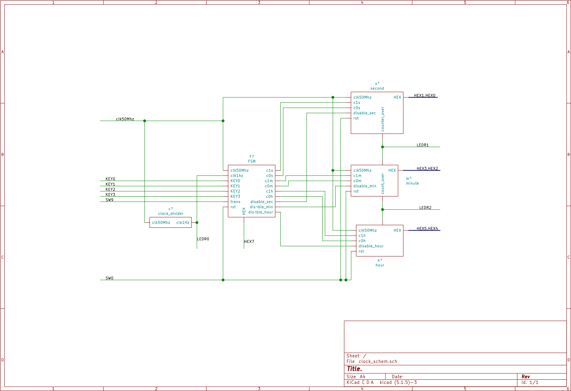

Figure : Digital clock schematic

Figure : FSM

This FSM works base on clock 1Hz and SW9. At every positive edge of clock, circuit will receive value of SW9. If the value is 1, it will change to the next state as the figure shown above. It means, it takes 1 period of clock(1 second) to change state. In second, minute and hour mode, FSM will generate output (dis_s, dis_m, dis_h) corresponding to each state to guide the second,minute and hour module to do their jobs.

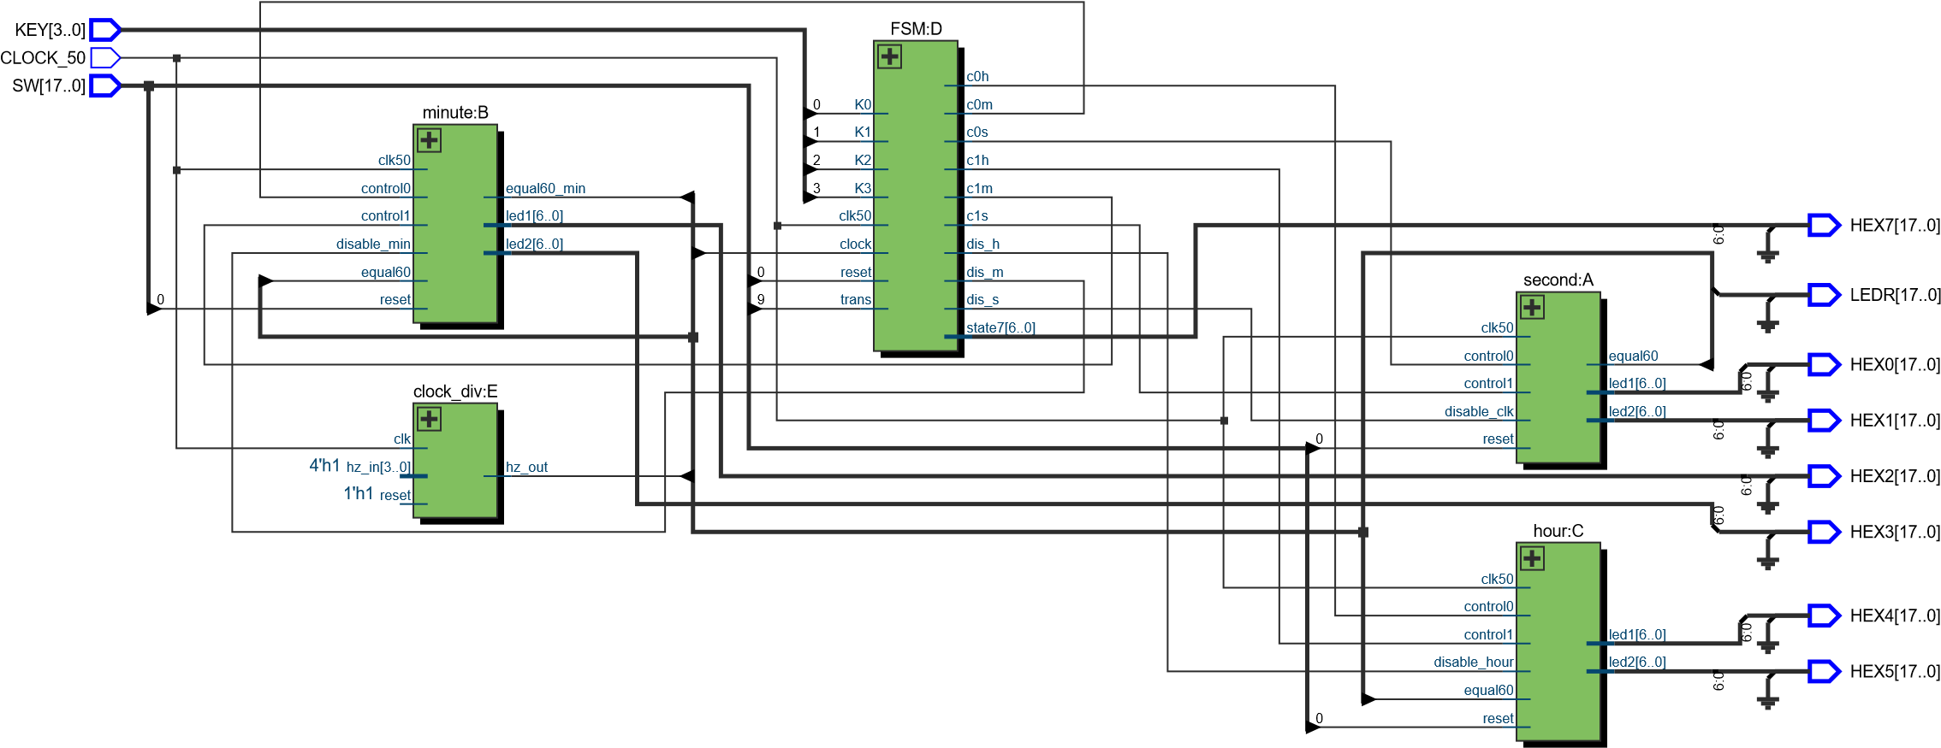

Figure : RTL viewer

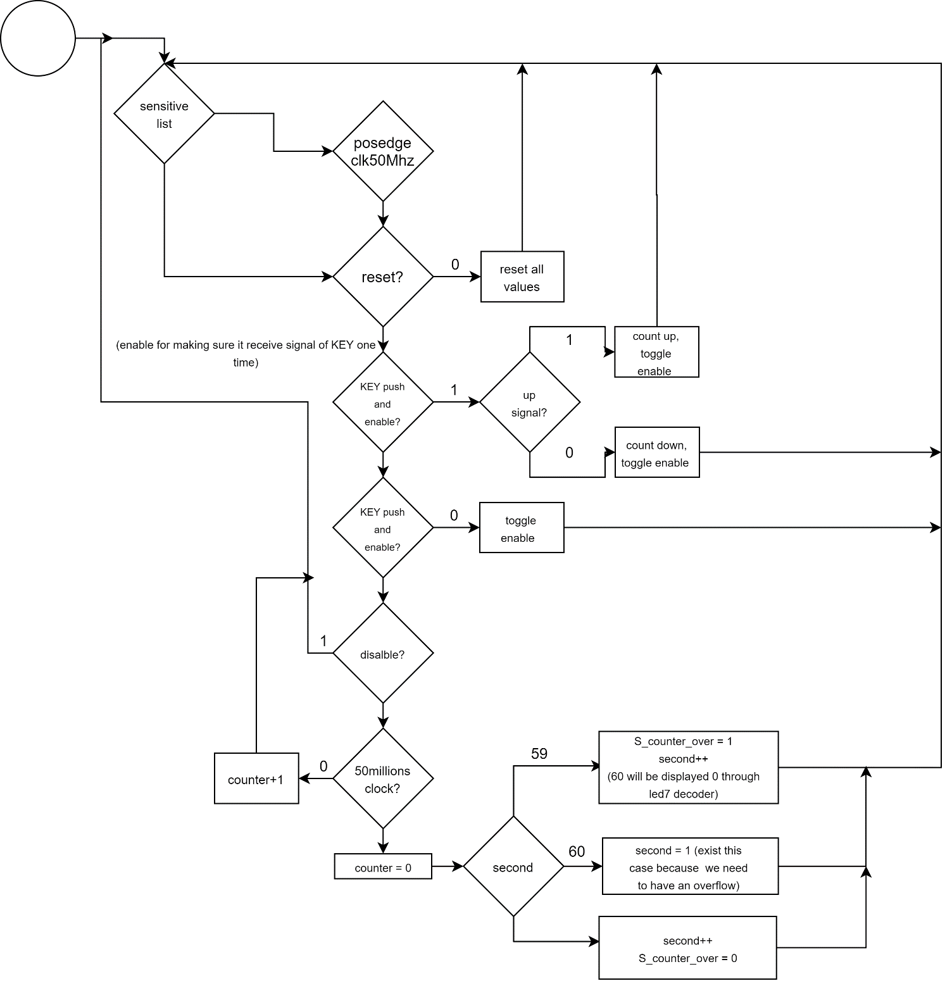

Figure 4: Flowchart of second module

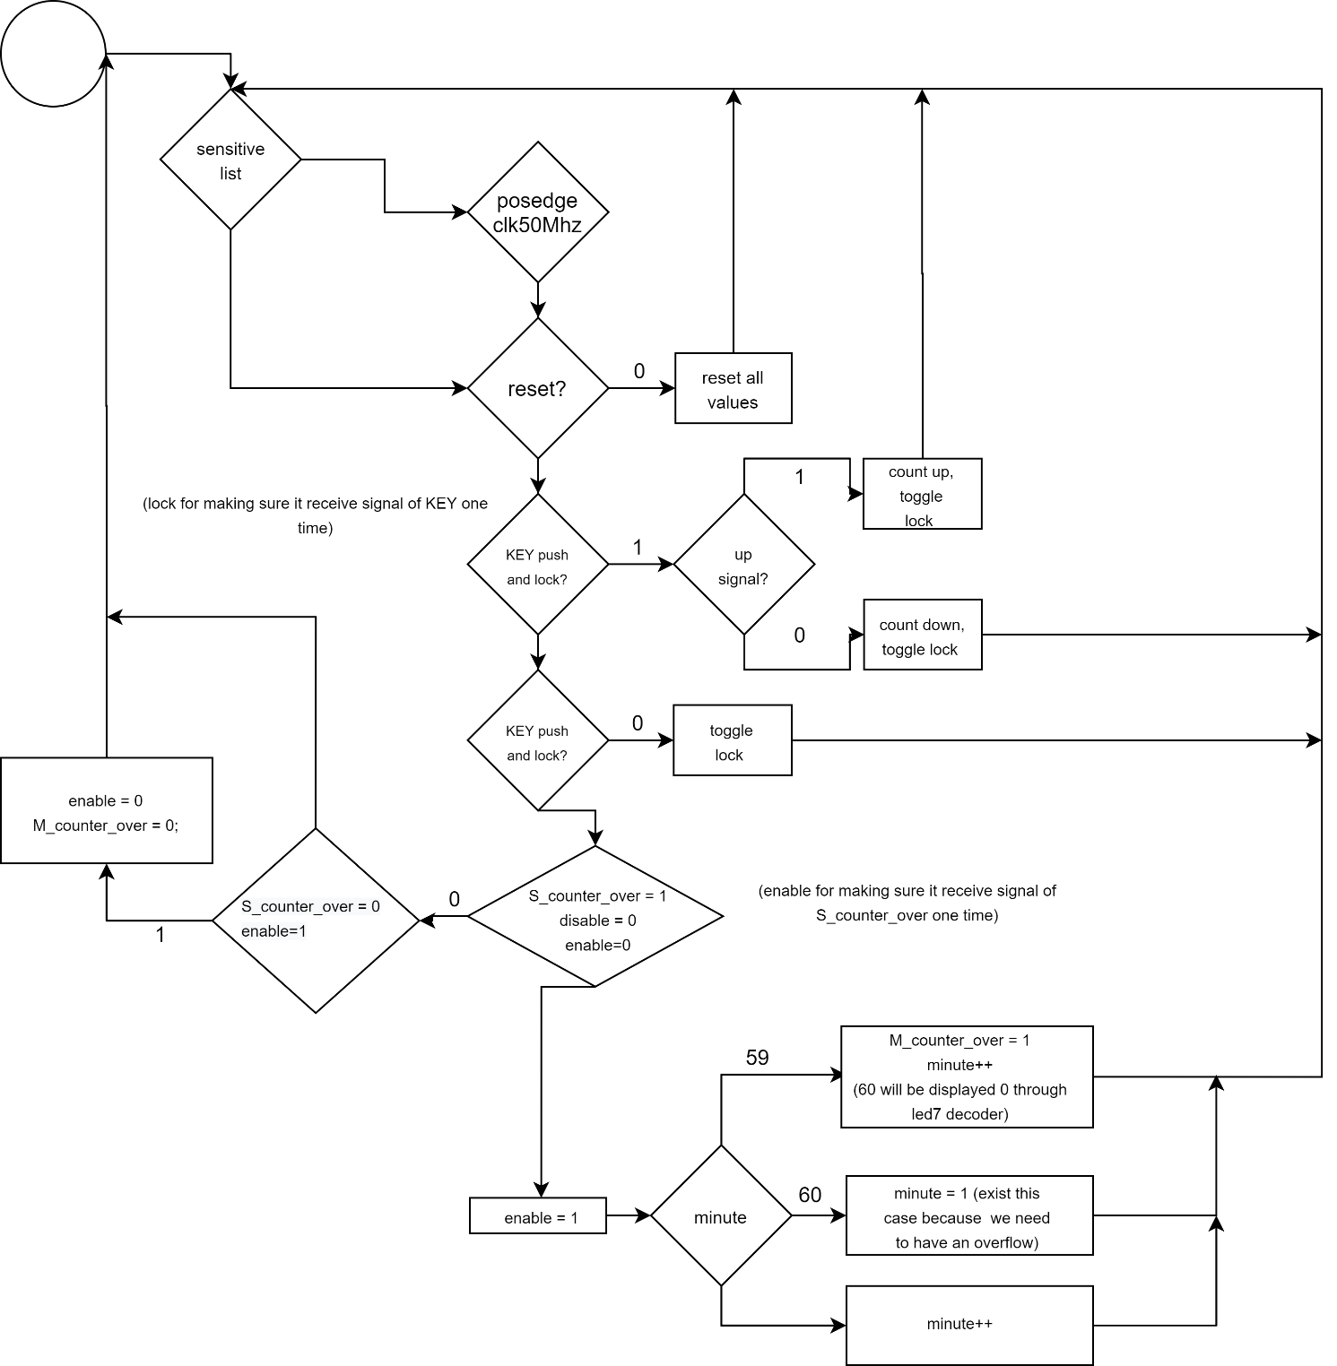

Figure 5: Flowchart of minute module

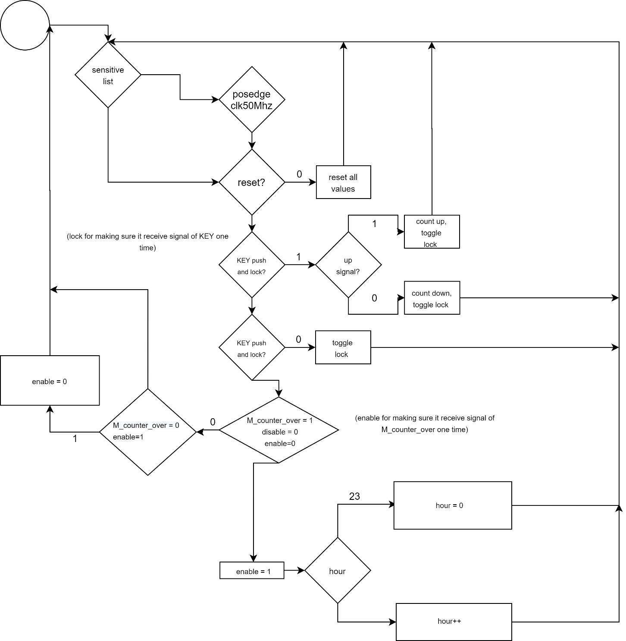

Figure 6: Flowchart of hour module

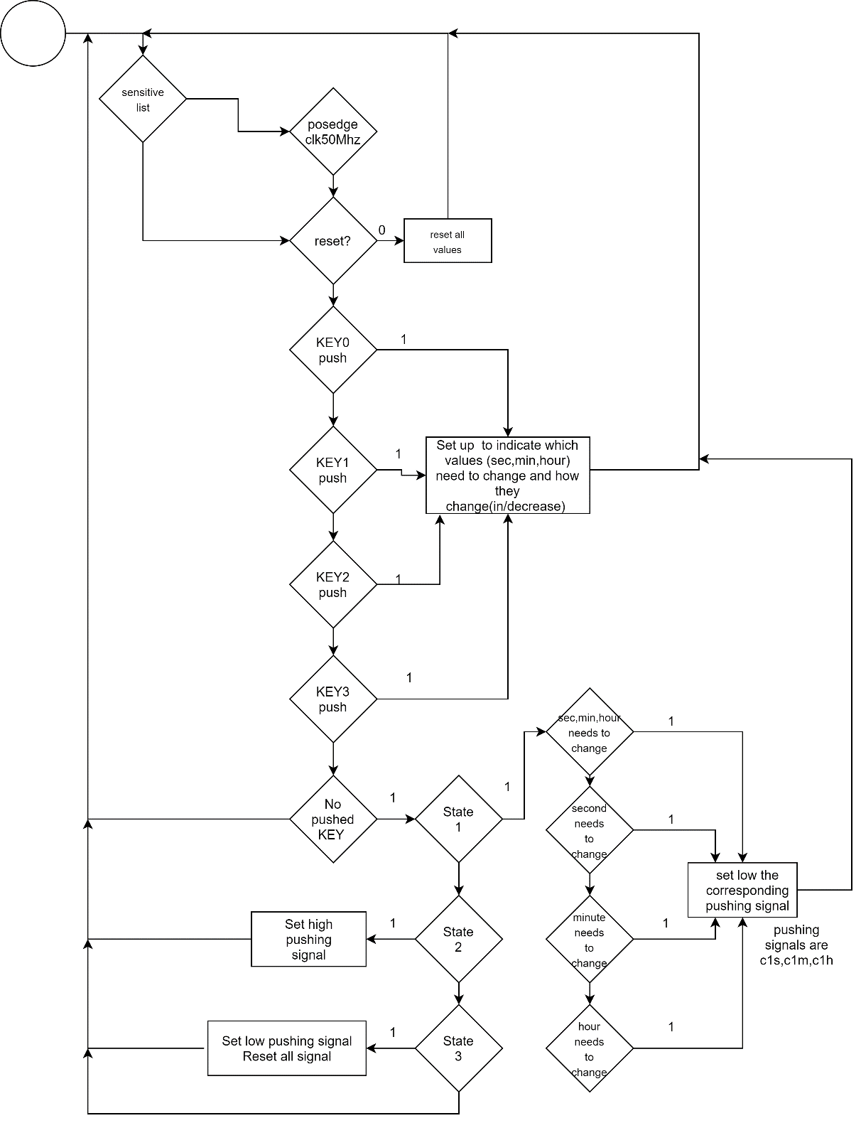

Figure 7: Flowchart of handling KEY input to control the second, minute, hour module

Explanation:

Second module: use clock 50MHz and reset signal for input. If it reaches 50,000,000 positive edges and it is not disable, second will count up 1. In addition, clock 50MHz is also used to catch the low signal (**c1s**, which is used to trigger the in/decrease function) generated by FSM module. In order to receive the low signal one time, adding an enable signal to stop receiving low signal from FSM module. When the signal is high, the enable will be toggle to make the circuit continue to receive low signal again.

Minute module: use clock 50MHz and reset signal for input. Clock is used to catch S_counter_over signal from second module and the low signal (**c1m**, which is used to trigger the in/decrease function) generated by FSM module. This module uses the same technic (enable signal) to make sure that it receives the signal one time.

Hour module: It is the same as minute.

Note: Each of three above modules uses 2 input signal to control the in/decrease function, one signal is for trigger function, another is for making the circuit knows what should it do(increase or decrease) after triggered.

FSM module: the first always block is used to control state of FSM. The second always block is used to handling Key input to generate the suitable command (c1s,c0s,c1m,c0m,c1h,c0h) for second,minute and hour module. This second block need 4 states to complete the handling: state 0 is indicate which values (sec,min,hour) need to change and how they change(in/decrease) base on the KEY inputs. state 1,state 2 and state 3 can be seen on the flowchart