Workshop 5
By traltb@fe.edu.vn
Bài 1:
The user enters a string of characters from the keyboard. Your task is to count the total number of characters in the string by manually iterating through each element until you encounter the null terminator \0.
Important Note: You are not allowed to use the built-in strlen() function from the <string.h> library.
Below is an example of how the program will run:
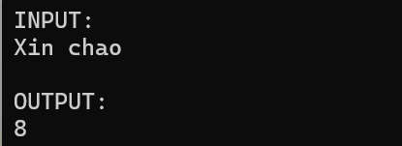

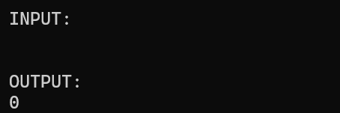
Bài 2:
The user enters a string from the keyboard (which may include spaces). Your task is to print the string in reverse order without using any built-in reversal functions (like strrev).
Below are input and output samples for the question:
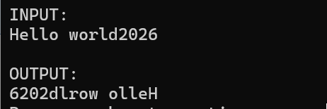

Bài 3:
The user enters a string (containing no spaces). Your program must determine if the string is a palindrome—meaning it reads the same forward and backward (e.g., "madam" or "racecar").
Print "Yes" if the string is a palindrome, and "No" if it is not.

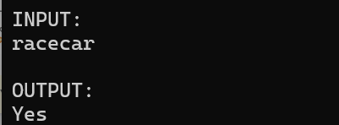

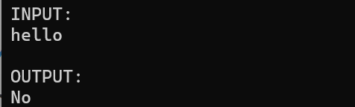
Bài 4:
The user enters a sentence that may contain multiple consecutive spaces between words, as well as leading or trailing spaces. Your task is to count the total number of words in the sentence.
A "word" is defined as a sequence of non-space characters separated by one or more spaces.

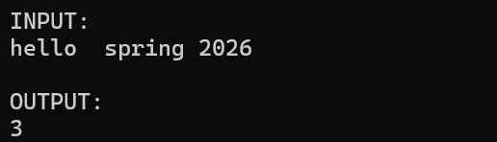
Bài 5:
The user provides three inputs: a string, a character to find, and a replacement character. Your program must find every occurrence of the target character within the string and replace it with the new one.
Finally, print both the total number of replacements made and the modified string.
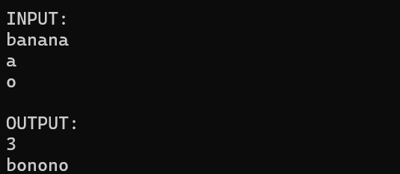

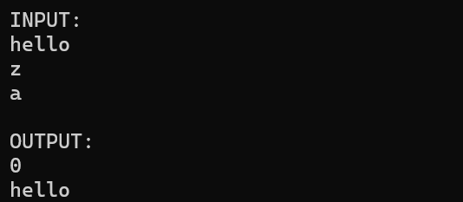

Bài 6:
The user enters the number of students n (where n<=10) and their respective names. Your program must sort the list of names in ascending alphabetical order (A-Z).
To perform the sorting, you must use the standard library functions strcmp() for comparison and strcpy() for swapping strings. Print the list of names both before and after sorting.
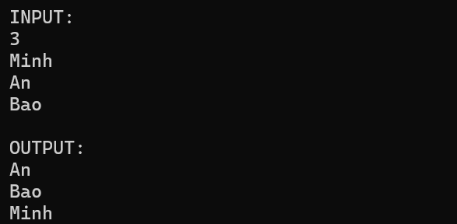

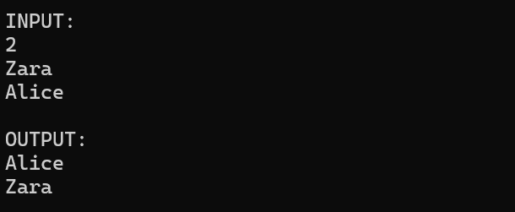
Bài 7:
The user enters a mixed string containing letters, numbers, and special characters (symbols/spaces). Your program must iterate through the string and count:
- The total number of digits (0-9).
- The total number of letters (a-z, A-Z).
- The total number of other characters (symbols, spaces, punctuation).
Print the results for each category on a separate line.
Below are examples of how the program will run:
