**Contents**

I Install Appium .............................................................................................................................................1

II Setting Demo and run ................................................................................................................................2

**I Install Appium**

1 Java

- Install Java JDK from [http://www.oracle.com/technetwork/java/javase/downloads/jdk8-](http://www.oracle.com/technetwork/java/javase/downloads/jdk8-downloads-2133151.html) [downloads-2133151.html](http://www.oracle.com/technetwork/java/javase/downloads/jdk8-downloads-2133151.html)

- Setting JAVA_HOME variable:

o Right click My Computer and select Properties.

o On the Advanced tab, select Environment Variables, and then edit JAVA_HOME to point to where the JDK software is located, for example, C:\Program Files\Java\jdk_version_folder.

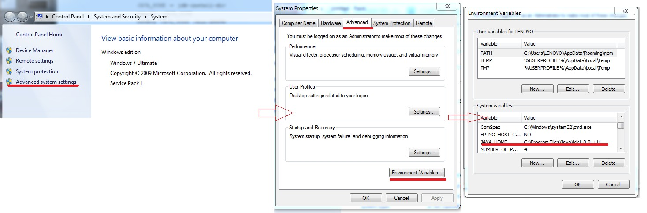

2 Android SDK

- Install Android SDK: from [https://download.com.vn/download/downloadurl?softwareid=22345#](https://download.com.vn/download/downloadurl?softwareid=22345)

then unzip to any folder. (example: C:\Android)

- Setting Android_Home variable : Perform same as setting Java_home. (refer [here )](http://www.software-testing-tutorials-automation.com/2015/09/set-androidhome-and-path-environment.html)

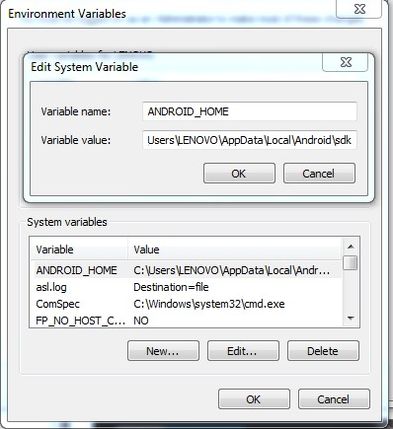

3 Appium

- Install Node.js from <https://nodejs.org/en/download/>

- After that, open terminal and run below command:

o npm install npm@latest

o npm install –g [appium@1.7.2](mailto:appium@1.7.2)

o npm install –g appium-doctor

o npm install –g wd

4 Install Maven

* Download Maven: <http://mirror.downloadvn.com/apache/maven/maven-3/3.3.9/binaries/apache-maven-3.3.9-bin.zip>.
* Unzip, for example: C:\tools\
* Press Windows+R, type systempropertiesadvanced, press Enter -> select Enviroment Variables button
* Set environment: MAVEN_HOME = C:\tools\
* Add to PATH environment variable: ;%MAVEN_HOME%\bin
* Close all
* Call cmd, run command:
  + mvn -v

**II Setting Demo and run**

* Get source and put it to anywhere : example C:\demo

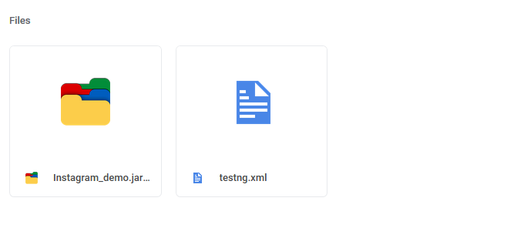

* Open explorer and go to C:\demo -> unzip file Instagram_demo.jar

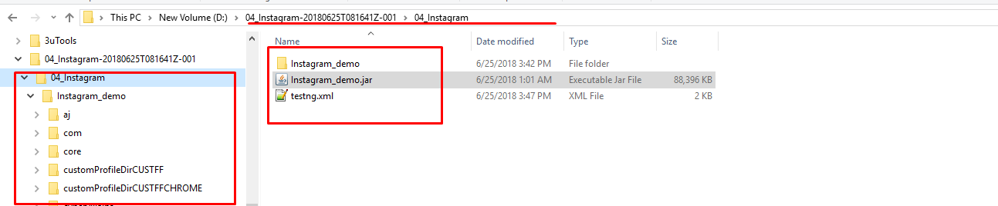

* Enable Developer mode on your device (refer here)
* After that, connect your device to PC and run below command on terminal to get your phone id
  + adb devices

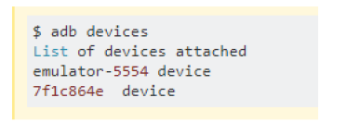

* Open file testg.xml to edit device info:

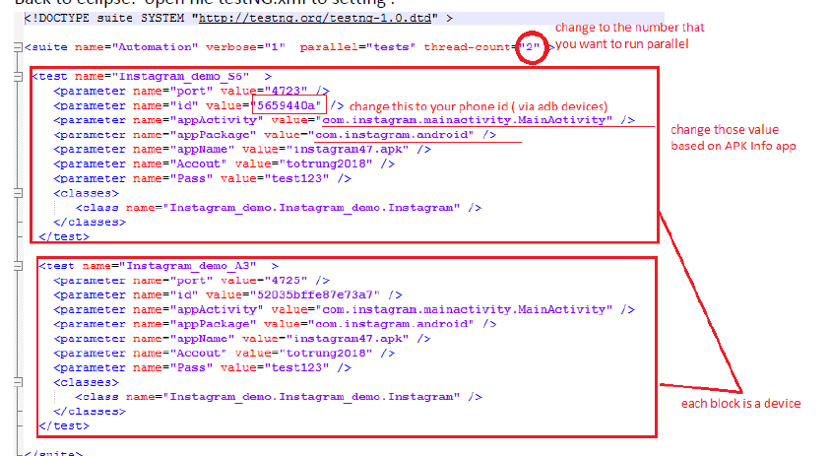

* Open Terminal and cd to C:\demo
* Run command :
  + java -cp Instagram_demo org.testng.TestNG testng.xml

