Trung Viet Nguyen

Homework 2

CIS 3308

**Website Title:** 1 vs 1 E-Sport Tournament Portal

**Marketing Material:**

Join the 1V1 E-Sport Tournament Portal and fulfill your dream of making money while enjoying your favorite game! Dozens of tournaments of different games to choose from, with prize pools of up to $1000! You can participate in multiple tournaments at the same time! Tournament registration is easy and can be cancelled anytime.

Account registration is free, but you can also pay a one-time membership fee and become a prime member of the website, with unique website banner and in-game gift when you register for tournaments! Membership fee can be paid anytime during or after account registration, and 50% of the membership fee goes to the tournaments’ prize pools. Become a member today!

**Data Model:**

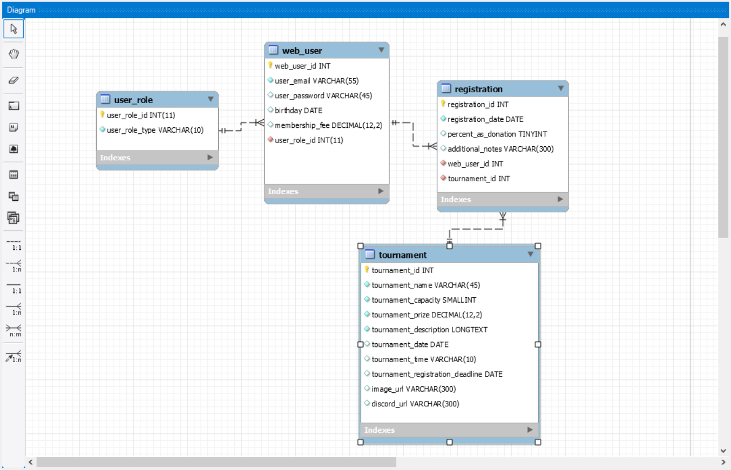

**Table Design:**

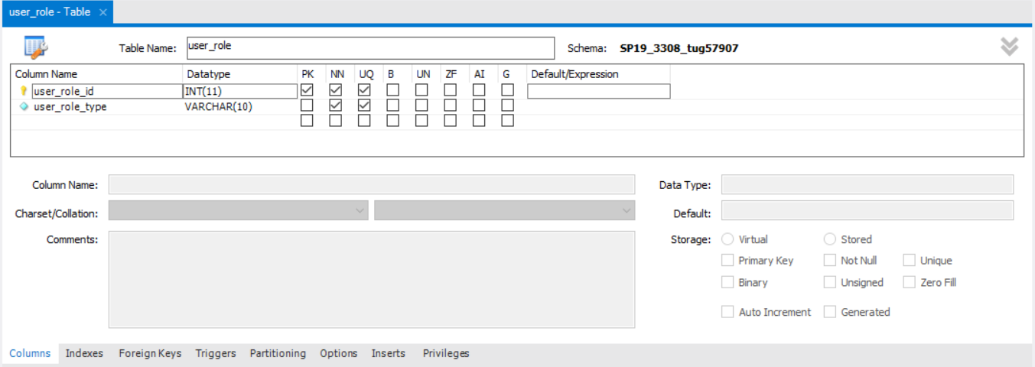

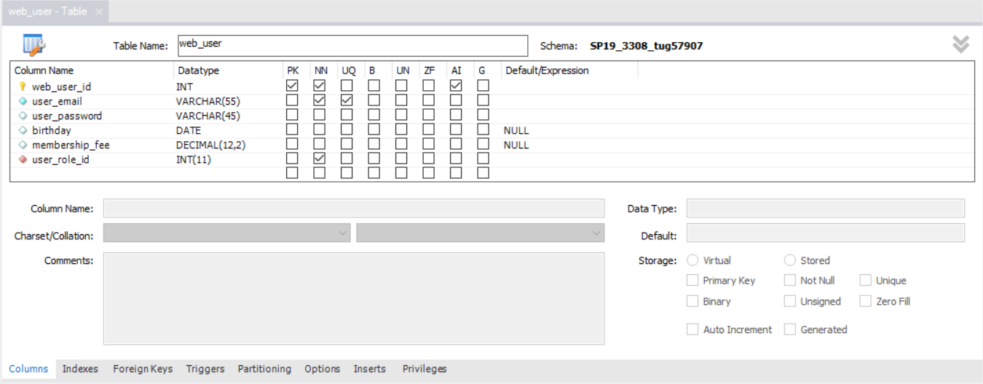

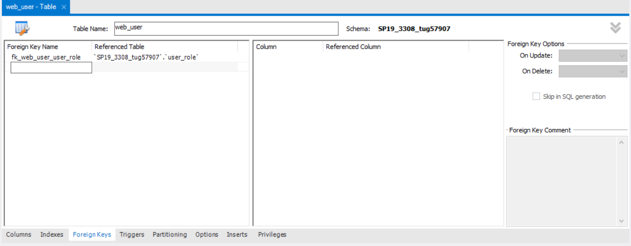

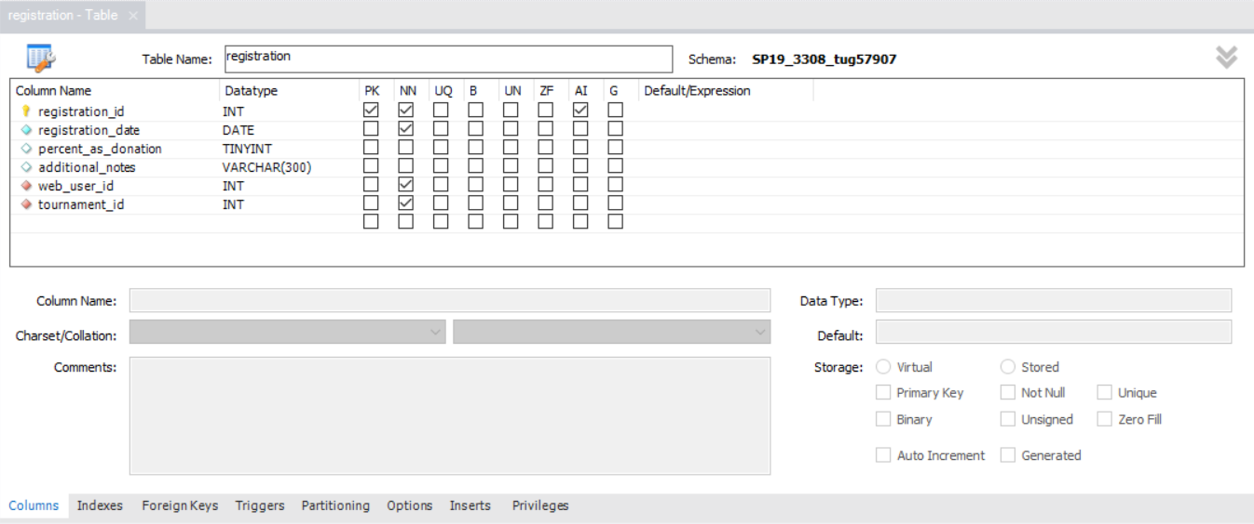

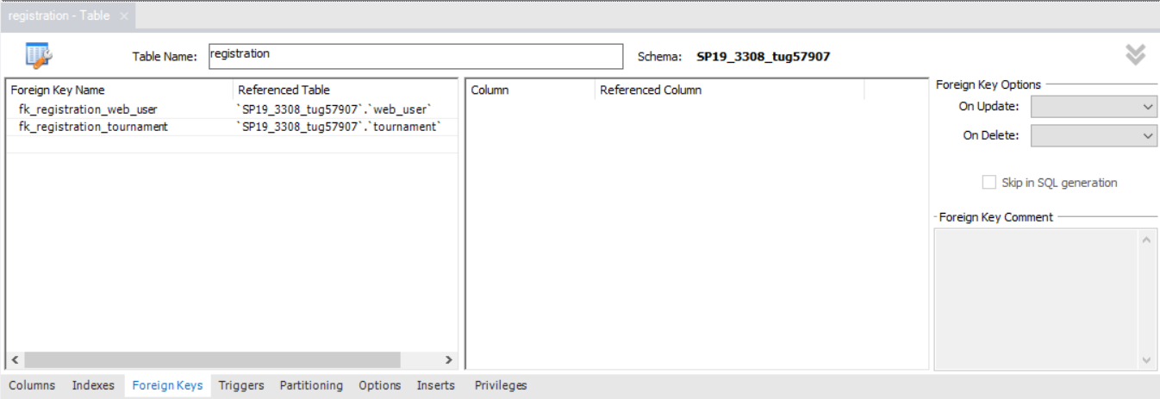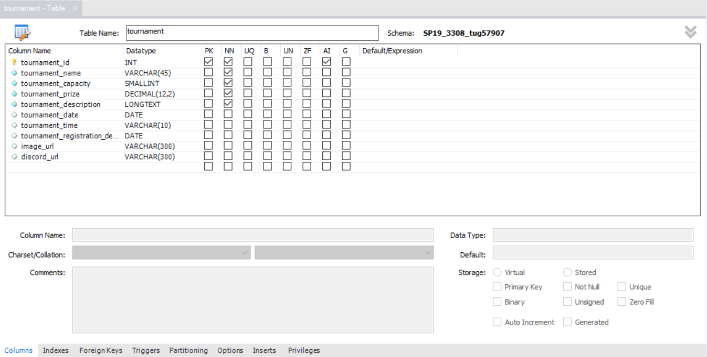

**SELECT Statements:**

1. List all of the columns of all records of your “other” table, ordering the columns in a way that you think users would like to view the data (don't use "select *"). Sort the data by the first column.

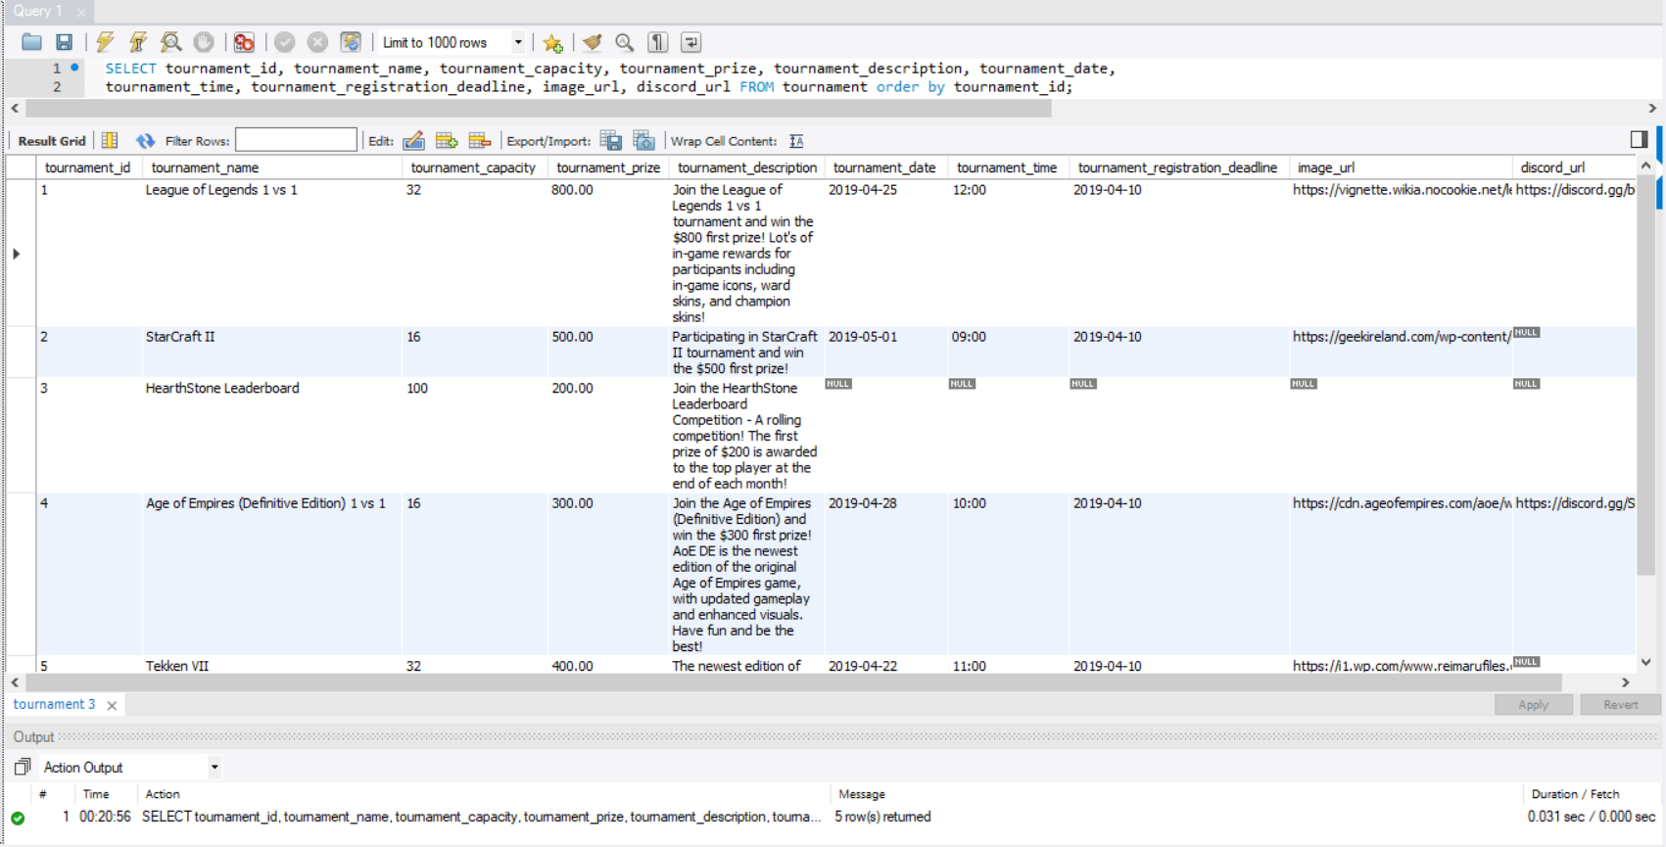

1. Show all the records from the web_user table joined with the user_role table. Show the role name first, then the role id, then the email address, followed by all the rest of the columns of your user table (ordered in a way you think users would like to view the data – show the role id once, not twice.) Order the result set by role name, then email address (as a secondary sort). Include all records.

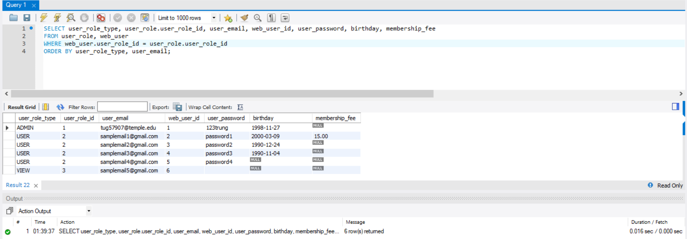

1. Join your associative table with your “other” table. Include all the columns except PK and FK (id) columns. Order the columns in a way you think users would like to see them (not "select *"). Order the result set by the first two or three columns.

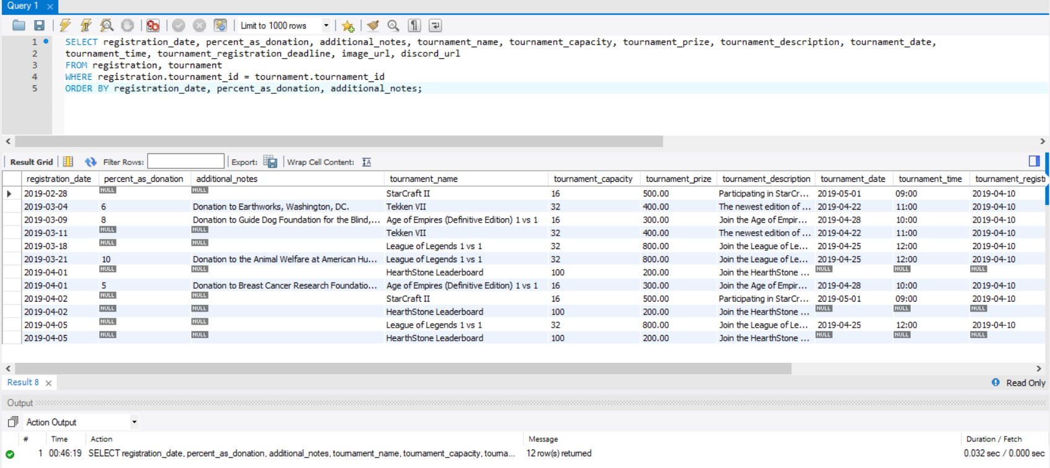

1. Join your associative table with your “other” table and with your user table. Include all the columns except PK and FK (id) columns. Order the columns in a way you think users would like to see them. Order the result set by the first two or three columns.

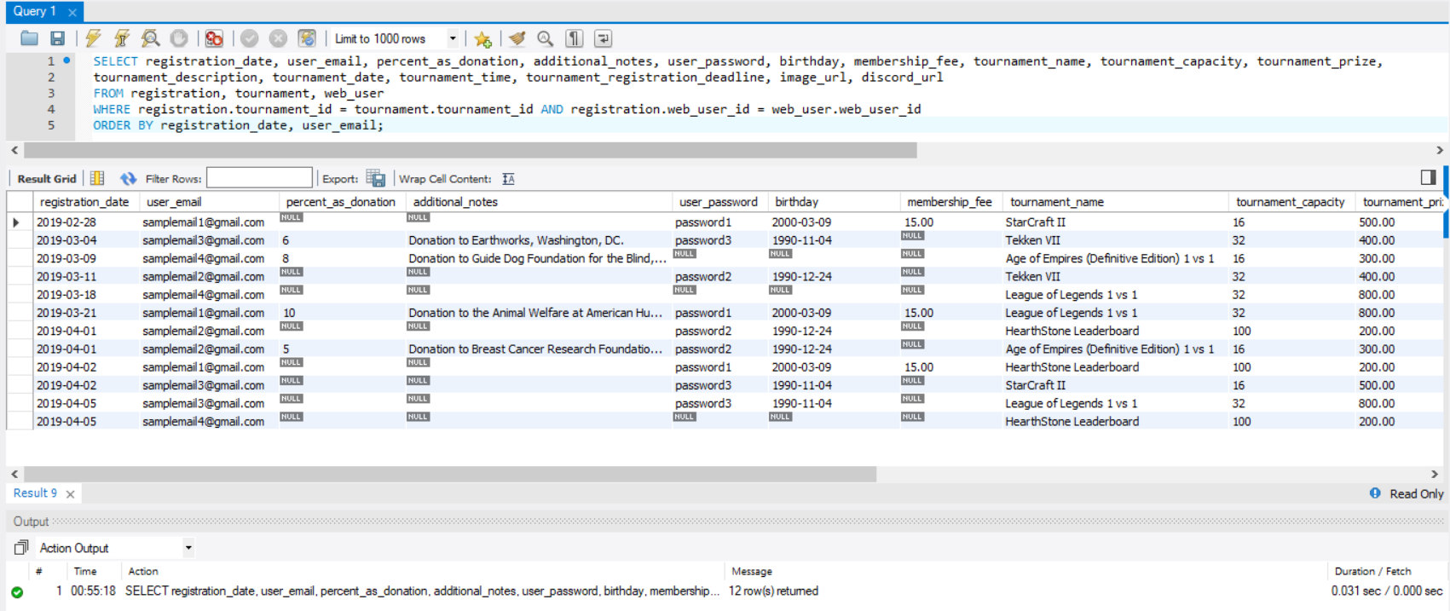

1. Join your associative table with your “other” table and with your user table and with your role table. Include all the columns except PK and FK (id) columns. Order the columns in a way you think users would like to see them. Order the result set by the first two or three columns.

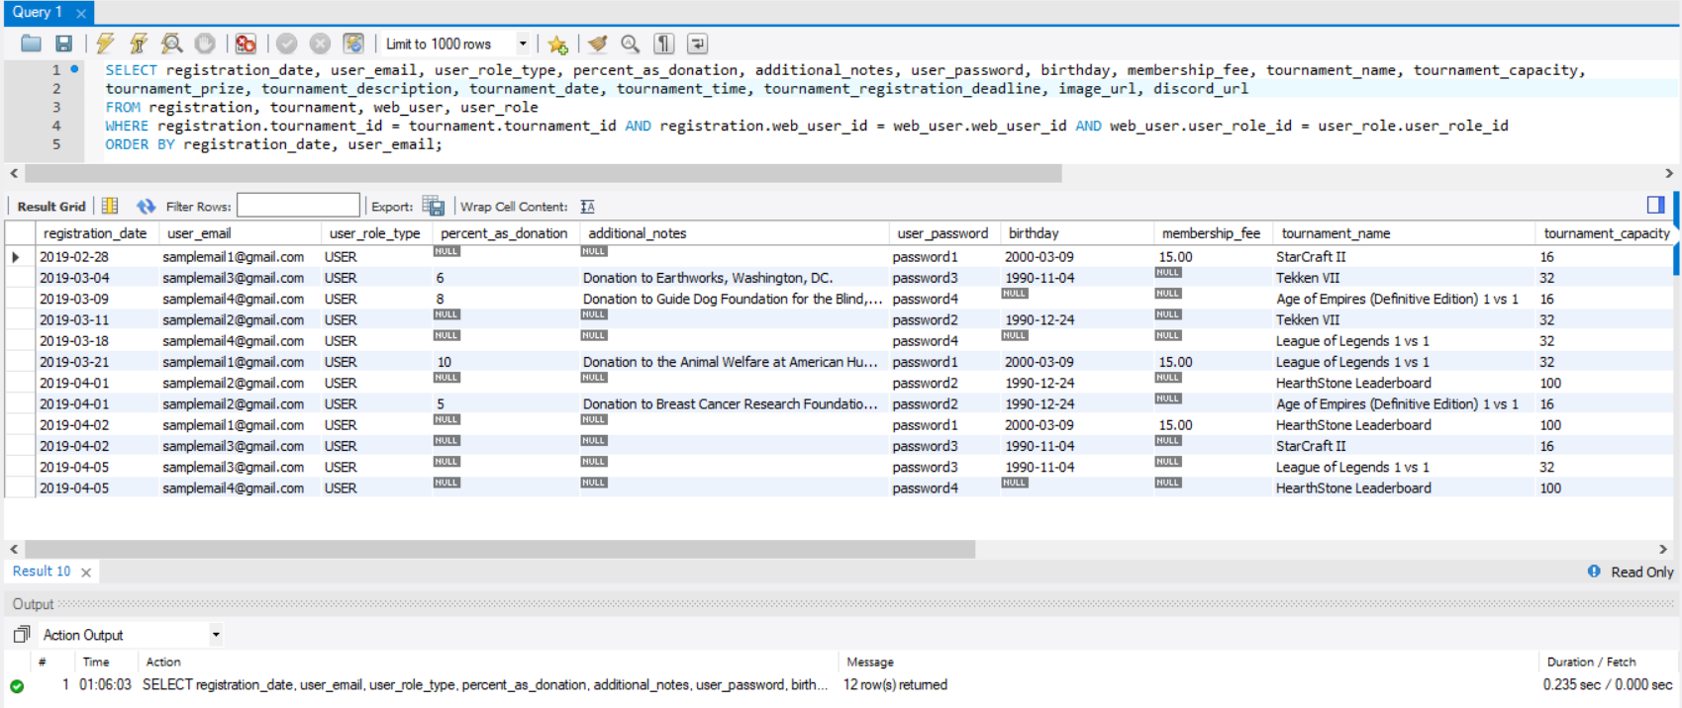

1. Modify your SELECT STATEMENT from item “e”, adding a condition to your WHERE so that you see only the data from one web_user (WHERE clause specifying a particular web_user_id). Select a user such that your result set has at least 2 records in it.

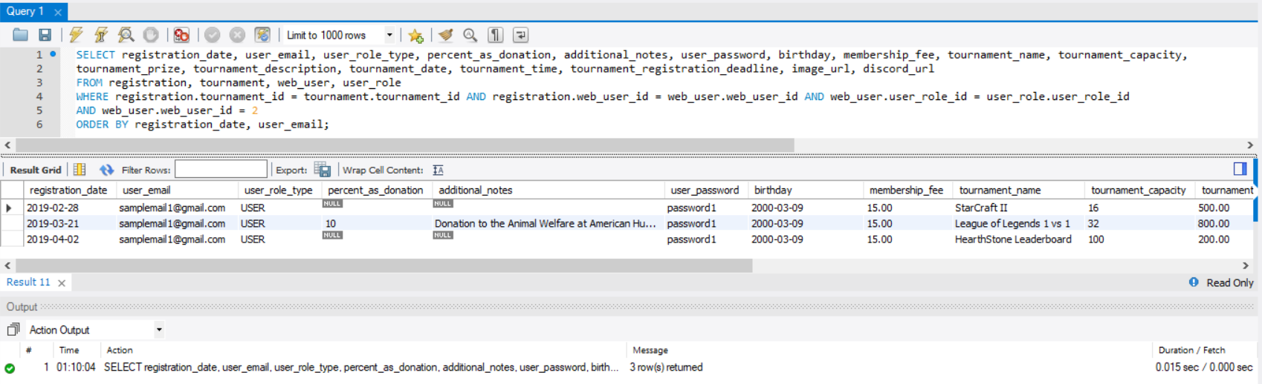

1. Modify your SELECT STATEMENT from item “e”, so that your WHERE clause specifies a criteria from your web_user table, a criteria from your “other” table, and a criteria from your associative table. Somewhere in your SELECT statement, use the LIKE keyword and % wildcard match. Come up with conditions such that your result set has at least 2 records in it. Example of using LIKE:

SELECT * FROM tableA, tableB WHERE tableB.tableA_id = tableA.tableA_id AND tableB.name LIKE '%temple%'

