Supplementary material
Who Gets an ESG Score? Coverage Selection and Firm Value in Five Southeast Asian Markets
This supplementary material accompanies "Who Gets an ESG Score? Coverage Selection and Firm Value in Five Southeast Asian Markets." Table S1 re-estimates the average effects of the first score over event years 0 to 3 after excluding one market at a time. Table S2 and Figure S1 show the number of non-financial firms that received their first LSEG ESG score in each year, by market. Table S3 reports the estimates for each market separately, Table S4 the number of firm-years available for each outcome, Table S5 the relative-magnitude bounds of Eq. (10) in the paper, and Table S6 the number of scored and control firms by event year for ln MTB. Table S7 and Figure S2 report the exploratory analyses added after the second review, and Table S8 decomposes the gap between the static two-way fixed effects estimate and the baseline. The pre-analysis plan is provided with the replication package.

Table S1. Leave-one-market-out estimates of the average effect of the first LSEG ESG score
Sample | ln(MTB) | ln(market cap) | Leverage (ratio) | ln(assets)
Without Indonesia | 0.017 (0.024) | −0.030 (0.030) | 0.011** (0.005) | 0.037* (0.020)
Without Malaysia | −0.003 (0.035) | 0.037 (0.038) | 0.022*** (0.008) | 0.046 (0.029)
Without Philippines | −0.001 (0.025) | −0.066** (0.031) | 0.009* (0.005) | 0.031* (0.019)
Without Singapore | −0.007 (0.025) | −0.066** (0.032) | 0.005 (0.005) | 0.063*** (0.019)
Without Thailand | 0.004 (0.029) | −0.096** (0.037) | 0.004 (0.005) | 0.040* (0.021)
Note(s): Cells show the average effect over event years 0 to 3 without the named market, with bootstrap standard errors in parentheses. *, **, and *** denote significance at 10%, 5%, and 1% (unadjusted p-values).
Source(s): Authors' own work based on LSEG ESG scores and Compustat Global data

Table S2. Number of non-financial firms by year of first LSEG ESG score and market
First score year | Indonesia | Malaysia | Philippines | Singapore | Thailand | Total
2015 | 2 | 0 | 2 | 0 | 4 | 8
2016 | 3 | 2 | 1 | 1 | 2 | 9
2017 | 1 | 4 | 0 | 0 | 2 | 7
2018 | 2 | 3 | 1 | 0 | 2 | 8
2019 | 1 | 2 | 0 | 9 | 18 | 30
2020 | 3 | 5 | 1 | 34 | 47 | 90
2021 | 6 | 96 | 5 | 3 | 31 | 141
2022 | 13 | 193 | 4 | 1 | 26 | 237
2023 | 8 | 83 | 0 | 2 | 16 | 109
2024 | 3 | 16 | 0 | 0 | 17 | 36
Note(s): Firms first scored in 2014 are excluded because they have no pre-coverage year.
Source(s): Authors' own work based on LSEG ESG scores

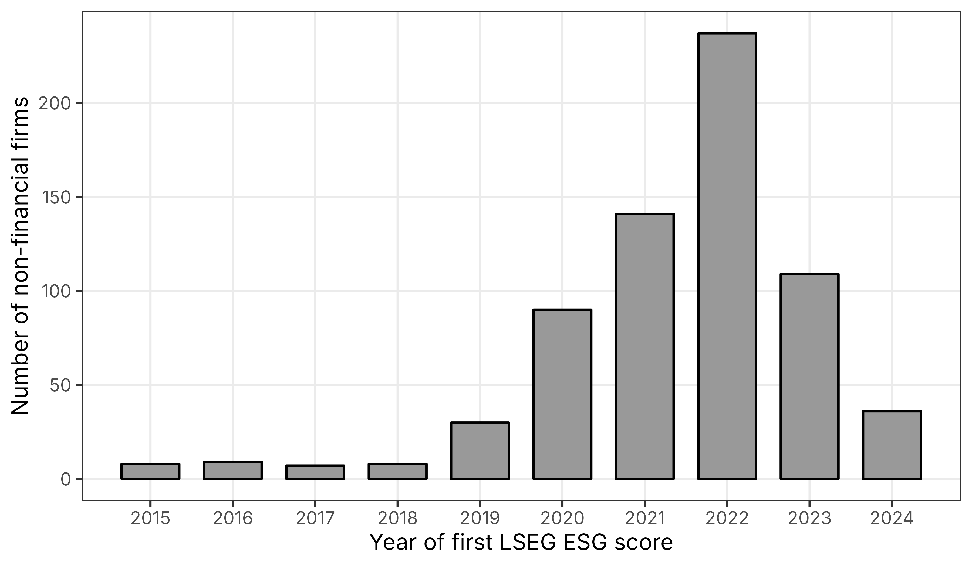
Figure S1. Number of non-financial firms by year of first LSEG ESG score
Note(s): Bars show the number of firms in the estimation sample first scored in each year, all five markets combined.
Source(s): Authors' own work based on LSEG ESG scores

Table S3. Estimates of the average effect of the first LSEG ESG score by market
Market | ln(MTB) | ln(market cap) | Leverage (ratio) | ln(assets) | Scored firms
Indonesia | 0.054 (0.128) | −0.018 (0.109) | 0.023 (0.018) | 0.123* (0.070) | 39
Malaysia | 0.009 (0.033) | −0.114** (0.048) | 0.002 (0.006) | 0.033 (0.024) | 372
Philippines | −0.006 (0.109) | 0.101 (0.128) | 0.041 (0.028) | 0.025 (0.079) | 14
Singapore | −0.037 (0.073) | 0.143* (0.087) | 0.048** (0.020) | 0.013 (0.084) | 46
Thailand | 0.027 (0.047) | 0.059 (0.059) | 0.025* (0.013) | 0.017 (0.040) | 157
Note(s): Cells show the average effect over event years 0 to 3 estimated within each market, with bootstrap standard errors in parentheses. *, **, and *** denote significance at 10%, 5%, and 1% (unadjusted p-values).
Source(s): Authors' own work based on LSEG ESG scores and Compustat Global data

Table S4. Firm-years and firms available for each outcome
Outcome | Scored firm-years | Scored firms | Never-scored firm-years | Never-scored firms | Share missing
ln(MTB) | 6,482 | 674 | 20,706 | 2,552 | 0.248
ln(market cap) | 6,710 | 675 | 22,417 | 2,576 | 0.195
Leverage (ratio) | 6,524 | 672 | 22,333 | 2,547 | 0.202
ln(assets) | 6,916 | 675 | 24,814 | 2,611 | 0.123
Note(s): Counts refer to the estimation sample; the last column is the share of firm-years with a missing outcome.
Source(s): Authors' own work based on LSEG ESG scores and Compustat Global data

Table S5. Relative-magnitude bounds for the average effect of the first LSEG ESG score
Outcome | M̄ | Max pre-period change | Bias bound | Robust 95% interval
ln(MTB) | 0.00 | 0.046 | 0.000 | [−0.046, 0.048]
ln(MTB) | 0.25 | 0.046 | 0.025 | [−0.071, 0.073]
ln(MTB) | 0.50 | 0.046 | 0.050 | [−0.096, 0.098]
ln(MTB) | 1.00 | 0.046 | 0.101 | [−0.147, 0.148]
ln(market cap) | 0.00 | 0.063 | 0.000 | [−0.109, 0.003]
ln(market cap) | 0.25 | 0.063 | 0.035 | [−0.144, 0.038]
ln(market cap) | 0.50 | 0.063 | 0.070 | [−0.179, 0.073]
ln(market cap) | 1.00 | 0.063 | 0.140 | [−0.249, 0.143]
Leverage (ratio) | 0.00 | 0.012 | 0.000 | [−0.001, 0.018]
Leverage (ratio) | 0.25 | 0.012 | 0.007 | [−0.007, 0.025]
Leverage (ratio) | 0.50 | 0.012 | 0.013 | [−0.014, 0.031]
Leverage (ratio) | 1.00 | 0.012 | 0.026 | [−0.027, 0.044]
ln(assets) | 0.00 | 0.035 | 0.000 | [0.007, 0.081]
ln(assets) | 0.25 | 0.035 | 0.020 | [−0.012, 0.101]
ln(assets) | 0.50 | 0.035 | 0.039 | [−0.032, 0.120]
ln(assets) | 1.00 | 0.035 | 0.078 | [−0.071, 0.159]
Note(s): The bias bound is M̄ times the largest change between consecutive pre-coverage estimates times the weighted mean of (e + 1) over event years 0 to 3 (Eq. 10). The robust interval widens the bootstrap 95% interval by this bound.
Source(s): Authors' own work based on LSEG ESG scores and Compustat Global data

Table S6. Scored firms and control firms by event year for ln(MTB)
Event year | Scored firms | Cohorts | Control firms (range)
−5 | 497 | 6 | 1,420–1,732
−4 | 521 | 7 | 1,431–1,800
−3 | 549 | 8 | 1,444–1,899
−2 | 581 | 9 | 1,455–2,065
0 | 615 | 10 | 1,453–2,189
1 | 578 | 9 | 1,442–2,034
2 | 483 | 8 | 1,430–1,895
3 | 270 | 7 | 1,418–1,796
4 | 141 | 6 | 1,407–1,732
Note(s): Scored firms are summed over cohorts; control firms are the smallest and largest number of never-scored firms across cohort cells.
Source(s): Authors' own work based on LSEG ESG scores and Compustat Global data

Table S7. Alternative specifications, inference, and initial-score splits for the average effect of the first LSEG ESG score
Specification | ln(MTB) | Pre-trend p | ln(market cap) | Pre-trend p
Baseline | 0.002 (0.024) | 0.074 | −0.055* (0.030) | 0.022
Baseline, market-by-industry cluster bootstrap | 0.002 (0.027) | 0.225 | −0.055 (0.037) | 0.001
R10, market-by-industry cluster bootstrap | −0.068*** (0.026) | 0.237 | −0.073** (0.031) | 0.002
No covariates | 0.025 (0.022) | 0.028 | 0.016 (0.025) | <0.001
Size measured at g − 3 | −0.008 (0.025) | 0.176 | −0.059* (0.032) | <0.001
Size quintile indicators | −0.010 (0.023) | 0.072 | −0.053* (0.029) | 0.016
Scored firms within control size range | −0.021 (0.026) | 0.212 | −0.096*** (0.035) | 0.133
Dated one year later (R10) | −0.068*** (0.024) | 0.072 | −0.073** (0.030) | 0.002
R10, size at original g − 1 | −0.074*** (0.024) | 0.066 | −0.060** (0.029) | 0.005
Dated two years later | −0.048* (0.025) | 0.023 | −0.022 (0.028) | 0.076
Malaysia, first scored 2021–2022 | 0.021 (0.037) | 0.549 | −0.146*** (0.051) | 0.491
Thailand and Singapore, 2019–2020 | −0.009 (0.048) | 0.006 | 0.041 (0.052) | <0.001
All other cohorts | −0.016 (0.034) | 0.006 | 0.005 (0.037) | 0.652
Cohorts first scored by 2019 | 0.094** (0.047) | 0.003 | 0.185*** (0.052) | <0.001
Cohorts first scored from 2020 | −0.010 (0.026) | 0.199 | −0.087*** (0.033) | 0.106
High residual initial score | −0.012 (0.029) |  | −0.051 (0.035)
Low residual initial score | 0.016 (0.033) |  | −0.059 (0.041)
High minus low | −0.027 (0.040) |  | 0.008 (0.046)
Note(s): Cells show the average effect over event years 0 to 3 with bootstrap standard errors in parentheses and the joint pre-trend p-value of Eq. (8); all rows are exploratory. *, **, and *** denote significance at 10%, 5%, and 1% (unadjusted p-values).
Source(s): Authors' own work based on LSEG ESG scores and Compustat Global data

Table S8. Decomposition of the gap between the static two-way fixed effects estimate and the baseline estimate
Estimator | ln(MTB) | ln(market cap)
Static TWFE, all firm-years (R6) | 0.064** (0.026) | 0.185*** (0.032)
Static TWFE, never-scored controls, event years −5 to 3 | 0.058** (0.025) | 0.149*** (0.030)
Heterogeneity-robust, no covariates (R2) | 0.025 (0.022) | 0.016 (0.025)
Heterogeneity-robust baseline | 0.002 (0.024) | −0.055* (0.030)
Note(s): Rows move step by step from Eq. (11) on all firm-years to the baseline of Eq. (6), with standard errors in parentheses (firm-clustered for TWFE, bootstrap otherwise). *, **, and *** denote significance at 10%, 5%, and 1%.
Source(s): Authors' own work based on LSEG ESG scores and Compustat Global data

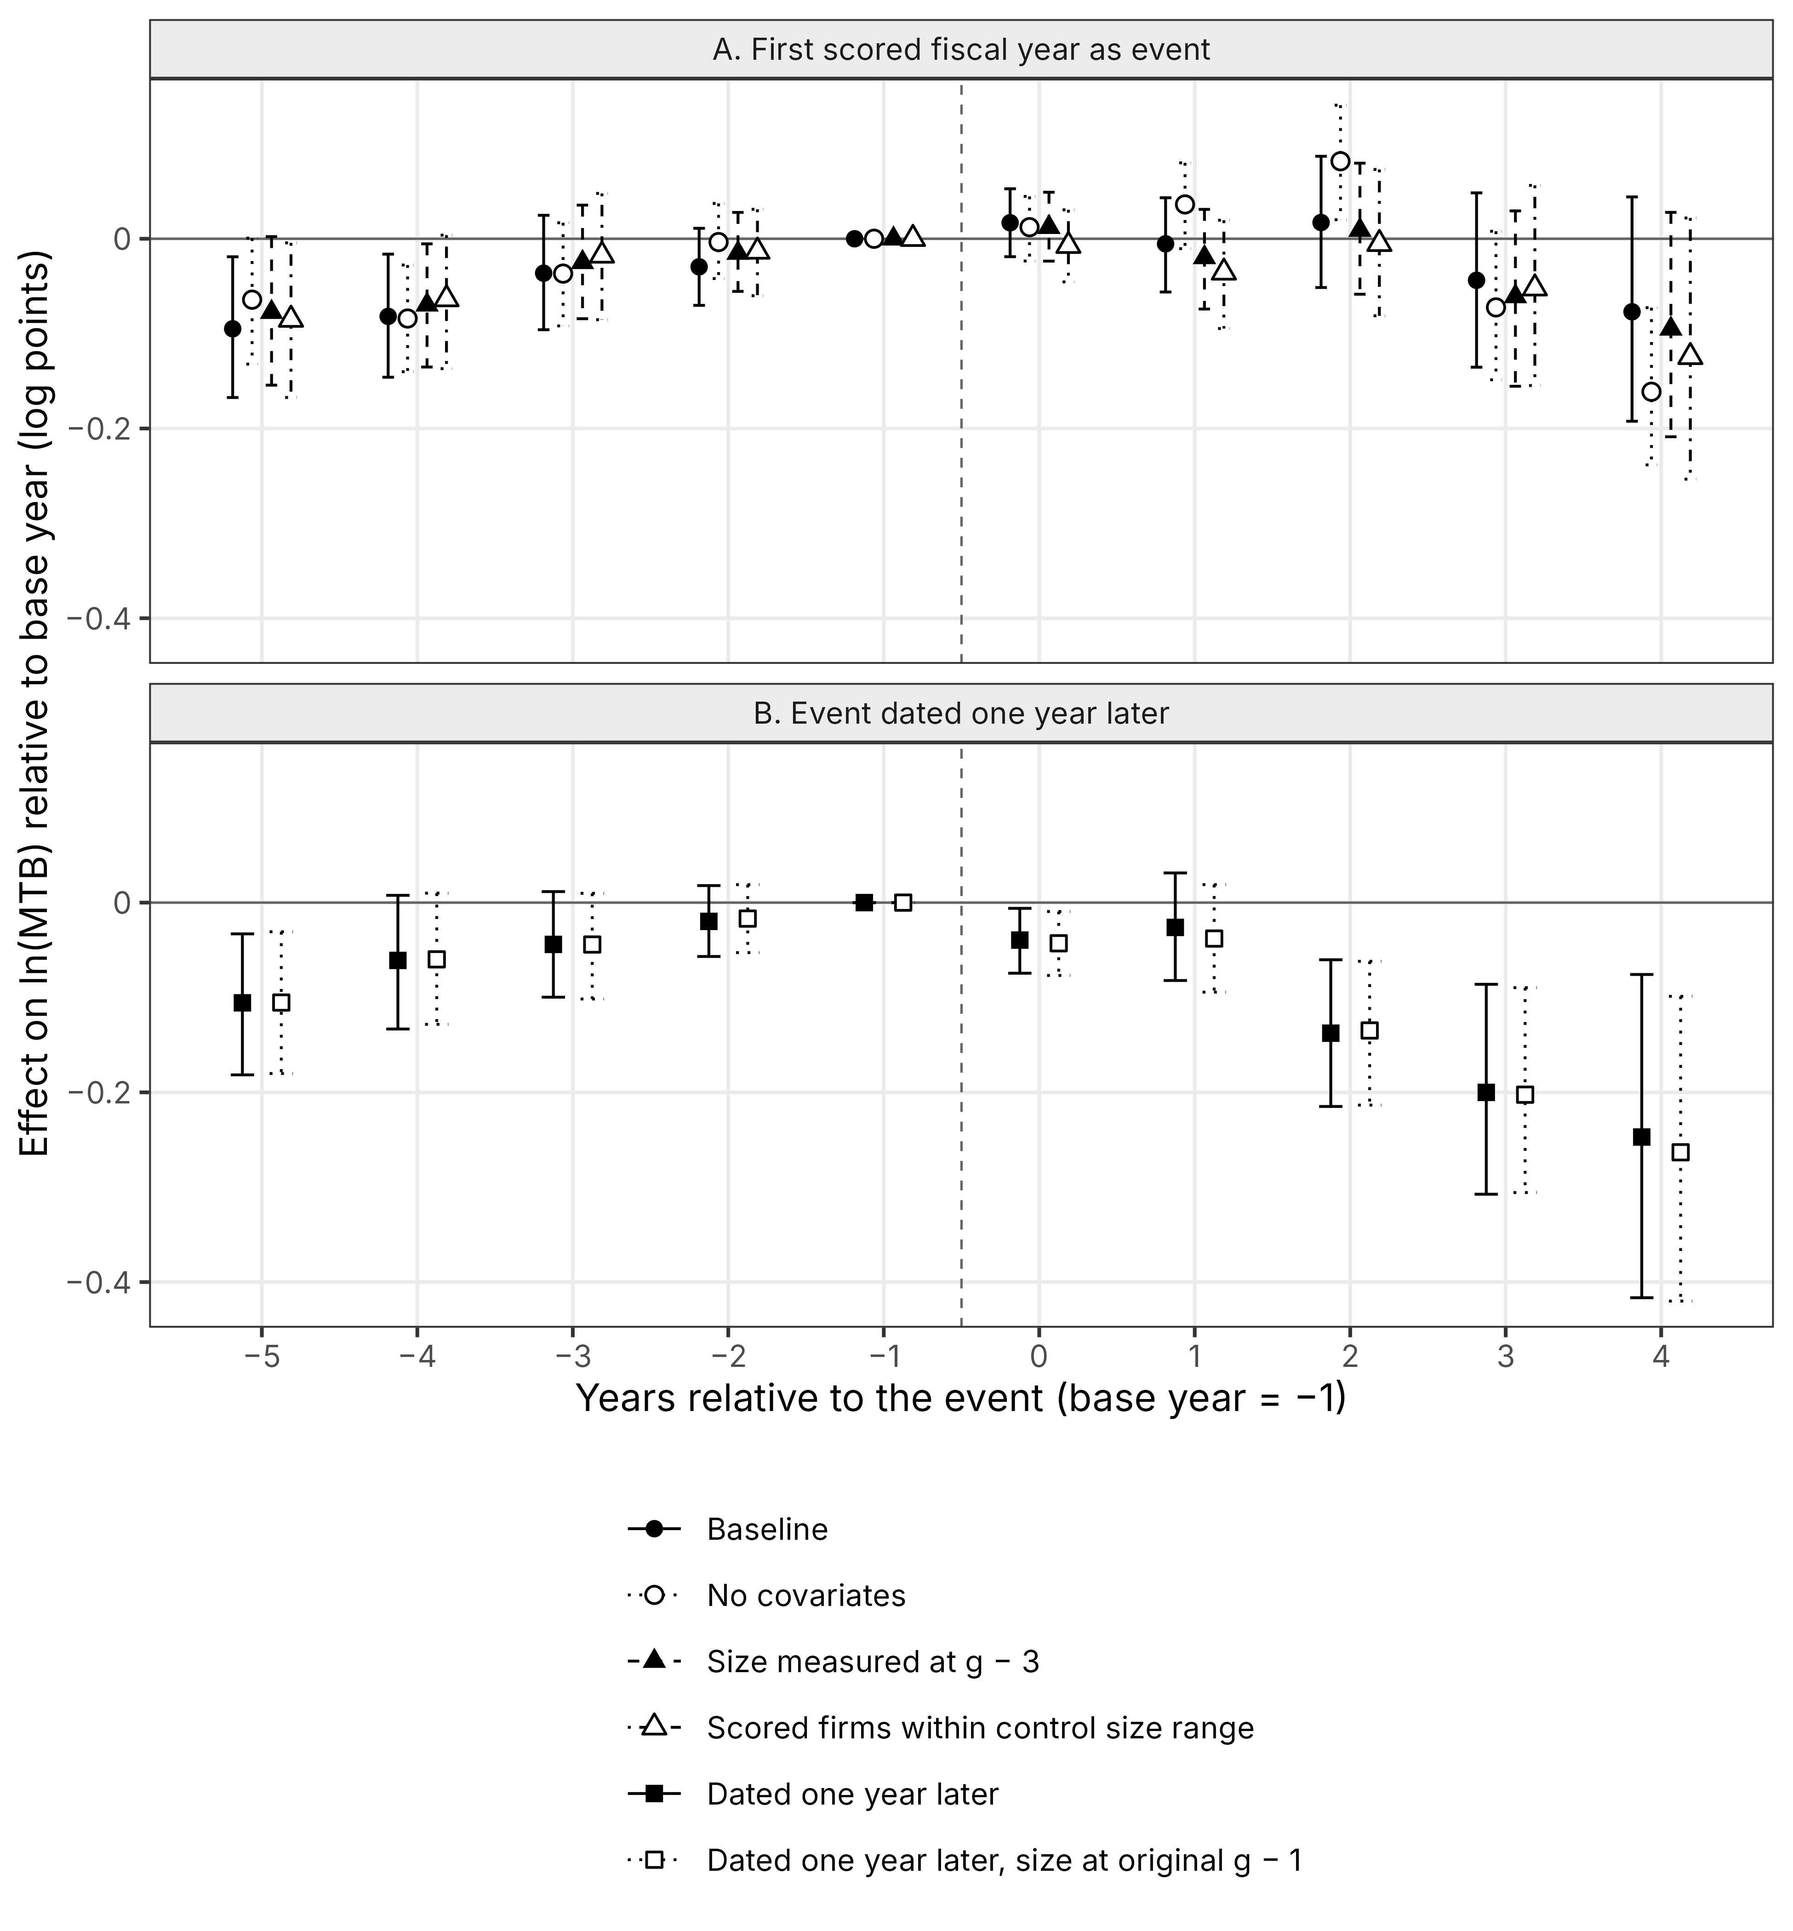
Figure S2. Event-time effects on ln(MTB) under alternative specifications and dating
Note(s): Panel A varies the size covariate and the support with the first scored fiscal year as event; panel B dates the event one year later. Marker shape and line type identify the specification, and bars are bootstrap 95% intervals.
Source(s): Authors' own work based on LSEG ESG scores and Compustat Global data

