Internet Appendix
Rated Firms Gain Value Before, Not After, Their First ESG Score: Evidence from Five Southeast Asian Markets
This Internet Appendix accompanies "Rated Firms Gain Value Before, Not After, Their First ESG Score: Evidence from Five Southeast Asian Markets." Table IA1 re-estimates the average effects of the first ESG score over event years 0 to 3 after excluding one market at a time. Table IA2 and Figure IA1 show the number of non-financial firms that received their first LSEG ESG score in each year, by market.

Table IA1 Leave-one-market-out estimates of the average effect of the first ESG score
Specification | ln(MTB) | ln(market capitalization) | Book leverage | ln(total assets)
Excluding Indonesia | 0.017 (0.024) | −0.030 (0.030) | 0.011** (0.005) | 0.037* (0.020)
Excluding Malaysia | −0.003 (0.035) | 0.037 (0.038) | 0.022*** (0.008) | 0.046 (0.029)
Excluding Philippines | −0.001 (0.025) | −0.066** (0.031) | 0.009* (0.005) | 0.031* (0.019)
Excluding Singapore | −0.007 (0.025) | −0.066** (0.032) | 0.005 (0.005) | 0.063*** (0.019)
Excluding Thailand | 0.004 (0.029) | −0.096** (0.037) | 0.004 (0.005) | 0.040* (0.021)
Each cell reports the average effect over event years 0 to 3 with the bootstrap standard error in parentheses, estimated as in the baseline after dropping all firms from the named market; *, **, and *** denote significance at the 10%, 5%, and 1% levels based on unadjusted p-values.
Source: Authors' calculations from LSEG ESG scores and Compustat Global.

Table IA2 Number of non-financial firms by year of first LSEG ESG score and market
First score year | Indonesia | Malaysia | Philippines | Singapore | Thailand | Total
2015 | 2 | 0 | 2 | 0 | 4 | 8
2016 | 3 | 2 | 1 | 1 | 2 | 9
2017 | 1 | 4 | 0 | 0 | 2 | 7
2018 | 2 | 3 | 1 | 0 | 2 | 8
2019 | 1 | 2 | 0 | 9 | 18 | 30
2020 | 3 | 5 | 1 | 34 | 47 | 90
2021 | 6 | 96 | 5 | 3 | 31 | 141
2022 | 13 | 193 | 4 | 1 | 26 | 237
2023 | 8 | 83 | 0 | 2 | 16 | 109
2024 | 3 | 16 | 0 | 0 | 17 | 36
Counts cover firms in the estimation sample; firms first scored in 2014 are excluded because they have no pre-coverage year.
Source: Authors' calculations from LSEG ESG scores.

Fig. IA1 Number of non-financial firms by year of first LSEG ESG score
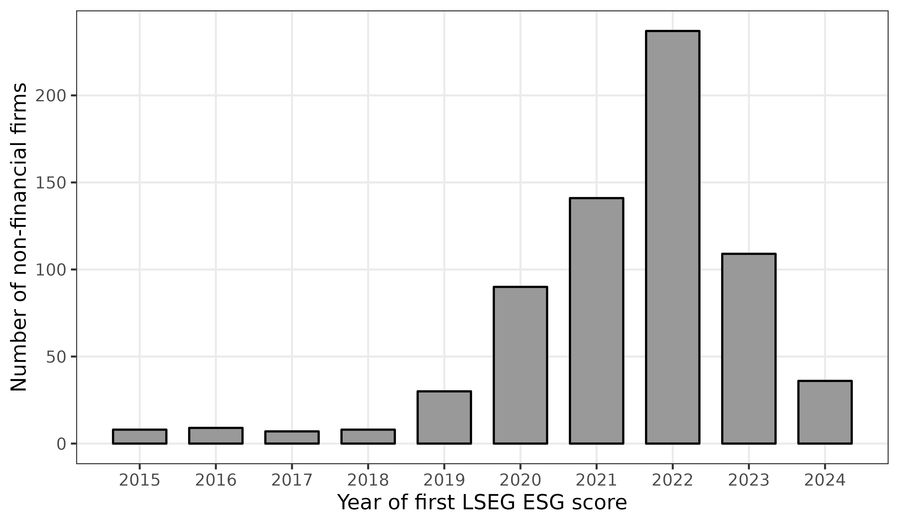
Bars show the number of firms in the estimation sample that received their first LSEG ESG score in each year, all five markets combined.
Source: Authors' calculations from LSEG ESG scores.

