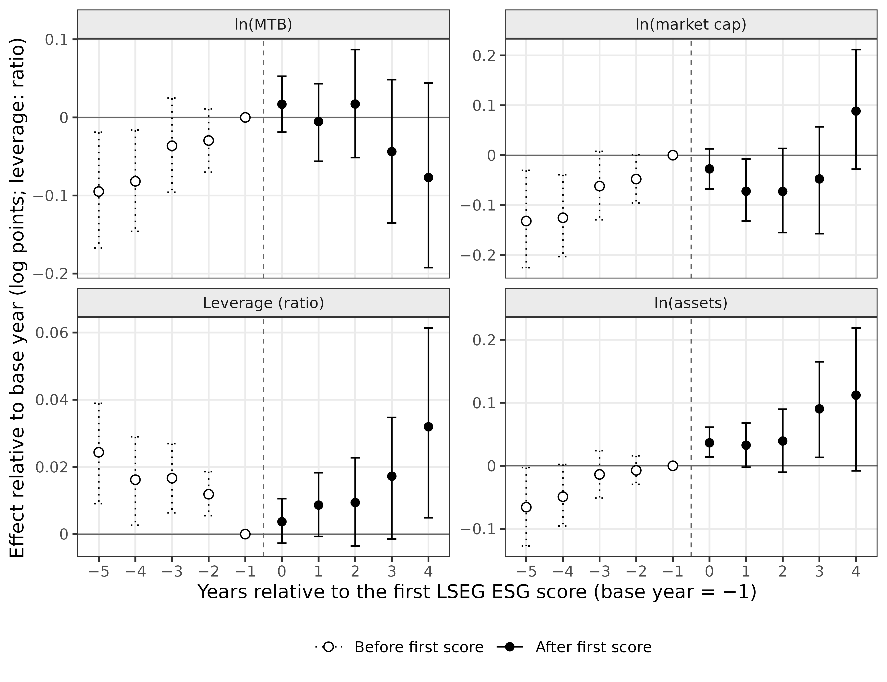
Figure 1. Event-time effects of the first LSEG ESG score on valuation, size, and leverage
Note(s): Markers show the estimates of Eq. (5) relative to event year −1 (set to zero), with bootstrap 95% intervals; open markers and dotted bars are years before the first score. Controls are never-scored firms with the covariates of Eq. (3), and event year 4 is not part of Eq. (6).
Source(s): Authors' own work based on LSEG ESG scores and Compustat Global data

