Supplemental Appendix
Rated at the Peak? Firm Valuation around the First LSEG ESG Score in Five Southeast Asian Markets
This Supplemental Appendix accompanies "Rated at the Peak? Firm Valuation around the First LSEG ESG Score in Five Southeast Asian Markets." Table S1 re-estimates the average effects of the first score over event years 0 to 3 after excluding one market at a time. Table S2 and Fig. S1 show the number of non-financial firms that received their first LSEG ESG score in each year, by market. Table S3 reports the estimates for each market separately, Table S4 the number of firm-years available for each outcome, Table S5 the relative-magnitude bounds of Eq. (10) in the paper, and Table S6 the number of scored and control firms by event year for ln MTB. The pre-analysis plan is provided with the replication package.

Table S1 Leave-one-market-out estimates of the average effect of the first LSEG ESG score
Sample | ln(MTB) | ln(market cap) | Leverage (ratio) | ln(assets)
Without Indonesia | 0.017 (0.024) | −0.030 (0.030) | 0.011** (0.005) | 0.037* (0.020)
Without Malaysia | −0.003 (0.035) | 0.037 (0.038) | 0.022*** (0.008) | 0.046 (0.029)
Without Philippines | −0.001 (0.025) | −0.066** (0.031) | 0.009* (0.005) | 0.031* (0.019)
Without Singapore | −0.007 (0.025) | −0.066** (0.032) | 0.005 (0.005) | 0.063*** (0.019)
Without Thailand | 0.004 (0.029) | −0.096** (0.037) | 0.004 (0.005) | 0.040* (0.021)
Cells show the average effect over event years 0 to 3 without the named market, with bootstrap standard errors in parentheses. *, **, and *** denote significance at 10%, 5%, and 1% (unadjusted p-values).
Source: Authors' calculations from LSEG ESG scores and Compustat Global.

Table S2 Number of non-financial firms by year of first LSEG ESG score and market
First score year | Indonesia | Malaysia | Philippines | Singapore | Thailand | Total
2015 | 2 | 0 | 2 | 0 | 4 | 8
2016 | 3 | 2 | 1 | 1 | 2 | 9
2017 | 1 | 4 | 0 | 0 | 2 | 7
2018 | 2 | 3 | 1 | 0 | 2 | 8
2019 | 1 | 2 | 0 | 9 | 18 | 30
2020 | 3 | 5 | 1 | 34 | 47 | 90
2021 | 6 | 96 | 5 | 3 | 31 | 141
2022 | 13 | 193 | 4 | 1 | 26 | 237
2023 | 8 | 83 | 0 | 2 | 16 | 109
2024 | 3 | 16 | 0 | 0 | 17 | 36
Firms first scored in 2014 are excluded because they have no pre-coverage year.
Source: Authors' calculations from LSEG ESG scores.

Fig. S1 Number of non-financial firms by year of first LSEG ESG score
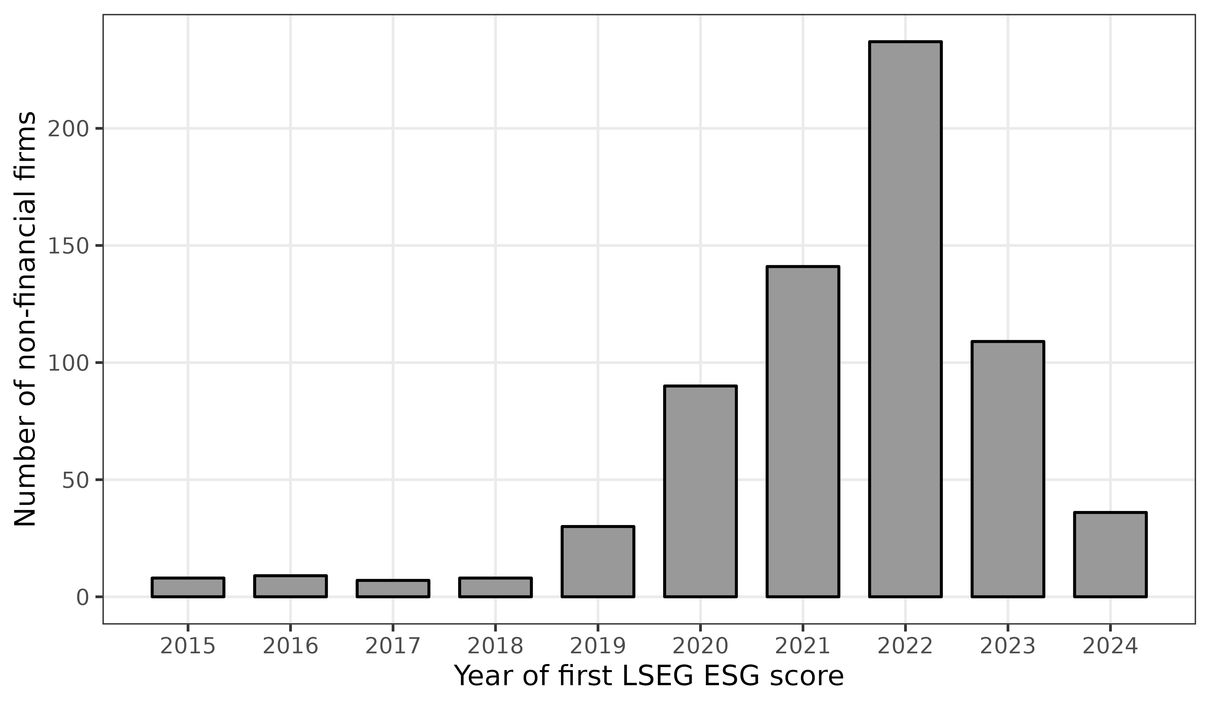
Bars show the number of firms in the estimation sample first scored in each year, all five markets combined.
Source: Authors' calculations from LSEG ESG scores.

Table S3 Estimates of the average effect of the first LSEG ESG score by market
Market | ln(MTB) | ln(market cap) | Leverage (ratio) | ln(assets) | Scored firms
Indonesia | 0.054 (0.128) | −0.018 (0.109) | 0.023 (0.018) | 0.123* (0.070) | 39
Malaysia | 0.009 (0.033) | −0.114** (0.048) | 0.002 (0.006) | 0.033 (0.024) | 372
Philippines | −0.006 (0.109) | 0.101 (0.128) | 0.041 (0.028) | 0.025 (0.079) | 14
Singapore | −0.037 (0.073) | 0.143* (0.087) | 0.048** (0.020) | 0.013 (0.084) | 46
Thailand | 0.027 (0.047) | 0.059 (0.059) | 0.025* (0.013) | 0.017 (0.040) | 157
Cells show the average effect over event years 0 to 3 estimated within each market, with bootstrap standard errors in parentheses. *, **, and *** denote significance at 10%, 5%, and 1% (unadjusted p-values).
Source: Authors' calculations from LSEG ESG scores and Compustat Global.

Table S4 Firm-years and firms available for each outcome
Outcome | Scored firm-years | Scored firms | Never-scored firm-years | Never-scored firms | Share missing
ln(MTB) | 6,482 | 674 | 20,706 | 2,552 | 0.248
ln(market cap) | 6,710 | 675 | 22,417 | 2,576 | 0.195
Leverage (ratio) | 6,524 | 672 | 22,333 | 2,547 | 0.202
ln(assets) | 6,916 | 675 | 24,814 | 2,611 | 0.123
Counts refer to the estimation sample; the last column is the share of firm-years with a missing outcome.
Source: Authors' calculations from LSEG ESG scores and Compustat Global.

Table S5 Relative-magnitude bounds for the average effect of the first LSEG ESG score
Outcome | M̄ | Max pre-period change | Bias bound | Robust 95% interval
ln(MTB) | 0.00 | 0.046 | 0.000 | [−0.046, 0.048]
ln(MTB) | 0.25 | 0.046 | 0.025 | [−0.071, 0.073]
ln(MTB) | 0.50 | 0.046 | 0.050 | [−0.096, 0.098]
ln(MTB) | 1.00 | 0.046 | 0.101 | [−0.147, 0.148]
ln(market cap) | 0.00 | 0.063 | 0.000 | [−0.109, 0.003]
ln(market cap) | 0.25 | 0.063 | 0.035 | [−0.144, 0.038]
ln(market cap) | 0.50 | 0.063 | 0.070 | [−0.179, 0.073]
ln(market cap) | 1.00 | 0.063 | 0.140 | [−0.249, 0.143]
Leverage (ratio) | 0.00 | 0.012 | 0.000 | [−0.001, 0.018]
Leverage (ratio) | 0.25 | 0.012 | 0.007 | [−0.007, 0.025]
Leverage (ratio) | 0.50 | 0.012 | 0.013 | [−0.014, 0.031]
Leverage (ratio) | 1.00 | 0.012 | 0.026 | [−0.027, 0.044]
ln(assets) | 0.00 | 0.035 | 0.000 | [0.007, 0.081]
ln(assets) | 0.25 | 0.035 | 0.020 | [−0.012, 0.101]
ln(assets) | 0.50 | 0.035 | 0.039 | [−0.032, 0.120]
ln(assets) | 1.00 | 0.035 | 0.078 | [−0.071, 0.159]
The bias bound is M̄ times the largest change between consecutive pre-coverage estimates times the weighted mean of (e + 1) over event years 0 to 3 (Eq. 10). The robust interval widens the bootstrap 95% interval by this bound.
Source: Authors' calculations from LSEG ESG scores and Compustat Global.

Table S6 Scored firms and control firms by event year for ln(MTB)
Event year | Scored firms | Cohorts | Control firms (range)
−5 | 497 | 6 | 1,420–1,732
−4 | 521 | 7 | 1,431–1,800
−3 | 549 | 8 | 1,444–1,899
−2 | 581 | 9 | 1,455–2,065
0 | 615 | 10 | 1,453–2,189
1 | 578 | 9 | 1,442–2,034
2 | 483 | 8 | 1,430–1,895
3 | 270 | 7 | 1,418–1,796
4 | 141 | 6 | 1,407–1,732
Scored firms are summed over cohorts; control firms are the smallest and largest number of never-scored firms across cohort cells.
Source: Authors' calculations from LSEG ESG scores and Compustat Global.

