Supplementary material
Who Gets an ESG Score? Coverage Selection and Firm Value in Five Southeast Asian Markets
This supplementary material accompanies "Who Gets an ESG Score? Coverage Selection and Firm Value in Five Southeast Asian Markets." Table S1 re-estimates the average effects of the first recorded score over event years 0 to 3 after excluding one market at a time. Table S2 shows the number of non-financial firms that received their first LSEG ESG score in each year by market, and Figure S1 for all markets combined. Table S3 reports the estimates for each market separately, Table S4 the number of firm-years available for each outcome, Table S5 the relative-magnitude bounds of Eq. (10) in the paper, and Table S6 the number of scored and control firms by event year for ln MTB. Table S7 and Figure S2 report further exploratory specifications, and Table S8 decomposes the gap between the static two-way fixed effects estimate and the baseline. Table S9 reports the weight of each market and coverage wave in the pooled estimate, Table S10 the estimates by wave under both datings, and Table S11 compares firm-years with and without an MTB ratio. Appendix A gives additional results. The pre-analysis plan is provided with the replication package.

Appendix A. Additional robustness results

A.1. Event year 4 (Section 5.2)
Only 141 scored firms from 6 cohorts reach event year 4; therefore, we plot that year in Figure 1 but exclude it from Eq. (6). Its estimates are −0.077 for MTB (p = 0.209) and 0.088 for market capitalization (p = 0.153).

A.2. Further timing variants of R10 (Section 5.4)
Under R10, the decline in log MTB loses significance once M̄ in Eq. (10) reaches 0.23. Holding total assets at the original base year gives −0.074 (p = 0.002), so the covariate timing does not drive R10. Dating coverage two years later gives −0.048 (95% interval −0.099 to 0.000), a smaller decline that is no longer significant at the 5% level.

A.3. Reconciling the R10 and baseline event-time paths (Section 5.4, Figure S2)
The baseline path in Figure 1 does not show the R10 decline because its later event years come from early cohorts, while its first post-coverage years pool all cohorts. Re-based within each cohort to the first recorded year, the baseline point estimates for event years 3 and 4 are −0.083 and −0.167, respectively. These lie closer to the corresponding R10 estimates of −0.138 and −0.200 than the pooled baseline path suggests. We report the re-based values without standard errors, as a reconciliation of the two paths rather than a test. Table 4 of the paper carries out the full step-by-step reconciliation on a common sample.

A.4. Size covariate and support (Section 5.6, Table S7, Figure S2)
Table S7 and Figure S2 vary the size covariate and support; Table 5 of the paper reports the full set of variants. The run-up does not depend on conditioning on base-year total assets. Without covariates, the MTB run-up from event year −5 to the base year is 6.6%, weaker than the baseline (event year −5 p = 0.068; pre-trend p = 0.028), and the market capitalization run-up is 24.0%. With total assets measured two years before the base year, it is 8.0% for MTB (pre-trend p = 0.176) and 20.3% for market capitalization.

A.5. Decomposition of the TWFE gap (Section 5.8, Table S8)
Table S8 shows the decomposition of the gap between the static TWFE estimate in row R6 and the headline MTB estimate. Restricting the regression to never-scored controls and event years −5 to 3 changes the estimate to only 0.058, while the heterogeneity-robust estimator gives 0.025 without covariates and 0.002 with them. Comparing each cohort with its own base year, rather than pooling all years, accounts for approximately half of the gap. Conditioning on base-year total assets accounts for most of the rest, and the choice of controls and window for little.

A.6. Market-by-market and early versus late cohorts (Section 5.8, Table S3)
Estimated market by market in Table S3, the MTB effect is 0.009 in Malaysia, with 372 scored firms, and 0.027 in Thailand, with 157. Indonesia, the Philippines, and Singapore have few scored firms and imprecise estimates. The 58 firms first scored by 2019 show a positive post-coverage MTB estimate of 0.094 (p = 0.047; 95% interval 0.002 to 0.185), and the larger group first scored from 2020 shows −0.010 (p = 0.687). The early estimate rests on few firms, is one of many exploratory comparisons, and is not adjusted for multiple testing, so we do not read it as evidence of a gain for early entrants.

A.7. Breadth of the Malaysian wave (Section 5.2, Figure 2)
The Malaysian wave added 289 firms in two years, yet 565 Malaysian firms remained never-scored, so it was broad but not market-wide.

A.8. Composition of the pooled estimate (Section 5.10, Table S9)
Table S9 counts scored firm-cells, one for each scored firm in each post-coverage cell of the ln(MTB) estimate, by market and by coverage wave. These counts are the weights of Eq. (6).

A.9. Dating by wave (Section 5.4, Table S10)
Table S10 reports, for each wave, the average change with coverage dated at the first recorded score year and one year later, estimated against all never-scored firms.

A.10. Firm-years with and without an MTB ratio (Section 5.7, Table S11)
Table S11 compares scored and never-scored firm-years with and without an MTB ratio in the estimation sample. Book leverage above 0.5 and Indonesian listing are more common among firm-years without an MTB ratio.

A.11. Other robustness checks (Sections 5.5 and 5.8)
Rows R1 to R4 of Table 3 give MTB effects of −0.001 with not-yet-scored firms among the controls, 0.025 without covariates, 0.031 without the 2020 and 2021 cohorts, and 0.016 when control firms below the size range of scored firms are dropped. Under the last restriction the market capitalization effect shrinks to −0.007 and the total assets effect is 0.101, against 0.011 without covariates. Row R7 removes a linear pre-trend with Eq. (9); its MTB effect is negative because a continued run-up would have raised valuations further. Row R8 adds market capitalization growth from g − 3 to the base year to the covariates; because control firms matched on past growth can themselves revert, it does not settle the reversal question. The placebo in row R5 gives 0.134 for log market capitalization (p < 0.001), and the static TWFE regression gives 0.185. Without Malaysia (row R9), the MTB effect is −0.003 (p = 0.940) and the market capitalization effect 0.037.
Table S1. Leave-one-market-out estimates of the average effect of the first LSEG ESG score
Sample | ln(MTB) | ln(market cap) | Leverage (ratio) | ln(assets)
Without Indonesia | 0.017 (0.024) | −0.030 (0.030) | 0.011** (0.005) | 0.037* (0.020)
Without Malaysia | −0.003 (0.035) | 0.037 (0.038) | 0.022*** (0.008) | 0.046 (0.029)
Without Philippines | −0.001 (0.025) | −0.066** (0.031) | 0.009* (0.005) | 0.031* (0.019)
Without Singapore | −0.007 (0.025) | −0.066** (0.032) | 0.005 (0.005) | 0.063*** (0.019)
Without Thailand | 0.004 (0.029) | −0.096** (0.037) | 0.004 (0.005) | 0.040* (0.021)
Note: Cells show the average effect over event years 0 to 3 without the named market, with bootstrap standard errors in parentheses. *, **, and *** denote significance at 10%, 5%, and 1% (unadjusted p-values).
Source: Authors' calculations from LSEG ESG scores and Compustat Global.
Table S2. Number of non-financial firms by year of first LSEG ESG score and market
First score year | Indonesia | Malaysia | Philippines | Singapore | Thailand | Total
2015 | 2 | 0 | 2 | 0 | 4 | 8
2016 | 3 | 2 | 1 | 1 | 2 | 9
2017 | 1 | 4 | 0 | 0 | 2 | 7
2018 | 2 | 3 | 1 | 0 | 2 | 8
2019 | 1 | 2 | 0 | 9 | 18 | 30
2020 | 3 | 5 | 1 | 34 | 47 | 90
2021 | 6 | 96 | 5 | 3 | 31 | 141
2022 | 13 | 193 | 4 | 1 | 26 | 237
2023 | 8 | 83 | 0 | 2 | 16 | 109
2024 | 3 | 16 | 0 | 0 | 17 | 36
Note: Firms first scored in 2014 are excluded because they have no pre-coverage year.
Source: Authors' calculations from LSEG ESG scores.
Figure S1. Number of non-financial firms by year of first LSEG ESG score
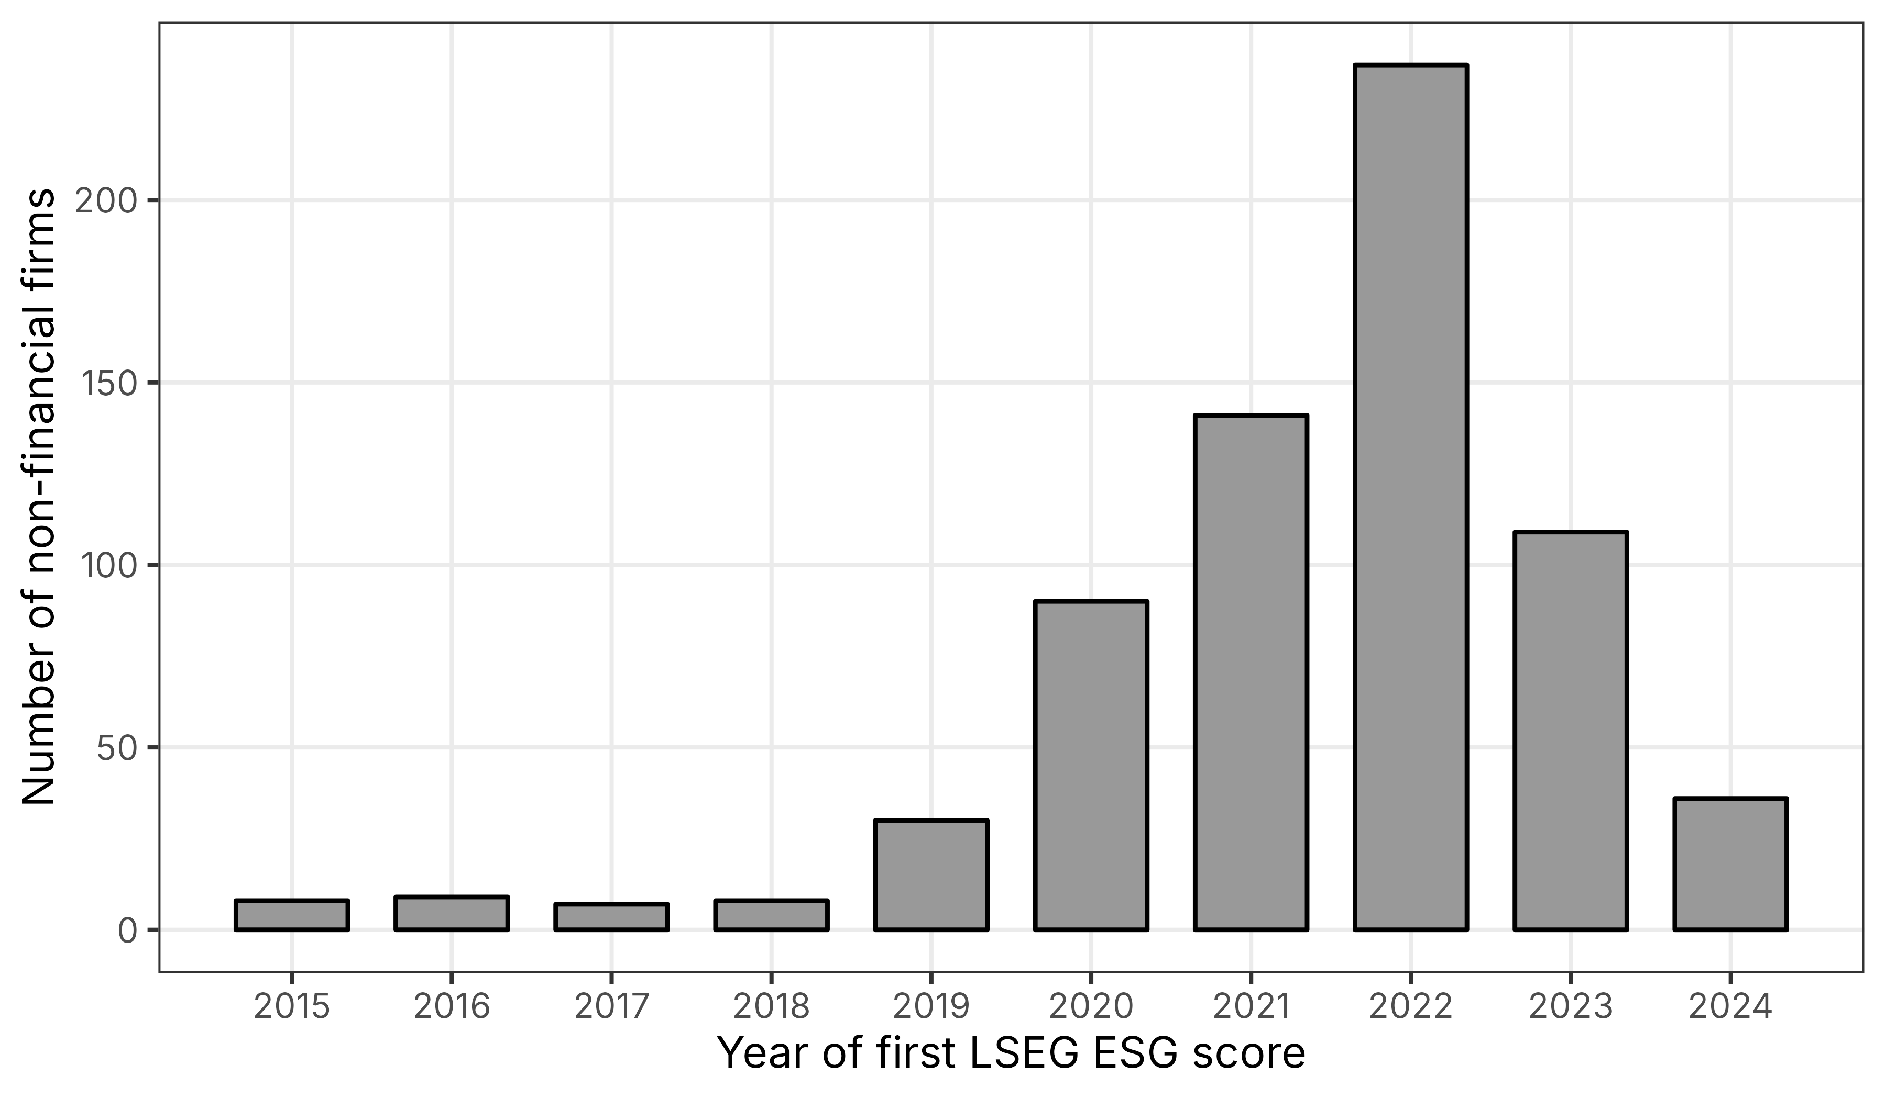
Note: Bars show the number of firms in the estimation sample first scored in each year, all five markets combined.
Source: Authors' calculations from LSEG ESG scores.
Table S3. Estimates of the average effect of the first LSEG ESG score by market
Market | ln(MTB) | ln(market cap) | Leverage (ratio) | ln(assets) | Scored firms
Indonesia | 0.054 (0.128) | −0.018 (0.109) | 0.023 (0.018) | 0.123* (0.070) | 39
Malaysia | 0.009 (0.033) | −0.114** (0.048) | 0.002 (0.006) | 0.033 (0.024) | 372
Philippines | −0.006 (0.109) | 0.101 (0.128) | 0.041 (0.028) | 0.025 (0.079) | 14
Singapore | −0.037 (0.073) | 0.143* (0.087) | 0.048** (0.020) | 0.013 (0.084) | 46
Thailand | 0.027 (0.047) | 0.059 (0.059) | 0.025* (0.013) | 0.017 (0.040) | 157
Note: Cells show the average effect over event years 0 to 3 estimated within each market, with bootstrap standard errors in parentheses. *, **, and *** denote significance at 10%, 5%, and 1% (unadjusted p-values).
Source: Authors' calculations from LSEG ESG scores and Compustat Global.
Table S4. Firm-years and firms available for each outcome
Outcome | Scored firm-years | Scored firms | Never-scored firm-years | Never-scored firms | Share missing
ln(MTB) | 6,482 | 674 | 20,706 | 2,552 | 0.248
ln(market cap) | 6,710 | 675 | 22,417 | 2,576 | 0.195
Leverage (ratio) | 6,524 | 672 | 22,333 | 2,547 | 0.202
ln(assets) | 6,916 | 675 | 24,814 | 2,611 | 0.123
Note: Counts refer to the estimation sample; the last column is the share of firm-years with a missing outcome.
Source: Authors' calculations from LSEG ESG scores and Compustat Global.
Table S5. Relative-magnitude bounds for the average effect of the first LSEG ESG score
Outcome | M̄ | Max pre-period change | Bias bound | Robust 95% interval
ln(MTB) | 0.00 | 0.046 | 0.000 | [−0.046, 0.048]
ln(MTB) | 0.25 | 0.046 | 0.025 | [−0.071, 0.073]
ln(MTB) | 0.50 | 0.046 | 0.050 | [−0.096, 0.098]
ln(MTB) | 1.00 | 0.046 | 0.101 | [−0.147, 0.148]
ln(market cap) | 0.00 | 0.063 | 0.000 | [−0.109, 0.003]
ln(market cap) | 0.25 | 0.063 | 0.035 | [−0.144, 0.038]
ln(market cap) | 0.50 | 0.063 | 0.070 | [−0.179, 0.073]
ln(market cap) | 1.00 | 0.063 | 0.140 | [−0.249, 0.143]
Leverage (ratio) | 0.00 | 0.012 | 0.000 | [−0.001, 0.018]
Leverage (ratio) | 0.25 | 0.012 | 0.007 | [−0.007, 0.025]
Leverage (ratio) | 0.50 | 0.012 | 0.013 | [−0.014, 0.031]
Leverage (ratio) | 1.00 | 0.012 | 0.026 | [−0.027, 0.044]
ln(assets) | 0.00 | 0.035 | 0.000 | [0.007, 0.081]
ln(assets) | 0.25 | 0.035 | 0.020 | [−0.012, 0.101]
ln(assets) | 0.50 | 0.035 | 0.039 | [−0.032, 0.120]
ln(assets) | 1.00 | 0.035 | 0.078 | [−0.071, 0.159]
Note: The bias bound is M̄ times the largest change between consecutive pre-coverage estimates times the weighted mean of (e + 1) over event years 0 to 3 (Eq. 10). The robust interval widens the bootstrap 95% interval by this bound.
Source: Authors' calculations from LSEG ESG scores and Compustat Global.
Table S6. Scored firms and control firms by event year for ln(MTB)
Event year | Scored firms | Cohorts | Control firms (range)
−5 | 497 | 6 | 1,420–1,732
−4 | 521 | 7 | 1,431–1,800
−3 | 549 | 8 | 1,444–1,899
−2 | 581 | 9 | 1,455–2,065
0 | 615 | 10 | 1,453–2,189
1 | 578 | 9 | 1,442–2,034
2 | 483 | 8 | 1,430–1,895
3 | 270 | 7 | 1,418–1,796
4 | 141 | 6 | 1,407–1,732
Note: Scored firms are summed over cohorts; control firms are the smallest and largest number of never-scored firms across cohort cells.
Source: Authors' calculations from LSEG ESG scores and Compustat Global.
Table S7. Alternative specifications, inference, and initial-score splits for the average effect of the first LSEG ESG score
Specification | ln(MTB) | Pre-trend p | ln(market cap) | Pre-trend p
Baseline | 0.002 (0.024) | 0.074 | −0.055* (0.030) | 0.022
Baseline, market-by-industry cluster bootstrap | 0.002 (0.027) | 0.225 | −0.055 (0.037) | 0.001
R10, market-by-industry cluster bootstrap | −0.068*** (0.026) | 0.237 | −0.073** (0.031) | 0.002
No covariates | 0.025 (0.022) | 0.028 | 0.016 (0.025) | <0.001
Size measured at g − 3 | −0.008 (0.025) | 0.176 | −0.059* (0.032) | <0.001
Size quintile indicators | −0.010 (0.023) | 0.072 | −0.053* (0.029) | 0.016
Scored firms within control size range | −0.021 (0.026) | 0.212 | −0.096*** (0.035) | 0.133
Dated one year later (R10) | −0.068*** (0.024) | 0.072 | −0.073** (0.030) | 0.002
R10, size at original g − 1 | −0.074*** (0.024) | 0.066 | −0.060** (0.029) | 0.005
Dated two years later | −0.048* (0.025) | 0.023 | −0.022 (0.028) | 0.076
Malaysia, first scored 2021–2022 | 0.021 (0.037) | 0.549 | −0.146*** (0.051) | 0.491
Thailand and Singapore, 2019–2020 | −0.009 (0.048) | 0.006 | 0.041 (0.052) | <0.001
All other cohorts | −0.016 (0.034) | 0.006 | 0.005 (0.037) | 0.652
Cohorts first scored by 2019 | 0.094** (0.047) | 0.003 | 0.185*** (0.052) | <0.001
Cohorts first scored from 2020 | −0.010 (0.026) | 0.199 | −0.087*** (0.033) | 0.106
High residual initial score | −0.012 (0.029) |  | −0.051 (0.035)
Low residual initial score | 0.016 (0.033) |  | −0.059 (0.041)
High minus low | −0.027 (0.040) |  | 0.008 (0.046)
Note: Cells show the average effect over event years 0 to 3 with bootstrap standard errors in parentheses and the joint pre-trend p-value of Eq. (8); all rows are exploratory. *, **, and *** denote significance at 10%, 5%, and 1% (unadjusted p-values).
Source: Authors' calculations from LSEG ESG scores and Compustat Global.
Table S8. Decomposition of the gap between the static two-way fixed effects estimate and the baseline estimate
Estimator | ln(MTB) | ln(market cap)
Static TWFE, all firm-years (R6) | 0.064** (0.026) | 0.185*** (0.032)
Static TWFE, never-scored controls, event years −5 to 3 | 0.058** (0.025) | 0.149*** (0.030)
Heterogeneity-robust, no covariates (R2) | 0.025 (0.022) | 0.016 (0.025)
Heterogeneity-robust baseline | 0.002 (0.024) | −0.055* (0.030)
Note: Rows move step by step from Eq. (11) on all firm-years to the baseline of Eq. (6), with standard errors in parentheses (firm-clustered for TWFE, bootstrap otherwise). *, **, and *** denote significance at 10%, 5%, and 1%.
Source: Authors' calculations from LSEG ESG scores and Compustat Global.
Figure S2. Event-time effects on ln(MTB) under alternative specifications and dating
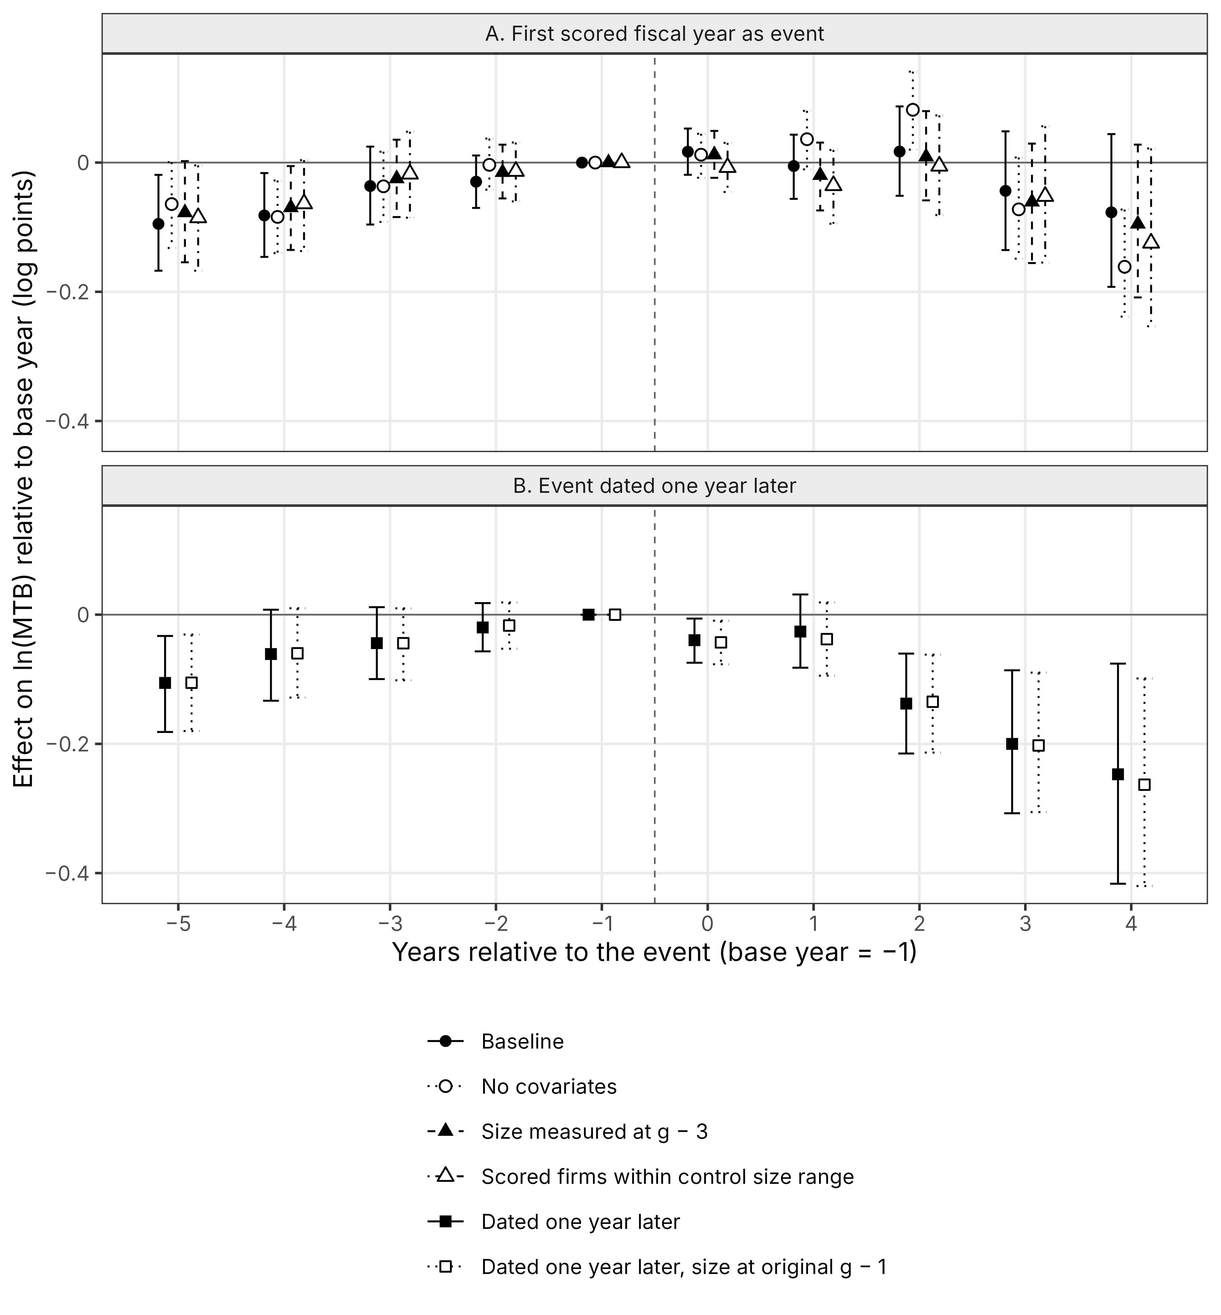
Note: Panel A varies the size covariate and the support with the first recorded fiscal year as event; panel B dates the event one year later. Marker shape and line type identify the specification, and bars are bootstrap 95% intervals.
Source: Authors' calculations from LSEG ESG scores and Compustat Global.
Table S9. Weight of each market and coverage wave in the pooled ln(MTB) estimate
Group | Scored firm-cells | Weight in the pooled estimate
Indonesia | 123 | 0.063
Malaysia | 1,074 | 0.552
Philippines | 52 | 0.027
Singapore | 178 | 0.091
Thailand | 519 | 0.267
Malaysian wave (first recorded 2021–2022) | 858 | 0.441
Thai and Singaporean wave (2019–2020) | 401 | 0.206
All other cohorts | 687 | 0.353
Calendar year 2015 | 8 | 0.004
Calendar year 2016 | 16 | 0.008
Calendar year 2017 | 22 | 0.011
Calendar year 2018 | 28 | 0.014
Calendar year 2019 | 49 | 0.025
Calendar year 2020 | 126 | 0.065
Calendar year 2021 | 243 | 0.125
Calendar year 2022 | 454 | 0.233
Calendar year 2023 | 523 | 0.269
Calendar year 2024 | 477 | 0.245
Note: Scored firm-cells count each scored firm once in every post-coverage cell (event years 0 to 3) of the baseline ln(MTB) estimate; weights are their shares (Eq. 6).
Source: Authors' calculations from LSEG ESG scores and Compustat Global.
Table S10. Average change by coverage wave under the two datings
Wave | First recorded year, ln(MTB) | One year later, ln(MTB) | First recorded year, ln(market cap) | One year later, ln(market cap)
Malaysian wave (first recorded 2021–2022) | 0.021 (0.037) | 0.012 (0.033) | −0.146*** (0.051) | −0.094* (0.052)
Thai and Singaporean wave (2019–2020) | −0.009 (0.048) | −0.136*** (0.046) | 0.041 (0.052) | −0.038 (0.053)
All other cohorts | −0.016 (0.034) | −0.111*** (0.037) | 0.005 (0.037) | −0.076* (0.040)
Note: Cells show the average effect over event years 0 to 3 of each dating, with bootstrap standard errors in parentheses, for each wave against all never-scored firms. *, **, and *** denote significance at 10%, 5%, and 1%.
Source: Authors' calculations from LSEG ESG scores and Compustat Global.
Table S11. Firm-years with and without a market-to-book ratio
Characteristic | Scored, MTB observed | Scored, MTB missing | Never-scored, MTB observed | Never-scored, MTB missing
Firm-years | 6,482 | 943 | 20,706 | 8,037
Median total assets (USD million) | 267.9 | 76.4 | 84.1 | 20.8
Median market capitalization (USD million) | 185.8 | 63.5 | 44.6 | 19.0
Mean book leverage | 0.236 | 0.307 | 0.222 | 0.339
Share with leverage above 0.5 | 0.08 | 0.15 | 0.08 | 0.25
Share Indonesian | 0.06 | 0.08 | 0.24 | 0.39
Share Malaysian | 0.59 | 0.64 | 0.21 | 0.22
Mean calendar year | 2019.3 | 2017.2 | 2019.5 | 2017.8
Share with market capitalization | 1.00 | 0.25 | 1.00 | 0.21
Note: Estimation sample, all firm-years from 2014 to 2024; amounts in U.S. dollars after winsorization at the 1st and 99th percentiles.
Source: Authors' calculations from LSEG ESG scores and Compustat Global.

