|  |  |
| --- | --- |
| FOREIGN TRADE UNIVERSITY  HCMC CAMPUS  **PROFESSIONAL OPERATION FACULTY**  **_________________________**  **PAPER NO. 1** | **FINAL EXAM QUESTIONS**  **PORTFOLIO MANAGEMENT**  **__________________________________**  **Semester: 1 Academic year: 2019 – 2020**  **Full-time/Part-time: Full time**  **Class code: 04**  **Form of Exam: Writen and Multiple choice**  **Duration: 90 minutes** *(excluding paper distribution time)* |

**SECTION A. MULTIPLE CHOICE (4 points)**

***There are 20 questions in this exam. Please choose ONE answer for each question. Each question is worth 0.2 points.***

**SECTION B. EXERCISES (6 points)**

**Question 1. Individual Investors (3 points)**

Paul and Marta Mattison are married, both 45 years old, and own their home with no debt. The couple earns a combined after-tax salary of EUR 250,000 per year. After paying for living expenses, they save EUR 100,000 per year, which is added to their joint investment account in equal monthly installments. The account’s current balance is EUR 350,000. Upon retirement, Paul will be entitled to a government-funded, after-tax pension of EUR 40,000 per year, which will be indexed to inflation.

The Mattisons meet with their financial advisor, Olivia Greer. They remind Greer that because their portfolio suffered significant losses during a previous recession, they prefer that it be allocated primarily to conservative investments. The couple expects no changes in salary, savings, or recurring living expenses for the next five years.

The Mattisons outline their financial goals over the next 15 years, at which point they both plan to retire.

Five years from now:

Purchase a second home worth approximately EUR 1,100,000 to be used for holidays. They expect to borrow 60% of the purchase price using a mortgage.

Ten years after the purchase of their second home:

Sell their first home, adding the sale proceeds to their investment account to help fund their retirement needs. Move into the second home.

Greer determines the Mattisons’ risk tolerance to be average.

1. **Identify** *two* factors that:
2. decreases the Mattisons’ ability to take risk. (0.5 points)
3. increases the Mattisons’ ability to take risk. (0.5 points)

Five years later, the Mattisons purchase their second home for EUR 1,100,000 using a combination of cash from their investment account and a mortgage. Following the purchase, their joint investment account is valued at EUR 700,000. Their income is unchanged and sufficient to cover the monthly mortgage payments, but they can now contribute only EUR 72,000 each year to their joint investment account, in equal monthly installments.

The Mattisons plan to work another 10 years until they retire, at which point they will move into their second home. Greer revisits her prior assessment of the Mattisons’ risk tolerance.

B. **Identify** *two* factors that:

1. decreases the Mattisons’ ability to take risk compared to five years ago. (0.5 points)
2. increases the Mattisons’ ability to take risk compared to five years ago. (0.5 points)

Greer estimates that, including the sale proceeds from their first home, the Mattisons will need EUR 3,000,000 upon retirement in 10 years to adequately supplement Paul’s pension and preserve their current lifestyle. The first home’s value is EUR 290,000, still with no debt, and is expected to appreciate by 3% per year. There are no capital gains taxes on home sales. Assume all cash flows occur at month-end.

1. **Calculate** the minimum annual after-tax return required for the Mattisons to be able toretire in 10 years, assuming Greer’s assumptions are correct. (1 point)

**Question 2. Portfolio Evaluation (1.5 points)**

Exhibit 1 presents the performance results for Vermillion Asset Management. This manager invests in a small number of sector within a broad equity universe. Vermillion’s investment objective is to outperform a custom benchmark determined by the firm investment committee

**Exhibit 1**

**Vermillion Asset Management Performance Results**

|  |  |  |  |  |
| --- | --- | --- | --- | --- |
| **Industry Sector** | **Weight (%)** | | **Return (%)** | |
| **Portfolio** | **Custom Benchmark** | **Portfolio** | **Custom Benchmark** |
| Consumer durables | 26.30 | 21.90 | 4.55 | 4.90 |
| Consumer nondurables | 31.00 | 34.80 | 3.60 | 3.10 |
| Financial | 21.20 | 20.90 | 3.90 | 3.30 |
| Technology | 21.50 | 22.40 | 1.30 | -0.20 |

1. Calculate the overall returns over the past year for both the Vermillion Asset Management equity portfolio and the benchmark portfolio, and state whether Vermillion has outperformed or underperformed the benchmark. (0.6 points)
2. Calculate both the pure sector allocation effect and the within-sector selection effect of Vermillion’s performance relative to the benchmark. (0.6 points)
3. Based on your answers to Parts A and B, **evaluate** Vermillion’s performance relative to the benchmark. (0.3 points)

**Question 3. Asset Allocation (1.5 points)**

Thurlow Corporation is a U.S.-based manufacturer of skis and snowboards that began operations in 1995. In order to attract skilled labor, Thurlow offers employees attractive benefits, which include a defined benefit pension plan, and annual wage increases above the rate of inflation. Tino Beveridge is a consultant to the board of trustees of Thurlow’s pension plan. The board asks Beveridge to recommend a strategic asset allocation for the pension plan given the following investment policy objectives:

* Return requirement: Earn an average annual return of 8.7 percent plus management and administration fees of 0.7 percent.
* Risk objective: A maximum standard deviation of portfolio returns of 10.0 percent.

**Exhibit 2**

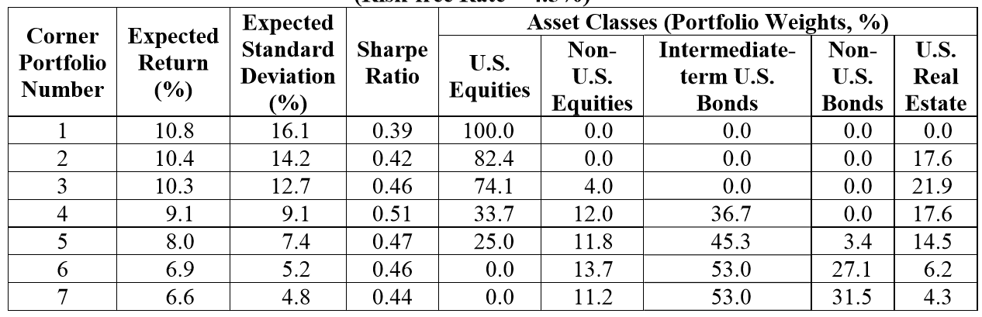

The risk free rate is 4.5%.

For the strategic asset allocation analysis, Beveridge has generated the corner portfolios shown in Exhibit 2. The Thurlow pension plan investment policy statement (IPS) prohibits short positions and the use of leverage. The IPS allows investment in any single portfolio or combination of portfolios described in Exhibit 2.

1. Select the most appropriate portfolio or combination of portfolios for the strategic asset allocation of the Thurlow pension plan. Justify your response with one reason other than meeting Thurlow’s return requirement. (0.5 points)
2. Determine the weight of total equities (U.S. and non-U.S. combined) in the most appropriate strategic asset allocation. (1 point)

**--------------------------------------***End of test***--------------------------------------**

***Note:*** *- This paper contains (number) 20 questions from Section A, 03 questions from Section B, 8 pages.*

*- Students are* ***not allowed*** *to use materials during the examination.*

*- Invigilators shall not provide further explanation.*

|  |  |
| --- | --- |
| **APPROVAL**  **COURSE DIRECTOR**  **(or DEAN/VICE DEAN OF THE FACULTY)**  (signature, full name) | **LECTURER**  Nguyen Thi Hoang Anh |