Related issue: <http://answers.axonivy.com/questions/2606/can-not-persist-business-data-to-repo-after-changing-data-type>

The problem is we can’t persist new data after changing the data structure

Example: We have Class Dossier, in this class we have a property named “person” with data type is Person:

**public** **class** Dossier {

**private** Person person;

}

**public** **class** Person {

**private** String firstName;

**private** String lastName;

**private** String userName;

**private** String personData;

**private** Date postDate;

**private** String message;

}

We are using ivy’s business data to store dossiers. And now we change Person’s structure to adapt the new changes (Person is replaced to NewPerson).

**public** **class** NewPerson {

**private** PersonData personData;

**private** Date postDate;

**private** String message;

}

**public** **class** PersonData {

**private** String userName;

**private** String firstName;

**private** String lastName;

}

Now whenever we try to persist a new Dossier, we will face an error. “Elasticsearch update index of document failed”

Because ElasticSearch store the obsolete Person structure, so when we change data structure, ElasticSearch can’t reindex to adapt the new structure.

Solution: We create a migrater service (perhaps belongs to the same module or independent module). In this service, it does 3 tasks:

* Load all the obsolete data from business data and convert it to new structure
* After loading all data successful, we clean database and force ElasticSearch to reindex
* Persist data.

When we change data structure, we need run the migrater to migrate existing data to new structure as well as force ElasticSearch to reindex. After that we are able to retrieve the old data and persist new data normally.

Sample Project

**MigrateElasticSearch**

* Run the project and try to save several dossiers firstly.
* 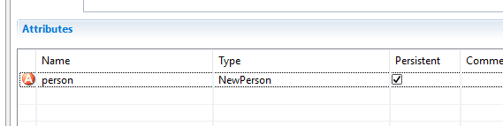Secondly, we change Dossier from using Person to NewPerson
* And don’t forget to change DossierService.java to using ***NewPerson.createInstance()*** instead of ***Person.createInstance()***
* Try to insert new Dossier, we will get a problem and can’t save anymore
* Now we run the module **PersonMigrater** to migrate the data, so after the migration, we can continue saving new data (also migrate the old structure to new structure)