

Website Hotel Recommender

SOFTWARE DESIGN SPECIFICATION

**Project Code: SE0765**

**Document Code: SE0765 – v1.0**

**<Ho Chi Minh, 17 October, 2013 >**

Record of change

*A - Added M - Modified D – Deleted

|  |  |  |  |  |
| --- | --- | --- | --- | --- |
| Effective Date | Changed Items | A* M, D | Change Description | New Version |
| 1 October 2013 | Initial version | A | 1st edition of system | 1.0 |
| 04 October 2013 | User case Diagram | A | Create Class Diagram | 1.0 |
| 10 October 2013 | Database Diagram | A | Create Class Diagram | 1.0 |
| 05 October 2013 | Modified User case Diagram | M | Modified Class Diagram | 1.1 |
|  |  |  |  |  |
|  |  |  |  |  |
|  |  |  |  |  |
|  |  |  |  |  |
|  |  |  |  |  |
|  |  |  |  |  |
|  |  |  |  |  |
|  |  |  |  |  |

SIGNATURE PAGE

**ORIGINATOR:** Phạm Thị Thu Hòa Date: 03 April, 2013

Đinh Quang Trung

Huỳnh Quang Thảo

Lê Tài Nhật Minh

**REVIEWERS:** Lâm Hữu Khánh Phương Date: 05 April, 2013

**APPROVAL:** Date: 05 April, 2013

TABLE OF CONTENTS

1 User Case Diagram 5

2 SYSTEM ARCHITECTURE 8

2 Database diagram 8

# user case diagram

**Website Hotel Recommender** design document contains descriptions of all user case of the system including:

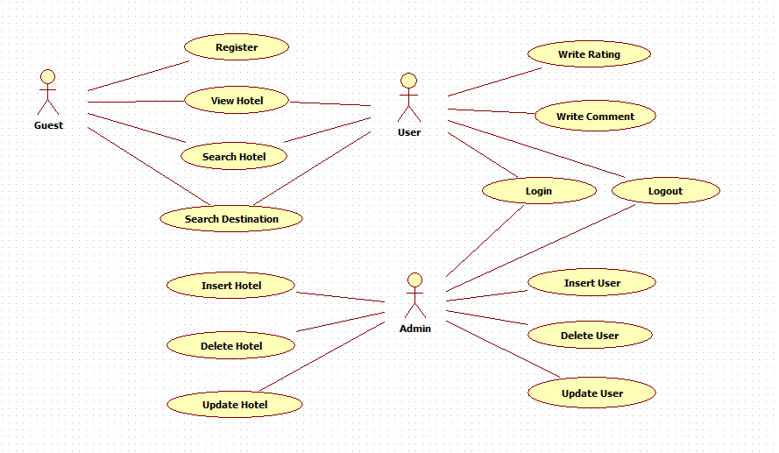

# SYSTEM Architecture

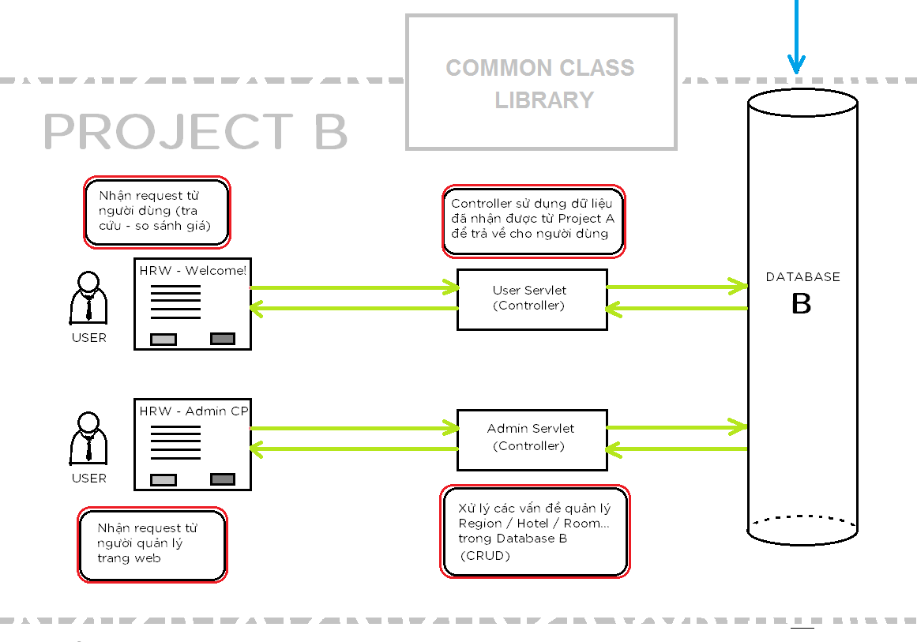The Model View Controller (MVC) is an architectural pattern used in software engineering. The pattern isolates "domain logic" (the application logic for the user) from input and presentation (GUI), permitting independent developments, testing and maintenance of each.

# DATABASE DIAGRAM

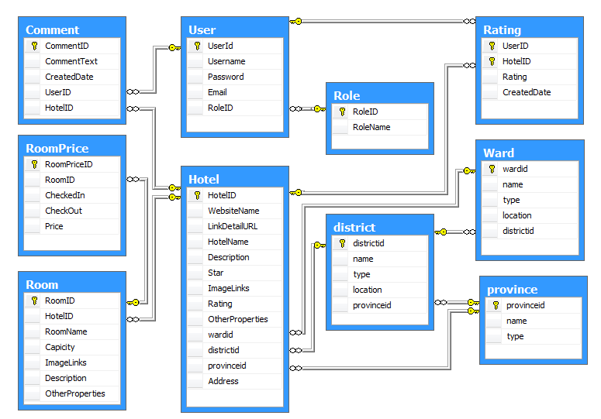

// no liet ke het chuc nang o day !!!

Add hotel

Delete hotel

Search

….

😐

dd