Creat new ADO

Create models

Add connection

**1. Login Form**

1.1 Access classes



1.2 MyLogin’s functions

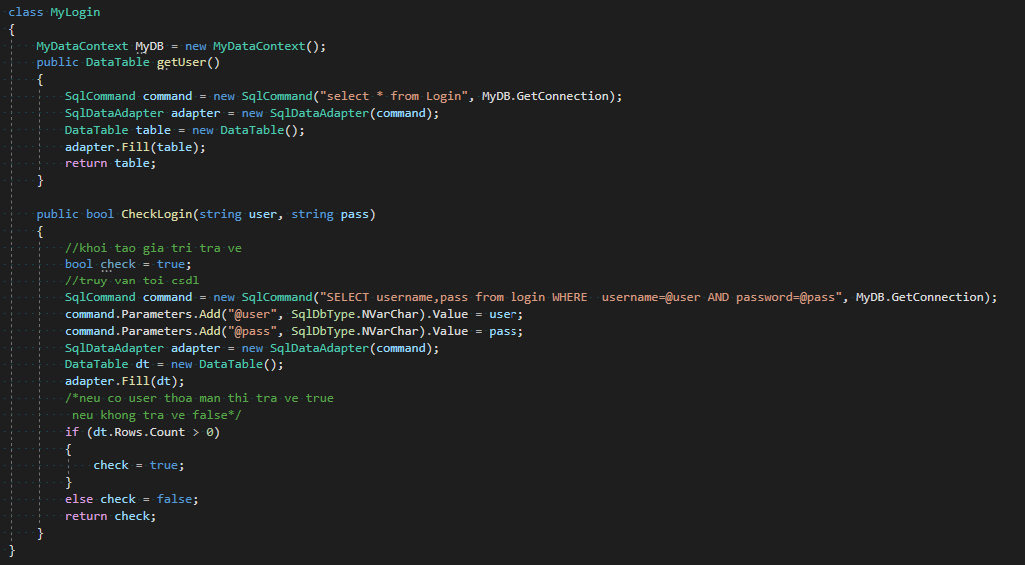

1.3 Form Login <demo>

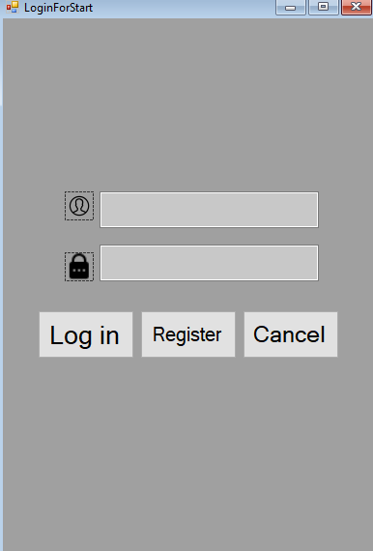

1.4 Log in button click

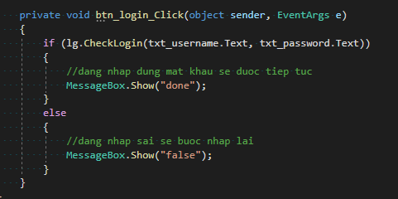

**2. Students**

2.1. Functions

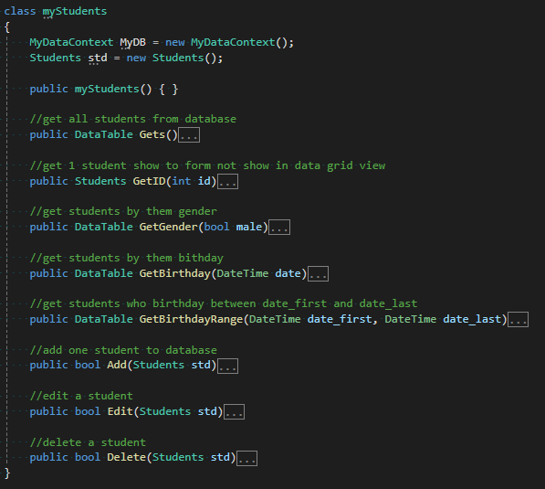

2.1.1. Gets()

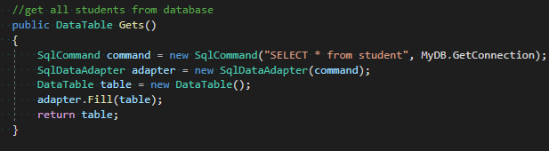

2.1.2. GetID(int id)

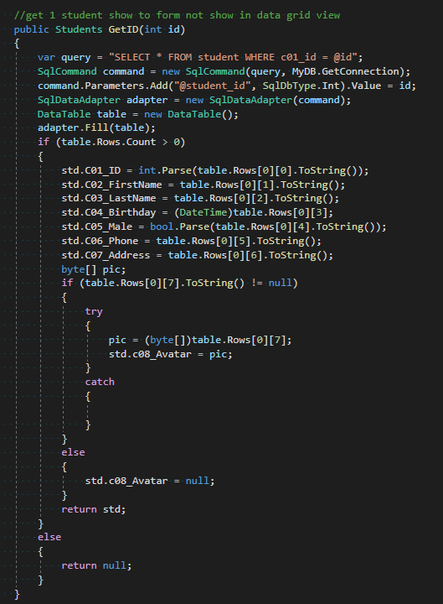

2.1.3. GetGender

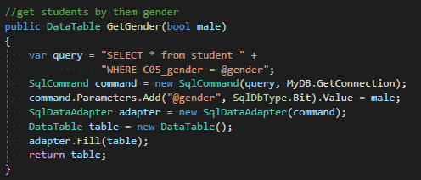

2.1.4. GetBirthday

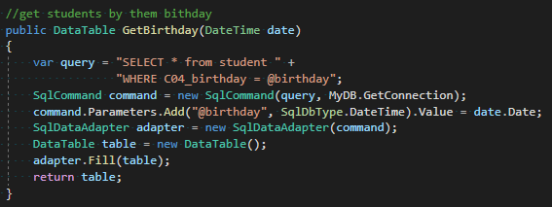

2.1.5. GetBirthdayRange

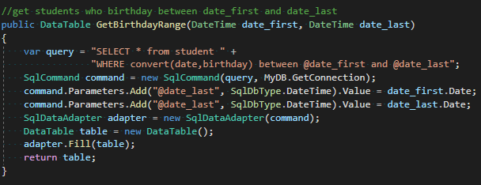

2.1.6. Add

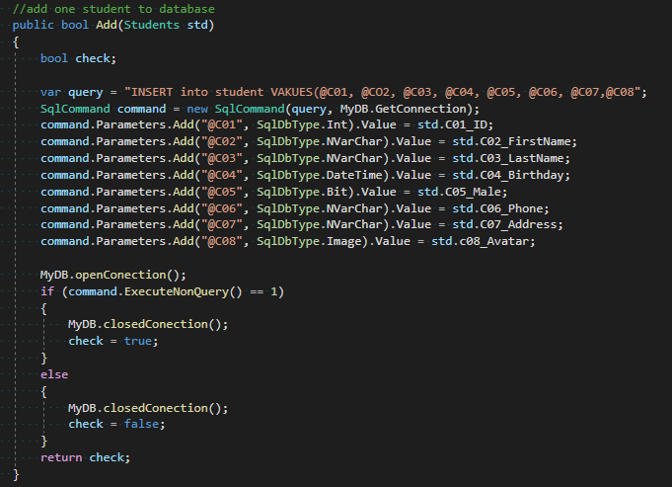

2.1.7. Edit

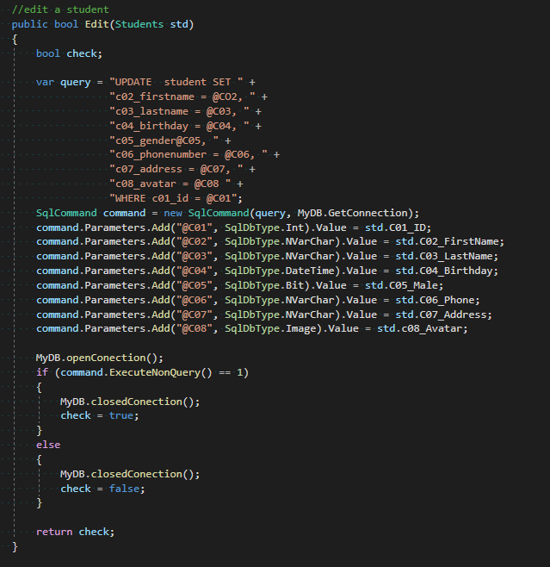

2.1.8. Delete

