Stack vs Heap Memory Allocation
stack, where each function gets its own memory for variables. In C/C++, heap memory is controlled by programmer as there is no automatic garbage collection.

- Stack allocation refers to the process of assigning memory for local variables and function calls in the call stack. It happens automatically when a function is called and is freed immediately when the function ends.
- How Stack Allocation Works
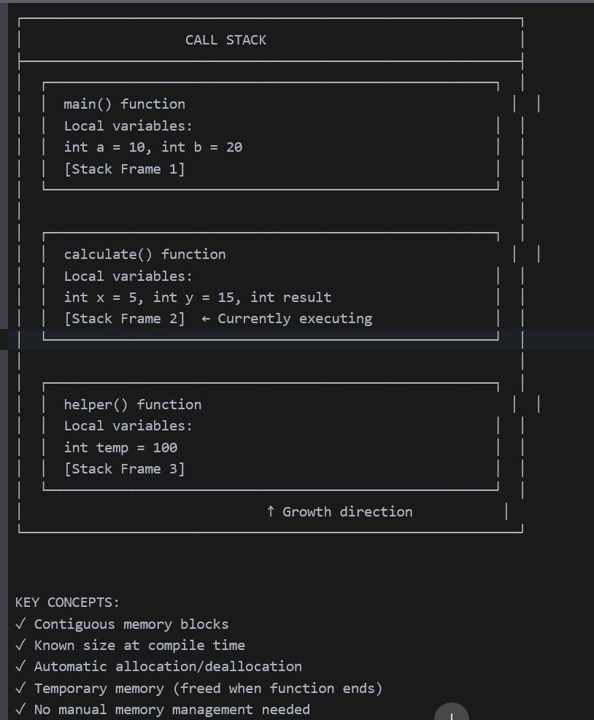
  - Memory is allocated in contiguous blocks within the call stack.
  - The size of memory required is already known before execution.
  - When a function is called, its local variables are allocated on the stack.
  - Once the function finishes execution, the allocated memory is automatically freed.
  - The programmer does not need to handle allocation or deallocation.
  - Since stack memory is freed when a function completes, it is also called temporary memory allocation.
Key Features of Stack Allocation
- Memory is available only while the function is running.
- Automatic deallocation occurs when the function ends.
- If the stack memory is full, an error like Java.lang.StackOverflowError occurs in Java and segmentation fault in C++.
- Safer than heap memory, as data can only be accessed by the owner thread.
- Faster than heap allocation due to automatic memory management.

Heap Allocation
Heap memory is allocated dynamically during program execution. Unlike stack memory, heap memory is not freed automatically when a function ends. Instead, it requires manual deallocation (In C/C++) or a garbage collector (in Java or Python) to reclaim unused memory.
The name heap has no relation to the heap data structure; it simply refers to a large pool of memory available for dynamic allocation. Whenever an object is created, it is stored in heap memory, while references to these objects are stored in stack memory. Heap allocation is less safe than stack allocation because heap data is accessible by multiple threads, increasing the risk of data corruption and memory leaks if not handled properly.
Categories of Heap Memory
Heap memory is divided into three categories, helping prioritize object storage and garbage collection:
- Young Generation – Stores new objects. When this space is full, unused objects are removed by the garbage collector, and surviving objects move to the Old Generation.
- Old (Tenured) Generation – Holds older objects that are no longer frequently used. These objects stay in memory unless explicitly removed.
- Permanent Generation (PermGen) – Stores JVM metadata, such as runtime classes and application methods.
Key Features of Heap Allocation
- If heap memory is full, JVM throws an error: java.lang.OutOfMemoryError.
- Unlike stack memory, automatic deallocation does not happen; a garbage collector is needed to free unused memory.
- Slower than stack memory due to manual allocation and garbage collection.
- Less thread-safe, as heap memory is shared among all threads.
- Typically larger in size compared to stack memory.
- Heap memory persists as long as the entire application is running.

Garbage Collection
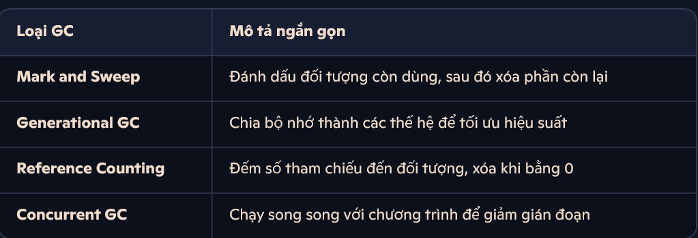
What GC Actually Does
Garbage Collection has two main jobs:
- Find unused objects (those no longer referenced by your code).
- Free up memory by deleting those objects so new ones can be created.
Mark-and-Sweep
How it works:
- Traverse all reachable objects from the root and mark them.
- Sweep through memory and delete unmarked (unreachable) objects.
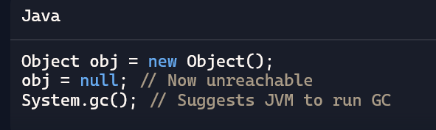
Reference Counting (Python-style)
Each object tracks how many references point to it.
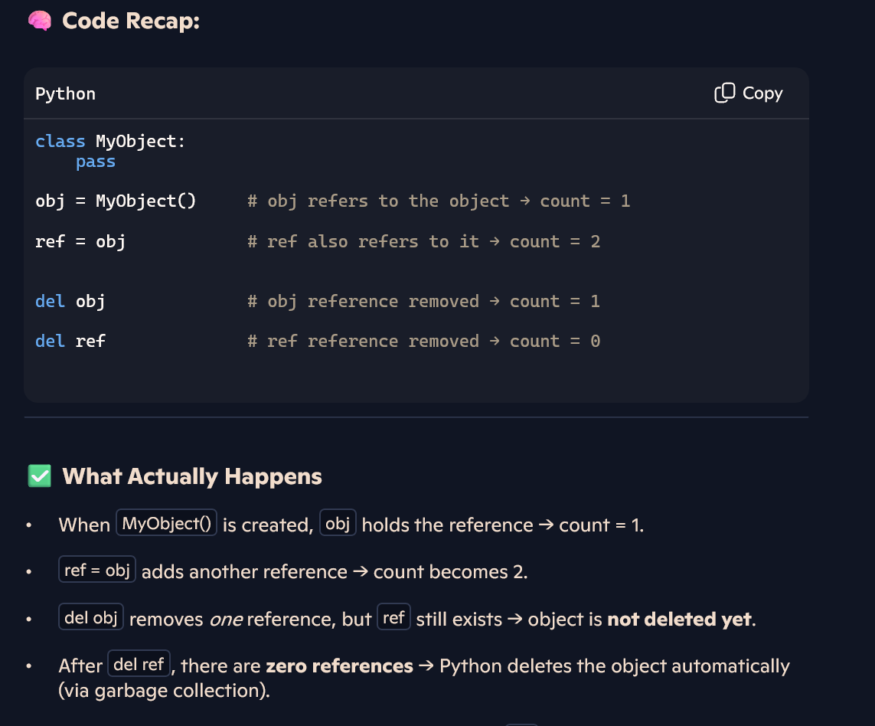🧠 Explanation: When no references remain, Python’s GC deletes the object.
Generational GC (Java HotSpot)
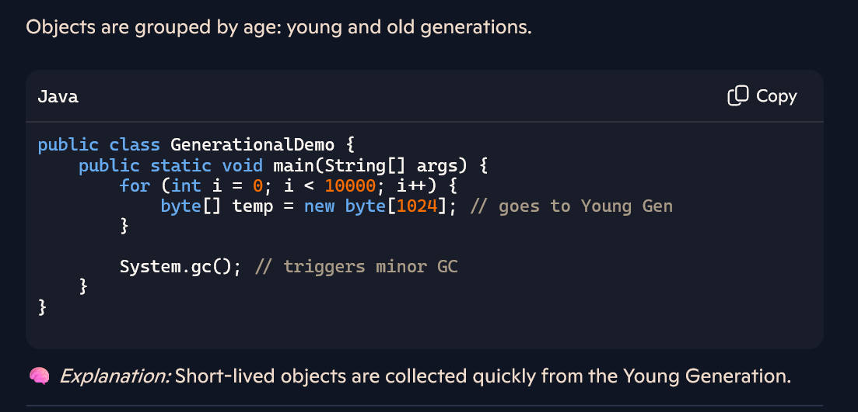
Copying Collector (Conceptual)
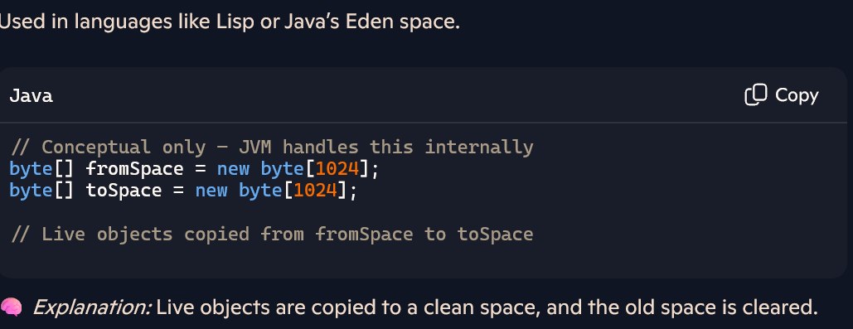Concurrent GC (Java G1 or Go)
