*Hanoi University of Science and Technology*

*School of Information and Communication Technology*



**Virus Information Application**

*Object Oriented Programming - IT3100E*

Group 10

*Hoang Trung Hieu 20226039*

*Ngo Minh Duc 20226028*

*Tran Tung Duong 20226033*

*Vu Nguyen Hao 20226037*

Table of contents

1. **Introduction………………………………………………………………**
2. **Design……………………………………………………………………...**
3. **Implementation Details…………………………………………………..**
4. **Object-Oriented Techniques……………………………………………..**
5. **Introduction**
6. *Project description*

A large number of health-related issues in the world have the involvement of viruses and they have caused great losses to humanity.

In this project, our application aims to provide valuable information about some of the most common viruses for users, including their basic information, structures, and infection processes.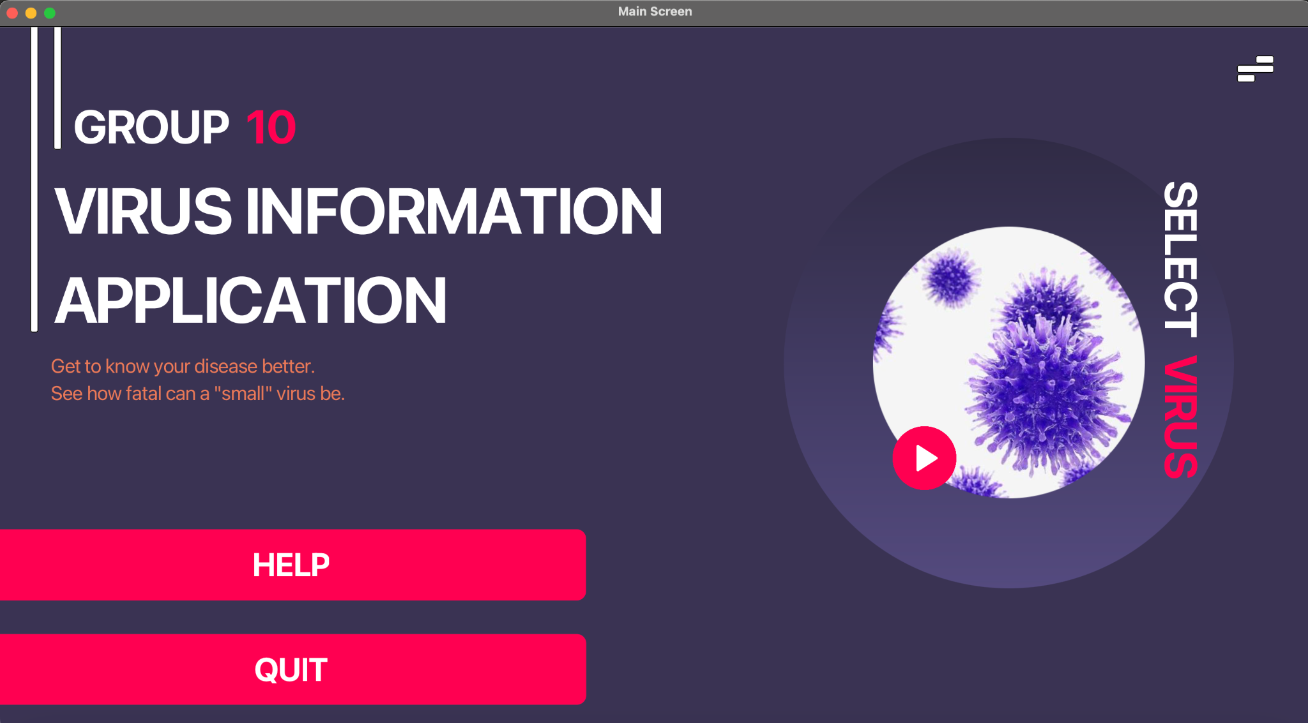

*Figure 1. Virus Information Interface.*

1. *Assignment of members*

| Member name | Student ID | Responsibility |
| --- | --- | --- |
| Hoang Trung Hieu | 20226039 | Researching virus details, designing diagrams, application logic processing |
| Vu Nguyen Hao | 20226037 | Designing User Interface |
| Ngo Minh Duc | 20226028 | Researching virus details, designing diagrams, application logic processing |
| Tran Tung Duong | 20226033 | Designing User Interface, writing documents |

Every member contributes the same amount of work in this project

1. *Application requirements*

This project requires some platforms and toolkits in order to set up and run the simulator:

* Environment: Java Development Kit (JDK), JavaFX Runtime, IDE (Eclipse is recommended)
* Library: JavaFX

1. **Design**
2. Use case diagrams

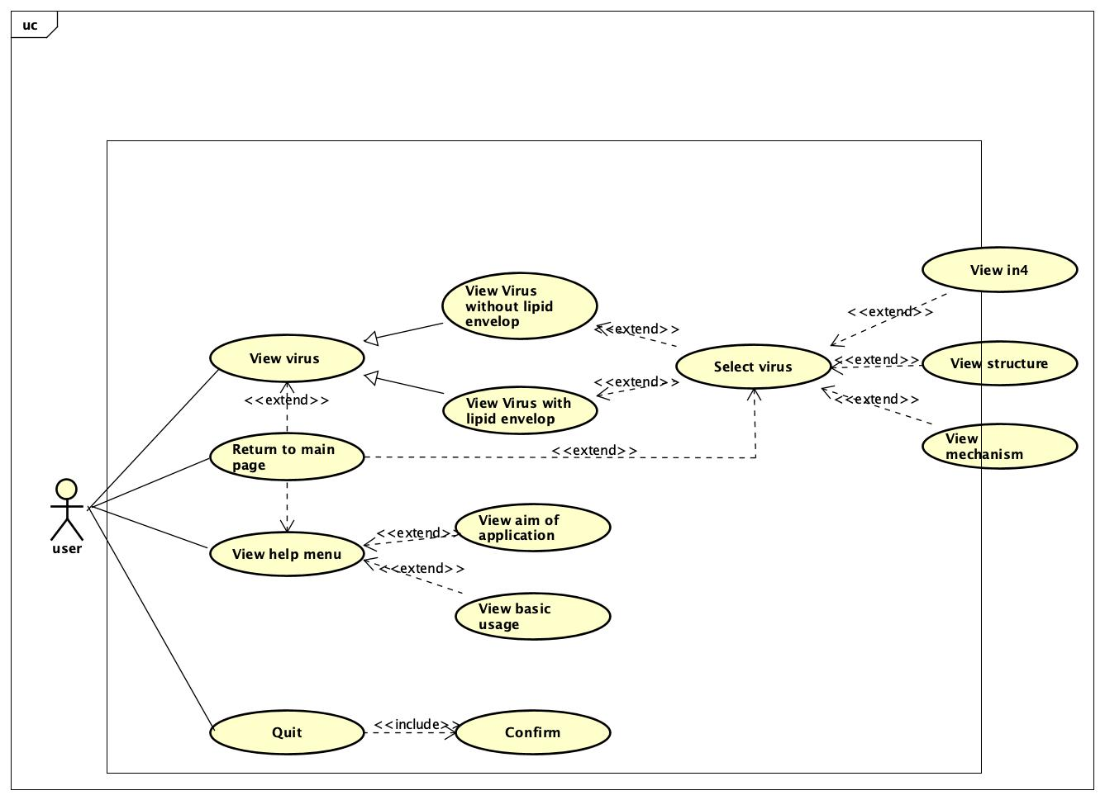

*Figure 2. Use case diagram.*

In detail:

* On the main screen: users have options to choose to view virus, view help menu, or quit.
* When users choose to view virus, there are options to choose between virus with lipid envelope and virus without lipid envelope.
* After choosing the desired type, the application will show 4 types of viruses for users to select.
* With each type of virus, the app displays:
* The basic information of the virus
* The structure of the virus
* The infection process of the virus
* The help menu shows the basic usage and aim of the application
* The quit button exits the application. The app also asks for confirmation before exiting.
* There is always a return button for users to get back to the main menu at any time.

1. Class diagrams

Our project can be divided into 2 big packages: *VirusStorage* and *GUIVirusFX*

1. *VirusStorage* package

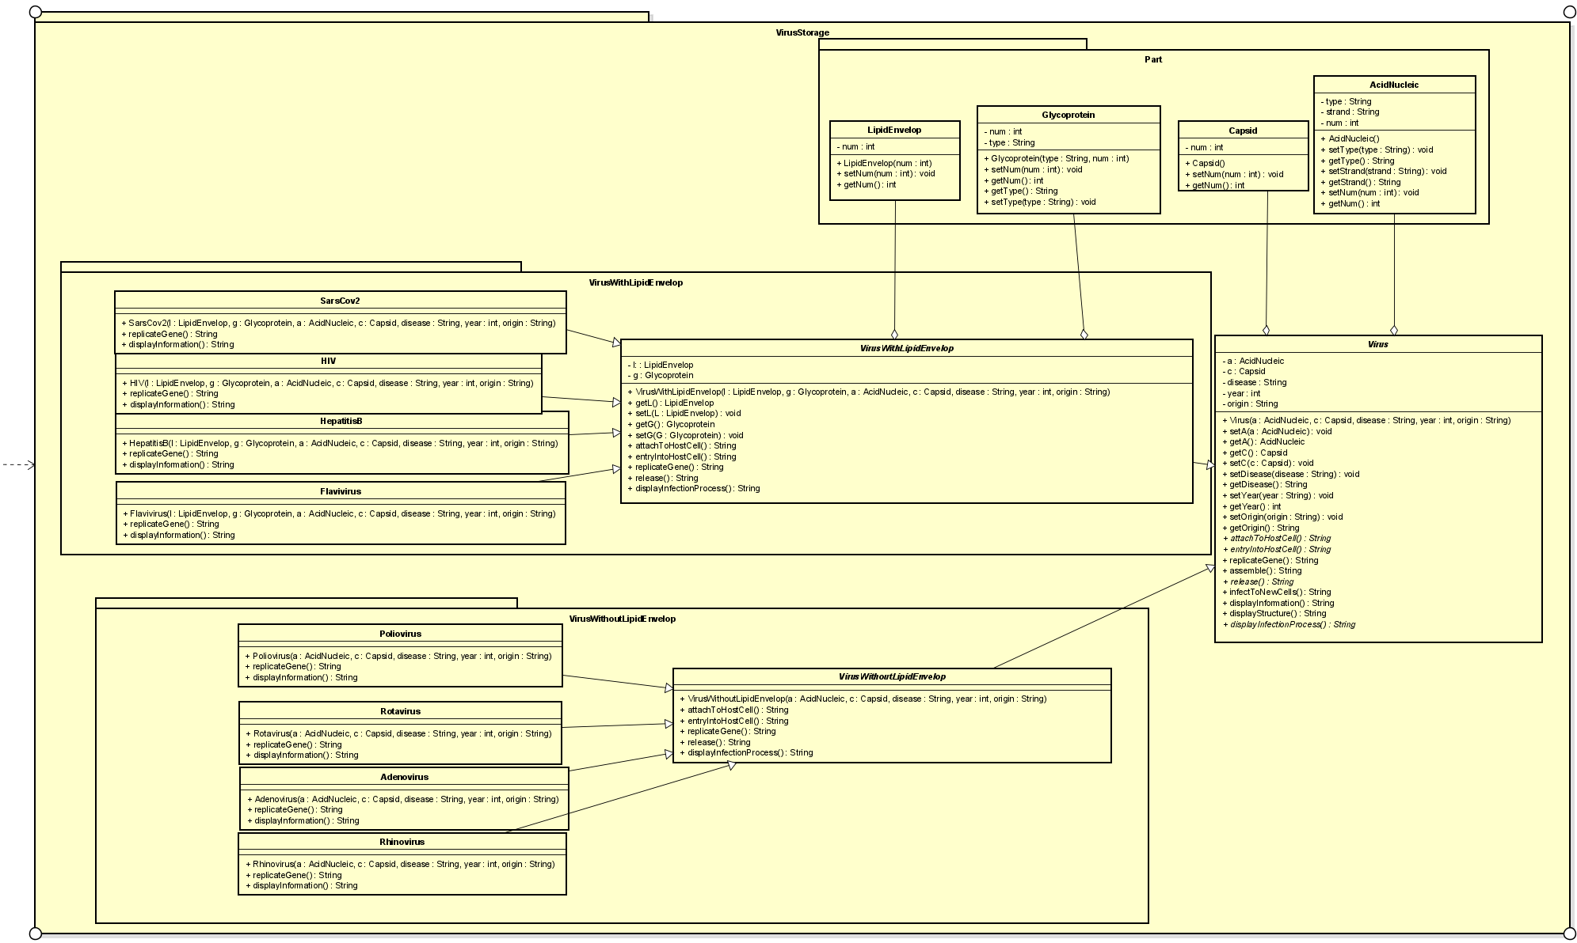

*Figure 3. VirusStorage package diagram.*

In detail:

| Packages | Classes | Contents |
| --- | --- | --- |
| *Part* | *AcidNucleic* | This package stores different parts of a virus. Every virus has AcidNucleic and Capsid, but only a virus of type VirusWithLipidEnvelop has Glycoprotein and LipidEnvelop |
| *Capsid* |
| *Glycoprotein* |
| *LipidEnvelop* |
|  | *Virus* | Has 3 important methods:   * displayInformation() * displayStructure() * displayInfectionProcess()   The infection process contains 6 steps:   * attachToHostCell() * entryIntoHostcell() * replicateGene() * assemble() * release() * infectToNewCells()   Besides, there are constructors, getters, and setters |
| *VirusWithLipidEnvelop* | *VirusWithLipidEnvelop* | Inherit from *Virus,* implement attachToHostCell(), entryIntoHostcell(), replicateGene(), release(), and displayInformation() |
| *HIV* | Inherit from *VirusWithLipidEnvelop*, implement replicateGene() and displayInformation() |
| *SarsCov2* |
| *HepatitisB* |
| *Flavivirus* |
| *VirusWithoutLipidEnvelop* | *VirusWithoutLipidEnvelop* | Inherit from *Virus,* implement attachToHostCell(), entryIntoHostcell(), replicateGene(), release(), and displayInformation() |
| *Rotavirus* | Inherit from *VirusWithoutLipidEnvelop*, implement replicateGene() and displayInformation() |
| *Rhinovirus* |
| *Adenovirus* |
| *Poliovirus* |

*Table 1. Packages and classes of VirusStorage package.*

1. *GUIVirusFX*

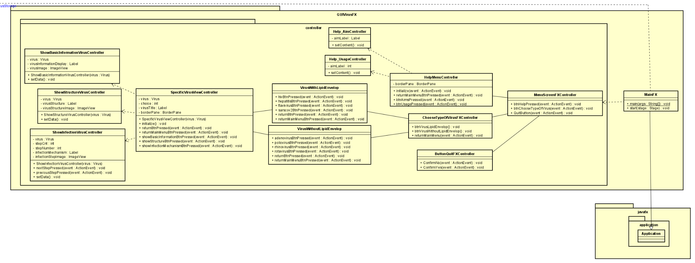

*Figure 4 . GUIVirusFX package diagram.*

In detail:

| Packages | Classes | Contents |
| --- | --- | --- |
|  | *MainFX* | Run application |
| *controller* | *MainScreenFXController* | The controller of the corresponding class |
| *HelpMenuController* |
| *Help_AimController* |
| *Help_UsageController* |
| *ChooseTypeOfVirusFXController* |
| *VirusWithLipidEnvelop* |
| *VirusWithoutLipidEnvelop* |
| *SpecificVirusViewController* |
| *ShowBasicInformationVirusController* |
| *ShowStructureVirusController* |
| *ShowInfectionVirusController* |

*Table 2. Packages and classes o VirusGUIFX package.*

1. **Implementation Details**
2. *main_package.VirusStorage*

* Abstract class Virus:
* attribute *a*: is an instance of *AcidNucleic* class
* attribute *c*: is an instance of *Capsid* class
* attribute *disease*: String type, contains information about disease that the virus causes
* attribute *year*: int type, the year in which virus is discovered
* attribute *origin*: String type, location where the virus originated
* constructor *Virus()*
* method *getA()*: returns attribute *a*
* method *setA()*: set attribute *a*
* method *getC()*: get attribute *c*
* method *setC()*: set attribute *c*
* method *getDisease()*: get attribute *disease*
* method *setDisease()*: set attribute *disease*
* method *getYear()*: get attribute *year*
* method *setYear()*: set attribute *year*
* method *getOrigin()*: get attribute *origin*
* method *setOrigin()*: set attribute *origin*
* method *attachToHostCell():* abstract method, returns String type, shows information of how the virus attach to host cell
* method *entryIntoHostCell()*: abstract method, returns String type, shows information of how the virus entries into host cell
* method *replicateGene()*: returns String type, shows information of how the virus replicates its genome
* method *assemble()*: returns String type, shows information of how the virus assemble
* method *release()*: returns String type, shows information of how the virus gets out of host cell
* method *infectToNewCells()*: returns String type, shows information of how the virus continues the process of infecting new cells
* method *displayInformation()*: returns String type, shows basic information of the virus
* method *displayStructure()*: returns String type, shows the structure of the virus
* method *displayInfectionProcess()*: returns String type, shows the whole infection process of the virus

1. main_package.VirusStorage.VirusWithLipidEnvelop

* Abstract class *VirusWithLipidEnvelop* inherits from *Virus*:
* attribute *l*: is an instance of *LipidEnvelop*
* attribute *g*: is an instance of *Glycoprotein*
* constructor *VirusWithLipidEnvelop()*
* method *getL()*: get attribute *l*
* method *setL()*: set attribute *l*
* method *getG()*: get attribute *G*
* method *setG()*: set attribute *G*
* method *attachToHostCell()*: returns String type, override method from *Virus*
* method *entryIntoHostCell()*: returns String type, override method form *Virus*
* method *replicateGene()*: returns String type, override method from *Virus*
* method *release()*: returns String type, override method from *Virus*
* method *displayInfectionProcess()*: returns String type, override method from *Virus*
* Class *SarsCov2* inherits from *VirusWithLipidEnvelop*
* constructor *SarsCov2()*
* method *replicateGene()*: returns String type, override method from parents’ classes
* method *displayInformation()*: returns String type, override method from *Virus*
* Class *HIV, HepatitisB, Flavivirus* has the same structures as *SarsCov2* except for their constructors

1. main_package.VirusStorage.VirusWithoutLipidEnvelop

* Abstract class *VirusWithoutLipidEnvelop* inherits from *Virus*:
* constructor *VirusWithoutLipidEnvelop()*:
* method *attachToHostCell()*: returns String type, override method from *Virus*
* method *entryIntoHostCell()*: returns String type, override method from *Virus*
* method *replicateGene()*: returns String type, override method from *Virus*
* method *release()*: returns String type, override method from *Virus*
* method *displayInfectionProcess()*: returns String type, override method from *Virus*
* Class *Poliovirus*:
* constructor *Poliovirus()*
* method *replicateGene()*: returns String type, override method from parents’ classes
* method *displayInformation()*: returns String type, override method from parents’ classes
* Class *Rotavirus, Adenovirus, Rhinovirus* have the same structures as *Poliovirus* except for their constructors

1. main_package.VirusStorage.Part

* Class *LipidEnvelop*:
* attribute *num*: int type
* constructor *LipidEnvelop()*
* method *setNum()*: set attribute *num*
* method *getNum()*: get attribute *num*
* Class *GlycoProtein*:
* attribute *num*: int type
* attribute *type*: String type
* constructor *GlycoProtein()*
* method *setNum()*: set attribute *num*
* method *getNum()*: get attribute *num*
* method *getType()*: get attribute *Type*
* method *setType()*: set attribute *Type*
* Class *Capsid:*
* attribute *num*: int type
* constructor *Capsid()*
* method *getNum()*: get attribute *num*
* method *setNum()*: set attribute *num*
* Class *AcidNucleic*:
* attribute *type*: String type
* attribute *strand*: String type
* attribute *num*: int type
* constructor *AcidNucleic()*
* method *setType()*: set attribute *type*
* method *getType()*: set attribute *type*
* method *getStrand()*: get attribute *strand*
* method *setStrand()*: set attribute *strand*
* method *getNum()*: get attribute *num*
* method *setNum()*: set attribute *num*

1. *main_package.GUIVirusFX*

* Class *MainFX* inherits from *Application*:
* method *start():* Load MainScreenFX.fxml, set stage and scene.
* method *main()*: Run the application.

1. main_package.GUIVirusFX.controller

* Class ButtonQuitFXController:
* method ConfirmNo(): Reload “MainScreenFX.fxml”, return to main menu scene.
* method ConfirmYes(): Quit the application.
* Class ChooseTypeOfVirusFXController():
* method btnVirusLipidEnvelop(): Load Virus with lipid envelope choosing screen stage.
* method btnVirusWithoutEnvelop(): Load Virus without lipid envelope choosing screen stage.
* method returnMainMenu(): Load main menu stage.
* Class Help_AimController:
* attribute aimLabel: Label type.
* method setContent(): set content (Aims of the application) of the label aimLabel.
* Class Help_UsageController:
* attribute aimLabel: Label type
* method setContent(): set content (Usage of the application) of the label aimLabel.
* Class HelpMenuController:
* attribute borderPane: BorderPane type
* attribute titleLabel: Label type
* method initialize(): Load “Help_Aim.fxml”, display Aim of the application beforehand.
* method returnMainMenuBtnPressed(): Load “MainScreen.fxml”, set main menu stage.
* method btnAimsPressed(): set controller class “Help_AimController”, set Center of borderPane to a new anchorPane contains aimLabel => display Aim
* method btnUsagePressed(): set controller class “Help_UsageController”, set Center of borderPane to a new anchorPane contains aimLabel => display Usage
* Class MenuScreenFXController:
* method btnHelpPressed(): Load Help Menu stage
* method btnChooseTypeOfVirus(): Load Choose Type of Virus Menu stage
* method QuitButton(): Load Quit Option menu stage
* Class VirusWithLipidEnvelopeFXController:
* method hivBtnPressed(): initialize a HIV object, transmit that object to “SpecificVirusViewController” class constructor. Start displaying the information display stage (of HIV).
* method hepatitisbBtnPressed(): initialize a HepatitisB object. The rest is the same as “hivBtnPressed”
* method flavivirusBtnPressed (): initialize a Flavivirus object. The rest is the same as “hivBtnPressed”
* method sarscov2BtnPressed(): initialize a SarsCov2 object. The rest is the same as “hivBtnPressed”
* method returnBtnPressed(): Load and set Choose Type of Virus stage.
* method returnMainMenuBtnPressed(): Load and set Main Menu screen stage.
* Class VirusWithoutLipidEnvelopeFXController:
* method adenovirusBtnPressed(): initialize a Adenovirus object, transmit that object to “SpecificVirusViewController” class constructor. Start displaying the information display stage (of Adenovirus).
* method poliovirusBtnPressed(): initialize a Poliovirus object. The rest is the same as “adenovirusBtnPressed”
* method rhinovirusBtnPressed (): initialize a Rhinovirus object. The rest is the same as “adenovirusBtnPressed”
* method rotavirusBtnPressed(): initialize a Rotavirus object. The rest is the same as “adenovirusBtnPressed”
* method returnBtnPressed(): Load and set Choose Type of Virus stage.
* method returnMainMenuBtnPressed(): Load and set Main Menu screen stage.
* Class ShowBasicInformationVirusController:
* attribute virus: Virus type
* attribute virusInformationDisplay: Label type
* attribute virusImage: ImageView type
* constructor ShowBasicInformationVirusController(Virus virus): set this.virus = virus
* method setData(): Display virus information and picture according to the chosen virus type
* Class ShowStructureVirusController:
* attribute virus: Virus type
* attribute virusStructure: Label type
* attribute virusStructureImage: ImageView type
* constructor ShowStructureVirusController(Virus virus): set this.virus = virus
* method setData(): Display virus structure and picture according to the chosen virus type
* Class ShowInfectionVirusController:
* attribute virus: Virus type
* attribute stepCnt: int type
* attribute stepNumber: Label type
* attribute infectionInformation: Label type
* attribute infectionStepImage: ImageView type
* constructor ShowInfectionVirusController(Virus virus): set this.virus = virus
* method setData():

1. **Object-Oriented techniques**
2. *Inheritance*

* Abstract class *Virus*
* 2 abstract classes *VirusWithLipidEnvelope* and *VirusWithoutLipidEnvelope* inherit from the class Virus
* 8 classes of specific viruses inherit from 2 above classes

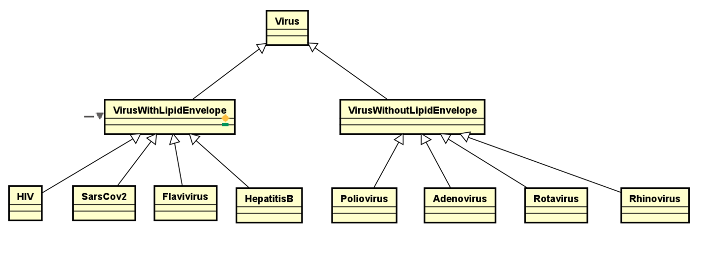

*Figure 5 . Demonstration of the inheritance design*

* Method overriding: The child class has a method with the same name and same signature of a method in its parent class

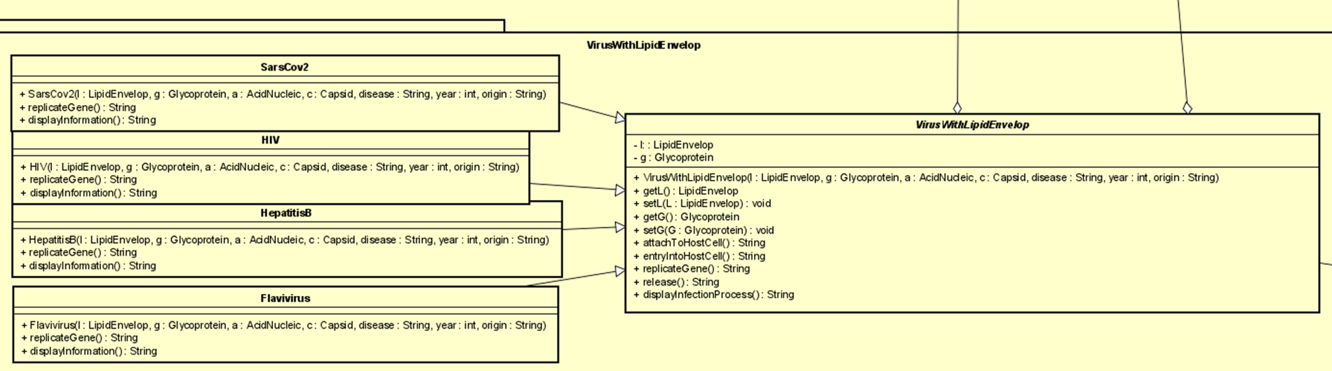

*Figure 6 . Demonstration of method overriding*

1. *Aggregation*

* A virus has some parts, including
* Acid Nucleic
* Capsid
* Lipid Envelope (for VirusWithLipidEnvelope)
* Glycoprotein (for VirusWithLipidEnvelope)

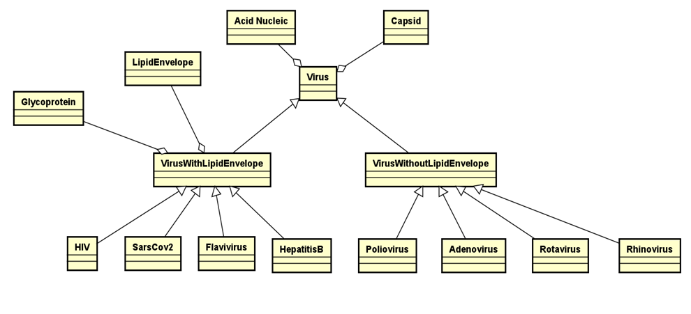

*Figure 7 . Demonstration of aggregation*

1. *Polymorphism*

* A single object can represent multiple different types (upcasting and downcasting)

E.g: HIV can be of HIV, VirusWithLipidEnvelope, and Virus data type