**MeetYourWriter**

1. **Translate Plugin : MjE Recruitment, Job verification , withdrawal,…**

You download loco translate plugin here :

<https://wordpress.org/plugins/loco-translate/>

You can see these below videos for the detail guide :

<https://www.youtube.com/watch?v=CzZdPuD9z7E>

<https://www.youtube.com/watch?v=zeHj1eDDFJ4>

1. **Change email title.**

You can copy the title of Email :

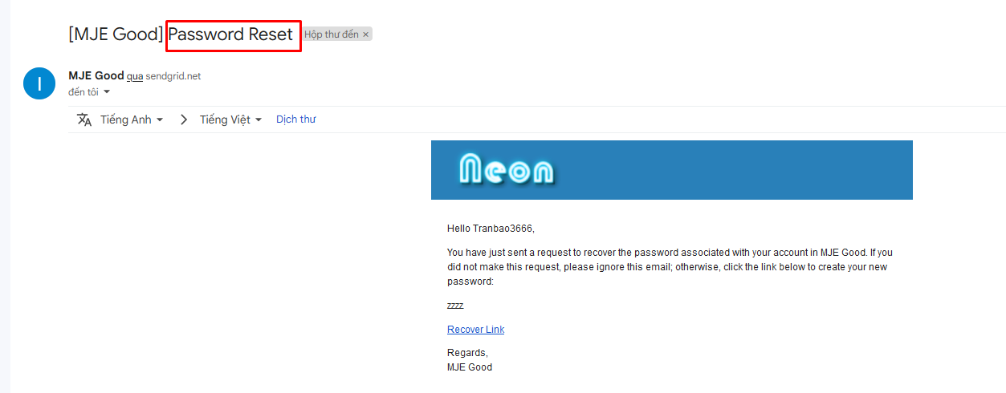

After that you can go to Engine Settings > Theme options > Choose translation tab and choose your language.

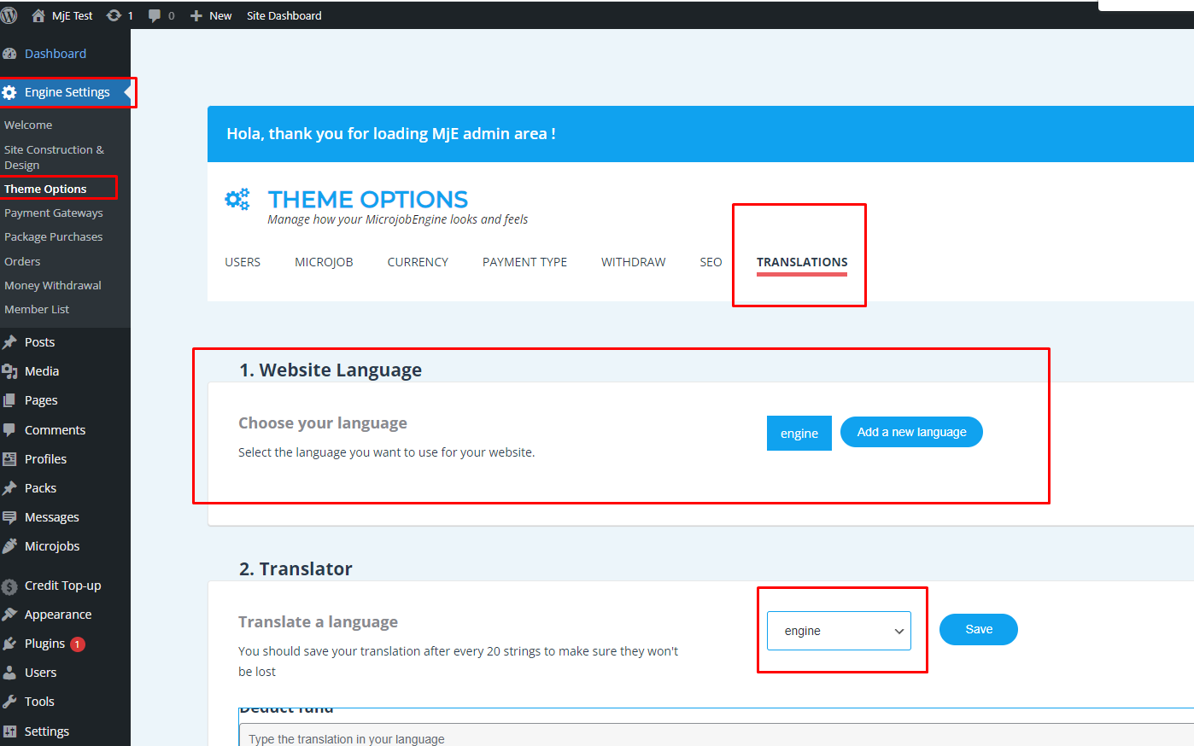

After that you can press ctr + f to search the email template by the title.

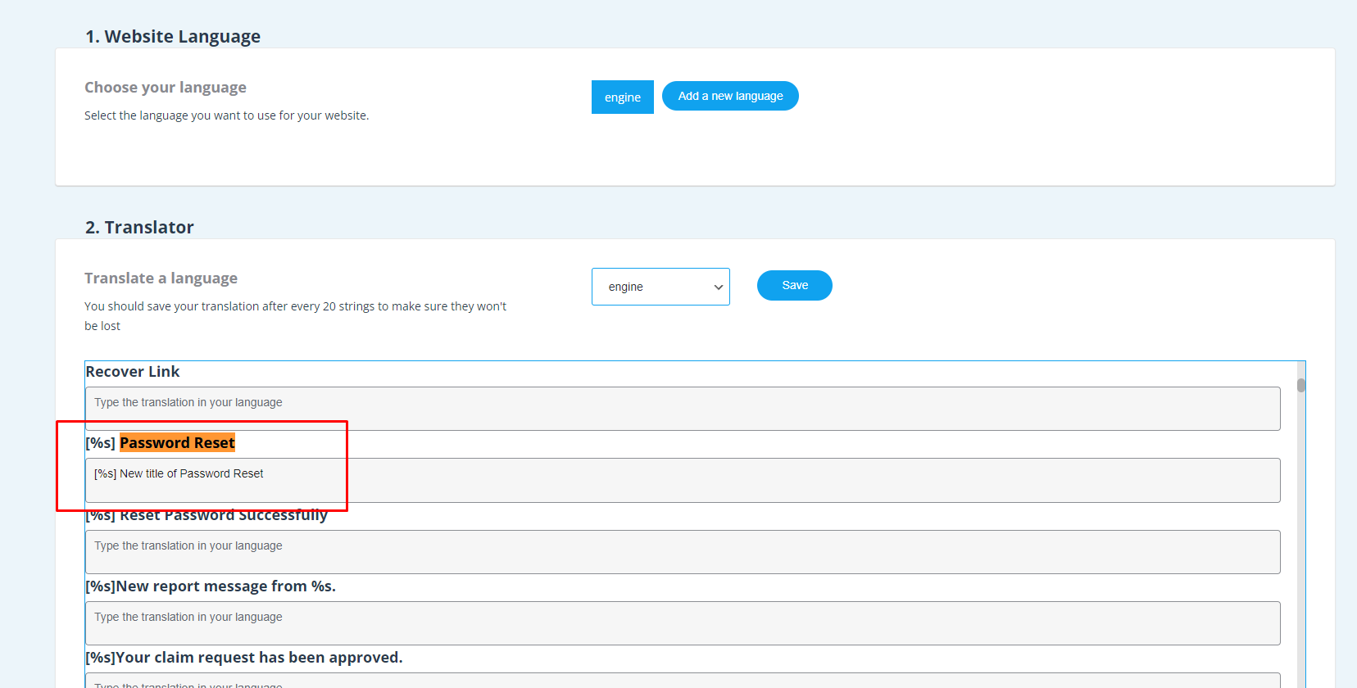

Please don’t forget to keep [%s] because that is the title of your site.

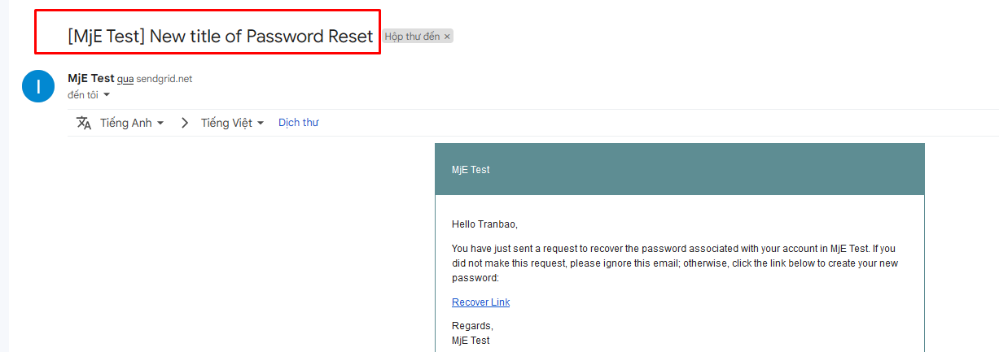

1. **Change the title of the pages**

There are many type of pages in MicrojobEngine so there will be many ways to change the title of pages and it depends on the type of pages

To change the title of post a service page ( this is a functional page of MJE )

You go to Pages > All pages and search post a service and click to edit, change the title

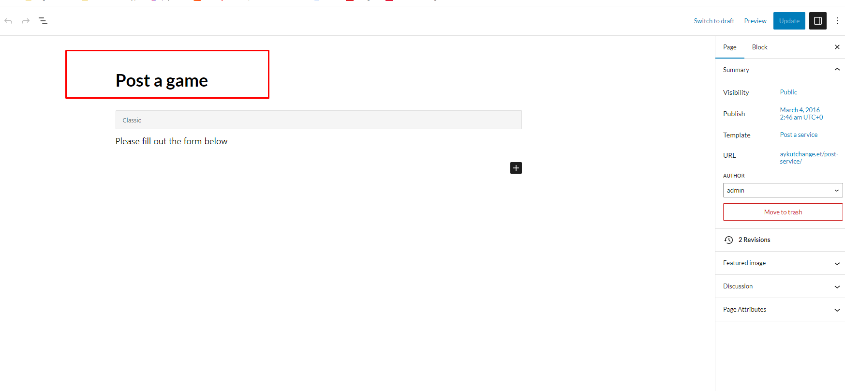

**PLEASE NOTICE THAT JUST ONLY CHANGE THE TITLE AND DO NOT CHANGE THE URL OF PAGE BECAUSE IT WILL MAKE THE PAGE NOTWORK CORRECTLY**

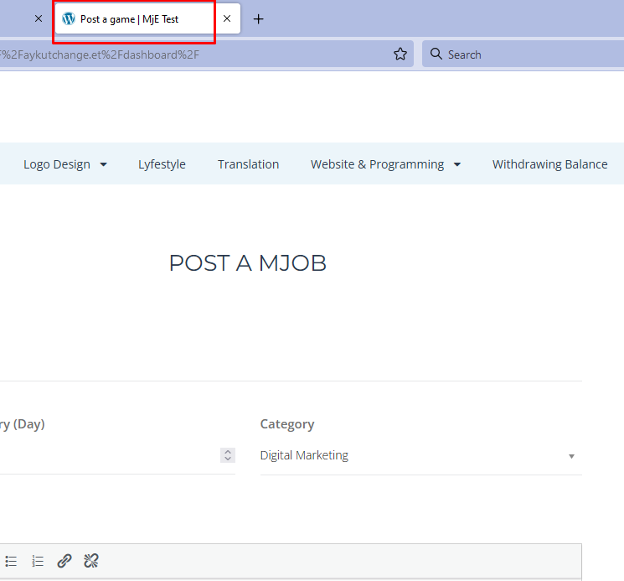

To change the title of Archive pages such as **archive-mjob_post.php**

You can use theme editor to edit microjobengine-child > functions.php

And add these lines of code :

function custom_archive_title($title) {

      if (is_post_type_archive('mjob_post')) {

        $title = 'Custom Archive Title for mjob_post';

      }

      return $title;

    }

    add_filter('post_type_archive_title', 'custom_archive_title',9999,1);