1. Here we need: 1. Private person, 2. Freelancer, 3. Sole Trader, 4. Enterprise

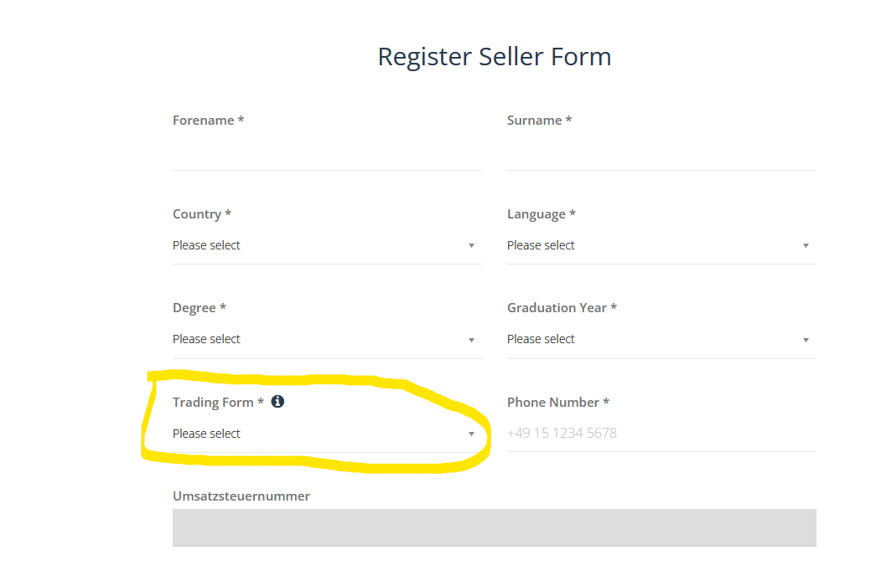

1. When user chooses “sole Trader” or “Enterprise“ Umsatzsteuer should be renamed to “Handelsregisternummer” -> how difficult, maybe with a simple if statement?