Requirements:

1. Get the header Central: Right now its left sided

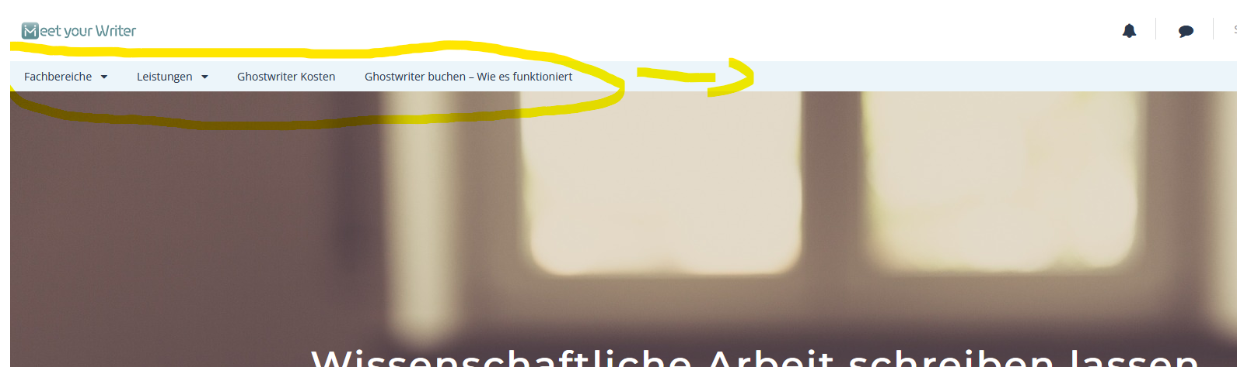

Also maybe suggestions for a better design for this page?

Centralize on every page:

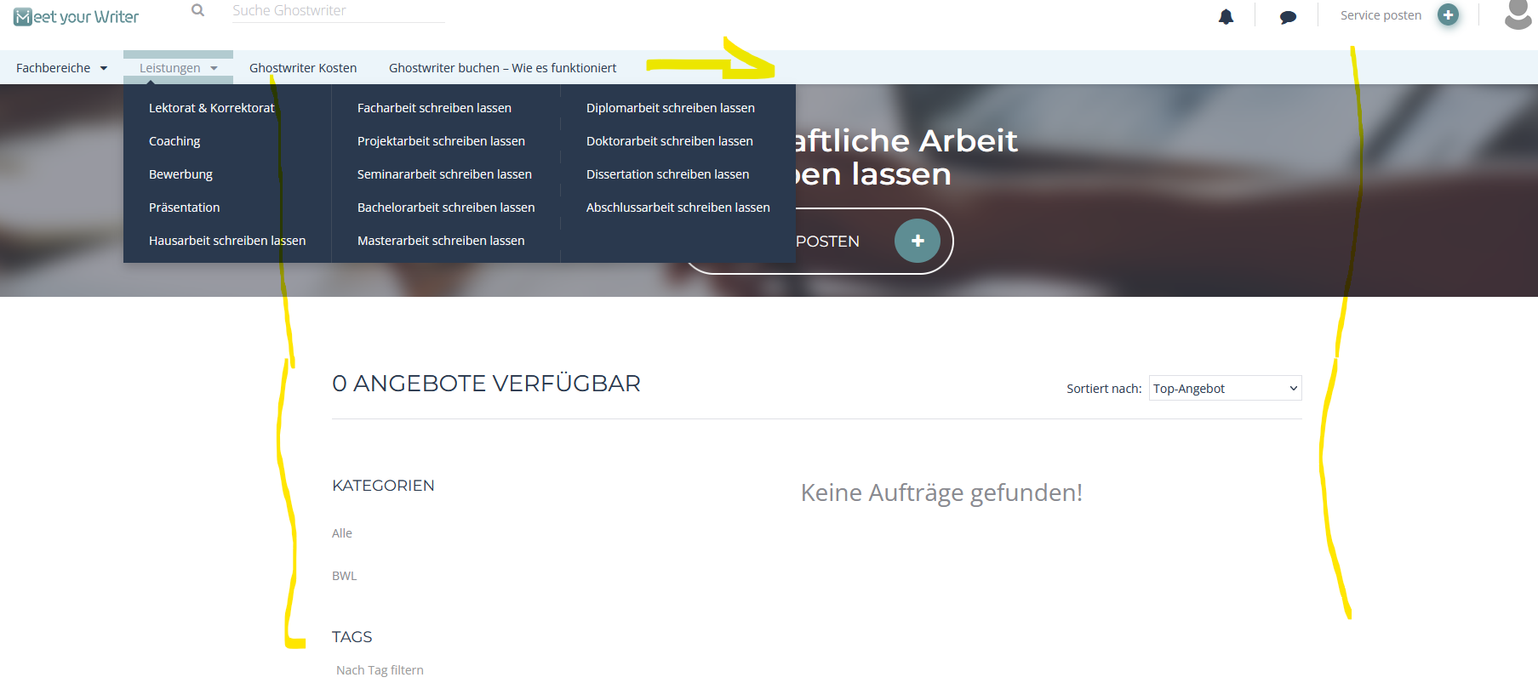

1. When clicking on the text the customer should be able to type in:

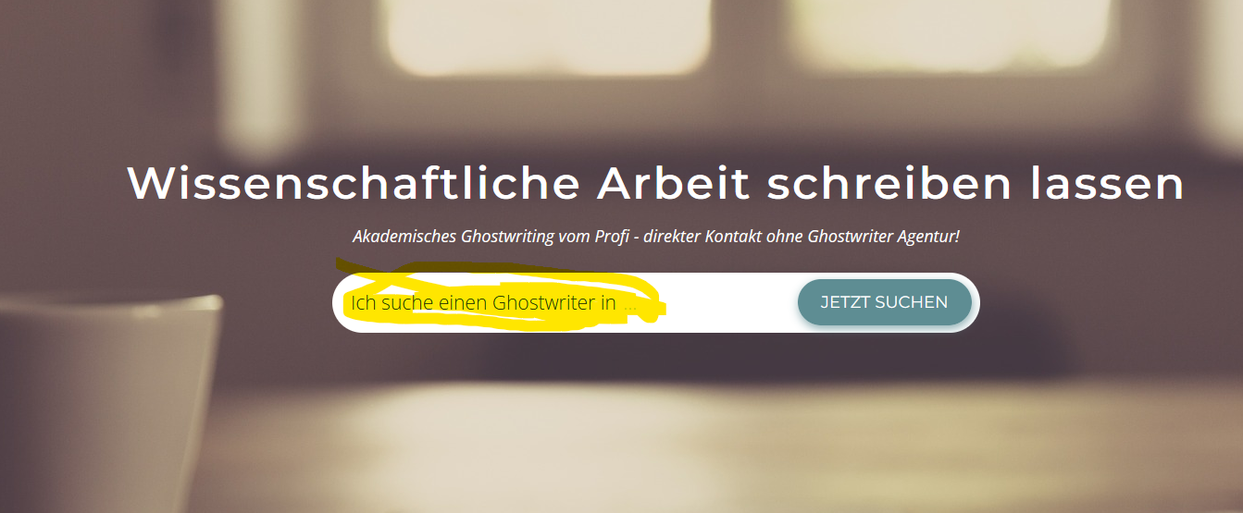

1. Comment out this “SERVICE POSTEN” Button on this page:

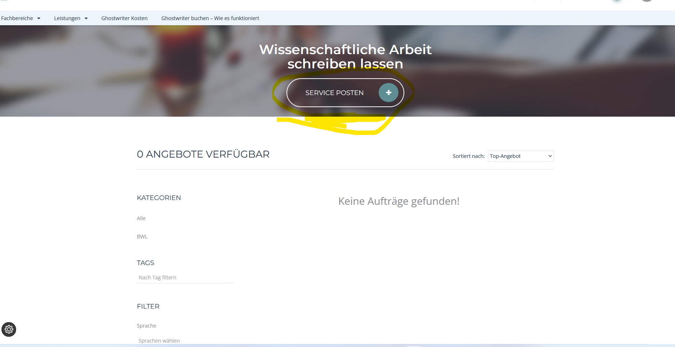

1. Here we need not only a link to the AGB. So there should stand: “Ich akzeptiere die *AGB(link to our AGB page)* und *Zahlungsbedingungen (link to* <https://onlinepaymentplatform.com/de/bedingungen-richtlinien/nutzungsbedingungen> *)*”

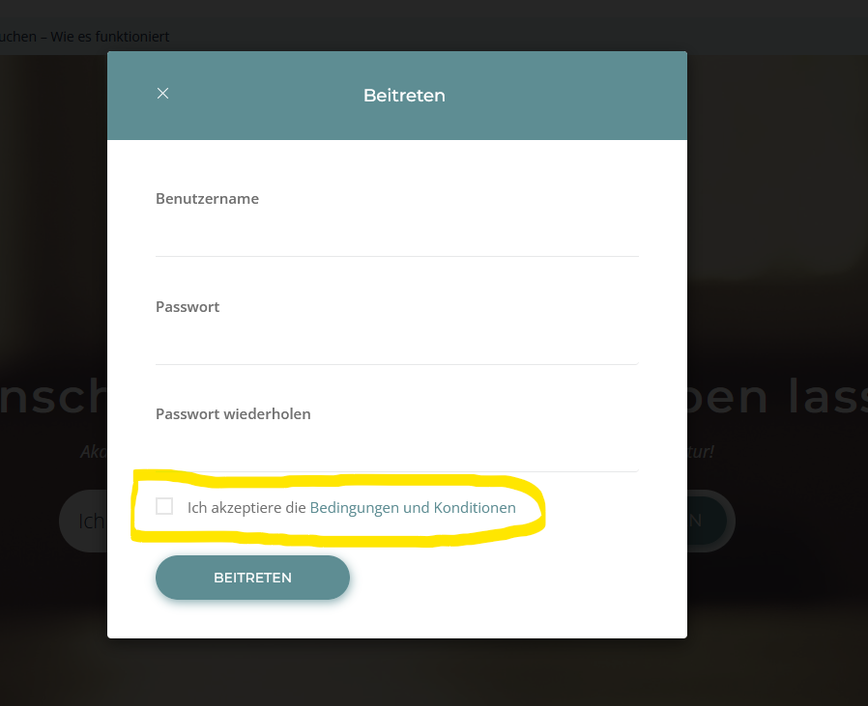

1. Ability to sort “Kind of Work (Art der Arbeit)” itself in the backend. Currently simply sorted alphabetically:

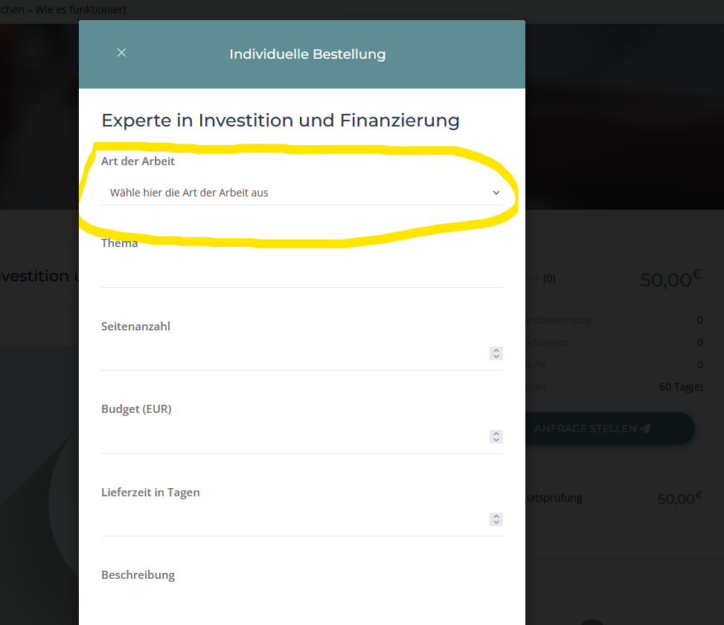

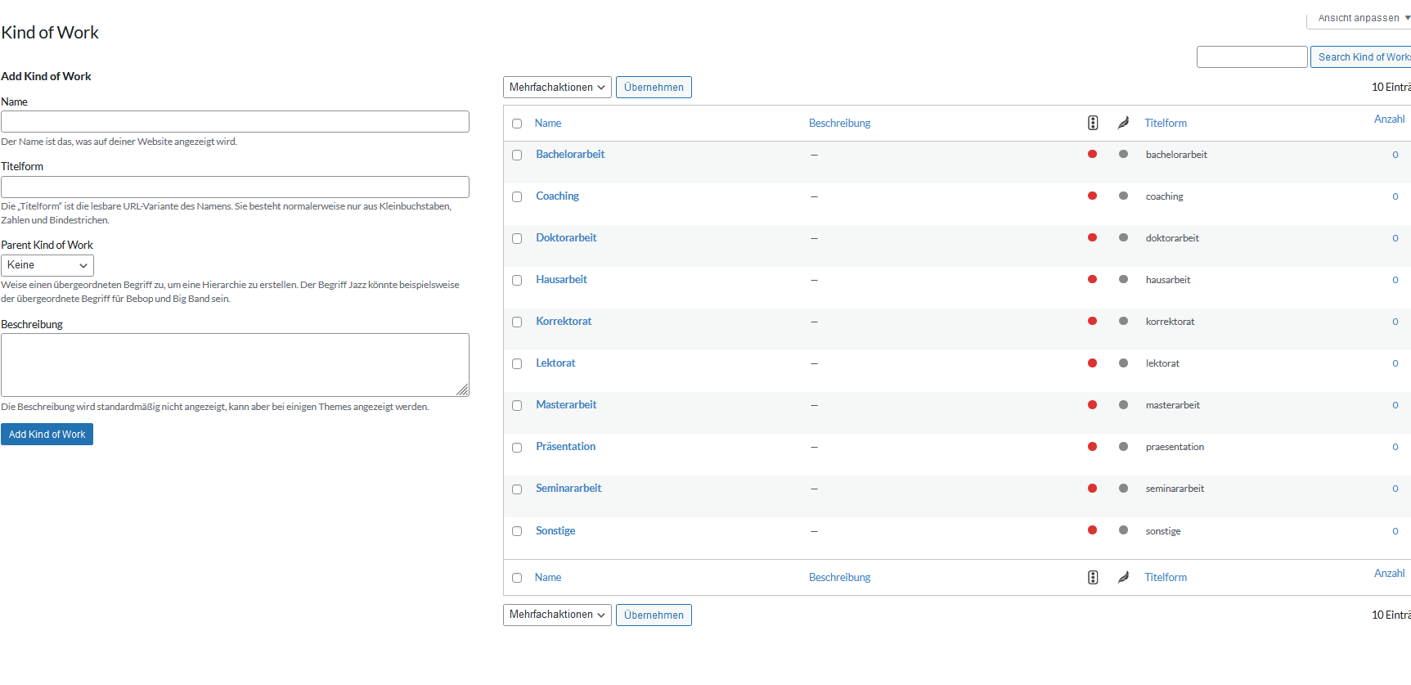

1. Make custom order(Individuelle Bestellung) from the length smaller. Width should stay the same: If the width is now 300px for example:
2. “Art der Arbeit” -> 200px next to it right “Seitenanzahl”->100px
3. „Thema“ ->300px
4. Budget (EUR) -> 150px next to it right “Lieferzeit in Tagen”->150px
5. “Beschreibung” -> 300px

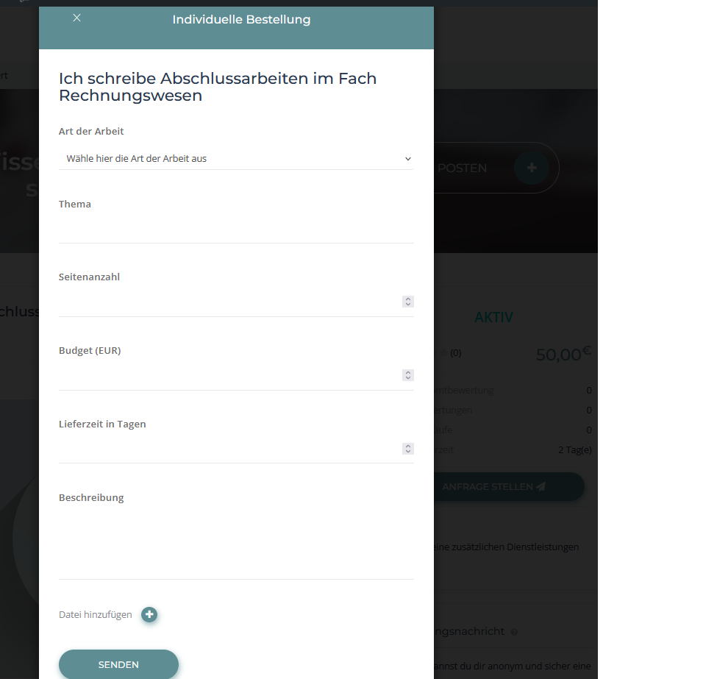

Same for sending an offer to the custom order: the height should get smaller but the width should remain the same: if the witdh is 300px for example, you should edit it in this relation:

1. “Art der Arbeit” -> 200px next to it right “Seitenanzahl”->100px
2. „Thema“ ->300px
3. Budget (EUR) -> 150px next to it right “Lieferzeit in Tagen”->150px
4. “Beschreibung” -> 300px

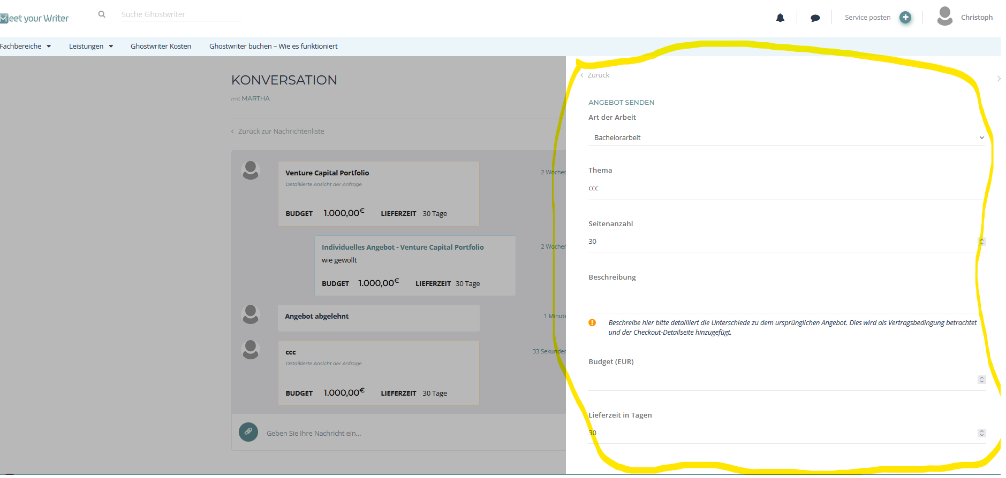

1. Translation of the tabs: like probably change the title tag in html? <title><title/>?

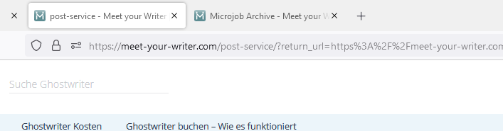

Its ok, when you show me where to find the tab titles, so I can translate them myself

1. Translation of the add on from microjob engine, like “My Withdrawal” “Job Verification”. best would be here when you can show me the files where I can change them directly in the code
2. Translation of the email titles(maybe you can show me here also where I can find it in the files? This would be easier to translate.



1. change the color of the banner in the emails:

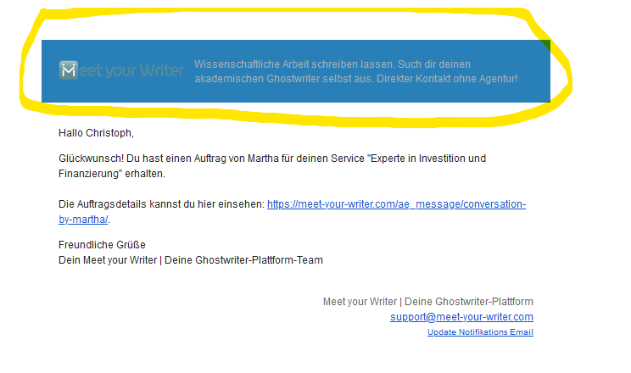

1. don’t know where to find the translation for this mail notification

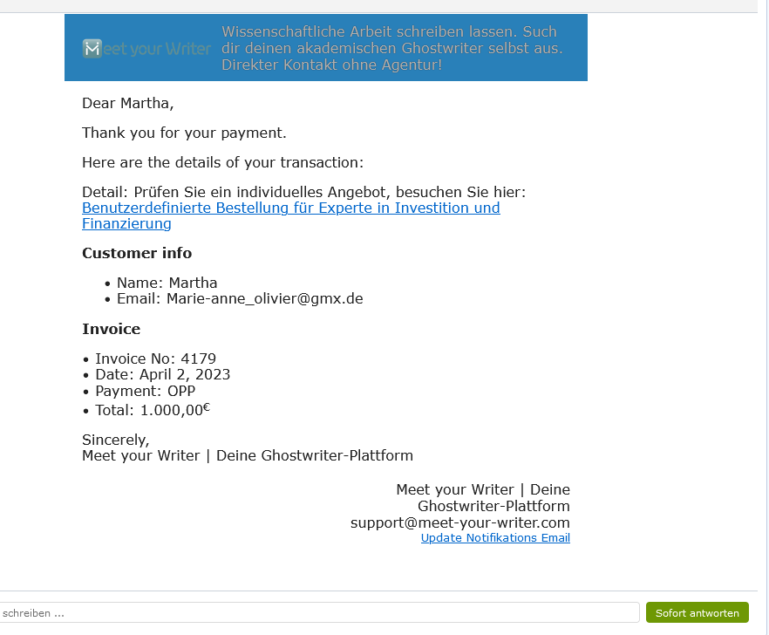

1. Responsive Design on mobile phone -> there are some things which look very ugly which needed to be fix. I ll send screenshots of them