1. Make a new Button, which is only available for registered Seller. The button should be implementet to the message Page(see below). The placement should be next to the “file attachement- button”, it should look like the attachment button from the colors, icon you can freely choose.

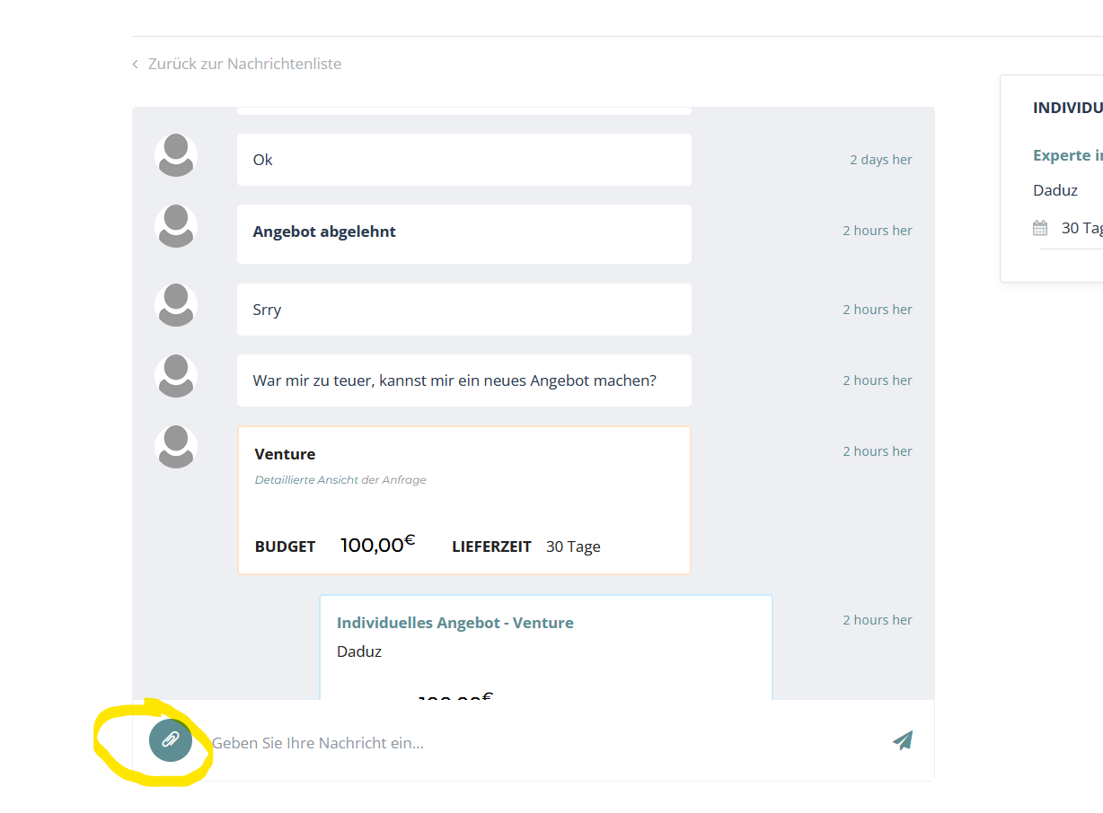

Function of the button: When seller clicks on it he can make the buyer an Offer, without getting a request. So when clicked on the button this site should pop up: 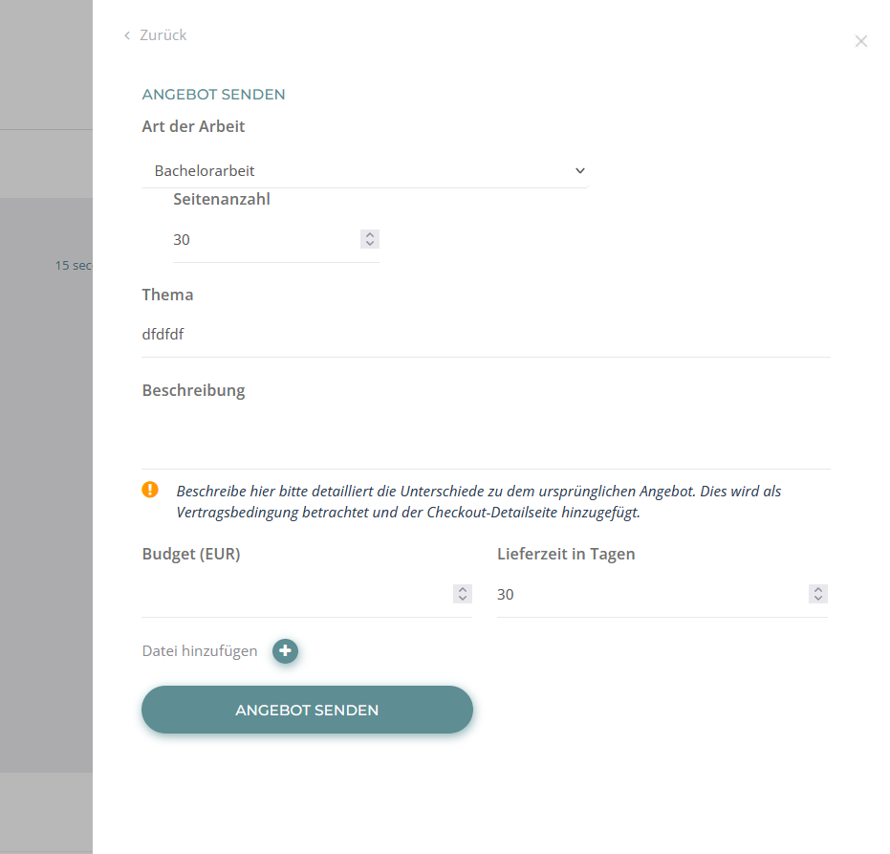

When he sent this offer for the buyer this page should come up(yellow marked) at the buyer. So basically he can accept and pay or refuse.

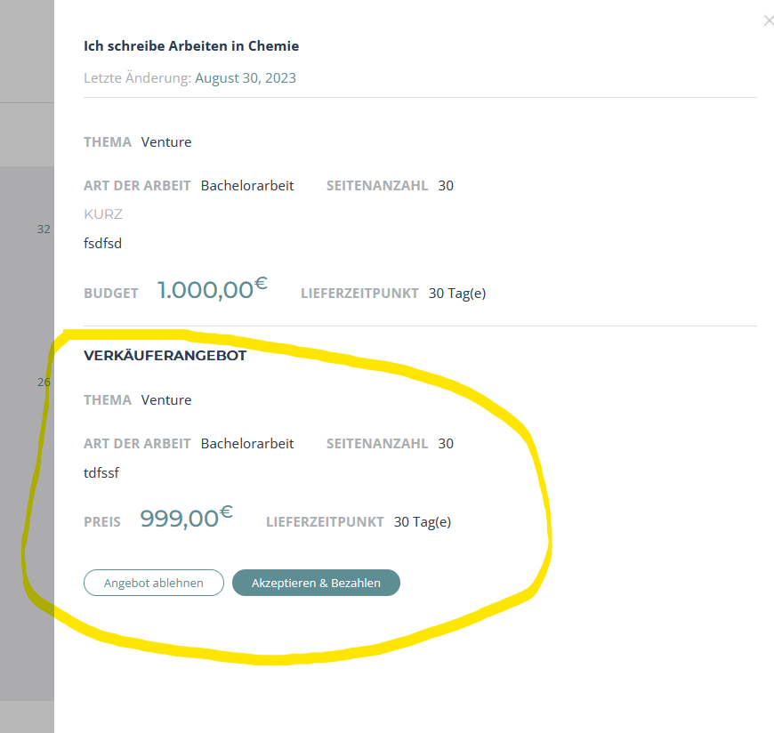

1. 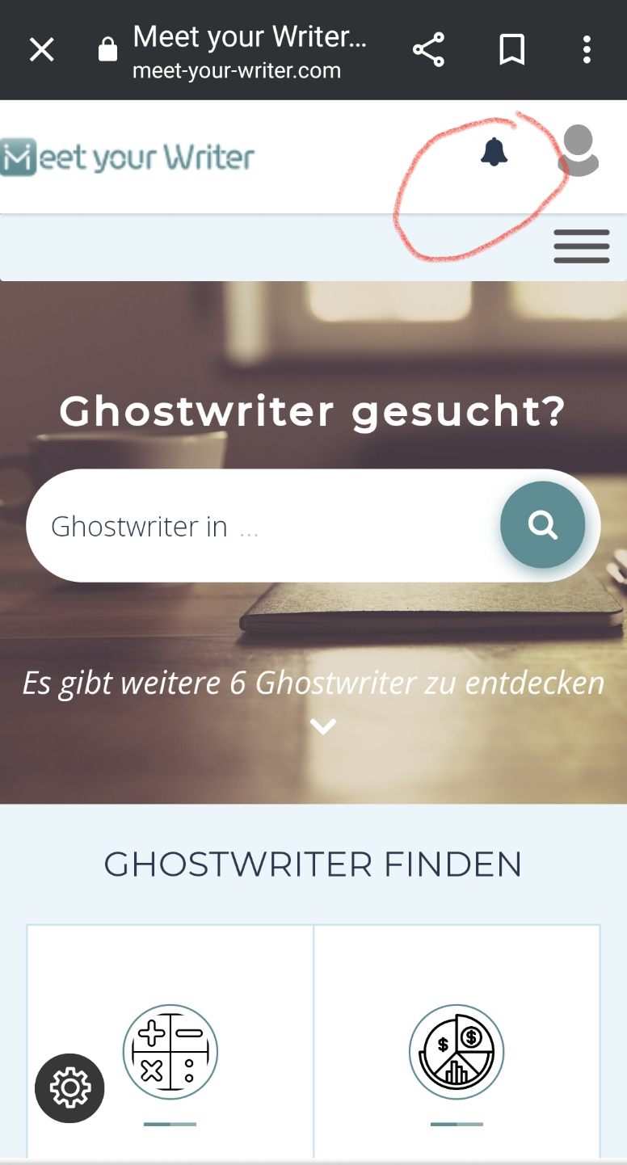A message button on mobile view, exactly like in desktop view, next to notification button. The message button should have also notifications like in desktop view (see second picture)

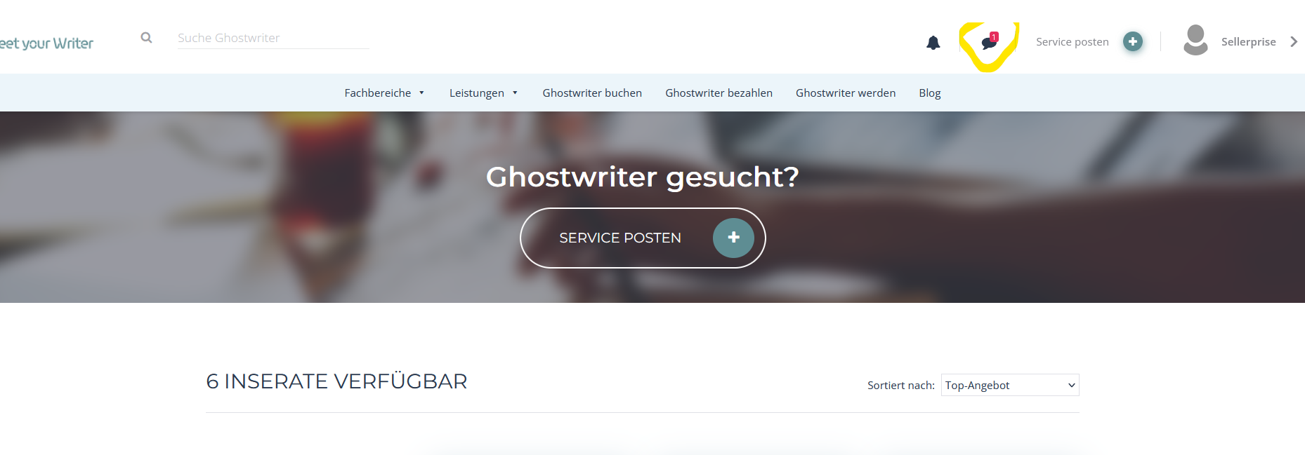

1. Can we change this text here, without changing the text on homepage? I need it to say here “Ghostwriter werden?” But homepage should stay “Ghostwriter gesucht?”

