1. For the sites in the menue header „Leistungen“ which are not categories, for example “Hausarbeit schreiben lassen” -> the translations don’t work(“Latest Microjobs”, “view all jobs”) and the formatting of the widgets are bad, they are not in alignment with the text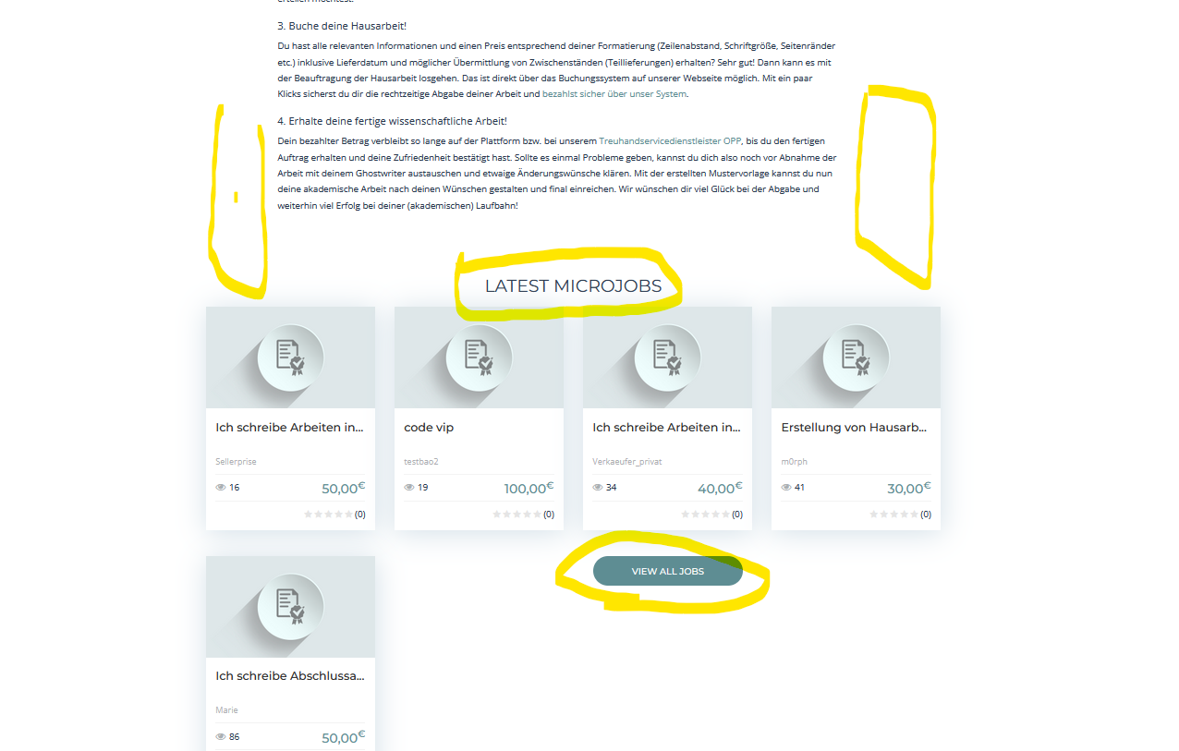

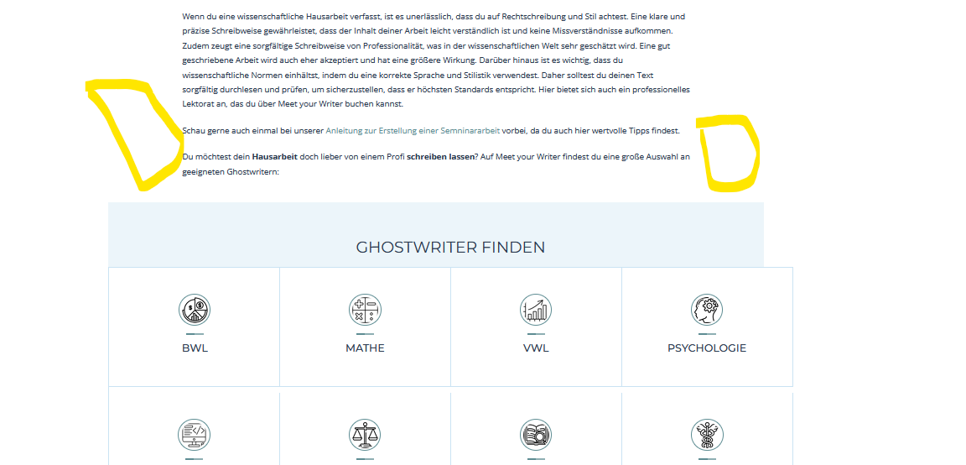

Same goes for the sites in the footer of “Leistungen” and for the sites “Ghostwriter buchen” and “Ghostwriter bezahlen”

**Mobile View:**

1. When not logged in, one can not use the hamburger menu to see the categories

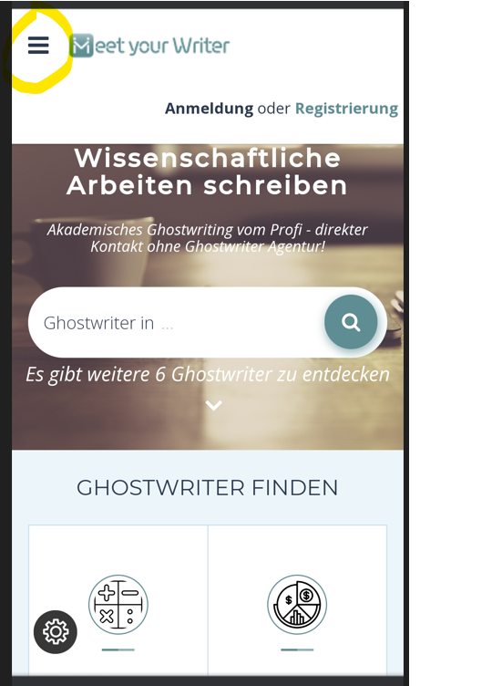

1. The home page does not look clean, is it possible to reduce the words just for the mobile view?

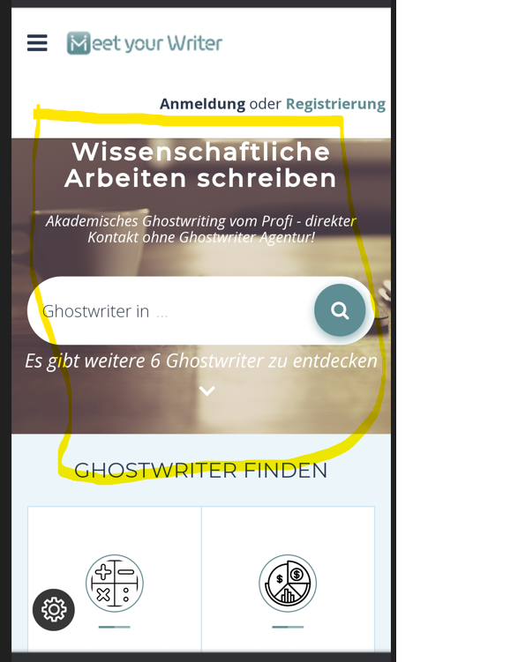

1. When you click on someones profile, this is how it looks: You cannot read the header “PROFIL VON VERKAUEFER_PRIVAT”

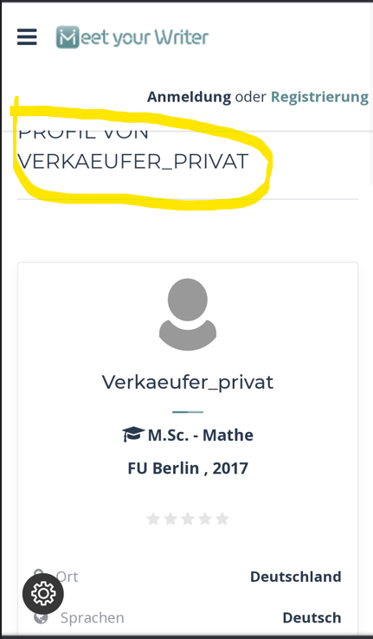

1. The padding is too small: 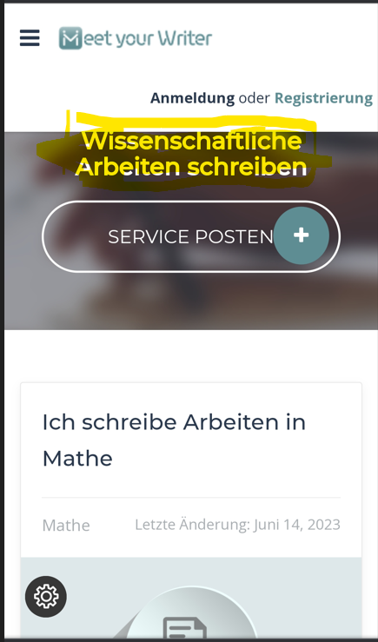
2. When you want to send someone a custom request, you see the button like this, which is very ugly:

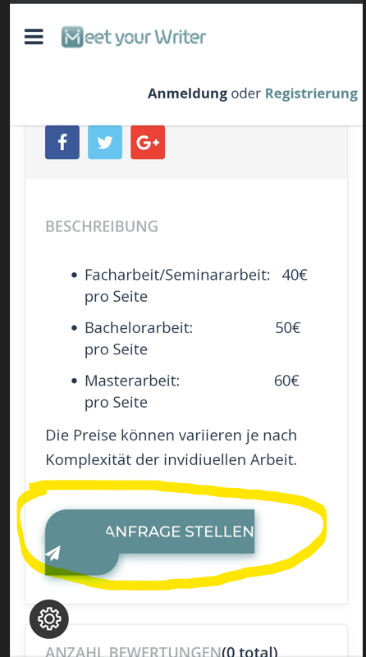

1. Notifications are not working in the mobile view: 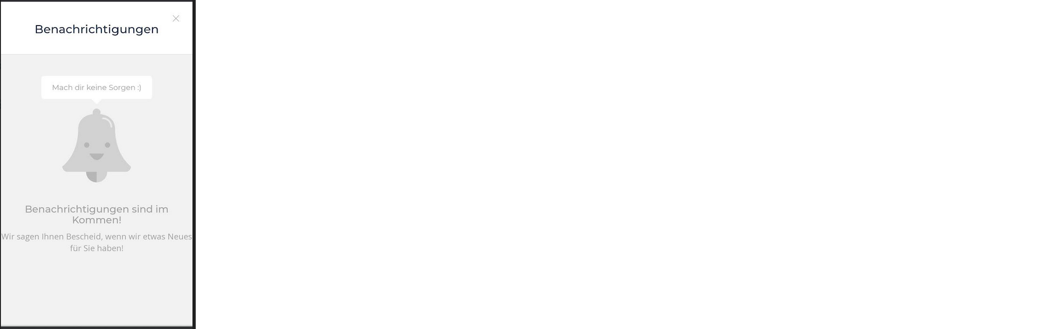
2. When custom offer is send its very hard to scroll the chat box down with the hand on mobile phone: 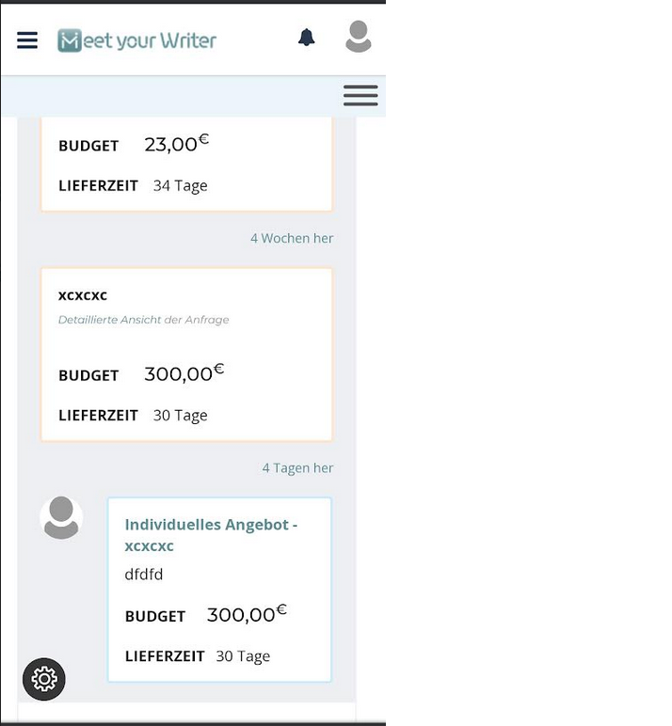
3. Two buttons from posting service page are broken: 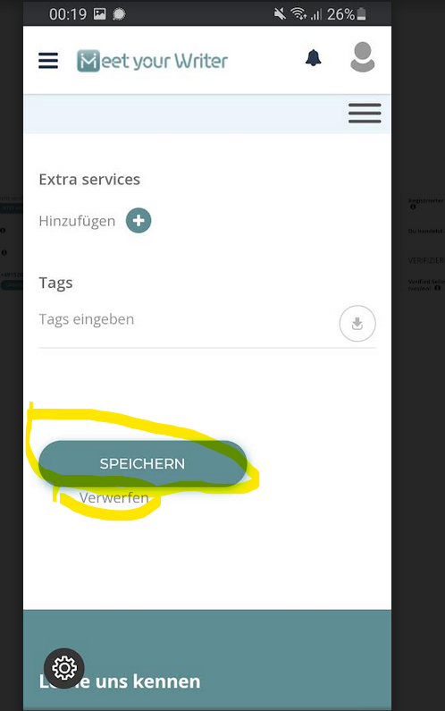
4. Posting service page, the header is not good readable: 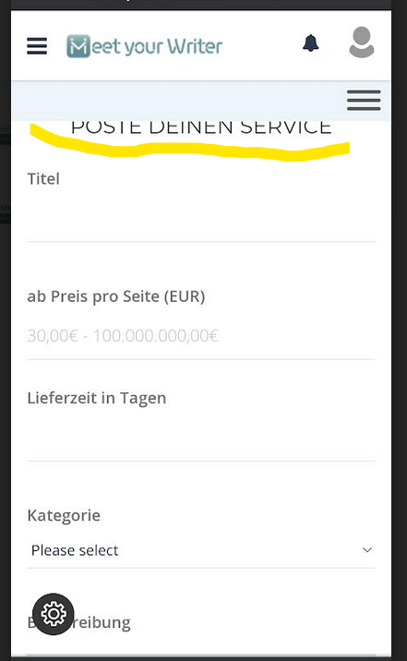

Same with conversation page: 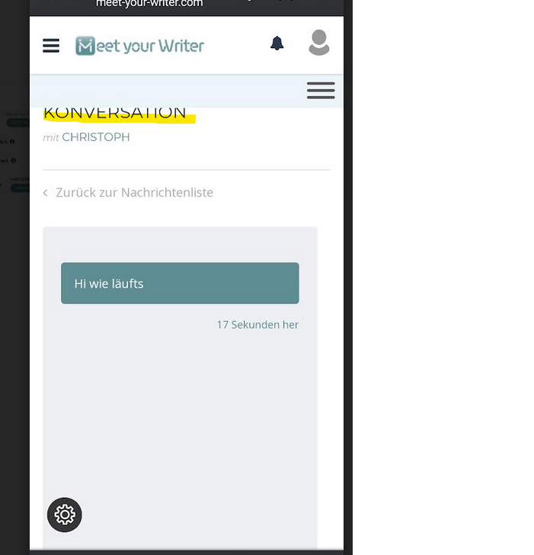

1. When user want to accept and pay the offer of seller, the two buttons are broken

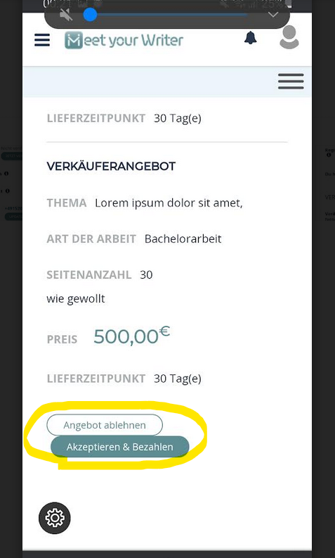

1. Second yellow marked hamburger menue is useless,you cannot open it

