1. **Input assistance**

* When seller receives custom order and clicks on this button immediately, instead of going to the whole view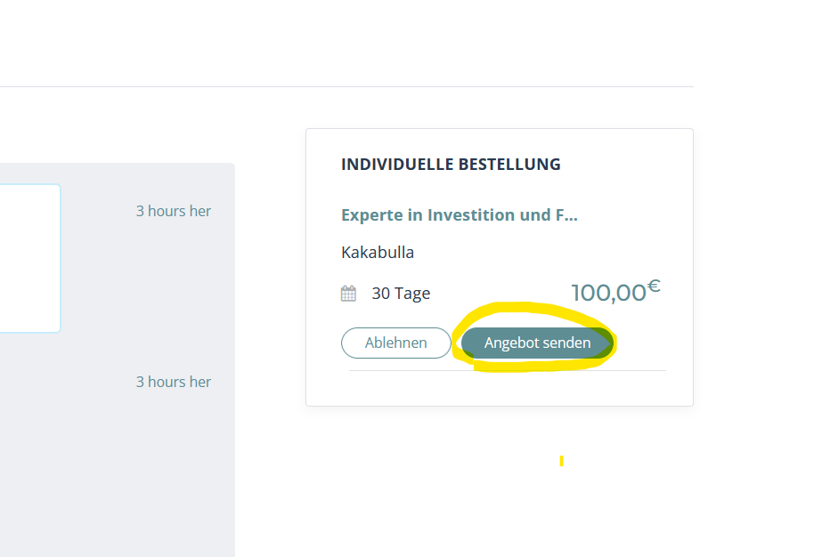
* He does not have input assistance:

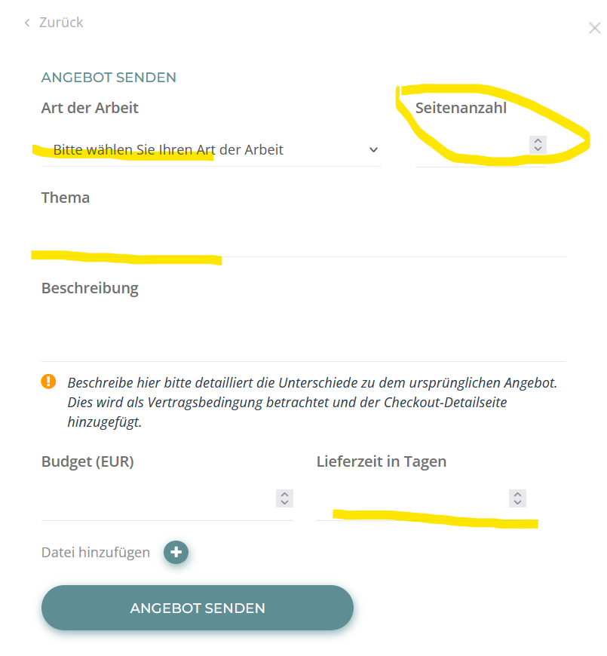

It should be like this:

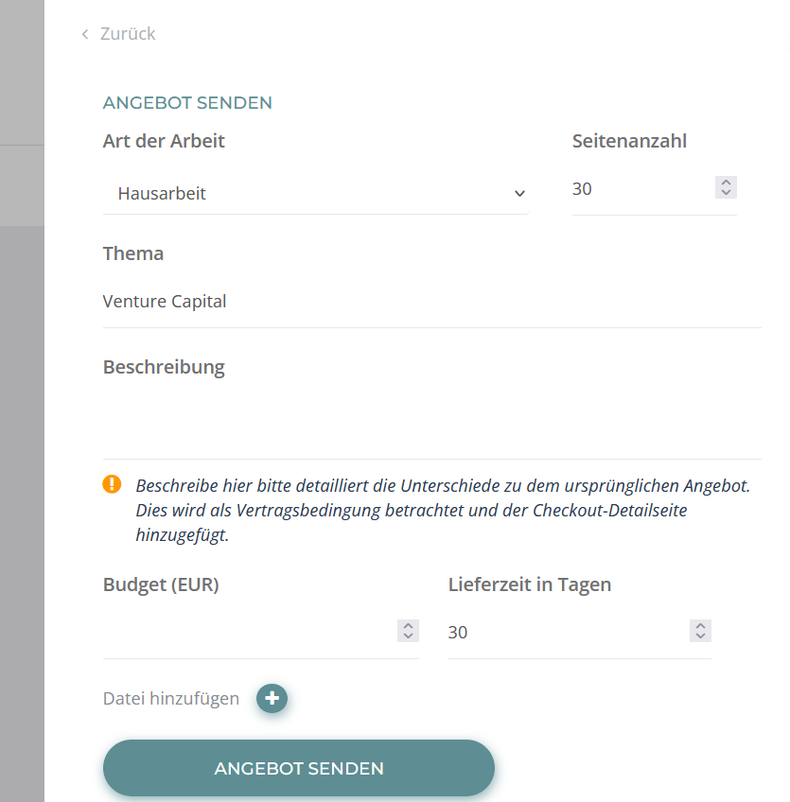

|  |  |
| --- | --- |
| My Profile | The text “Test test” under “Beschreibung” in “Mein Profil” is not transferred to the field “Beschreibung” when clicking on “Registrieren”(when user filled out “Beschreibung”=description, before he clicked “Registrieren”= register)  see picture below:    Better: when he already filled out “Beschreibung” it should be seen when he registers under “Beschreibung” |

1. 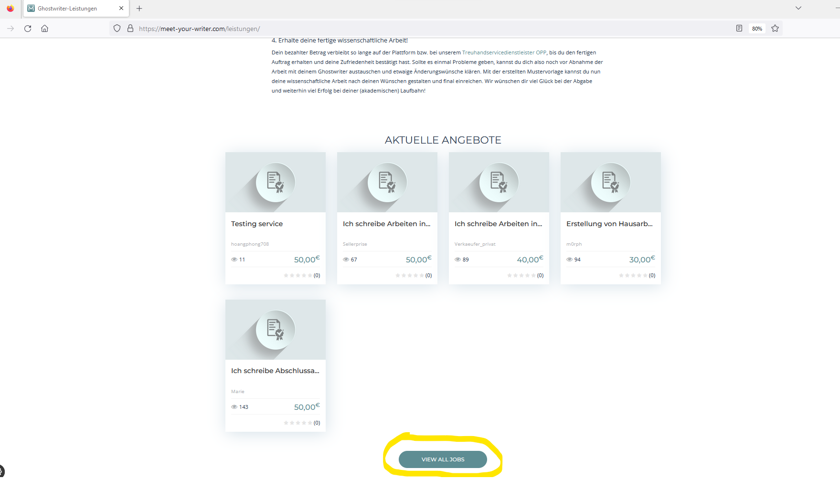I still couldn’t translate “view all jobs” for all Pages
2. Change „Einstellungen Für Abonnenten“ to „Einstellungen für Abonnenten“

And „Passwort Ändern“ to „Passwort ändern“. Probably the CSS for that is right now text-transform=Capitalize?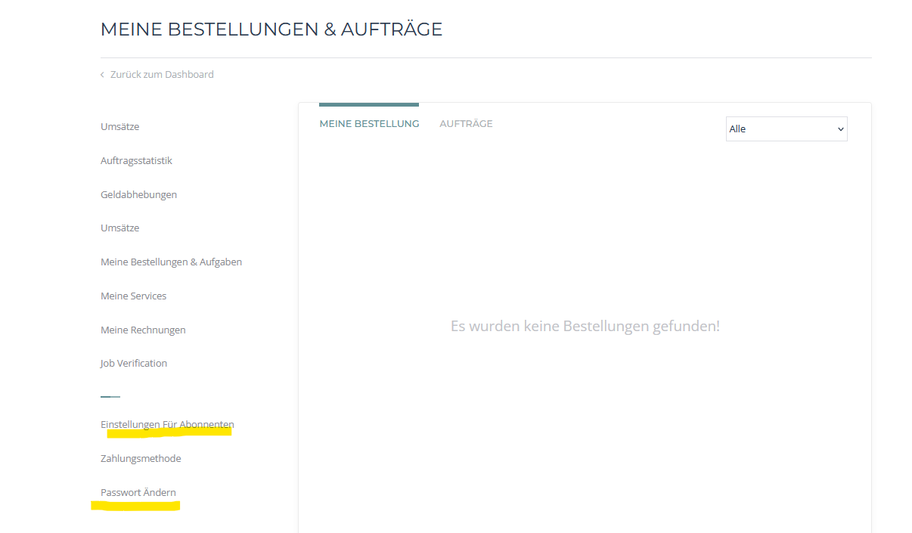

1. 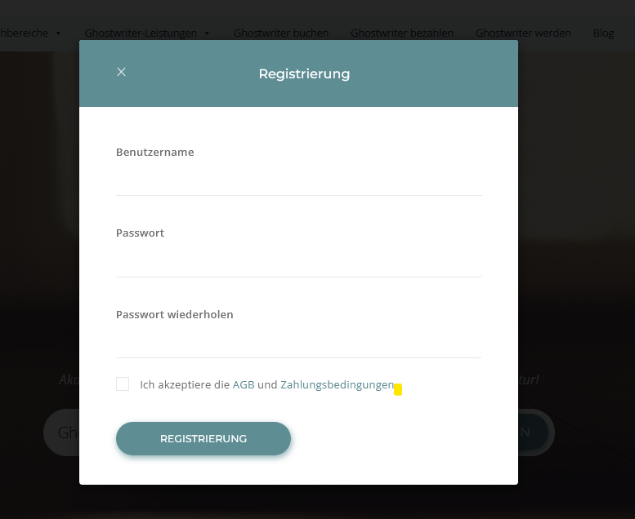

I didn’t know where to find it in the files, here we just need a point in the end of: “Ich akzeptiere die AGB und Zahlungsbedingungen.”

1. I changed the link here, in this file: microjobengine/template/about-block.php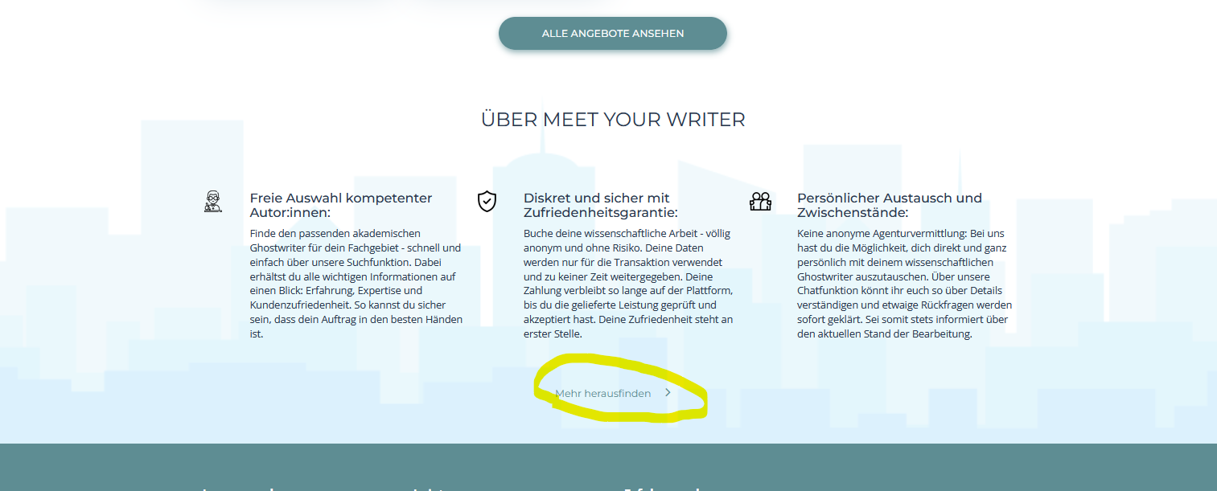

It works, but please can you look if its ok how I did it :D

1. **Proven Expert Trustami and Trustpilot in the footer:**

|  |  |
| --- | --- |
| Footer | **HTML-Code für Proven Expert:**    <!-- ProvenExpert Bewertungssiegel -->  <a  href=<https://www.provenexpert.com/meet-your-writer/?utm_source=Widget&amp;utm_medium=Widget&amp;utm_campaign=Widget> title="Kundenbewertungen &amp; Erfahrungen zu Meet your Writer. Mehr Infos anzeigen." target="_blank" style="text-decoration:none;" rel="noopener noreferrer"><img src=<https://images.provenexpert.com/ea/04/e31843e1cf96d8dbab4247e17e17/widget_portrait_180_de_0.png> alt="Erfahrungen &amp; Bewertungen zu Meet your Writer" width="180" height="216" style="border:0" /></a>  <!-- ProvenExpert Bewertungssiegel -->    **HTML-Code für Trustpilot:**    Fügen Sie diesen Code in den Head-Bereich des HTML-Codes Ihrer Website ein.  <!-- TrustBox script -->  <script type="text/javascript" src="//widget.trustpilot.com/bootstrap/v5/tp.widget.bootstrap.min.js" async></script>  <!-- End TrustBox script -->    Fügen Sie diesen Code an der Stelle in den HTML-Code Ihrer Website ein, an der die TrustBox angezeigt werden soll.  <!-- TrustBox widget - Micro Review Count -->  <div class="trustpilot-widget" data-locale="de-DE" data-template-id="5419b6a8b0d04a076446a9ad" data-businessunit-id="63ea165d89beef73c3cb903d" data-style-height="24px" data-style-width="100%" data-theme="light" data-min-review-count="0" data-style-alignment="center">    <a href="https://de.trustpilot.com/review/meet-your-writer.com" target="_blank" rel="noopener">Trustpilot</a>  </div>  <!-- End TrustBox widget -->    **HTML-Code für Trustami:**  <!--Trustami Logo-->  <a href="https://www.trustami.com/erfahrung/meet-your-writer-com-bewertung" target="blank" title="Trustami Bewertungen und Erfahrungen von Meet-your-writer.com"><img src="https://cdn.trustami.com/img/trustami-logo-text-128.png" style="width: 144px; height: 32px" alt="Trustami Logo" /></a>  This all should look like this and come on the right Side of the footer: |

1. **Change to Ghostwriter werden?**

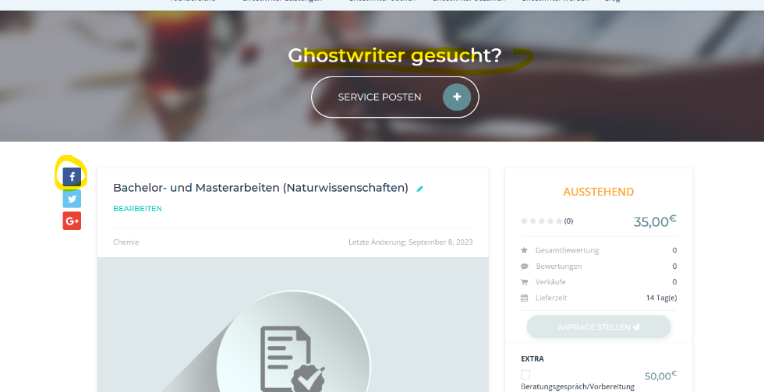

1. **Facebook, Instagram and Pinterest links**

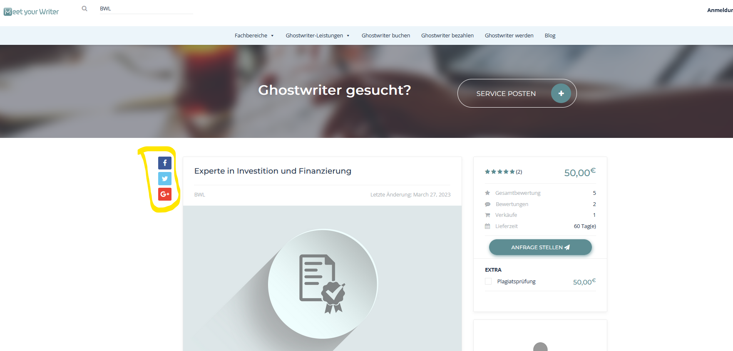

Include the yellow marked icons to all pages and link them to our urls:

Facebook: <https://www.facebook.com/profile.php?id=100083169046788>

Instagram: [https://instagram.com/meet.your.writer](https://instagram.com/meet.your.writer?igshid=OGQ5ZDc2ODk2ZA==)

Pinterest: <https://www.pinterest.de/meetyourwriter>

Change google and twitter icons to Instagram and pinterest

1. **Both Searchfunctions should also consider the categories:**

Not all services from bwl are shown in the example: what I like is that also other services from other categories are shown because the word bwl is in their text. But I would also like it to show all bwl categories as well. And here please also change “Ghostwriter gesucht” to “Ghostwriter werden”

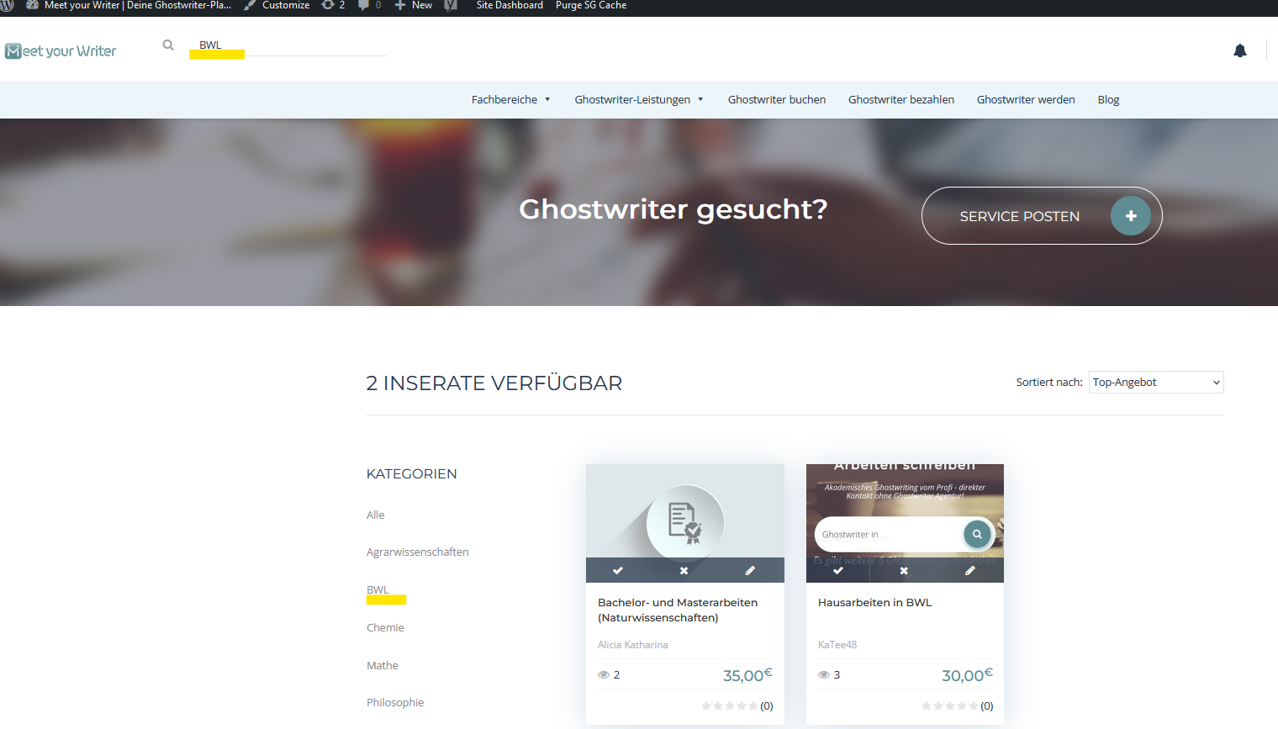

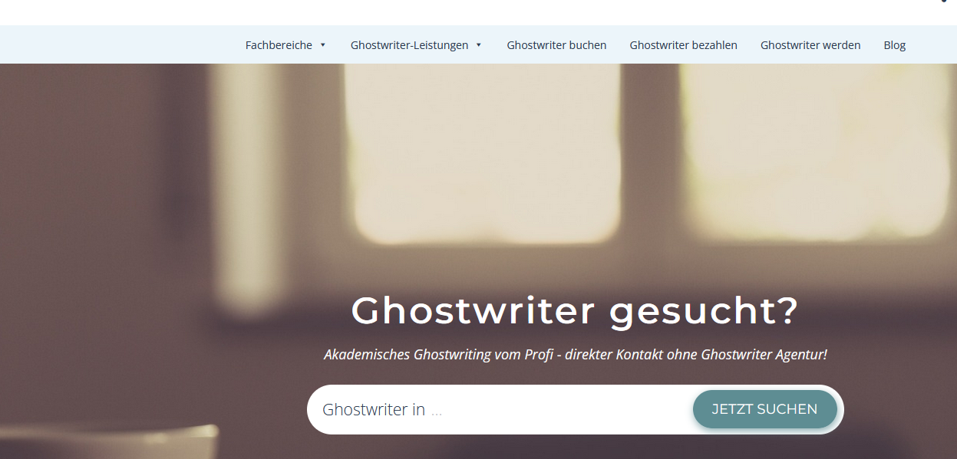

1. **Social Media Pinterest Tag in the head section**

For Pinterest, I need the following verification: Add HTML tag.

Add this tag to the <head> section of your web page.

<meta name="p:domain_verify" content="9682236fe504ad406d194c858598aff6"/>

1. Can I sort the header menue? -> Alphabetically?
2. Where can I translate the blog section? 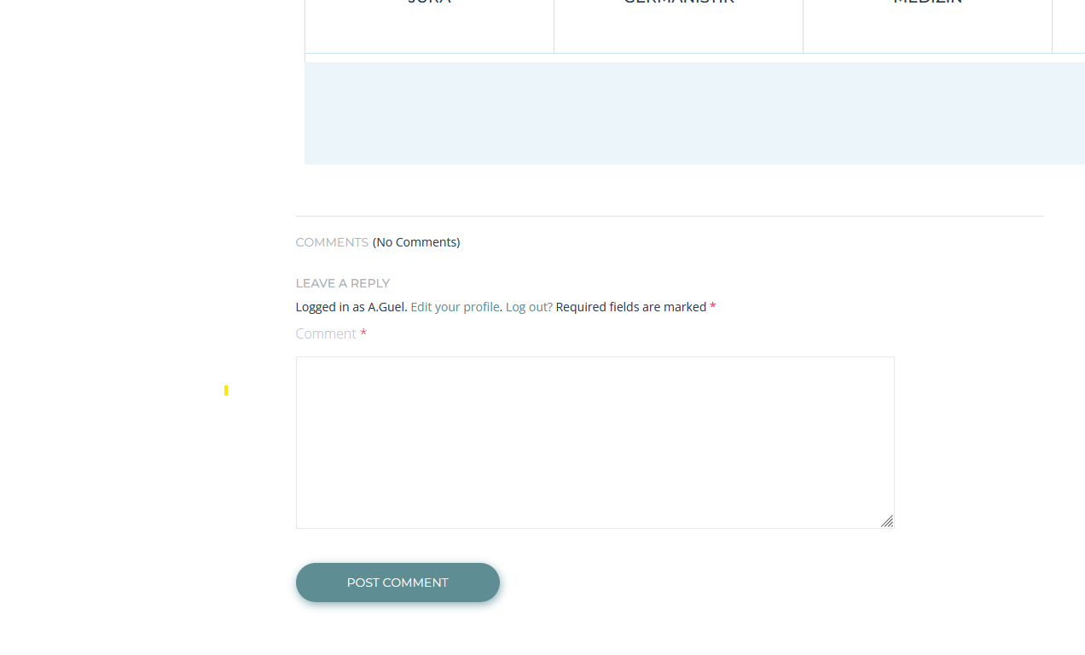
3. Blog posts (for all posts and future posts): Can you bring the widget in alignment without changing the text structure. By for example making the width smaller?

