REMAINING CORRECTIONS AND ACTIONS 123redaction.fr

URGENT:
1) When logged in as a Freelancer: go to the top right on my profile name then select MY PROFILE: Then at Portfolio: click on the orange button: add new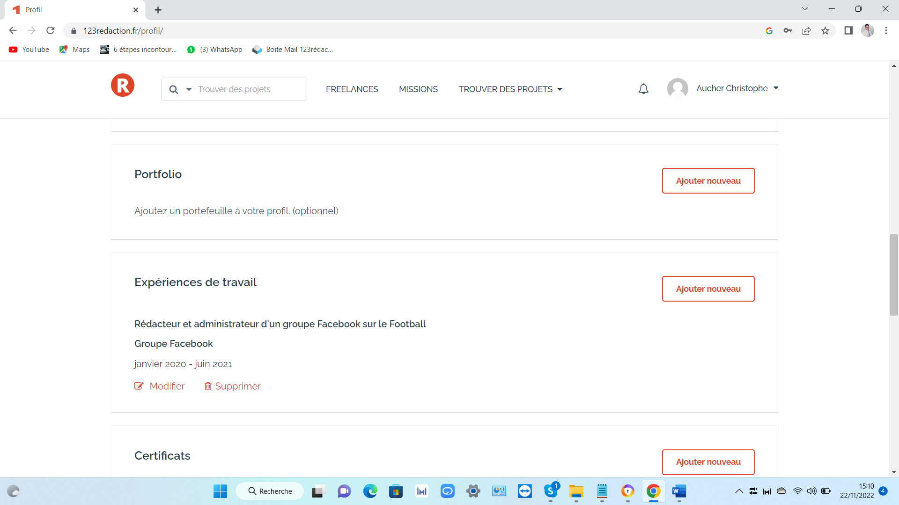
According to the display above the drop-down menu is cut off and located below the field at the bottom: in skills (optional): make the drop-down menu appear above the field so that it is visible on the screen (the drop-down menu depends on the skills entered in the freelance profile): to be processed by developer. URL link: https://123redaction.fr/profil/

2) When connected in Freelance: go to the top right on my profile name then select MY PROJECTS: click on the button: workspace: misadjusted the text in the button: 1st error: In the workspace button and below the button: work: To be processed by developer (in project holder connection it is Ok: checked). Link: https://123redaction.fr/mes-projets/

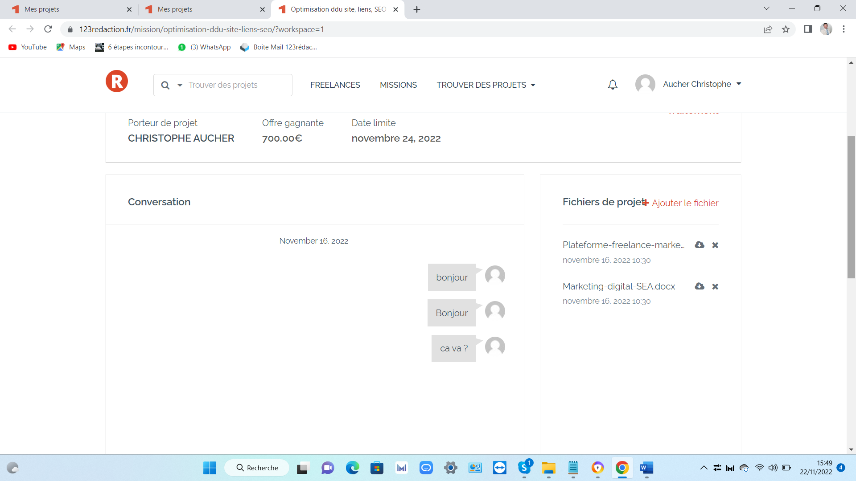
3) When logged in as a Project Holder: go to the top right on my profile name then select MY PROJECTS: click on the button: workspace: text overlay: Project files in black and orange + add file or + lock file: words on top of each other (depending on context). Link: https://123redaction.fr/mission/optimisation-ddu-site-liens-seo/?workspace=1
4) Workspace of the 2 accounts Freelance or Project Sponsor: the response bar (message) is too low and not visible on the screen, move it up to the level of the last message sent by one or the other. When connected as a Freelancer: go to the top right of my profile name then select MY PROJECTS: click on the button: workspace: link: https://123redaction.fr/mission/optimisation-ddu-site-liens-seo/?workspace=1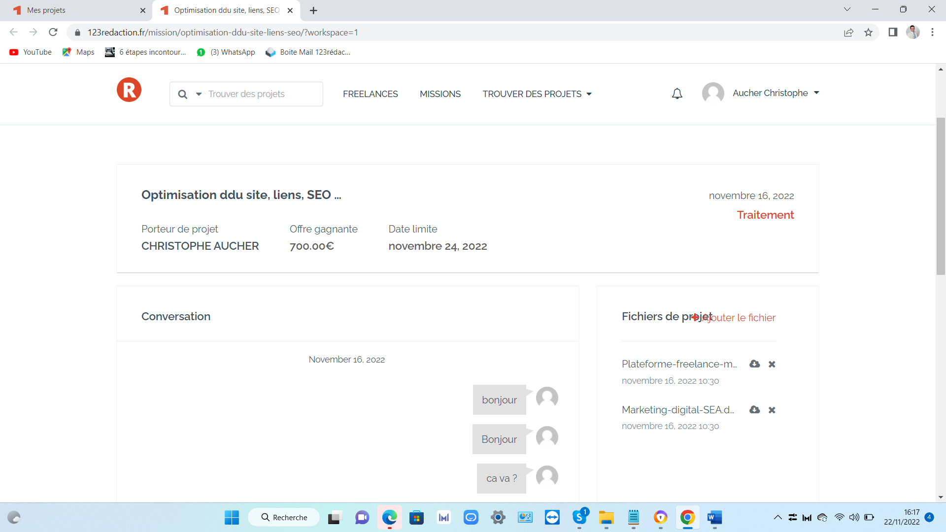

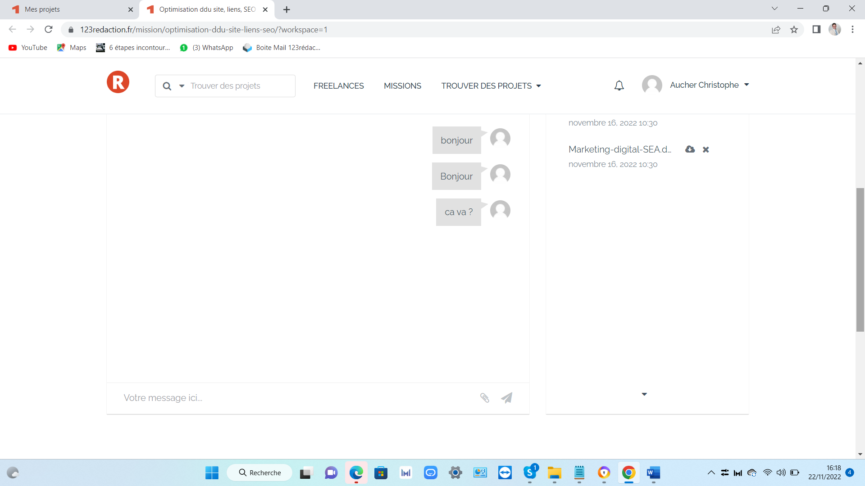
When logged in as a Project Developer: go to the top right of my profile name and select MY PROJECTS: click on the button: workspace: link: https://123redaction.fr/mission/optimisation-ddu-site-liens-seo/?workspace=1
=>To be processed by developer.
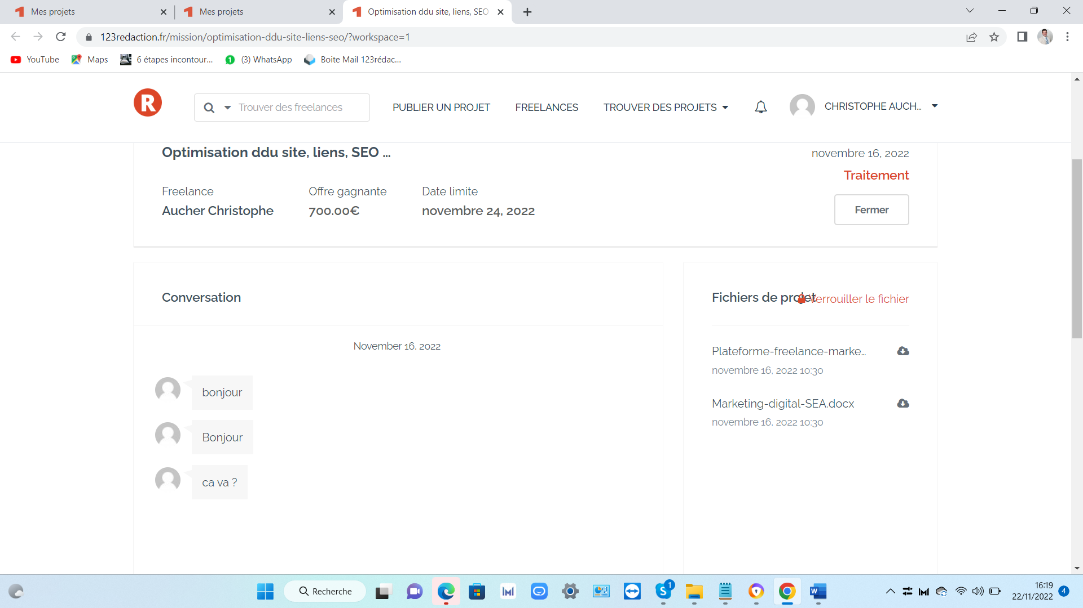

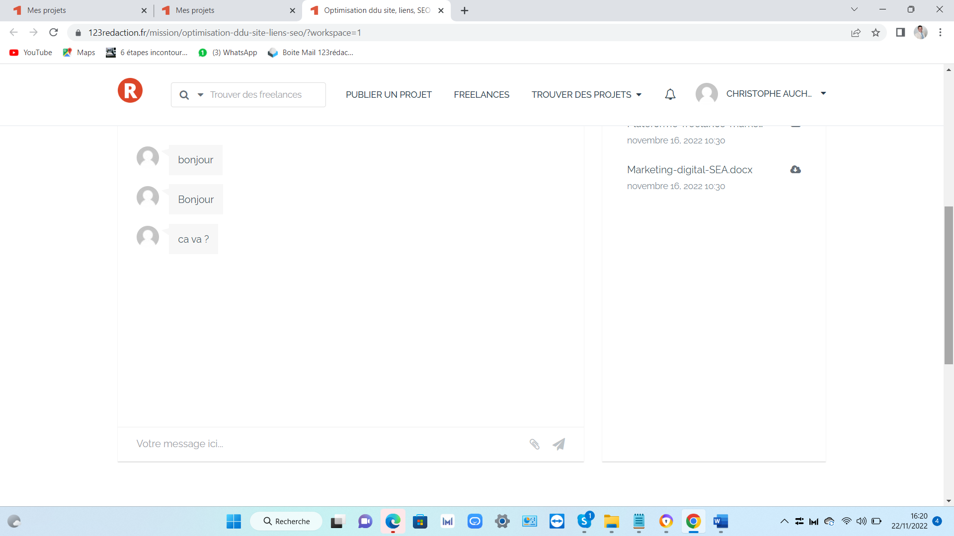
5) When you access 123redaction.fr, without logging in as a Freelancer or Project Developer, the 3 images of the BLOG articles on the home page appear, but not the text (or partially):
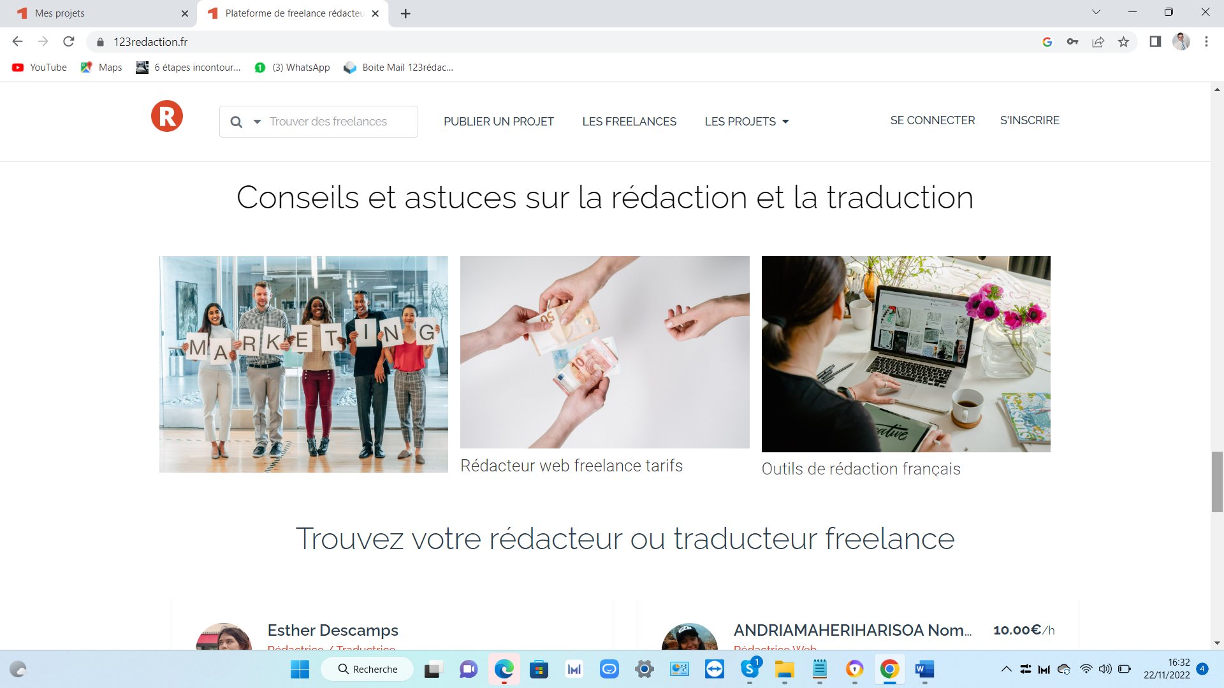

When refreshing the current page or if you log in as a freelancer or project owner: the text display is GOOD.
=>To be treated by the developer.

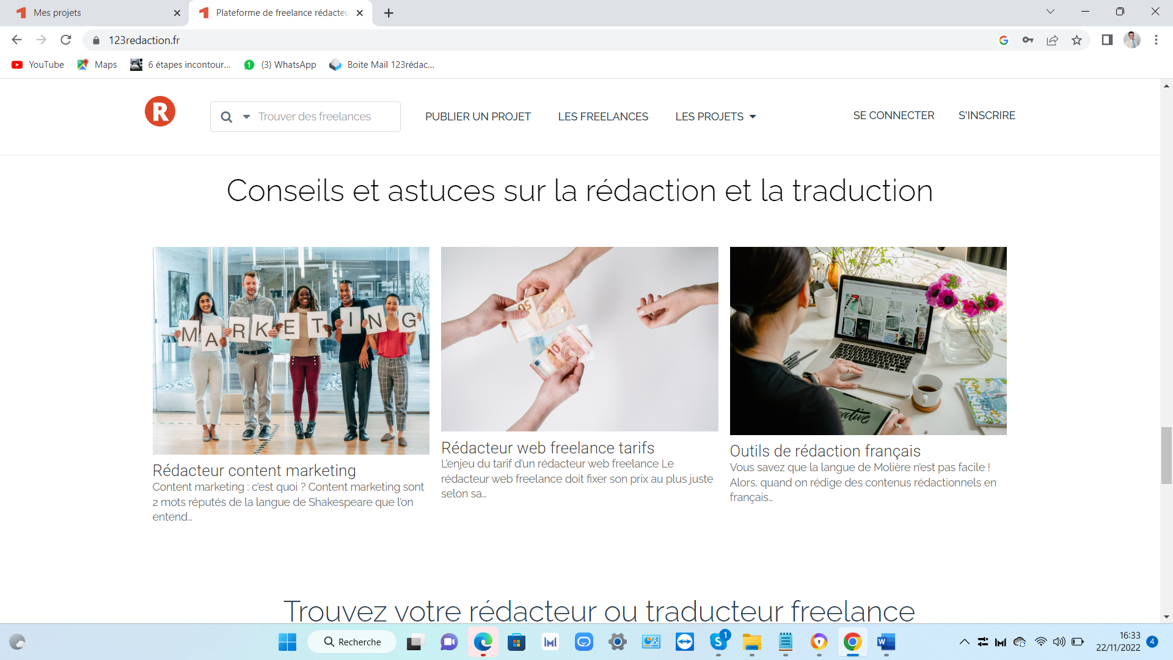

6) Spelling error in Freelance and Project Developer when logged in: Freelance: When logged in as Freelance: go to the top right of my profile name then select MY PROFILE: Then, under the name: 0 projects worked: note instead 0 project(s) worked. Project Developer: When connected as a Project Developer: go to the top right of my profile name and select MY PROFILE: Then, underneath the name: 1 projects posted: note instead: 1 project(s) worked on.
Project Developer: link: https://123redaction.fr/profil/

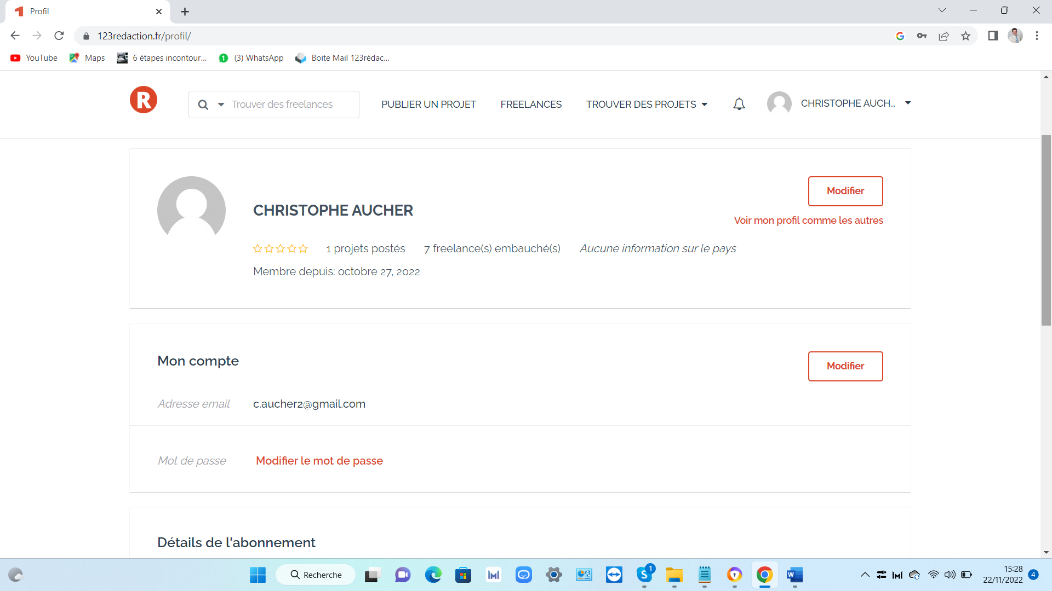
Freelance : link : https://123redaction.fr/profil/
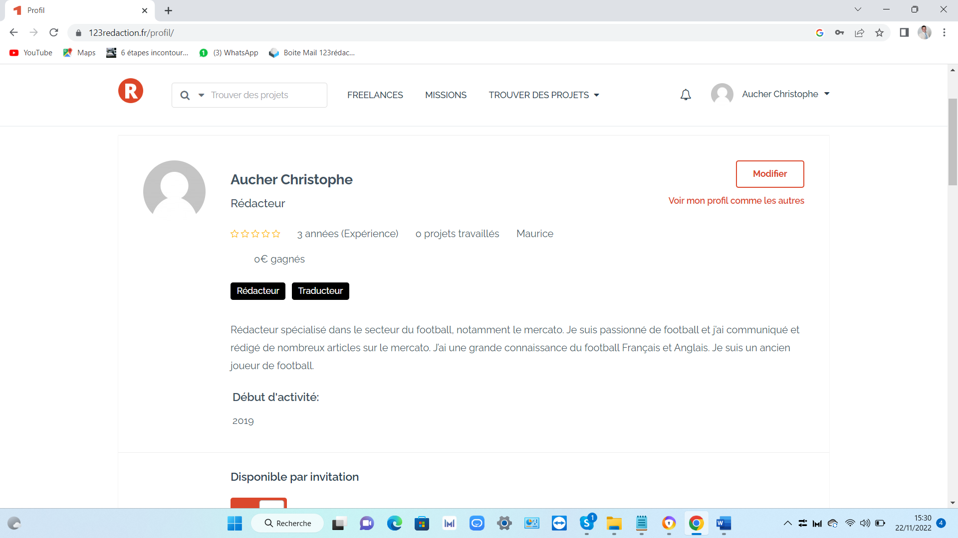
=>To be processed by developer.

7)When the mission is created by the project owner: if he/she makes mistakes or errors on the online mission: impossible to go back and make changes on the online mission: spelling error or text change .... Future improvements to be dealt with by the developer.
=>Because my project owners are missing the edit button

8) The number of freelancers on the directory has a problem. Arriving on the home page for example there are 400 freelancers, we click on page 2 there are 380 freelancers, we click on page 1,380 freelancers.

