

**Document Revision History**

| Version | Date | Author/Editor | Comments |
| --- | --- | --- | --- |
| 1.0.0 | 14/10/2022 | Jade | Initial version of this document |
|  |  |  |  |
|  |  |  |  |

**Table of Contents**

**Flow chart 3**

**Admin portal 4**

PAC listing 4

Create PAC 5

**Patient portal 6**

Patient to fill in the form 6

**Provider portal 8**

Dashboard 8

**Admin portal 9**

Assessor form listing 9

Assessor form details 10

# Flow chart

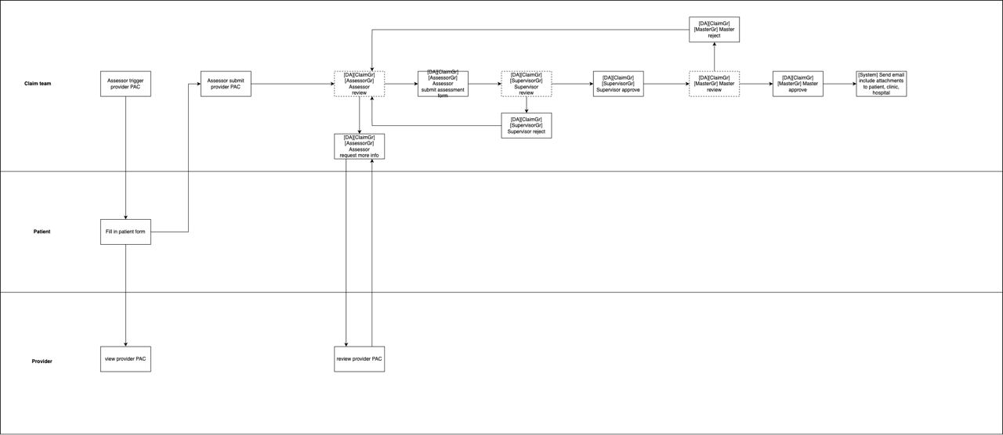

The tables below describe all status of one case

| **Claim Status** | **Definition** |
| --- | --- |
| Assessor triggered PAC | After assessor request PAC |
| Patient submitted PAC | After patient submit PAC |
| Assessor submitted Provider Form | Assessor has submitted the PAC |
| Clarification Required | Claim Assessor to manually change the status to Clarification Required and send back the PAC to provider to complete all information |
| Assessment in Progress | Status will auto change back to ‘Assessment in Progress’ when Claim Assessor receives clarification response from provider. The information in PAC form is completed |
| Pending Supervisor Approval | Assessor has completed review  Assessor has submitted the case to Supervisor for review & approval |
| Pending Master Approval | For case under Level 3, Supervisor/Master has completed review |
| Approved | Assessor/Supervisor/Master submits case with status Approved |
| Rejected | Assessor/Supervisor/Master submits case with status Rejected |
| Cancelled | Assessor/Supervisor/Master submits case with status Cancelled |

# Admin portal

## PAC listing

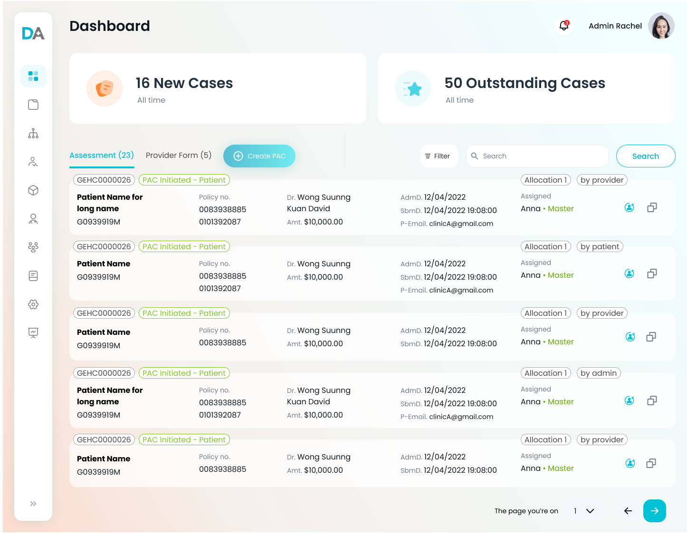

Acceptance criteria:

* By clicking create PAC button, assessor can create PAC

## Create PAC

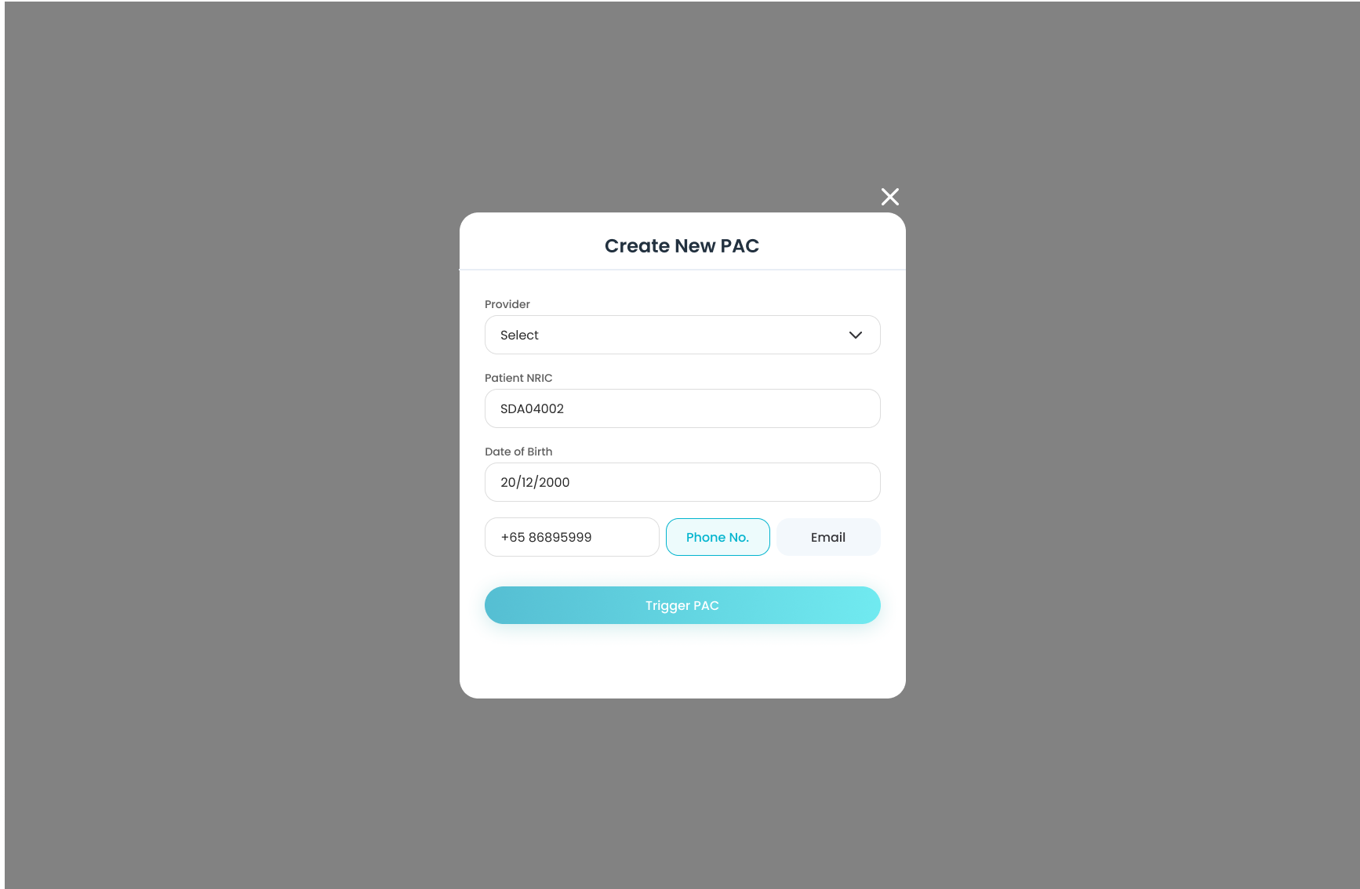

Acceptance criteria:

* Show all actived provider for assessor to select, do not show inactived provider
* Assessor can choose the provider to view the PAC created. Only the provider selected can view the PAC
* Enter NRIC and DOB matching the API validation to trigger the PAC, use the API check the same as provider PAC flow
* Enter Phone or Email to receive the PAC link and other emails to the same as provider PAC flow
* The PAC created with status: Assessor triggered PAC

# Patient portal

## Patient to fill in the form

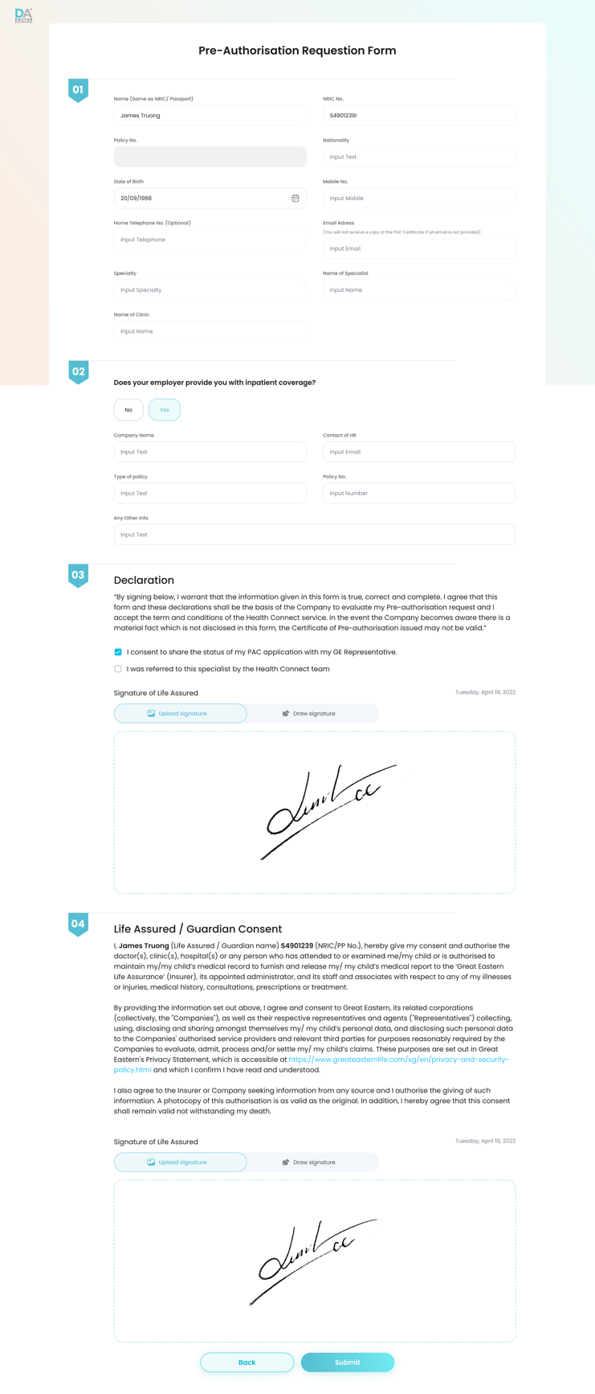

Acceptance criteria:

* Patient fills in the form as the current flow

# Provider portal

## Dashboard

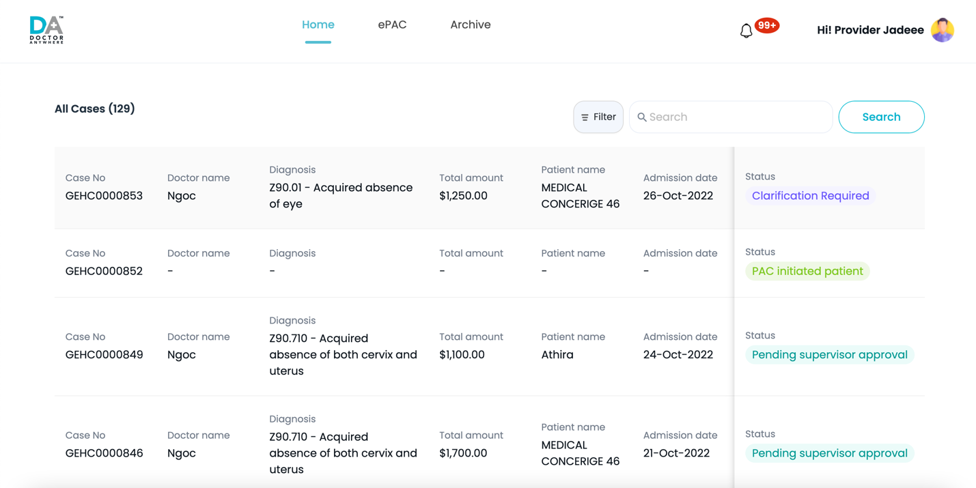

Acceptance criteria:

* After the patient fills the form, the provider selected can view it and not edit.
* The PAC shown in the provider and admin dashboard with status Patient submitted PAC

# Admin portal

## Assessor form listing

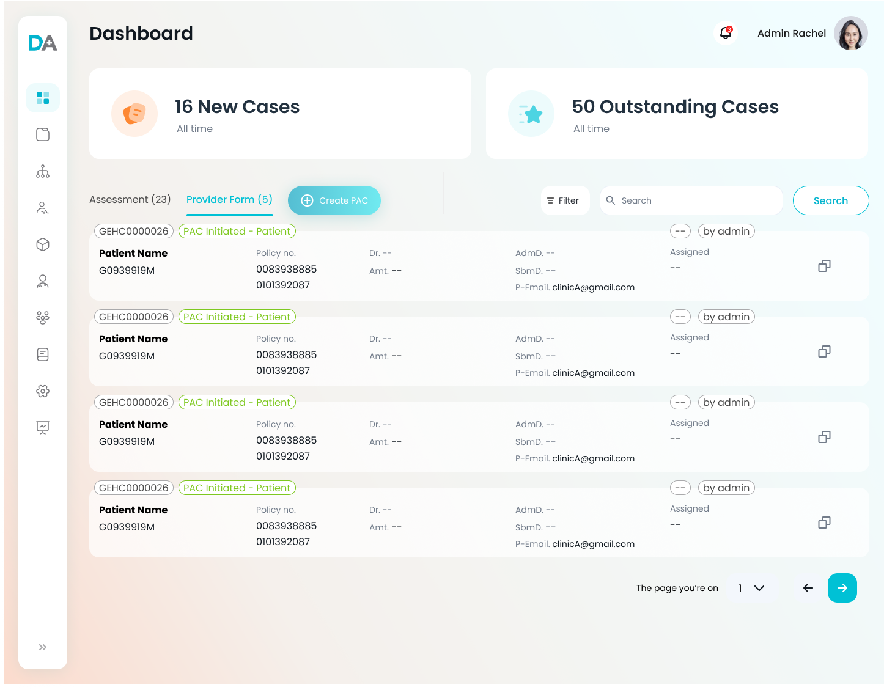

Acceptance criteria:

* Show all the PACs **created by assessor and assigned by allocation to assessor** under Assessment tab in Admin Dashboard
* Show “by admin” for all the PACs created by assessor
* Show “by provider” for all the PACs created by provider
* The PAC is assigned to Assessor by Allocation logic
* Super admin can view, claim team can edit the PAC as the current logic in provider PAC flow, the same comment feature

## Assessor form details

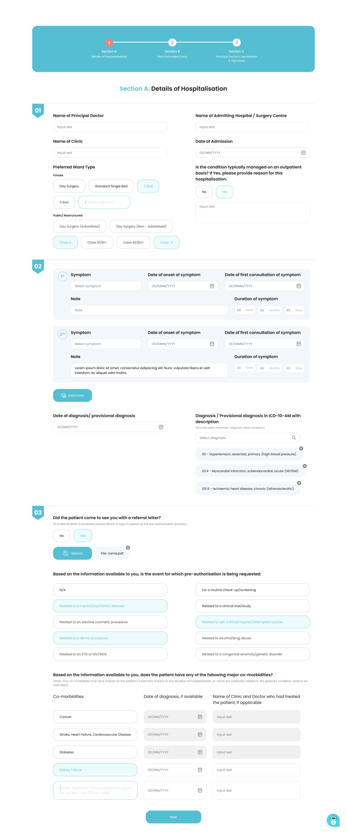

Acceptance criteria:

* Assessor can fill the form, all the validation are the same as provider PAC flow
* Do the header of assessor form to the same as claim assessment header
* After the assessor fills in the form, the assessor can submit the case with status Assessor submitted Provider Form
* Assessor can submit the case back to provider to view with status Clarification required
* Can submit the case to Supervisor with status Pending Supervisor Approval
* The rest status and archive flow are the same as the provider PAC flow