Solution Design

1. **Database design:**

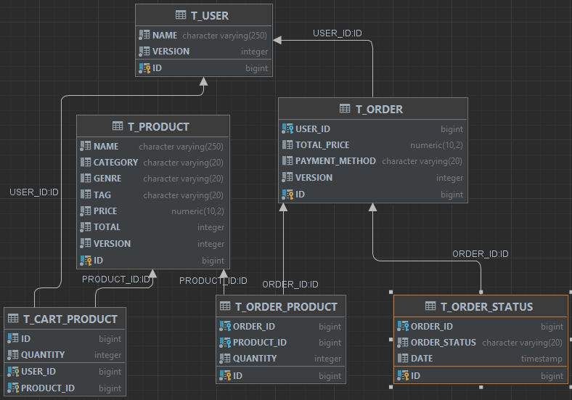

T_PRODUCT: to store a game

T_CART_PRODUCT: store many games in a Cart link to a T_USER .

T_ORDER: an user have many orders, each order includes several game products T_ORDER_PRODUCT.

T_ORDER_STATUS: store status of order during it process.

1. **Basic workflow diagram**

