**Comments**

**1. Homepage**A. the quote text should be in BOLD and the “**Roisin Kelly – Rome, Italy” should not  
B. Need more spacing between the headline Why Choose London Food Lovers? And the text below it**

C. There should be more spacing between the “View All Tours” button and the text above it.  
D. Instead of the button “View All Tours” it should say “View Tours” and the font should be bold  
E. Instead of the headline: **LONDON SOHO TOUR** it should be “SOHO INTERNATIONAL FOOD TOUR”

F. Some text gets out of the grid – I marked it in a black line so you can see it:  
  
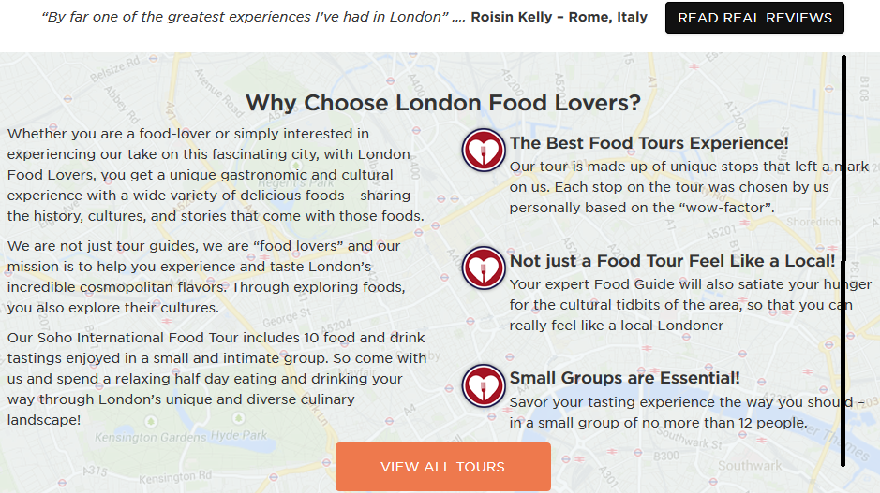

G. The 3 heart icons are too close to the text – move the text a bit to the right

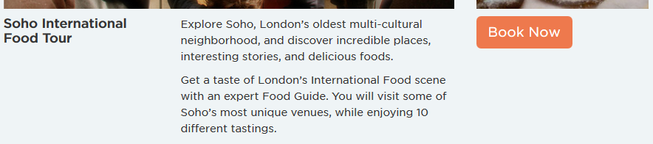H. The “Book Now” button below should be aligned to the middle of the picture above it, not aligned to the left:

I. We also send it will be a slider with changing pictures…  
J. Remove this line: “For more information about this tour click [here](http://londonfoodlovers.com/)”  
K. The address and the phone in the footer are not correct. I sent you the info please replace it.  
L. At the end it says: “© Food Lovers Limited. All Rights Reserved”. Should say “2014 Food Lovers Tours LTD. All Rights Reserved”.  
M. For the SEO text please write: London Food Lovers Food Tours are rated among the top London Attractions, London Tours, London Private Tours, London Group Tours and London Food Tours.   
N. For SEO we need a Sitemap page and link to this page from the footer. (Similar to this page: <http://www.eatingitalyfoodtours.com/sitemap/>)   
O. I don’t like this radio buttons – they are not subtle:  


P. Social icons need to be removed also from the footer at this point  
Q. Until we create a TripAdvisor active profile, just remove the TripAdvisor box  
R. The “BOOK NOW” button in the header links to the “Contact Us” page by mistake…

1. 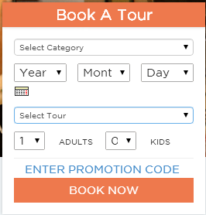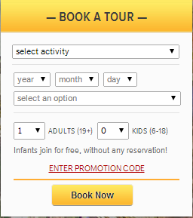**The booking form:**The form should look exactly like here: <http://www.myvaticantour.com/>   
     
     
     
     
     
     
     
     
     
     
     
     
     
     
     
     
     
     
     
     
     
     
     
     
     
     
     
   Meaning:  
   A. Dates fields should be much smaller   
   B. near ADULTS it should say (13+) and near KIDS it should say (5-13)  
   C. The line “ENTER PROMOTION CODE” should be small  
   D. The BOOK NOW button should be small and not be flat, but like the reference  
   E. The first field should already say “Soho International Food Tour”  
   F. The “select an option” should already say: “Morning Tour – English - 09:45AM”   
   G. The form should appear on ALL pages of the website
2. Review page comments – already sent yesterday. Please remember to take off the “Submit a Review” from there
3. Left Panel on inner pages – sent you the comments yesterday
4. 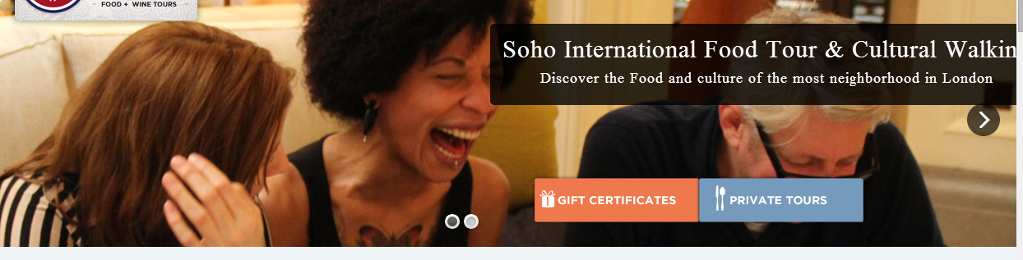Soho Food Tour Page:   
   A. The “Reviews” Tab should show the reviews that appear in the Reviews page. (Same as it works here: <http://www.darkrome.com/tours/vatican-tours/skip-the-line-vatican-museum-sistine-chapel-group-tour> )  
   B. Something is not ok with the text box on the header image (look how it’s cut on the right side – this problem exists in more pages –please check):

Also the sub-headline there misses a work “The most (missing word) neighborhood in London”

1. 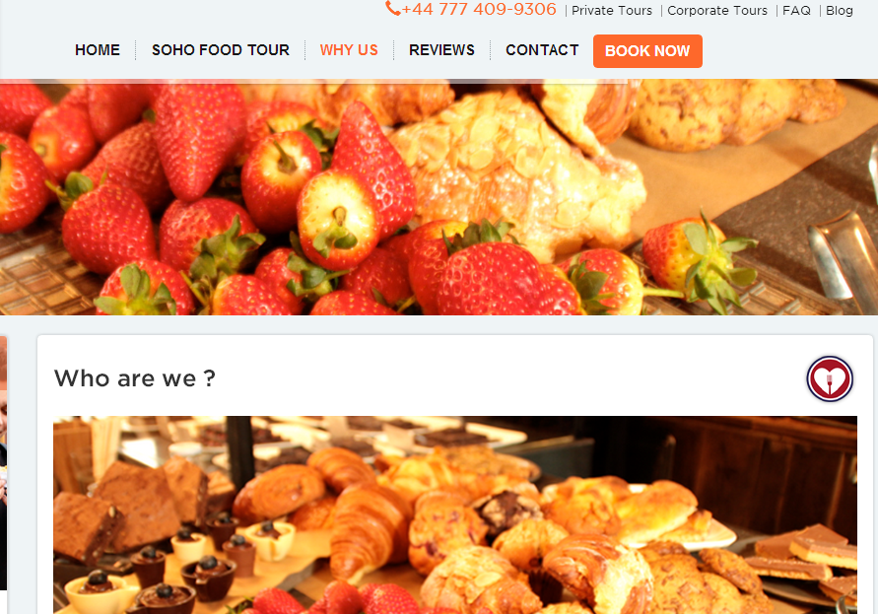“Why Us” Page:   
   A. It’s strange that you use the same pictures for the upper header and for the content part. See for how it looks like (It has to be different pictures):

B. The heart icons are nice but I think they should be to the left of the headlines

1. 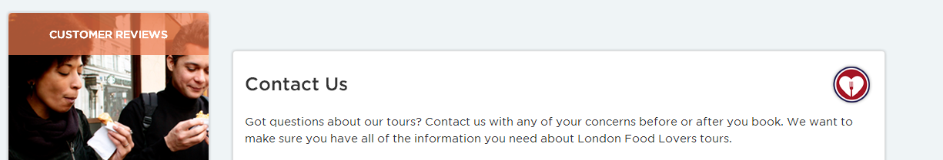Contact Us page:  
   A. Remove social icons at this point  
   B. At the end of the “PRIVATE TOURS AND GIFTS” text there should be 2 links to these pages  
   C. At the end of the “STILL HAVE QUESTIONS” text there should be link to the FAQ page  
   D. The elements need to be aligned:

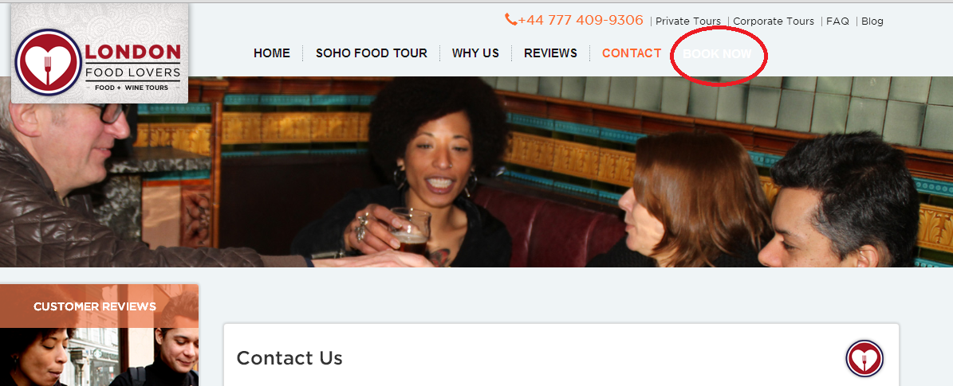E. When you are on the “Contact” Page, the “BOOK NOW” button at the header disappears:

1. FAQ page: At the end of the questions you should have a text box saying: “Didn’t find what you are looking for? Contact Us (the Contact Us should be a link to the contact us page.
2. Blog – I am still waiting to see it
3. Gift Certificate Page:   
   A. The header doesn’t have an image:  
   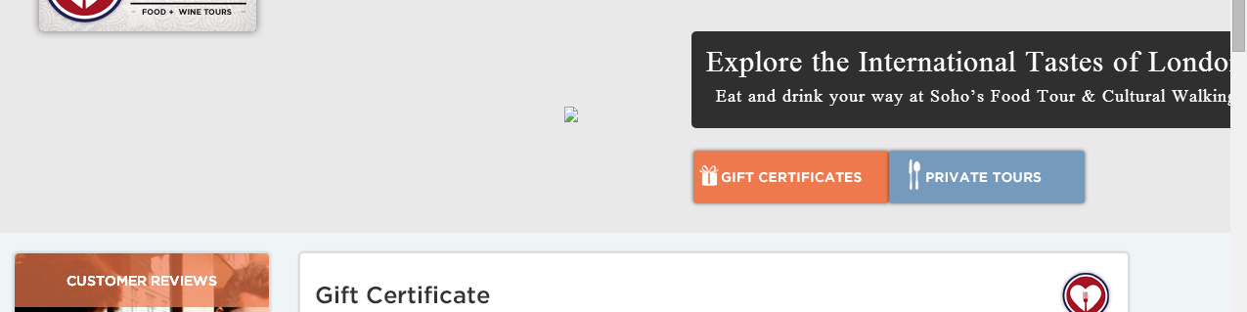  
   B. There should be only image there – no text or buttons on the image  
   C. This text box doesn’t look good:  
   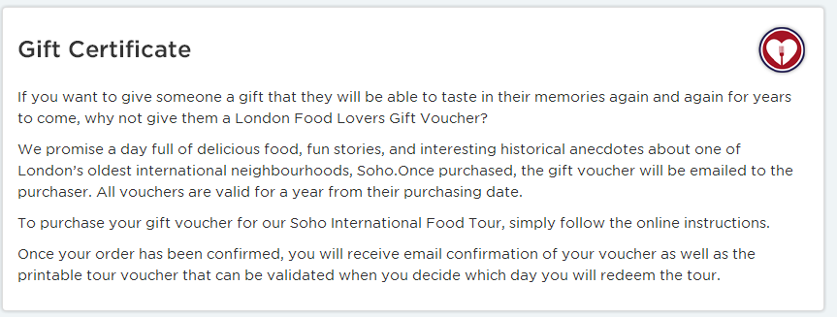

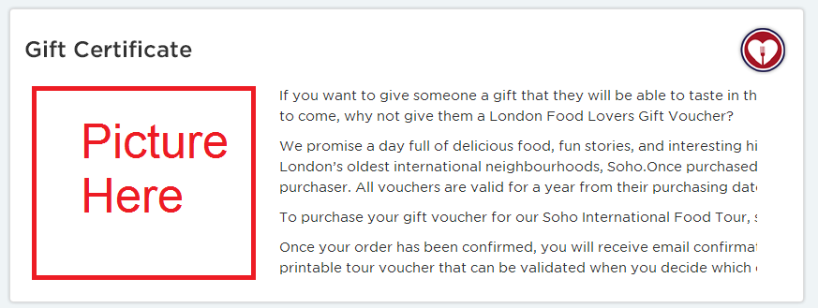I suggest adding a picture. Here is an illustration:

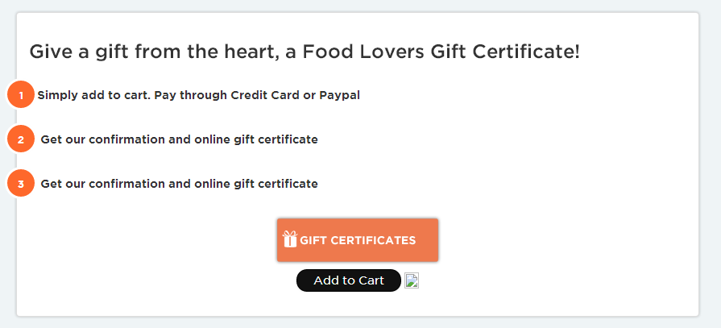D. This text box has a few problems:

* The numbers are out of the greed
* The second and third line have the same text
* We originally planned on using PayPal for this but we want to use Authorize.net for this. Can you check with Checkfront if they have a mechanism to buy a gift certificate, and if so, change the process and call for action accordingly?

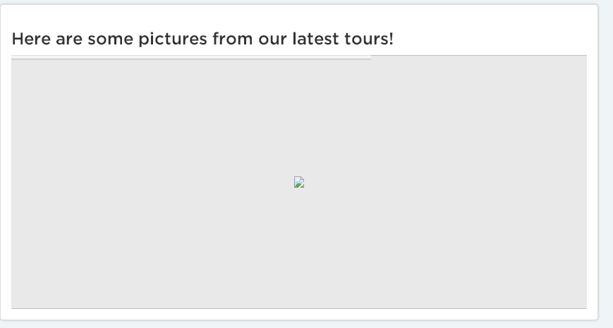E. The images here don’t work:

1. 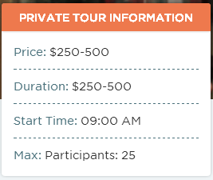Private Tours Page:  
   A. please remove this box

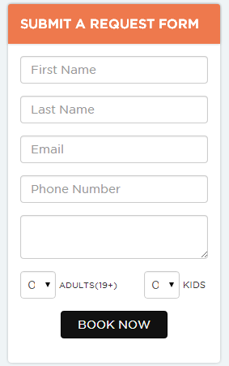B. The Request form is not with the fields I requested:

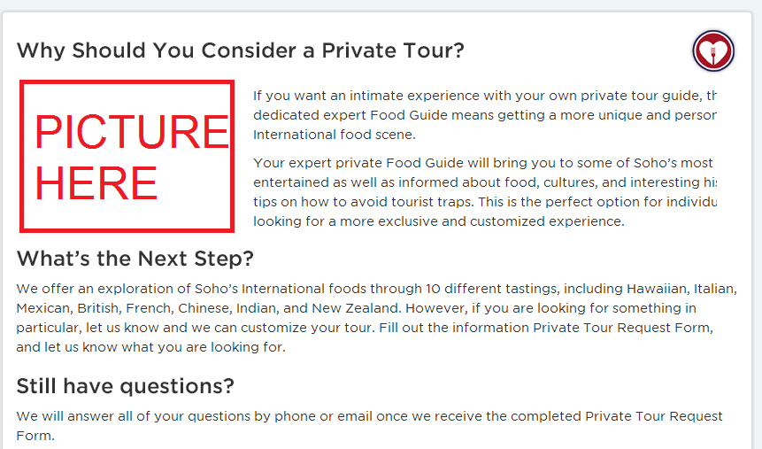C. Regarding the text – same comment as I had before – should add a picture – see illustration:

1. Corporate Tours Page: Same comments as the Private Tours Page