Study Case
Design
Individual
Revision: 0.1
Copyright © 2014 All Rights Reserved. No part of this document may be reproduced, stored in a retrieval system, distributed or transmitted, in any form, or by any means, electronic or otherwise, including photocopying, reprinting, or recording, for any purpose, without the express prior written permission of Trung Huynh.

REVISION HISTORY
Revision No. | Date | Description of Change | Author | Reviewed & Approved By
0.1 | 15-Oct-14 | Initial draft document | Trung Huynh | N/A

Contents
- 1. Introduction 3
1.1 Purpose 3
1.2 Scope 3
1.3 Audience 3
1.4 Acronyms and Abbreviations 3
1.5 References 4
- 2. Design Overview 5
2.1 Description components and technical 5
- 3. Design Considerations 7
3.1 Dependencies 7
3.2 Constraints 7
3.3 Design Methods 7
- 4. Architectural Strategies 9
4.1 Programming Environment 9
4.2 Memory Management Policy 9
4.2.1 Response Time 9
4.2.2 Inter-Process Communication Mechanism 9
4.3 Logging and Tracing 9
- 5. Functional Design 11
5.1 Common 11
5.1.1 Get information from internet 11
5.1.2 Saving result to review offline 12

Figures
Figure 1: Application architecture 5
Figure 2: Retrieve information 11
Figure 3: Save information 12

Chapter
1

Introduction

Purpose
This document presents the design of Study Case. It covers the design, configuration logic and implementation of the entire Study Case.

Scope
The scope of this document is limited to provide the architecture of Study Case, the design and the process of the Study Case.

Audience
The intended audience of this document includes the following but is not limited to:
- User

Acronyms and Abbreviations

Acronym | Explanation
API | Application Programming Interface
HTTP | Hypertext Transfer Protocol
TCP/IP | Transmission Control Protocol/Internet Protocol

References

Chapter
2

Design Overview
The Study Case is divided into two parts with the figure below.
Figure 1: Application architecture

Description components and technical

Google Places API: the library to access and retrieve information from Google Places.
Application: uses API to get information and retrieve them to save result.
Chapter
3

Design Considerations

Dependencies
- Any operating system.
- Python 2.7.
- Terminal command line.

Constraints
N/A

Design Methods
N/A

Chapter
4

Architectural Strategies

Programming Environment
- Windows 8.1
- Eclipse 4.4 tool (PyDev), Cygwin (python 2.7) runtime environment.

Memory Management Policy
N/A

Response Time
Request & response time should be less than 5s.

Inter-Process Communication Mechanism
TCP/IP will be used for communication between application and internet.

Logging and Tracing
N/A
Chapter
5

Functional Design

Common

Get information from internet
Functionality ID: func_01
Description: By using Internet Service (google.com) to collect the information of the restaurants in Ho Chi Minh, Viet Nam.
User can type the command in terminal to get information from internet. The scripts will retrieve information from data and show to user the name, address and phone number of these restaurants.
User can consider to save information have got to local disk (refer in section 5.1.2).

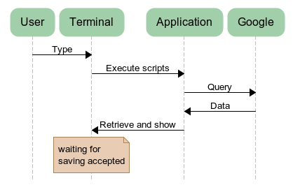
Figure 2: Retrieve information

Saving result to review offline
Functionality ID: func_02
Description: After get information, the teminal is waiting for user’s acceptance to save it to local disk.
User type Yes or No to save information or not. The file will appear on local disk in same with the scripts location.

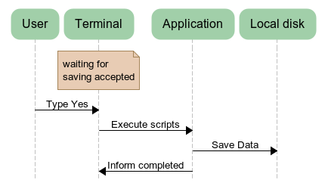
Figure 3: Save information

