Nguyen Hoang Bao Chau

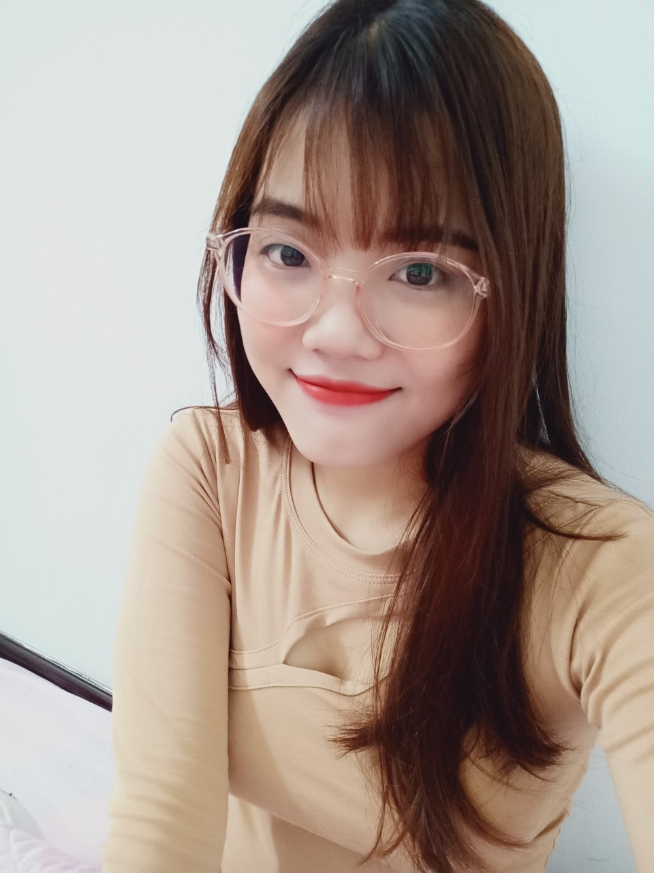

**Date of birth:** January 27, 1997.

**Gender:** Female

**Phone:** 035 880 4580

**Email:** nguyenhoangbaochau1997@gmail.com

# OBJECTIVE

With the belief of treasuring what we have learnt rather than how long I have experienced; I am trying hard every single day to exploit new challenging yet exciting things in life.

My short - term intention is to seek for one position that can allow me to extent my knowledge as well as experience in Business Development, specialized in Vietnam E-commerce.

# WORK EXPERIENCE

**07.2019 – 09.2019 VNPT Hau Giang**

*Internship – accomplished the term successfully with unexpected outcomes.*

* Support information and guide customers to use digital signatures, electronic invoices, tax declaration and social insurance software.
* Providing appropriate help, advice and recommendations based on for customers.
* Understand workflow, especially with the software installation and support to guide customers to use the service.
* Analyze and handle the problems that customers encounter when using the company's services.

**04.2017 – 11. 2019** **CGV Vi Thanh**

*Part-time employee - achieving great complement from management team.*

- Doing research & investigate other competitor’s activities.

- Survey and collect customer feedbacks and market situations.

- Handling customer complaints

- Continuously increasing sales skills.

**12.2020 – ACACY LIMITED COMPANY**

*IT Programmer - IT DEPARTMENT.*

- Learn the basics of departments in the company.

- Get to know your company's customers and partners.

- Join the Office IT project. Implementing projects on Net Core, Angula, Mongodb with the main programming language is C #. Working with SQL, python, report, data.

# EDUCATION

**10. 2015- 05.2020**  **Can Tho University**

*Major****:****Information Technology*

# SKILLS

English, SQL, Excel, Power Point, Teamwork, Eclipse, Netbeans, SQL server, MySQL, Visual Studio, Atom, PHP, Python, HTML/javascritps, Java, C++, C#….

*---------------------------------------------------------------------------------------------*

*Discovered true passion was not that easy. Luckily, I found one and I am diving in it.*

*If life only let me choose 01 ability to keep, I will not hesitate to choose the* ***SELF – STUDYING.***