

COS30018 – Intelligent Systems

**REPORT**

TASK B1 – SETUP



**TABLE OF CONTENTS**

*Table of contents…………………………………………………………………………………………………………………2*

*I. Setup……………………………………………………………………………………………………………………………….3*

*1. Setup environment on local machine………………………………………………………………………3*

*2. Setup virtual environment………………………………………………………………………………………4*

*3. Setup project………………………………………………………………………………………………………….5*

*II. Testing………………………………………………………………………………………………………………………*

*1. Testing* ***v0.1*** *and* ***P1****……………………………………………………………………………………………*

*2. Testing* ***P2****…………………………………………………………………………………………………………*

*III. Conclusion……………………………………………………………………………………………………………………*

**SETUP**

**1. Setup environment on local machine**

First, I have installed Python, version 3.10.7, from <https://www.python.org/downloads/>

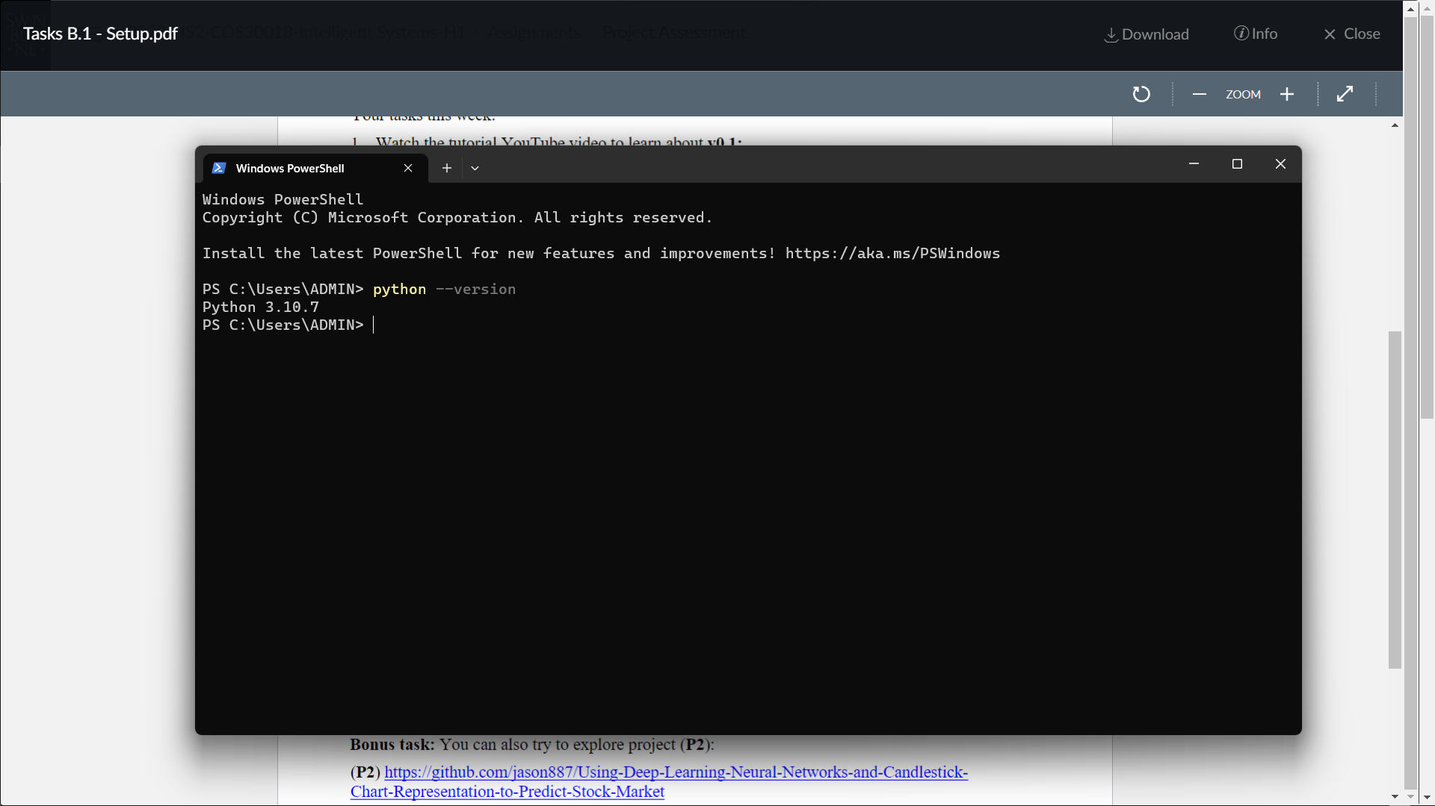

Then is the installation of some necessary libraries for the project, including *pandas*, *pandas-datareader*, *numpy*, *tensorflow*, *yfinance* and *scikit-learn* using *pip*:













**2. Setup virtual environment**

To create Python virtual environment, I have used the library of *venv* as a common virtual environment library for Python.

I have created a new virtual environment, and named it “myenv”:

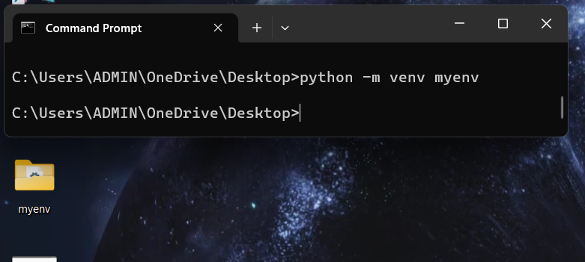

To activate the virtual environment, I change the directory into myenv\Scripts, and run the activate.bat file:

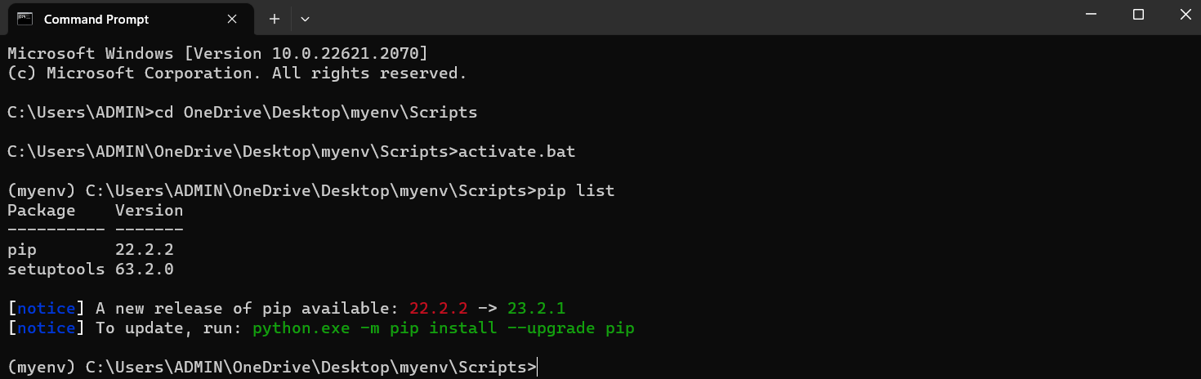

Now, It is possible to install Python packages or libraries without affecting the system-wide Python installation in my local machine.

To deactivate it, I run the deactivate.bat instead.

