Custom project progress report

COS30017 Software Development for Mobile Devices 2023

Trung Kien Nguyen

104053642

Table of Contents

Overview of project 1

Weekly reports 1

Week 7 1

Week 8 3

Week 9 6

Week 10 6

Week 11 6

Level 1: Design evidence 6

Level 2: App evidence 6

Level 3: Extended research evidence 6

# Overview of project

My project is a cryptocurrency app using Android Development with Kotlin. Like many typical apps in the market, such as CoinGecko, Coinbase, Kraken, etc., my app has some basic functionalities as follows:

* User authentication: The app allows users to create accounts, log in with them, or reset their password in case of forgetting.
* Wallet managing: It also creates and manages cryptocurrency wallets for different cryptocurrencies, e.g. Bitcoin, Etherium, ….
* Viewing transaction history
* Buy and sell cryptocurrencies as will.

# Weekly reports

## Week 7

*Note: I have completed Core 1, submitted Core 2, but not completed the discussion tasks. However, I decided to continue with the custom project as the resubmission for those discussions would not be available until 6 Oct 2023 (end of week 9)*

In this step, I focused mainly in searching and referring to the cryptocurrency applications on the market, especially those available on the Android platform:

* Coinbase: In my opinion, this app has an user-friendly interface, ideal for beginners. It offers a secure and regulated platform for buying, selling, and managing cryptocurrencies.

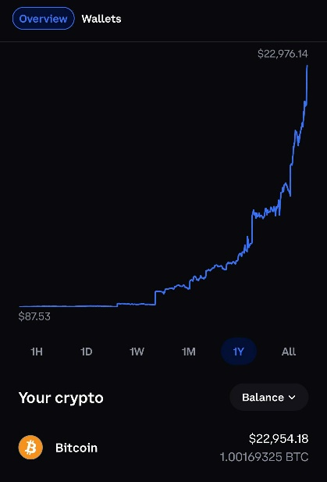

* Binance: This offers not only a wide range of cryptocurrencies for trading, but also additional features like advanced charting tools. It's one of the most popular app among experienced traders.

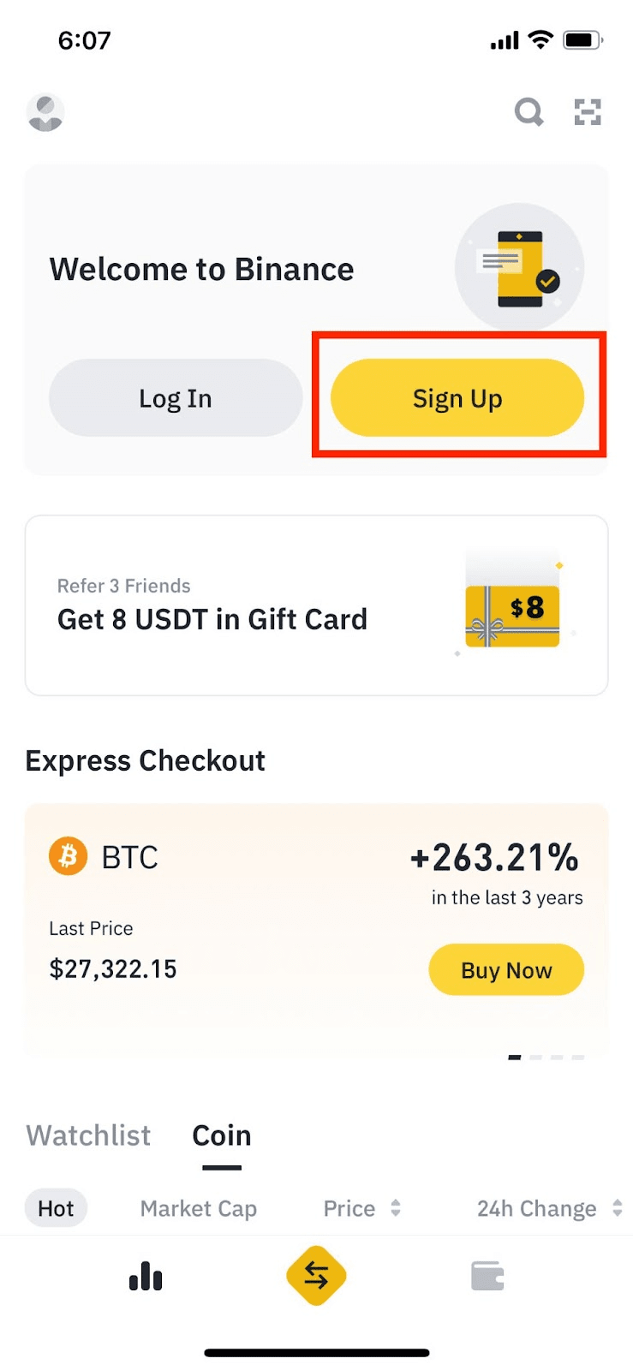

* Kraken: I firmly believe that this app is well-known for its strong security features, providing access to a variety of cryptocurrencies and trading pairs.

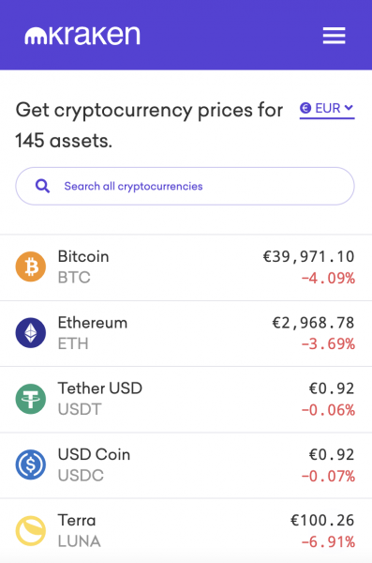

In the following week (Week 8), I think I will try to complete the Authentication feature of the app (Login/Signup). I prefer to use the Google Firebase’s authentication functionality.

## Week 8

*Note: I have completed Core 1, submitted Core 2, but not completed the discussion tasks. However, I decided to continue with the custom project as the resubmission for those discussions would not be available until 6 Oct 2023 (end of week 9)*

To begin with, I have set up the repository for the Custom Project via the Github Classroom link on Canvas:

<https://github.com/SoftDevMobDev-2023-Classrooms/customproject1-trungkiennguyen22082004>

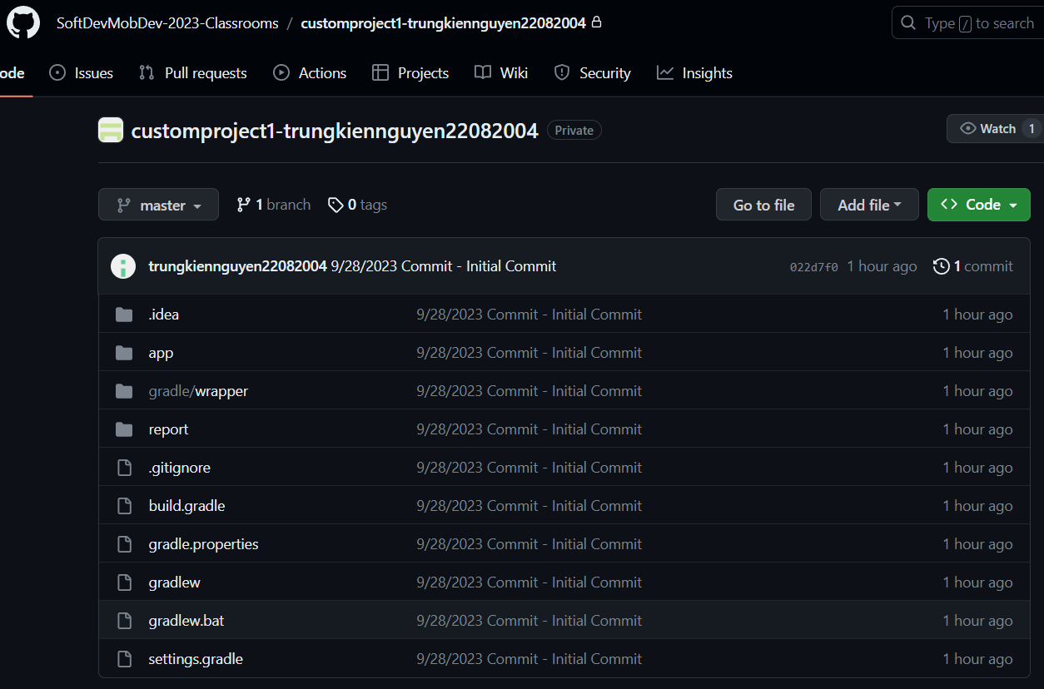

For the Authentication task, I have implemented two activities, including LoginActivity and SignupActivity.

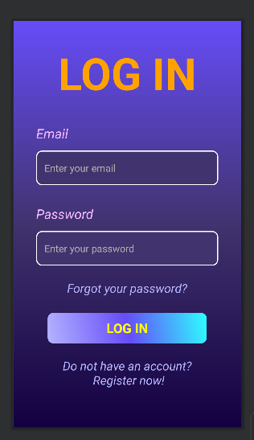

*LoginActivity’s layout*

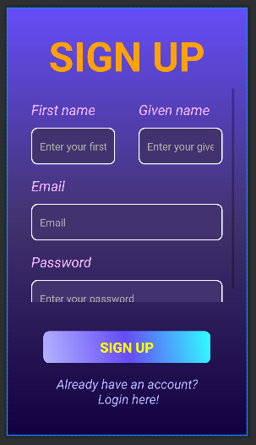

*SignupActivity’s layout*

I have use the Google Firebase’s functionality of Authentication using Email/Password:

* Login: Using the method “signInWithEmailAndPassword()” of FirebaseAuth

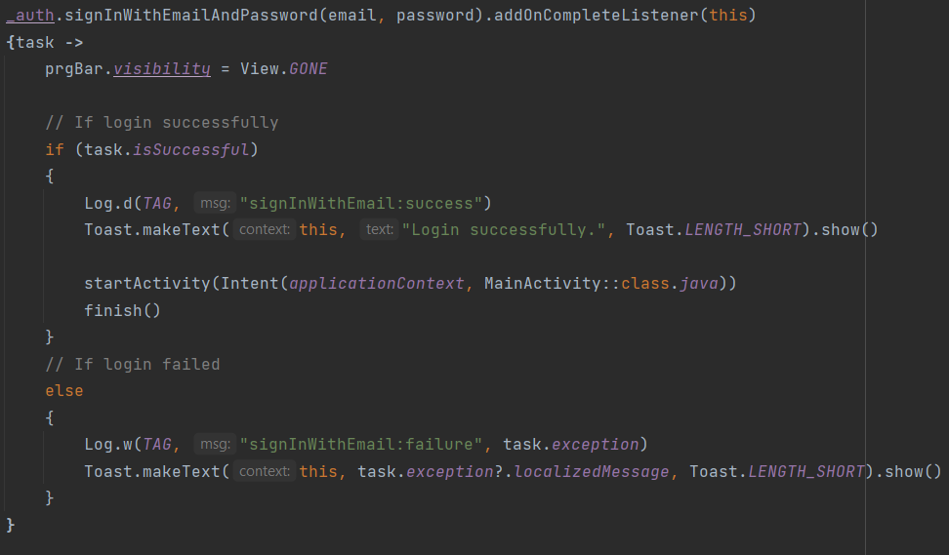

* Signup: Using the method “createUserWithEmailAndPassword()” of FirebaseAuth

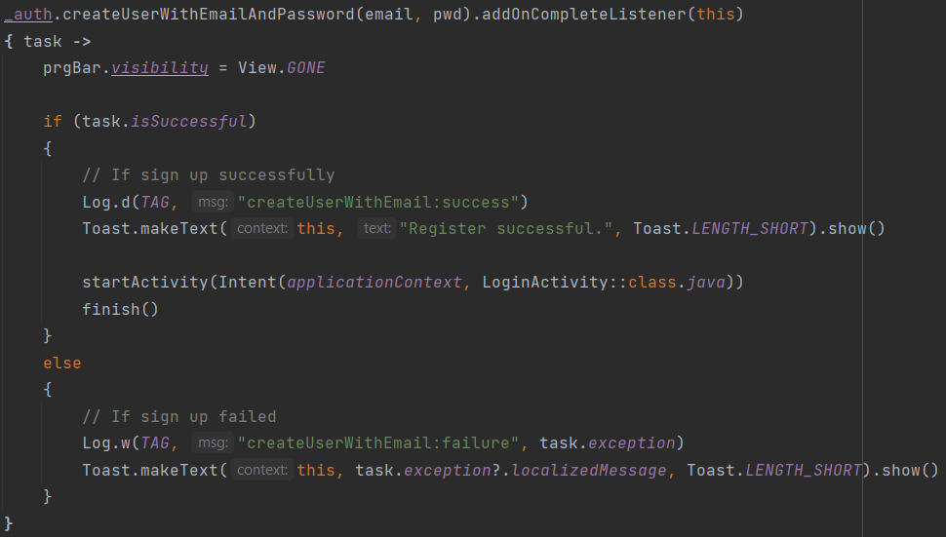

I have use “Signup” to create some new users for testing:

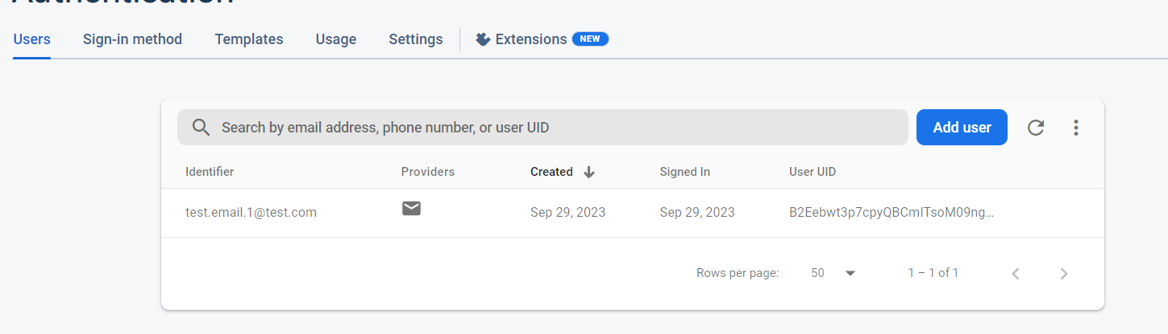

## Week 9

*Note: I have completed Core 1, completed Core 2, I have just submitted the Redo for discussion tasks since they had been available in the Friday morning.*

*Firstly, I continued my work on the Authentication functionality of my custom app, adding the forgot-password and reset-password feature:*

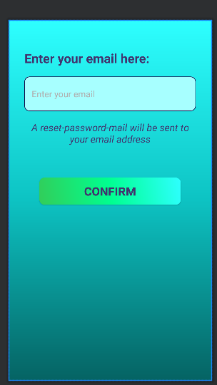

*ForgotPasswordActivity’s layout*

I have used the “sendPasswordResetEmal()” method to sent a resetting-password email to the entered email address:

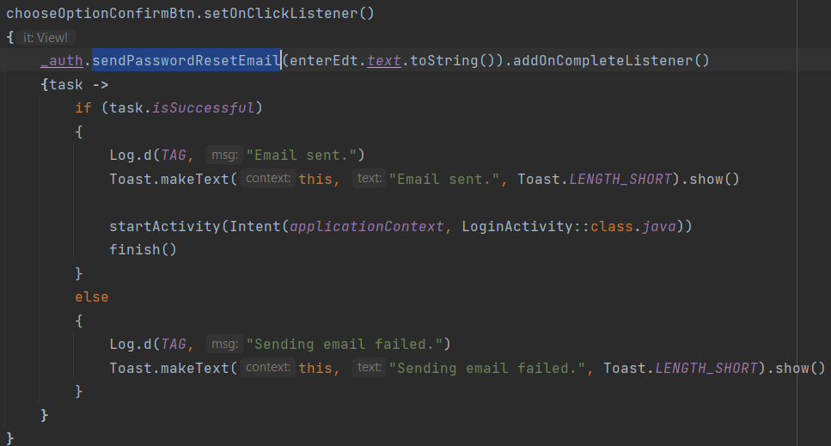

I have tested that functionality, the resetting-password email will look like:

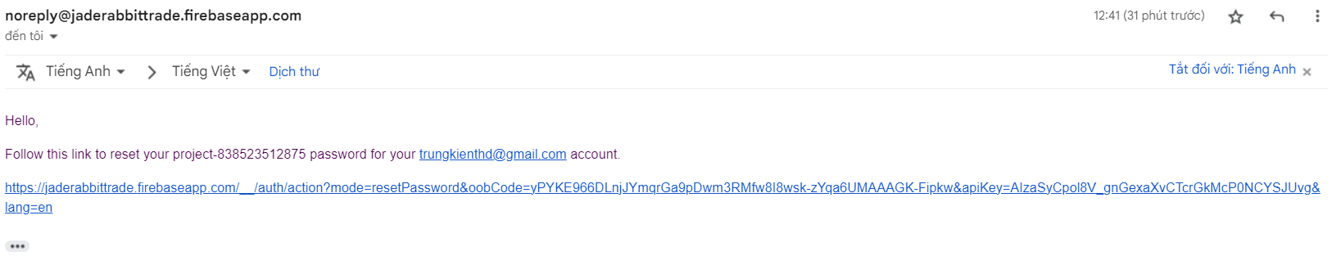

And this is the resetting-password interface:

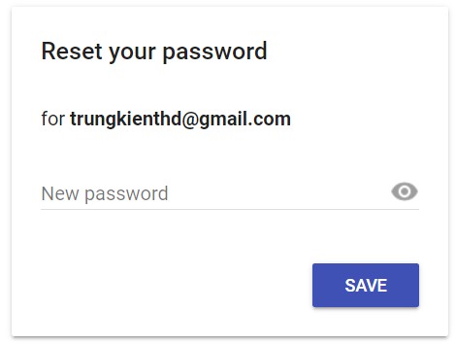

Next, I stored the User data (First Name, Last Name, …) in Firebase’s feature of Cloud Firestore

After create a Cloud Firestore Database, I have added the “Firestore.DocumentReference.set(user)” method to store the First name, last name and email of the user to the Firebase Cloud Firestore’s database during the signing up process:

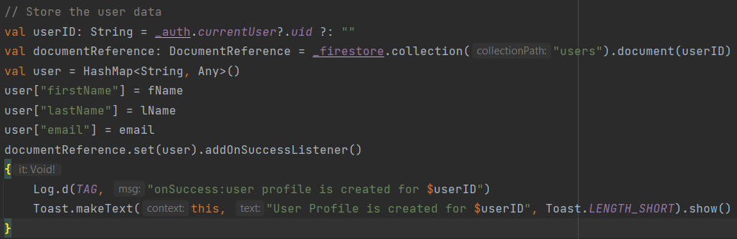

I have created a new account for testing this function, and this is the output:

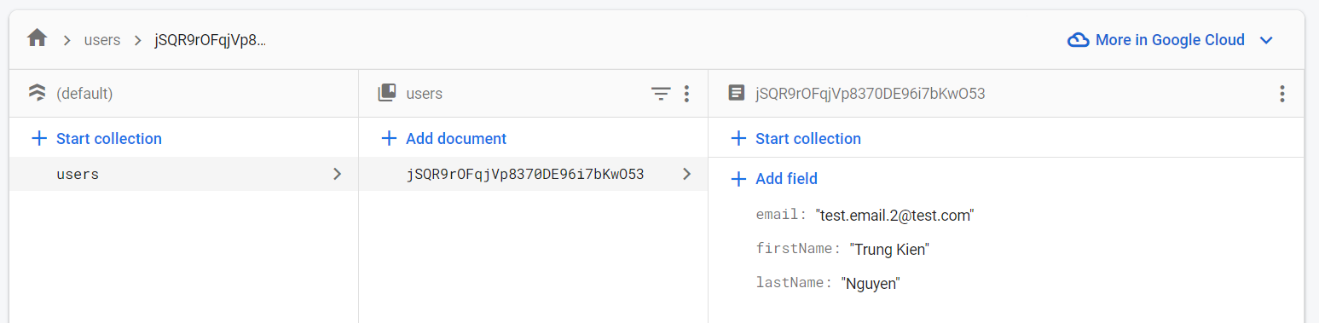

## Week 10

*[NOTE: as of week 10, if you have not completed Core 1, not completed Core, not submitted Core 3 nor an extension task, you will also need to justify why you should be encouraged to continue with a custom project. There is no point focusing on this task when the basics are not complete and your progress report will be marked as incomplete.]*

## Week 11

*[NOTE: as of week 11, if you have not submitted/completed all other Core/Extension tasks, you will also need to justify why you should be encouraged to continue with a custom project. There is no point focusing on this task when the basics are not complete and your progress report will be marked as incomplete.]*

# Level 1: Design evidence

# Level 2: App evidence

# Level 3: Extended research evidence

# References