TASK 4 V4.1 — COMPACT VISUAL RESULT
Visual PASS | AI Final | Avg. Placement Conf. | Avg. RGB Delta | Avg. Cost | Retries
2 / 2 | 2 / 2 | 0.925 | 78.05 | $0.252683 | 0
Evidence: original → AI-integrated final
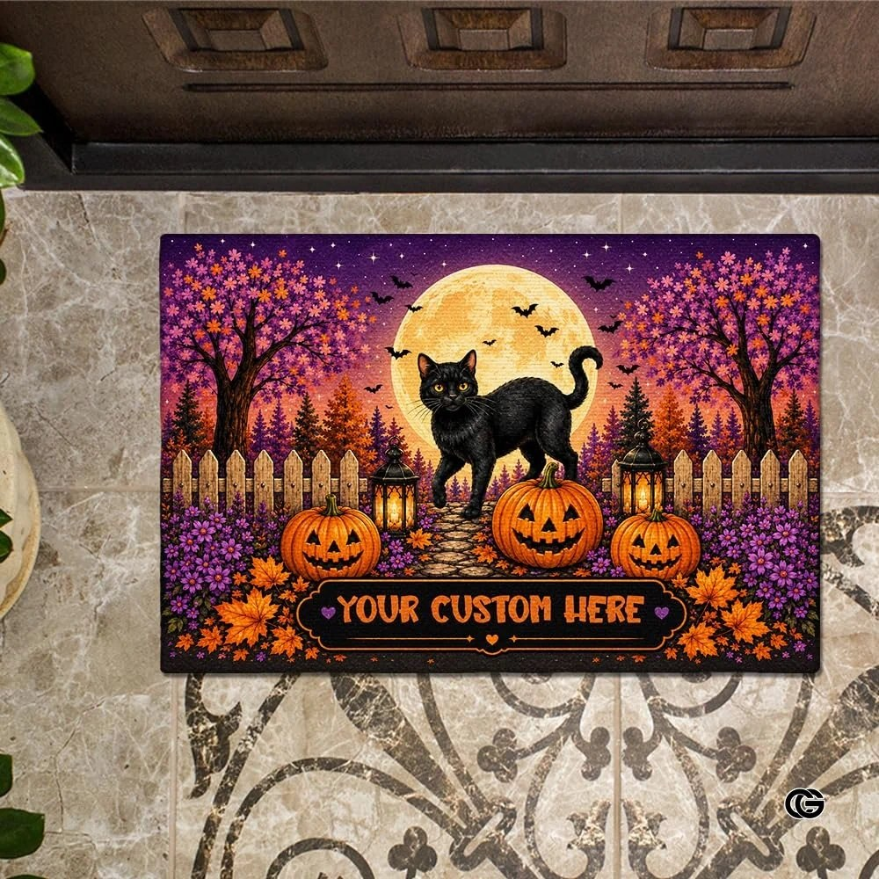  OLD — Doormat | 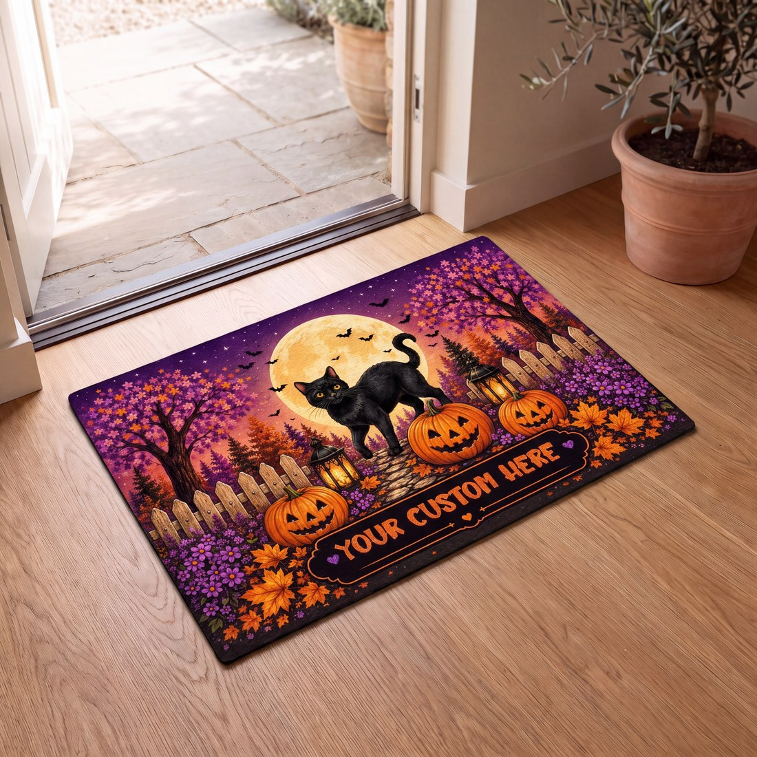  NEW — Final AI | CASE 1 — HALLOWEEN DOORMAT  Visual score: 7.5 → 9.0 / 10  Placement confidence: 0.900  Integration RGB Delta: 83.32  Total pipeline cost: $0.252396  Latency G / P / I: 384.48s / 28.04s / 138.57s  Pipeline / Integration: success / accepted  Final source: ai_integration  RESULT: PASS
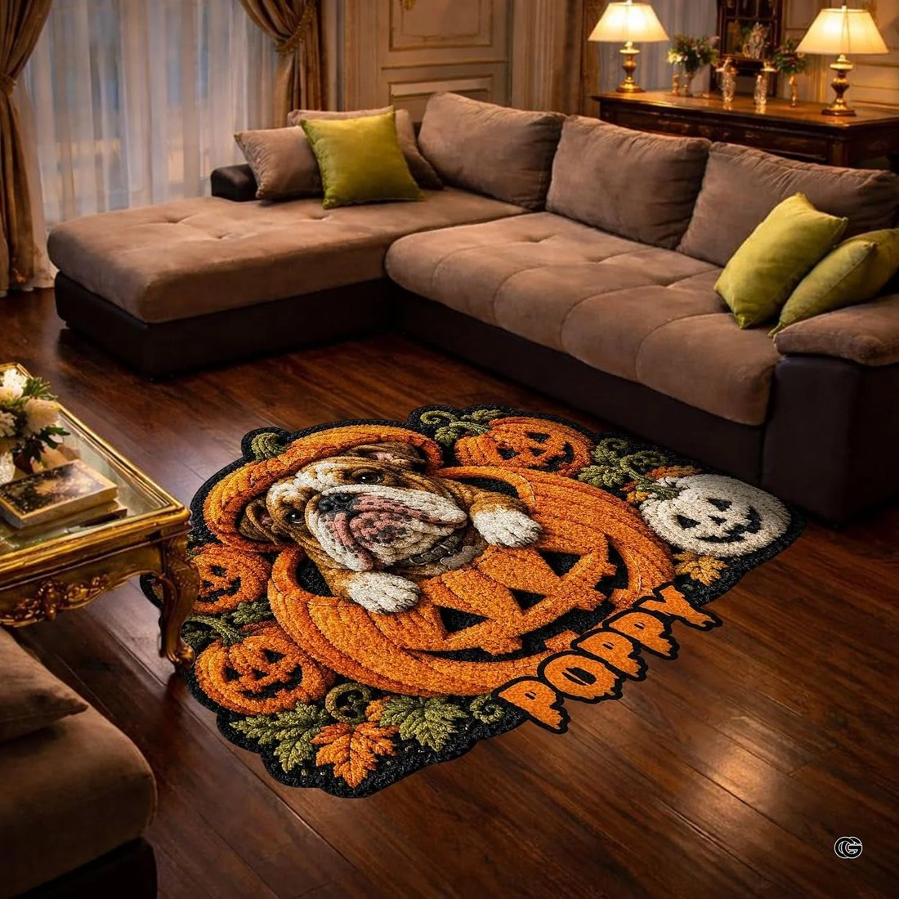  OLD — Area Rug | 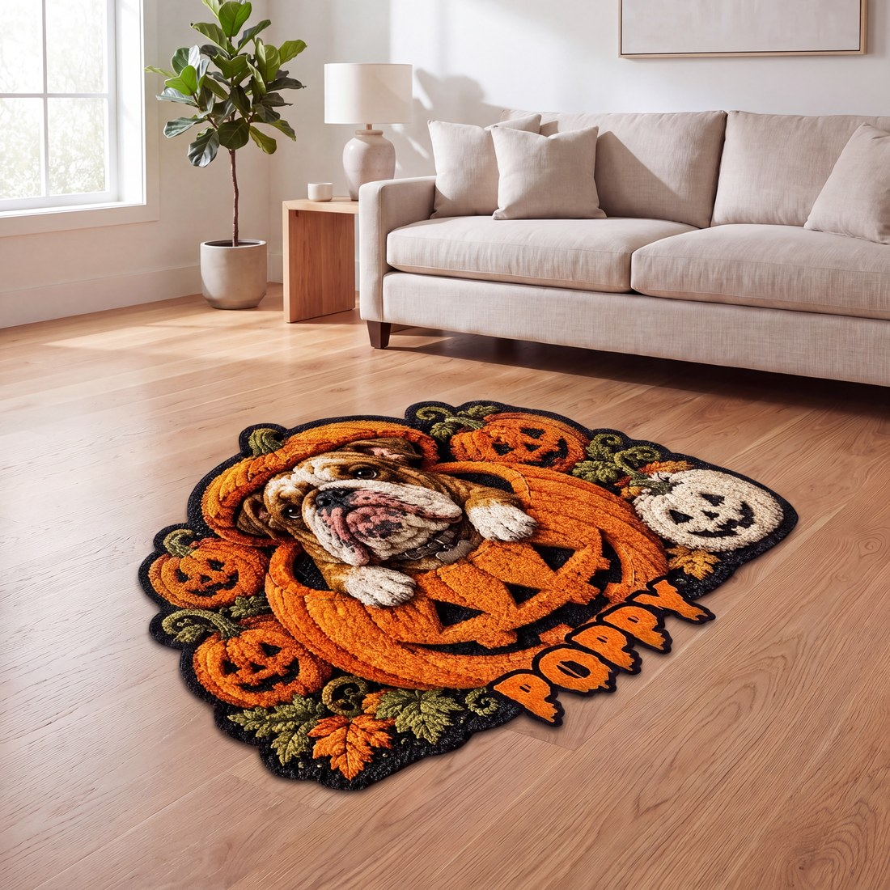  NEW — Final AI | CASE 2 — HALLOWEEN AREA RUG  Visual score: 6.0 → 8.8 / 10  Placement confidence: 0.950  Integration RGB Delta: 72.78  Total pipeline cost: $0.252970  Latency G / P / I: 222.04s / 26.54s / 110.05s  Pipeline / Integration: success / accepted  Final source: ai_integration  RESULT: PASS
NHẬN XÉT
• Case 1: Visual 7.5 → 9.0 (+1.5); placement/lighting tự nhiên hơn — PASS.
• Case 2: Visual 6.0 → 8.8 (+2.8); cải thiện rõ ở scale/contact/perspective — PASS.
• RGB Delta 83.32 / 72.78 = telemetry; không dùng làm quality score. QA tiếp theo: product/artwork fidelity.
FINAL: 2/2 visual PASS • Background/placement/perspective PASS • Main remaining QA: product/artwork fidelity

