ĐẠI HỌC QUỐC GIA THÀNH PHỐ HỒ CHÍ MINH
TRƯỜNG ĐẠI HỌC CÔNG NGHỆ THÔNG TIN
KHOA CÔNG NGHỆ PHẦN MỀM



MÔN LẬP TRÌNH TRỰC QUAN
BÀI TẬP THỰC HÀNH 5

GVHD: Nguyễn Ngọc Quí
Sinh viên thực hiện: Nguyễn Huỳnh Anh Trung

Tp. Hồ Chí Minh, 12/2025
NHẬN XÉT CỦA GIÁO VIÊN HƯỚNG DẪN

……., ngày……...tháng……năm 2025

Người nhận xét
(Ký tên và ghi rõ họ tên)
MỤC LỤC
1 Xây dựng ứng dụng xử lý font văn bản như sau: 6
2 Viết chương trình liệt kê tất cả Font chữ có trong hệ thống có dạng như sau: 16
3 Viết ứng dụng hiển thị giờ hệ thống như hình vẽ sau: 20
4 Xây dựng vẽ các hình cơ bản sau: 26
5 Viết chương trình cho phép demo các loại bút vẽ (pen) như sau: 32
6 Xây dựng chương trình vẽ hình cơ bản như sau: 47

DANH MỤC BẢNG
Bảng 1.1 Bai04.Designer.cs 7
Bảng 1.2 Bai04.cs 12
Bảng 2.1 Bai06.Designer.cs 17
Bảng 2.2 Bai06.cs 18
Bảng 3.1 Bai08.Designer.cs 21
Bảng 3.2 Bai08.cs 22
Bảng 4.1 Bai09.Designer.cs 27
Bảng 4.2 Bai09.cs 30
Bảng 5.1 Bai10.Designer.cs 34
Bảng 5.2 Bai10.cs 41
Bảng 6.1 Bai11.Designer.cs 49
Bảng 6.2 Bai11.cs 55

DANH MỤC HÌNH ẢNH
Hình 1-1 VD GUI Bài 04 6
Hình 1-2 GUI Bài 04 7
Hình 2-1 VD GUI Bài 06 16
Hình 2-2 GUI Bài 06 17
Hình 3-1 VD GUI Bài 08 20
Hình 3-2 GUI Bài 08 21
Hình 4-1 VD GUI Bài 09 26
Hình 4-2 GUI Bài 09 - 1 26
Hình 4-3 GUI Bài 09 - 2 27
Hình 5-1 VD GUI Bài 10 - 1 32
Hình 5-2 VD GUI Bài 10 - 2 33
Hình 5-3 GUI Bài 10 34
Hình 6-1 VD GUI Bài 11 48
Hình 6-2 GUI Bài 11 49

NỘI DUNG BÀI LÀM

Xây dựng ứng dụng xử lý font văn bản như sau:
Hình 1-1 VD GUI Bài 04
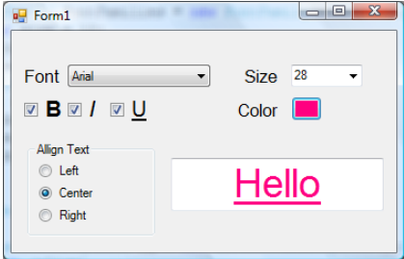
- Cho chọn kiểu Font (gồm các font có sẵn trong hệ thống)
- Chọn kích thước (Size), in đậm (B), in nghiêng (I), gạch dưới (U)
- Canh lề trái, phải hoặc giữa
- Chọn màu chữ: khi nhấn button, hiện ColorDialog cho người dùng chọn màu

- Mô tả đầu vào và đầu ra của chương trình:
- Input: Các thao tác chỉnh kiểu chữ như: đổi màu chữ, chỉnh kích thước chữ, in đậm, in nghiêng, gạch dưới, canh lề trái, canh lề phải, canh lề giữa.
- Output: Hiển thị kiểu chữ dưới richtextbox cho người dùng thấy.

Hình 1-2 GUI Bài 04
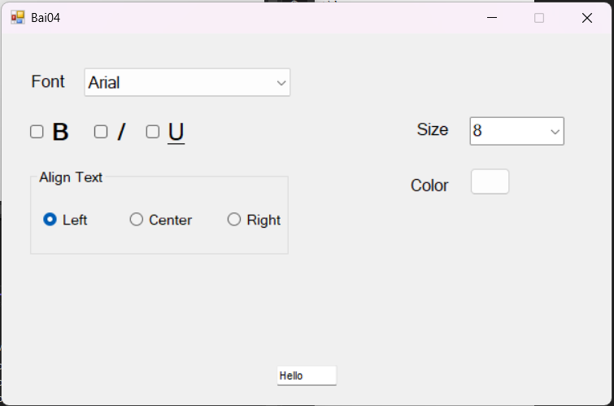

- Nội dung code của Bài 04
Bảng 1.1 Bai04.Designer.cs
namespace BTTH5 {
partial class Bai04 {
/// <summary>
/// Required designer variable.
/// </summary>
private System.ComponentModel.IContainer components = null;

/// <summary>
/// Clean up any resources being used.
/// </summary>
/// <param name="disposing">true if managed resources should be disposed; otherwise, false.</param>
protected override void Dispose(bool disposing) {
if (disposing && (components != null)) {
components.Dispose();
}
base.Dispose(disposing);
}

#region Windows Form Designer generated code

/// <summary>
/// Required method for Designer support - do not modify
/// the contents of this method with the code editor.
/// </summary>
private void InitializeComponent() {
this.tbShow = new System.Windows.Forms.TextBox();
this.lSize = new System.Windows.Forms.Label();
this.cbSize = new System.Windows.Forms.ComboBox();
this.lColor = new System.Windows.Forms.Label();
this.bColor = new System.Windows.Forms.Button();
this.colorDialog1 = new System.Windows.Forms.ColorDialog();
this.cbFont = new System.Windows.Forms.ComboBox();
this.lFont = new System.Windows.Forms.Label();
this.checkBBold = new System.Windows.Forms.CheckBox();
this.checkBItalic = new System.Windows.Forms.CheckBox();
this.checkBUnderline = new System.Windows.Forms.CheckBox();
this.groupBox1 = new System.Windows.Forms.GroupBox();
this.rbRight = new System.Windows.Forms.RadioButton();
this.rbCenter = new System.Windows.Forms.RadioButton();
this.rbLeft = new System.Windows.Forms.RadioButton();
this.groupBox1.SuspendLayout();
this.SuspendLayout();
//
// tbShow
//
this.tbShow.BackColor = System.Drawing.SystemColors.ControlLightLight;
this.tbShow.Font = new System.Drawing.Font("Microsoft Sans Serif", 7.8F, System.Drawing.FontStyle.Regular, System.Drawing.GraphicsUnit.Point, ((byte)(0)));
this.tbShow.Location = new System.Drawing.Point(360, 401);
this.tbShow.Name = "tbShow";
this.tbShow.ReadOnly = true;
this.tbShow.Size = new System.Drawing.Size(62, 22);
this.tbShow.TabIndex = 0;
this.tbShow.TabStop = false;
this.tbShow.Text = "Hello";
this.tbShow.FontChanged += new System.EventHandler(this.tbShow_FontChanged);
//
// lSize
//
this.lSize.AutoSize = true;
this.lSize.Font = new System.Drawing.Font("Microsoft Sans Serif", 12F, System.Drawing.FontStyle.Regular, System.Drawing.GraphicsUnit.Point, ((byte)(0)));
this.lSize.Location = new System.Drawing.Point(538, 104);
this.lSize.Name = "lSize";
this.lSize.Size = new System.Drawing.Size(51, 25);
this.lSize.TabIndex = 1;
this.lSize.Text = "Size";
//
// cbSize
//
this.cbSize.Font = new System.Drawing.Font("Microsoft Sans Serif", 12F, System.Drawing.FontStyle.Regular, System.Drawing.GraphicsUnit.Point, ((byte)(0)));
this.cbSize.FormattingEnabled = true;
this.cbSize.Items.AddRange(new object[] {
"8",
"9",
"10",
"11",
"12",
"14",
"16",
"18",
"20",
"22",
"24",
"26",
"28",
"36",
"48",
"72"});
this.cbSize.Location = new System.Drawing.Point(613, 101);
this.cbSize.Name = "cbSize";
this.cbSize.Size = new System.Drawing.Size(123, 33);
this.cbSize.TabIndex = 1;
this.cbSize.Text = "8";
this.cbSize.TextChanged += new System.EventHandler(this.cbSize_TextChange);
//
// lColor
//
this.lColor.AutoSize = true;
this.lColor.Font = new System.Drawing.Font("Microsoft Sans Serif", 12F, System.Drawing.FontStyle.Regular, System.Drawing.GraphicsUnit.Point, ((byte)(0)));
this.lColor.Location = new System.Drawing.Point(530, 171);
this.lColor.Name = "lColor";
this.lColor.Size = new System.Drawing.Size(59, 25);
this.lColor.TabIndex = 3;
this.lColor.Text = "Color";
//
// bColor
//
this.bColor.Location = new System.Drawing.Point(613, 163);
this.bColor.Name = "bColor";
this.bColor.Size = new System.Drawing.Size(54, 33);
this.bColor.TabIndex = 2;
this.bColor.UseVisualStyleBackColor = true;
this.bColor.Click += new System.EventHandler(this.button1_Click);
//
// cbFont
//
this.cbFont.DropDownStyle = System.Windows.Forms.ComboBoxStyle.DropDownList;
this.cbFont.Font = new System.Drawing.Font("Microsoft Sans Serif", 12F, System.Drawing.FontStyle.Regular, System.Drawing.GraphicsUnit.Point, ((byte)(0)));
this.cbFont.FormattingEnabled = true;
this.cbFont.Location = new System.Drawing.Point(108, 42);
this.cbFont.Name = "cbFont";
this.cbFont.Size = new System.Drawing.Size(269, 33);
this.cbFont.TabIndex = 0;
this.cbFont.SelectedIndexChanged += new System.EventHandler(this.cbFont_SelectedIndexChanged);
//
// lFont
//
this.lFont.AutoSize = true;
this.lFont.Font = new System.Drawing.Font("Microsoft Sans Serif", 12F, System.Drawing.FontStyle.Regular, System.Drawing.GraphicsUnit.Point, ((byte)(0)));
this.lFont.Location = new System.Drawing.Point(33, 45);
this.lFont.Name = "lFont";
this.lFont.Size = new System.Drawing.Size(51, 25);
this.lFont.TabIndex = 5;
this.lFont.Text = "Font";
//
// checkBBold
//
this.checkBBold.AutoSize = true;
this.checkBBold.Font = new System.Drawing.Font("Microsoft Sans Serif", 18F, System.Drawing.FontStyle.Bold, System.Drawing.GraphicsUnit.Point, ((byte)(0)));
this.checkBBold.Location = new System.Drawing.Point(38, 100);
this.checkBBold.Name = "checkBBold";
this.checkBBold.Size = new System.Drawing.Size(58, 40);
this.checkBBold.TabIndex = 6;
this.checkBBold.Text = "B";
this.checkBBold.UseVisualStyleBackColor = true;
this.checkBBold.CheckedChanged += new System.EventHandler(this.checkBBold_CheckedChanged);
//
// checkBItalic
//
this.checkBItalic.AutoSize = true;
this.checkBItalic.Font = new System.Drawing.Font("Microsoft Sans Serif", 18F, System.Drawing.FontStyle.Italic, System.Drawing.GraphicsUnit.Point, ((byte)(0)));
this.checkBItalic.Location = new System.Drawing.Point(121, 100);
this.checkBItalic.Name = "checkBItalic";
this.checkBItalic.Size = new System.Drawing.Size(45, 40);
this.checkBItalic.TabIndex = 7;
this.checkBItalic.Text = "I";
this.checkBItalic.UseVisualStyleBackColor = true;
this.checkBItalic.CheckedChanged += new System.EventHandler(this.checkBItalic_CheckedChanged);
//
// checkBUnderline
//
this.checkBUnderline.AutoSize = true;
this.checkBUnderline.Font = new System.Drawing.Font("Microsoft Sans Serif", 18F, System.Drawing.FontStyle.Underline, System.Drawing.GraphicsUnit.Point, ((byte)(0)));
this.checkBUnderline.Location = new System.Drawing.Point(189, 100);
this.checkBUnderline.Name = "checkBUnderline";
this.checkBUnderline.Size = new System.Drawing.Size(59, 40);
this.checkBUnderline.TabIndex = 8;
this.checkBUnderline.Text = "U";
this.checkBUnderline.UseVisualStyleBackColor = true;
this.checkBUnderline.CheckedChanged += new System.EventHandler(this.checkBUnderline_CheckedChanged);
//
// groupBox1
//
this.groupBox1.Controls.Add(this.rbRight);
this.groupBox1.Controls.Add(this.rbCenter);
this.groupBox1.Controls.Add(this.rbLeft);
this.groupBox1.Font = new System.Drawing.Font("Microsoft Sans Serif", 10.2F, System.Drawing.FontStyle.Regular, System.Drawing.GraphicsUnit.Point, ((byte)(0)));
this.groupBox1.Location = new System.Drawing.Point(38, 163);
this.groupBox1.Name = "groupBox1";
this.groupBox1.Size = new System.Drawing.Size(339, 106);
this.groupBox1.TabIndex = 9;
this.groupBox1.TabStop = false;
this.groupBox1.Text = "Align Text";
//
// rbRight
//
this.rbRight.AutoSize = true;
this.rbRight.Location = new System.Drawing.Point(259, 49);
this.rbRight.Name = "rbRight";
this.rbRight.Size = new System.Drawing.Size(69, 24);
this.rbRight.TabIndex = 2;
this.rbRight.Text = "Right";
this.rbRight.UseVisualStyleBackColor = true;
this.rbRight.CheckedChanged += new System.EventHandler(this.rbRight_CheckedChanged);
//
// rbCenter
//
this.rbCenter.AutoSize = true;
this.rbCenter.Location = new System.Drawing.Point(130, 49);
this.rbCenter.Name = "rbCenter";
this.rbCenter.Size = new System.Drawing.Size(80, 24);
this.rbCenter.TabIndex = 1;
this.rbCenter.Text = "Center";
this.rbCenter.UseVisualStyleBackColor = true;
this.rbCenter.CheckedChanged += new System.EventHandler(this.rbCenter_CheckedChanged);
//
// rbLeft
//
this.rbLeft.AutoSize = true;
this.rbLeft.Checked = true;
this.rbLeft.Location = new System.Drawing.Point(17, 49);
this.rbLeft.Name = "rbLeft";
this.rbLeft.Size = new System.Drawing.Size(59, 24);
this.rbLeft.TabIndex = 0;
this.rbLeft.TabStop = true;
this.rbLeft.Text = "Left";
this.rbLeft.UseVisualStyleBackColor = true;
this.rbLeft.CheckedChanged += new System.EventHandler(this.rbLeft_CheckedChanged);
//
// Bai04
//
this.AutoScaleDimensions = new System.Drawing.SizeF(8F, 16F);
this.AutoScaleMode = System.Windows.Forms.AutoScaleMode.Font;
this.ClientSize = new System.Drawing.Size(800, 450);
this.Controls.Add(this.groupBox1);
this.Controls.Add(this.checkBUnderline);
this.Controls.Add(this.checkBItalic);
this.Controls.Add(this.checkBBold);
this.Controls.Add(this.cbFont);
this.Controls.Add(this.lFont);
this.Controls.Add(this.bColor);
this.Controls.Add(this.lColor);
this.Controls.Add(this.cbSize);
this.Controls.Add(this.lSize);
this.Controls.Add(this.tbShow);
this.FormBorderStyle = System.Windows.Forms.FormBorderStyle.FixedSingle;
this.MaximizeBox = false;
this.Name = "Bai04";
this.Text = "Bai04";
this.groupBox1.ResumeLayout(false);
this.groupBox1.PerformLayout();
this.ResumeLayout(false);
this.PerformLayout();

}

#endregion

private System.Windows.Forms.TextBox tbShow;
private System.Windows.Forms.Label lSize;
private System.Windows.Forms.ComboBox cbSize;
private System.Windows.Forms.Label lColor;
private System.Windows.Forms.Button bColor;
private System.Windows.Forms.ColorDialog colorDialog1;
private System.Windows.Forms.ComboBox cbFont;
private System.Windows.Forms.Label lFont;
private System.Windows.Forms.CheckBox checkBBold;
private System.Windows.Forms.CheckBox checkBItalic;
private System.Windows.Forms.CheckBox checkBUnderline;
private System.Windows.Forms.GroupBox groupBox1;
private System.Windows.Forms.RadioButton rbRight;
private System.Windows.Forms.RadioButton rbCenter;
private System.Windows.Forms.RadioButton rbLeft;
}
}

Bảng 1.2 Bai04.cs
using System;
using System.Collections.Generic;
using System.ComponentModel;
using System.Data;
using System.Drawing;
using System.Drawing.Text;
using System.Linq;
using System.Text;
using System.Threading.Tasks;
using System.Windows.Forms;

namespace BTTH5 {
public partial class Bai04 : Form {
public Bai04() {
InitializeComponent();

addFont_CBFont();

InitializeControl();
}

private void InitializeControl() {
this.SuspendLayout();

cbFont.Text = "Arial";
}

private void addFont_CBFont() {
InstalledFontCollection FONTS = new InstalledFontCollection();
foreach(FontFamily font in FONTS.Families) {
cbFont.Items.Add(font.Name);
}
}

private void tbShow_FontChanged(object sender, EventArgs e) {
int textWidth = TextRenderer.MeasureText("Hello", tbShow.Font).Width;
int textHeight = TextRenderer.MeasureText("Hello", tbShow.Font).Height;

tbShow.Width = textWidth * 2;

tbShow.Location = new Point((this.ClientSize.Width - tbShow.Width) / 2, this.ClientSize.Height - tbShow.Height - 20);
}

private void cbSize_TextChange(object sender, EventArgs e) {
if (string.IsNullOrEmpty(cbSize.Text))
return;

float FontSize;

if(!float.TryParse(cbSize.Text, out FontSize) || FontSize <= 0) {
MessageBox.Show("Nhập số dương.", "ERROR", MessageBoxButtons.OK, MessageBoxIcon.Error);
cbSize.Text = "";
return;
}
if(FontSize > 80) {
MessageBox.Show("Font Size quá lớn!", "ERROR", MessageBoxButtons.OK, MessageBoxIcon.Error);
cbSize.Text = "";
return;
}

Font old = tbShow.Font;

tbShow.Font = new Font(tbShow.Font.FontFamily, FontSize, old.Style);
}

private void button1_Click(object sender, EventArgs e) {
DialogResult r = colorDialog1.ShowDialog();

if (r == DialogResult.OK) {
bColor.BackColor = colorDialog1.Color;
tbShow.ForeColor = colorDialog1.Color;
}
}

private void cbFont_SelectedIndexChanged(object sender, EventArgs e) {
if (cbFont.SelectedItem == null)
return;

Font old = tbShow.Font;

tbShow.Font = new Font(cbFont.Text, float.Parse(cbSize.Text), old.Style);
}

private void rbLeft_CheckedChanged(object sender, EventArgs e) {
if (rbLeft.Checked) {
tbShow.TextAlign = HorizontalAlignment.Left;
}
}

private void rbCenter_CheckedChanged(object sender, EventArgs e) {
if (rbCenter.Checked) {
tbShow.TextAlign = HorizontalAlignment.Center;
}
}

private void rbRight_CheckedChanged(object sender, EventArgs e) {
if (rbRight.Checked) {
tbShow.TextAlign= HorizontalAlignment.Right;
}
}

private void checkBBold_CheckedChanged(object sender, EventArgs e) {
Font old = tbShow.Font;

FontStyle newStyle = tbShow.Font.Style;
newStyle = checkBBold.Checked ? (newStyle | FontStyle.Bold) : (newStyle & ~FontStyle.Bold);

tbShow.Font = new Font(old, newStyle);
}

private void checkBItalic_CheckedChanged(object sender, EventArgs e) {
Font old = tbShow.Font;

FontStyle newStyle = tbShow.Font.Style;
newStyle = checkBItalic.Checked ? (newStyle | FontStyle.Italic) : (newStyle & ~FontStyle.Italic);

tbShow.Font = new Font(old, newStyle);
}

private void checkBUnderline_CheckedChanged(object sender, EventArgs e) {
Font old = tbShow.Font;

FontStyle newStyle = tbShow.Font.Style;
newStyle = checkBUnderline.Checked ? (newStyle | FontStyle.Underline) : (newStyle & ~FontStyle.Underline);

tbShow.Font = new Font(old, newStyle);
}
}
}

- Các testcase của chương trình:
Đã được upload lên drive.

Viết chương trình liệt kê tất cả Font chữ có trong hệ thống có dạng như sau:
Hình 2-1 VD GUI Bài 06
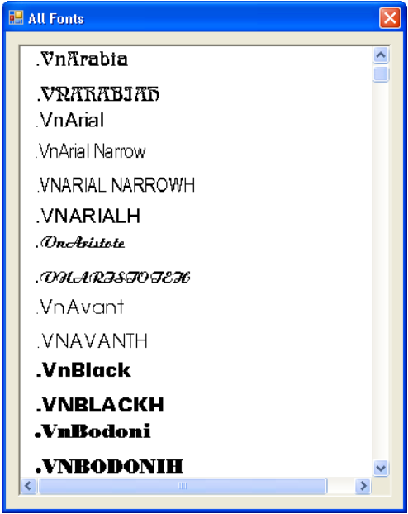

- Mô tả đầu vào và đầu ra của chương trình:
- Input: Lấy các font có sẵn của hệ thống.
- Output: Hiển thị các font đó lên form, các tên font có định dạng của chính nó.
Hình 2-2 GUI Bài 06
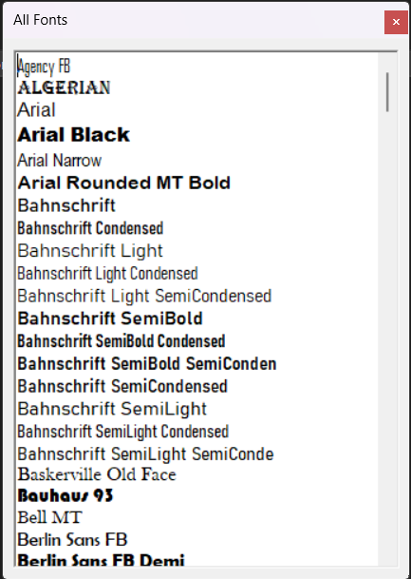

- Nội dung code của Bài 06
Bảng 2.1 Bai06.Designer.cs
namespace BTTH5 {
partial class Bai06 {
/// <summary>
/// Required designer variable.
/// </summary>
private System.ComponentModel.IContainer components = null;

/// <summary>
/// Clean up any resources being used.
/// </summary>
/// <param name="disposing">true if managed resources should be disposed; otherwise, false.</param>
protected override void Dispose(bool disposing) {
if (disposing && (components != null)) {
components.Dispose();
}
base.Dispose(disposing);
}

#region Windows Form Designer generated code

/// <summary>
/// Required method for Designer support - do not modify
/// the contents of this method with the code editor.
/// </summary>
private void InitializeComponent() {
this.richTextBox1 = new System.Windows.Forms.RichTextBox();
this.SuspendLayout();
//
// richTextBox1
//
this.richTextBox1.BackColor = System.Drawing.SystemColors.ControlLightLight;
this.richTextBox1.Font = new System.Drawing.Font("Microsoft Sans Serif", 10.8F, System.Drawing.FontStyle.Regular, System.Drawing.GraphicsUnit.Point, ((byte)(0)));
this.richTextBox1.Location = new System.Drawing.Point(12, 12);
this.richTextBox1.Name = "richTextBox1";
this.richTextBox1.ReadOnly = true;
this.richTextBox1.Size = new System.Drawing.Size(432, 536);
this.richTextBox1.TabIndex = 0;
this.richTextBox1.Text = "";
//
// Bai06
//
this.AutoScaleDimensions = new System.Drawing.SizeF(8F, 16F);
this.AutoScaleMode = System.Windows.Forms.AutoScaleMode.Font;
this.ClientSize = new System.Drawing.Size(456, 560);
this.Controls.Add(this.richTextBox1);
this.FormBorderStyle = System.Windows.Forms.FormBorderStyle.FixedToolWindow;
this.Name = "Bai06";
this.Text = "All Fonts";
this.ResumeLayout(false);

}

#endregion

private System.Windows.Forms.RichTextBox richTextBox1;
}
}

Bảng 2.2 Bai06.cs
using System;
using System.Collections.Generic;
using System.ComponentModel;
using System.Data;
using System.Drawing;
using System.Drawing.Text;
using System.Linq;
using System.Text;
using System.Threading.Tasks;
using System.Windows.Forms;

namespace BTTH5 {
public partial class Bai06 : Form {
public Bai06() {
InitializeComponent();

AddFonts();
}

private void AddFonts() {
InstalledFontCollection Fonts = new InstalledFontCollection();

foreach(FontFamily font in Fonts.Families) {
int start = richTextBox1.Text.Length;

richTextBox1.AppendText(font.Name + "\n");

richTextBox1.SelectionStart = start;
richTextBox1.SelectionLength = font.Name.Length;

richTextBox1.SelectionFont = new Font(font.Name, 12);
}

richTextBox1.SelectionLength = 0;
richTextBox1.SelectionStart = 0;
}
}
}

- Các testcase của chương trình:
Đã được upload lên drive.

Viết ứng dụng hiển thị giờ hệ thống như hình vẽ sau:
Hình 3-1 VD GUI Bài 08
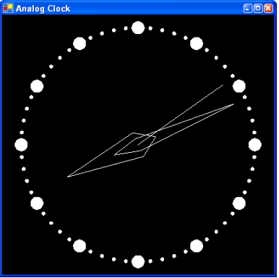

- Mô tả đầu vào và đầu ra của chương trình:
- Input: Lấy thời gian của hệ thống.
- Output: Hiển thị thời gian ra form dưới dạng đồng hồ kim.

Hình 3-2 GUI Bài 08
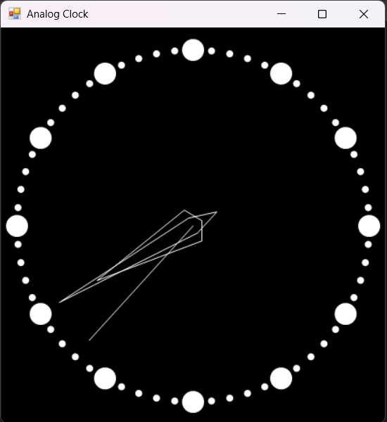

- Nội dung code của Bài 08
Bảng 3.1 Bai08.Designer.cs
namespace BTTH5 {
partial class Bai08 {
/// <summary>
/// Required designer variable.
/// </summary>
private System.ComponentModel.IContainer components = null;

/// <summary>
/// Clean up any resources being used.
/// </summary>
/// <param name="disposing">true if managed resources should be disposed; otherwise, false.</param>
protected override void Dispose(bool disposing) {
if (disposing && (components != null)) {
components.Dispose();
}
base.Dispose(disposing);
}

#region Windows Form Designer generated code

/// <summary>
/// Required method for Designer support - do not modify
/// the contents of this method with the code editor.
/// </summary>
private void InitializeComponent() {
this.components = new System.ComponentModel.Container();
this.timer1 = new System.Windows.Forms.Timer(this.components);
this.SuspendLayout();
//
// timer1
//
this.timer1.Enabled = true;
this.timer1.Tick += new System.EventHandler(this.timer1_Tick);
//
// Bai08
//
this.AutoScaleDimensions = new System.Drawing.SizeF(8F, 16F);
this.AutoScaleMode = System.Windows.Forms.AutoScaleMode.Font;
this.BackColor = System.Drawing.SystemColors.ActiveCaptionText;
this.ClientSize = new System.Drawing.Size(583, 554);
this.DoubleBuffered = true;
this.FormBorderStyle = System.Windows.Forms.FormBorderStyle.FixedSingle;
this.Name = "Bai08";
this.Text = "Analog Clock";
this.Paint += new System.Windows.Forms.PaintEventHandler(this.Bai08_Paint);
this.ResumeLayout(false);

}

#endregion

private System.Windows.Forms.Timer timer1;
}
}

Bảng 3.2 Bai08.cs
using System;
using System.Collections.Generic;
using System.ComponentModel;
using System.Data;
using System.Drawing;
using System.Linq;
using System.Text;
using System.Threading.Tasks;
using System.Windows.Forms;

namespace BTTH5 {
public partial class Bai08 : Form {
DateTime now;
public Bai08() {
InitializeComponent();

now = DateTime.Now;
}

private void Bai08_Paint(object sender, PaintEventArgs e) {
DrawClockFace(e.Graphics);

DrawSecond(e.Graphics);
DrawMinute(e.Graphics);
DrawHour(e.Graphics);
}

private void DrawClockFace(Graphics g) {
g.SmoothingMode = System.Drawing.Drawing2D.SmoothingMode.AntiAlias;

int centerX = this.ClientSize.Width / 2;
int centerY = this.ClientSize.Height / 2;

int minuteSize = 8;
int radius = Math.Min(centerX, centerY) - minuteSize - 10;

for (int i = 0; i < 60; i++) {
double theta = -i * (360 / 60) * Math.PI / 180;

double x = centerX + radius * Math.Cos(theta) - minuteSize / 2f;
double y = centerY + radius * Math.Sin(theta) - minuteSize / 2f;

g.FillEllipse(Brushes.White, (float)x, (float)y, minuteSize, minuteSize);
}

int hourSize = 25;

for (int i = 0; i < 12; ++i) {
double theta = i * (360 / 12) * Math.PI / 180;

double x = centerX + radius * Math.Cos(theta) - hourSize / 2f;
double y = centerY + radius * Math.Sin(theta) - hourSize / 2f;

g.FillEllipse(Brushes.White, (float)x, (float)y, hourSize, hourSize);
}
}

private void DrawSecond(Graphics g) {
g.SmoothingMode = System.Drawing.Drawing2D.SmoothingMode.AntiAlias;

int second = now.Second;

int centerX = this.ClientSize.Width / 2;
int centerY = this.ClientSize.Height / 2;
Point center = new Point(centerX, centerY);

double theta = (second * (360 / 60) - 90) * Math.PI / 180;

double x = centerX + 175 * Math.Cos(theta);
double y = centerY + 175 * Math.Sin(theta);
Point head = new Point((int)x, (int)y);

g.DrawLine(Pens.White, center, head);
}

private void DrawMinute(Graphics g) {
g.SmoothingMode = System.Drawing.Drawing2D.SmoothingMode.AntiAlias;

int minute = now.Minute;

int centerX = this.ClientSize.Width / 2;
int centerY = this.ClientSize.Height / 2;

double theta = (minute * (360 / 60) - 90) * Math.PI / 180;

double x = centerX + 10 * Math.Cos(theta + Math.PI / 2);
double y = centerY + 10 * Math.Sin(theta + Math.PI / 2);
Point left = new Point((int)x, (int)y);

x = centerX + 10 * Math.Cos(theta - Math.PI / 2);
y = centerY + 10 * Math.Sin(theta - Math.PI / 2);
Point right = new Point((int)x, (int)y);

x = centerX + 32 * Math.Cos(theta + Math.PI);
y = centerY + 32 * Math.Sin(theta + Math.PI);
Point end = new Point((int)x, (int)y);

x = centerX + 175 * Math.Cos(theta);
y = centerY + 175 * Math.Sin(theta);
Point head = new Point((int)x, (int)y);

Point[] point = new Point[] {
head, left, end, right
};

g.DrawPolygon(Pens.White, point);
}

private void DrawHour(Graphics g) {
g.SmoothingMode = System.Drawing.Drawing2D.SmoothingMode.AntiAlias;

int hour = now.Hour;

int centerX = this.ClientSize.Width / 2;
int centerY = this.ClientSize.Height / 2;

double theta = (hour * (360 / 12) - 90) * Math.PI / 180;

double x = centerX + 20 * Math.Cos(theta + Math.PI / 2);
double y = centerY + 20 * Math.Sin(theta + Math.PI / 2);
Point left = new Point((int)x, (int)y);

x = centerX + 20 * Math.Cos(theta - Math.PI / 2);
y = centerY + 20 * Math.Sin(theta - Math.PI / 2);
Point right = new Point((int)x, (int)y);

x = centerX + 12 * Math.Cos(theta + Math.PI);
y = centerY + 12 * Math.Sin(theta + Math.PI);
Point end = new Point((int)x, (int)y);

x = centerX + 125 * Math.Cos(theta);
y = centerY + 125 * Math.Sin(theta);
Point head = new Point((int)x, (int)y);

Point[] point = new Point[] {
head, left, end, right
};

g.DrawPolygon(Pens.White, point);
}

private void timer1_Tick(object sender, EventArgs e) {
now = DateTime.Now;

this.Invalidate();
}
}
}

- Các testcase của chương trình:
Đã được upload lên drive.

Xây dựng vẽ các hình cơ bản sau:
Hình 4-1 VD GUI Bài 09
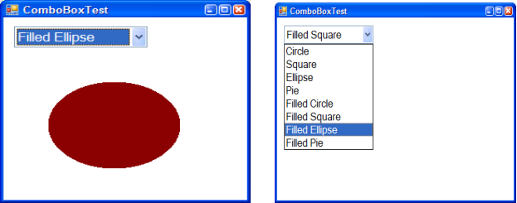

- Mô tả đầu vào và đầu ra của chương trình:
- Input: Người dùng có thể chọn các loại hình vẽ.
- Output: Hiển thị hình vẽ đó ra form theo kích thước mà người dùng muốn, có Preview khi kéo chuột chọn kích thước hình.

Hình 4-2 GUI Bài 09 - 1
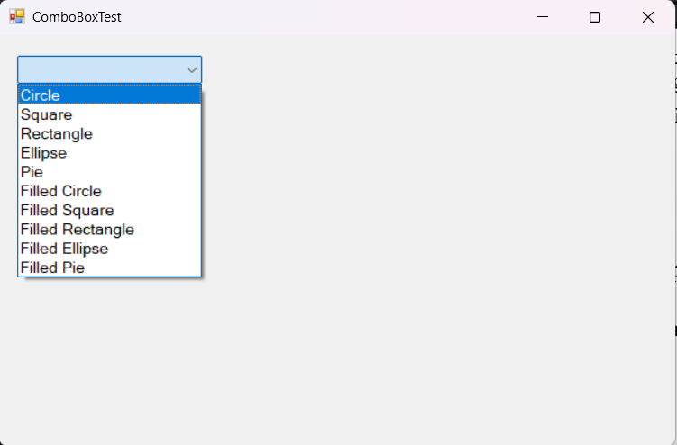
Hình 4-3 GUI Bài 09 - 2
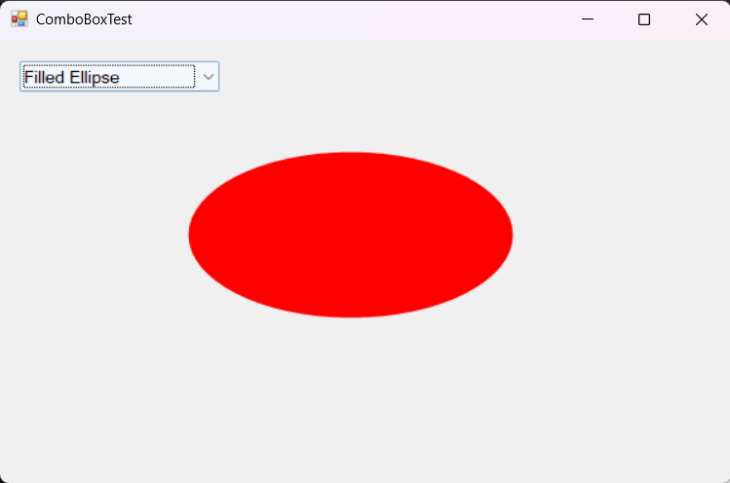

- Nội dung code của Bài 09
Bảng 4.1 Bai09.Designer.cs
namespace BTTH5 {
partial class Bai09 {
/// <summary>
/// Required designer variable.
/// </summary>
private System.ComponentModel.IContainer components = null;

/// <summary>
/// Clean up any resources being used.
/// </summary>
/// <param name="disposing">true if managed resources should be disposed; otherwise, false.</param>
protected override void Dispose(bool disposing) {
if (disposing && (components != null)) {
components.Dispose();
}
base.Dispose(disposing);
}

#region Windows Form Designer generated code

/// <summary>
/// Required method for Designer support - do not modify
/// the contents of this method with the code editor.
/// </summary>
private void InitializeComponent() {
this.comboBox1 = new System.Windows.Forms.ComboBox();
this.groupBox1 = new System.Windows.Forms.GroupBox();
this.tbSweepAngle = new System.Windows.Forms.TextBox();
this.label1 = new System.Windows.Forms.Label();
this.tbStartAngle = new System.Windows.Forms.TextBox();
this.label2 = new System.Windows.Forms.Label();
this.groupBox1.SuspendLayout();
this.SuspendLayout();
//
// comboBox1
//
this.comboBox1.DropDownStyle = System.Windows.Forms.ComboBoxStyle.DropDownList;
this.comboBox1.Font = new System.Drawing.Font("Microsoft Sans Serif", 10.8F, System.Drawing.FontStyle.Regular, System.Drawing.GraphicsUnit.Point, ((byte)(0)));
this.comboBox1.FormattingEnabled = true;
this.comboBox1.Items.AddRange(new object[] {
"Circle",
"Square",
"Rectangle",
"Ellipse",
"Pie",
"Filled Circle",
"Filled Square",
"Filled Rectangle",
"Filled Ellipse",
"Filled Pie"});
this.comboBox1.Location = new System.Drawing.Point(22, 23);
this.comboBox1.Name = "comboBox1";
this.comboBox1.Size = new System.Drawing.Size(217, 30);
this.comboBox1.TabIndex = 0;
//
// groupBox1
//
this.groupBox1.Controls.Add(this.tbStartAngle);
this.groupBox1.Controls.Add(this.label2);
this.groupBox1.Controls.Add(this.tbSweepAngle);
this.groupBox1.Controls.Add(this.label1);
this.groupBox1.Location = new System.Drawing.Point(22, 68);
this.groupBox1.Name = "groupBox1";
this.groupBox1.Size = new System.Drawing.Size(217, 96);
this.groupBox1.TabIndex = 1;
this.groupBox1.TabStop = false;
this.groupBox1.Visible = false;
//
// tbSweepAngle
//
this.tbSweepAngle.Location = new System.Drawing.Point(136, 49);
this.tbSweepAngle.Name = "tbSweepAngle";
this.tbSweepAngle.Size = new System.Drawing.Size(75, 22);
this.tbSweepAngle.TabIndex = 1;
this.tbSweepAngle.Text = "90";
//
// label1
//
this.label1.AutoSize = true;
this.label1.Font = new System.Drawing.Font("Microsoft Sans Serif", 10.2F, System.Drawing.FontStyle.Regular, System.Drawing.GraphicsUnit.Point, ((byte)(0)));
this.label1.Location = new System.Drawing.Point(5, 49);
this.label1.Name = "label1";
this.label1.Size = new System.Drawing.Size(111, 20);
this.label1.TabIndex = 0;
this.label1.Text = "Sweep Angle:";
//
// tbStartAngle
//
this.tbStartAngle.Location = new System.Drawing.Point(136, 21);
this.tbStartAngle.Name = "tbStartAngle";
this.tbStartAngle.Size = new System.Drawing.Size(75, 22);
this.tbStartAngle.TabIndex = 3;
this.tbStartAngle.Text = "90";
//
// label2
//
this.label2.AutoSize = true;
this.label2.Font = new System.Drawing.Font("Microsoft Sans Serif", 10.2F, System.Drawing.FontStyle.Regular, System.Drawing.GraphicsUnit.Point, ((byte)(0)));
this.label2.Location = new System.Drawing.Point(19, 23);
this.label2.Name = "label2";
this.label2.Size = new System.Drawing.Size(97, 20);
this.label2.TabIndex = 2;
this.label2.Text = "Start Angle:";
//
// Bai09
//
this.AutoScaleDimensions = new System.Drawing.SizeF(8F, 16F);
this.AutoScaleMode = System.Windows.Forms.AutoScaleMode.Font;
this.ClientSize = new System.Drawing.Size(800, 450);
this.Controls.Add(this.groupBox1);
this.Controls.Add(this.comboBox1);
this.DoubleBuffered = true;
this.Name = "Bai09";
this.Text = "ComboBoxTest";
this.Paint += new System.Windows.Forms.PaintEventHandler(this.Bai09_Paint);
this.MouseDown += new System.Windows.Forms.MouseEventHandler(this.Bai09_MouseDown);
this.MouseMove += new System.Windows.Forms.MouseEventHandler(this.Bai09_MouseMove);
this.MouseUp += new System.Windows.Forms.MouseEventHandler(this.Bai09_MouseUp);
this.groupBox1.ResumeLayout(false);
this.groupBox1.PerformLayout();
this.ResumeLayout(false);

}

#endregion

private System.Windows.Forms.ComboBox comboBox1;
private System.Windows.Forms.GroupBox groupBox1;
private System.Windows.Forms.TextBox tbSweepAngle;
private System.Windows.Forms.Label label1;
private System.Windows.Forms.TextBox tbStartAngle;
private System.Windows.Forms.Label label2;
}
}

Bảng 4.2 Bai09.cs
using System;
using System.Collections.Generic;
using System.ComponentModel;
using System.Data;
using System.Drawing;
using System.Linq;
using System.Text;
using System.Threading.Tasks;
using System.Windows.Forms;

namespace BTTH5 {
public partial class Bai09 : Form {
private Point startPoint;
private Point endPoint;
private bool flag;

public Bai09() {
InitializeComponent();
}

private void Bai09_MouseDown(object sender, MouseEventArgs e) {
startPoint = e.Location;
flag = true;
}

private void Bai09_MouseUp(object sender, MouseEventArgs e) {
endPoint = e.Location;
flag = false;
this.Invalidate();
}

private void Bai09_Paint(object sender, PaintEventArgs e) {
groupBox1.Visible = false;
string choice = comboBox1.Text;
Graphics g = e.Graphics;
g.SmoothingMode = System.Drawing.Drawing2D.SmoothingMode.AntiAlias;

int x = Math.Min(startPoint.X, endPoint.X);
int y = Math.Min(startPoint.Y, endPoint.Y);

int width = Math.Abs(endPoint.X - startPoint.X);
int height = Math.Abs(endPoint.Y - startPoint.Y);
int d = Math.Max(width, height);

int sweepAngle;
int startAngle;
if (!int.TryParse(tbSweepAngle.Text, out sweepAngle)) {
MessageBox.Show("Nhập số nguyên Sweep Angle.", "ERROR");
tbSweepAngle.Text = "0";
return;
}
if (!int.TryParse(tbStartAngle.Text, out startAngle)) {
MessageBox.Show("Nhập số nguyên Start Angle.", "ERROR");
tbStartAngle.Text = "0";
return;
}

switch (choice) {
case "Circle":
g.DrawEllipse(Pens.Black, x, y, d, d);
break;
case "Filled Circle":
g.FillEllipse(Brushes.Red, x, y, d, d);
break;
case "Square":
g.DrawRectangle(Pens.Black, x, y, d, d);
break;
case "Filled Square":
g.FillRectangle(Brushes.Red, x, y, d, d);
break;
case "Ellipse":
g.DrawEllipse(Pens.Black, x, y, width, height);
break;
case "Filled Ellipse":
g.FillEllipse(Brushes.Red, x, y, width, height);
break;
case "Rectangle":
g.DrawRectangle(Pens.Black, x, y, width, height);
break;
case "Filled Rectangle":
g.FillRectangle(Brushes.Red, x, y, width, height);
break;
case "Pie":
groupBox1.Visible = true;

if (width == 0 || height == 0 || sweepAngle == 0)
break;
g.DrawPie(Pens.Black, x, y, width, height, startAngle, sweepAngle);
break;
case "Filled Pie":
groupBox1.Visible = true;

if (width == 0 || height == 0 || sweepAngle == 0)
break;
g.FillPie(Brushes.Red, x, y, width, height, startAngle, sweepAngle);
break;
}
}

private void Bai09_MouseMove(object sender, MouseEventArgs e) {
if (flag) {
endPoint = e.Location;

this.Invalidate();
}
}
}
}

- Các testcase của chương trình:
Đã được upload lên drive.

Viết chương trình cho phép demo các loại bút vẽ (pen) như sau:
Hình 5-1 VD GUI Bài 10 - 1
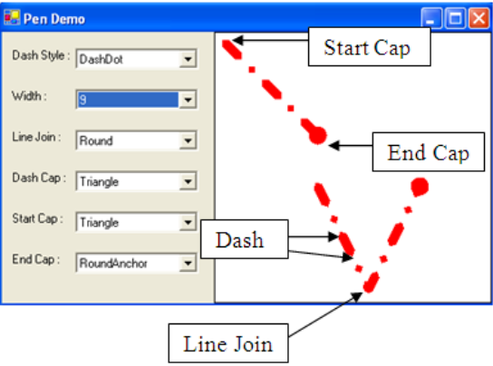

Hình 5-2 VD GUI Bài 10 - 2
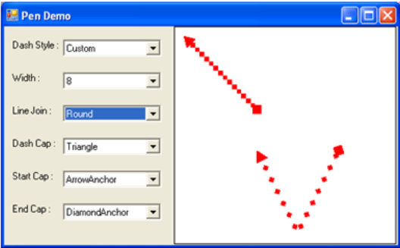

- Mô tả đầu vào và đầu ra của chương trình:
- Input: Người dùng có thể chọn các loại nét vẽ (nét liền, nét đứt, đường chấm, đường gạch chấm, tự tạo nét, …), độ đậm, kiểu kết hợp hai đường, kiểu các nét đứt, hình dạng của điểm bắt đầu, kết thúc,….
- Output: Hiển thị các nét đó ra form theo yêu cầu của người dùng, có Preview khi kéo chuột chọn kích thước hình.

Hình 5-3 GUI Bài 10
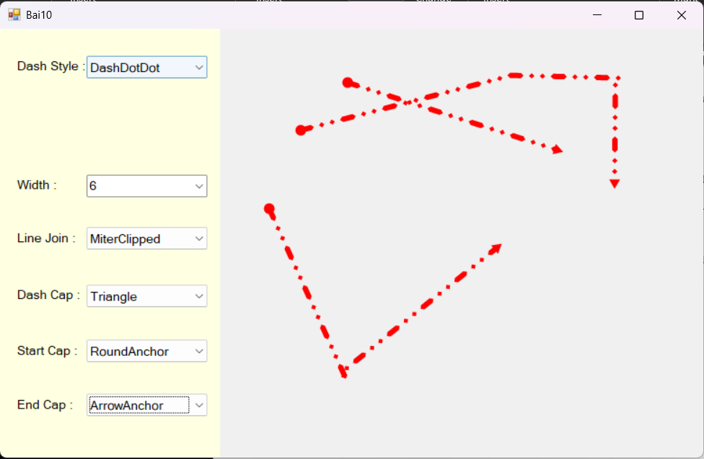

- Nội dung code của Bài 09
Bảng 5.1 Bai10.Designer.cs
namespace BTTH5 {
partial class Bai10 {
/// <summary>
/// Required designer variable.
/// </summary>
private System.ComponentModel.IContainer components = null;

/// <summary>
/// Clean up any resources being used.
/// </summary>
/// <param name="disposing">true if managed resources should be disposed; otherwise, false.</param>
protected override void Dispose(bool disposing) {
if (disposing && (components != null)) {
components.Dispose();
}
base.Dispose(disposing);
}

#region Windows Form Designer generated code

/// <summary>
/// Required method for Designer support - do not modify
/// the contents of this method with the code editor.
/// </summary>
private void InitializeComponent() {
this.panel1 = new System.Windows.Forms.Panel();
this.tbDCustom = new System.Windows.Forms.TextBox();
this.lDCustom = new System.Windows.Forms.Label();
this.cbEndCap = new System.Windows.Forms.ComboBox();
this.lEndCap = new System.Windows.Forms.Label();
this.cbStartCap = new System.Windows.Forms.ComboBox();
this.lStartCap = new System.Windows.Forms.Label();
this.cbDashCap = new System.Windows.Forms.ComboBox();
this.lDashCap = new System.Windows.Forms.Label();
this.cbLineJoin = new System.Windows.Forms.ComboBox();
this.lLineJoin = new System.Windows.Forms.Label();
this.cbWidth = new System.Windows.Forms.ComboBox();
this.lWidth = new System.Windows.Forms.Label();
this.cbDashStyle = new System.Windows.Forms.ComboBox();
this.lDashStyle = new System.Windows.Forms.Label();
this.panel1.SuspendLayout();
this.SuspendLayout();
//
// panel1
//
this.panel1.BackColor = System.Drawing.SystemColors.Info;
this.panel1.Controls.Add(this.tbDCustom);
this.panel1.Controls.Add(this.lDCustom);
this.panel1.Controls.Add(this.cbEndCap);
this.panel1.Controls.Add(this.lEndCap);
this.panel1.Controls.Add(this.cbStartCap);
this.panel1.Controls.Add(this.lStartCap);
this.panel1.Controls.Add(this.cbDashCap);
this.panel1.Controls.Add(this.lDashCap);
this.panel1.Controls.Add(this.cbLineJoin);
this.panel1.Controls.Add(this.lLineJoin);
this.panel1.Controls.Add(this.cbWidth);
this.panel1.Controls.Add(this.lWidth);
this.panel1.Controls.Add(this.cbDashStyle);
this.panel1.Controls.Add(this.lDashStyle);
this.panel1.Dock = System.Windows.Forms.DockStyle.Left;
this.panel1.Location = new System.Drawing.Point(0, 0);
this.panel1.Name = "panel1";
this.panel1.Size = new System.Drawing.Size(325, 586);
this.panel1.TabIndex = 0;
//
// tbDCustom
//
this.tbDCustom.Font = new System.Drawing.Font("Microsoft Sans Serif", 10.2F, System.Drawing.FontStyle.Regular, System.Drawing.GraphicsUnit.Point, ((byte)(0)));
this.tbDCustom.Location = new System.Drawing.Point(128, 118);
this.tbDCustom.Name = "tbDCustom";
this.tbDCustom.Size = new System.Drawing.Size(177, 27);
this.tbDCustom.TabIndex = 25;
this.tbDCustom.Text = "Ex: 5,3,1,3";
this.tbDCustom.TextChanged += new System.EventHandler(this.tbDCustom_TextChanged);
//
// lDCustom
//
this.lDCustom.Anchor = ((System.Windows.Forms.AnchorStyles)(((System.Windows.Forms.AnchorStyles.Top | System.Windows.Forms.AnchorStyles.Bottom)
| System.Windows.Forms.AnchorStyles.Left)));
this.lDCustom.AutoSize = true;
this.lDCustom.Font = new System.Drawing.Font("Microsoft Sans Serif", 10.2F, System.Drawing.FontStyle.Regular, System.Drawing.GraphicsUnit.Point, ((byte)(0)));
this.lDCustom.Location = new System.Drawing.Point(21, 121);
this.lDCustom.Name = "lDCustom";
this.lDCustom.Size = new System.Drawing.Size(77, 20);
this.lDCustom.TabIndex = 24;
this.lDCustom.Text = "Custom :";
//
// cbEndCap
//
this.cbEndCap.Anchor = ((System.Windows.Forms.AnchorStyles)(((System.Windows.Forms.AnchorStyles.Top | System.Windows.Forms.AnchorStyles.Bottom)
| System.Windows.Forms.AnchorStyles.Left)));
this.cbEndCap.DropDownStyle = System.Windows.Forms.ComboBoxStyle.DropDownList;
this.cbEndCap.Font = new System.Drawing.Font("Microsoft Sans Serif", 10.2F, System.Drawing.FontStyle.Regular, System.Drawing.GraphicsUnit.Point, ((byte)(0)));
this.cbEndCap.FormattingEnabled = true;
this.cbEndCap.Items.AddRange(new object[] {
"NoAnchor",
"Flat",
"Square",
"Round",
"Triangle",
"ArrowAnchor",
"SquareAnchor",
"RoundAnchor",
"DiamondAnchor",
"Custom"});
this.cbEndCap.Location = new System.Drawing.Point(128, 499);
this.cbEndCap.Name = "cbEndCap";
this.cbEndCap.Size = new System.Drawing.Size(177, 28);
this.cbEndCap.TabIndex = 23;
this.cbEndCap.TextChanged += new System.EventHandler(this.StartEndCap_TextChange);
//
// lEndCap
//
this.lEndCap.Anchor = ((System.Windows.Forms.AnchorStyles)(((System.Windows.Forms.AnchorStyles.Top | System.Windows.Forms.AnchorStyles.Bottom)
| System.Windows.Forms.AnchorStyles.Left)));
this.lEndCap.AutoSize = true;
this.lEndCap.Font = new System.Drawing.Font("Microsoft Sans Serif", 10.2F, System.Drawing.FontStyle.Regular, System.Drawing.GraphicsUnit.Point, ((byte)(0)));
this.lEndCap.Location = new System.Drawing.Point(21, 502);
this.lEndCap.Name = "lEndCap";
this.lEndCap.Size = new System.Drawing.Size(83, 20);
this.lEndCap.TabIndex = 22;
this.lEndCap.Text = "End Cap :";
//
// cbStartCap
//
this.cbStartCap.Anchor = ((System.Windows.Forms.AnchorStyles)(((System.Windows.Forms.AnchorStyles.Top | System.Windows.Forms.AnchorStyles.Bottom)
| System.Windows.Forms.AnchorStyles.Left)));
this.cbStartCap.DropDownStyle = System.Windows.Forms.ComboBoxStyle.DropDownList;
this.cbStartCap.Font = new System.Drawing.Font("Microsoft Sans Serif", 10.2F, System.Drawing.FontStyle.Regular, System.Drawing.GraphicsUnit.Point, ((byte)(0)));
this.cbStartCap.FormattingEnabled = true;
this.cbStartCap.Items.AddRange(new object[] {
"NoAnchor",
"Flat",
"Square",
"Round",
"Triangle",
"ArrowAnchor",
"SquareAnchor",
"RoundAnchor",
"DiamondAnchor",
"Custom"});
this.cbStartCap.Location = new System.Drawing.Point(128, 425);
this.cbStartCap.Name = "cbStartCap";
this.cbStartCap.Size = new System.Drawing.Size(177, 28);
this.cbStartCap.TabIndex = 21;
this.cbStartCap.TextChanged += new System.EventHandler(this.StartEndCap_TextChange);
//
// lStartCap
//
this.lStartCap.Anchor = ((System.Windows.Forms.AnchorStyles)(((System.Windows.Forms.AnchorStyles.Top | System.Windows.Forms.AnchorStyles.Bottom)
| System.Windows.Forms.AnchorStyles.Left)));
this.lStartCap.AutoSize = true;
this.lStartCap.Font = new System.Drawing.Font("Microsoft Sans Serif", 10.2F, System.Drawing.FontStyle.Regular, System.Drawing.GraphicsUnit.Point, ((byte)(0)));
this.lStartCap.Location = new System.Drawing.Point(21, 428);
this.lStartCap.Name = "lStartCap";
this.lStartCap.Size = new System.Drawing.Size(90, 20);
this.lStartCap.TabIndex = 20;
this.lStartCap.Text = "Start Cap :";
//
// cbDashCap
//
this.cbDashCap.Anchor = ((System.Windows.Forms.AnchorStyles)(((System.Windows.Forms.AnchorStyles.Top | System.Windows.Forms.AnchorStyles.Bottom)
| System.Windows.Forms.AnchorStyles.Left)));
this.cbDashCap.DropDownStyle = System.Windows.Forms.ComboBoxStyle.DropDownList;
this.cbDashCap.Font = new System.Drawing.Font("Microsoft Sans Serif", 10.2F, System.Drawing.FontStyle.Regular, System.Drawing.GraphicsUnit.Point, ((byte)(0)));
this.cbDashCap.FormattingEnabled = true;
this.cbDashCap.Items.AddRange(new object[] {
"Round",
"Flat",
"Triangle"});
this.cbDashCap.Location = new System.Drawing.Point(128, 349);
this.cbDashCap.Name = "cbDashCap";
this.cbDashCap.Size = new System.Drawing.Size(177, 28);
this.cbDashCap.TabIndex = 19;
this.cbDashCap.TextChanged += new System.EventHandler(this.cbDashCap_TextChanged);
//
// lDashCap
//
this.lDashCap.Anchor = ((System.Windows.Forms.AnchorStyles)(((System.Windows.Forms.AnchorStyles.Top | System.Windows.Forms.AnchorStyles.Bottom)
| System.Windows.Forms.AnchorStyles.Left)));
this.lDashCap.AutoSize = true;
this.lDashCap.Font = new System.Drawing.Font("Microsoft Sans Serif", 10.2F, System.Drawing.FontStyle.Regular, System.Drawing.GraphicsUnit.Point, ((byte)(0)));
this.lDashCap.Location = new System.Drawing.Point(21, 352);
this.lDashCap.Name = "lDashCap";
this.lDashCap.Size = new System.Drawing.Size(94, 20);
this.lDashCap.TabIndex = 18;
this.lDashCap.Text = "Dash Cap :";
//
// cbLineJoin
//
this.cbLineJoin.Anchor = ((System.Windows.Forms.AnchorStyles)(((System.Windows.Forms.AnchorStyles.Top | System.Windows.Forms.AnchorStyles.Bottom)
| System.Windows.Forms.AnchorStyles.Left)));
this.cbLineJoin.DropDownStyle = System.Windows.Forms.ComboBoxStyle.DropDownList;
this.cbLineJoin.Font = new System.Drawing.Font("Microsoft Sans Serif", 10.2F, System.Drawing.FontStyle.Regular, System.Drawing.GraphicsUnit.Point, ((byte)(0)));
this.cbLineJoin.FormattingEnabled = true;
this.cbLineJoin.Items.AddRange(new object[] {
"Miter",
"MiterClipped",
"Bevel",
"Round"});
this.cbLineJoin.Location = new System.Drawing.Point(128, 271);
this.cbLineJoin.Name = "cbLineJoin";
this.cbLineJoin.Size = new System.Drawing.Size(177, 28);
this.cbLineJoin.TabIndex = 17;
this.cbLineJoin.TextChanged += new System.EventHandler(this.cbLineJoin_TextChanged);
//
// lLineJoin
//
this.lLineJoin.Anchor = ((System.Windows.Forms.AnchorStyles)(((System.Windows.Forms.AnchorStyles.Top | System.Windows.Forms.AnchorStyles.Bottom)
| System.Windows.Forms.AnchorStyles.Left)));
this.lLineJoin.AutoSize = true;
this.lLineJoin.Font = new System.Drawing.Font("Microsoft Sans Serif", 10.2F, System.Drawing.FontStyle.Regular, System.Drawing.GraphicsUnit.Point, ((byte)(0)));
this.lLineJoin.Location = new System.Drawing.Point(21, 274);
this.lLineJoin.Name = "lLineJoin";
this.lLineJoin.Size = new System.Drawing.Size(87, 20);
this.lLineJoin.TabIndex = 16;
this.lLineJoin.Text = "Line Join :";
//
// cbWidth
//
this.cbWidth.Anchor = ((System.Windows.Forms.AnchorStyles)(((System.Windows.Forms.AnchorStyles.Top | System.Windows.Forms.AnchorStyles.Bottom)
| System.Windows.Forms.AnchorStyles.Left)));
this.cbWidth.Font = new System.Drawing.Font("Microsoft Sans Serif", 10.2F, System.Drawing.FontStyle.Regular, System.Drawing.GraphicsUnit.Point, ((byte)(0)));
this.cbWidth.FormattingEnabled = true;
this.cbWidth.Items.AddRange(new object[] {
"1",
"2",
"3",
"4",
"5",
"6",
"8",
"10",
"12",
"14",
"16",
"18",
"20"});
this.cbWidth.Location = new System.Drawing.Point(128, 199);
this.cbWidth.Name = "cbWidth";
this.cbWidth.Size = new System.Drawing.Size(177, 28);
this.cbWidth.TabIndex = 15;
this.cbWidth.TextChanged += new System.EventHandler(this.cbWidth_TextChanged);
//
// lWidth
//
this.lWidth.Anchor = ((System.Windows.Forms.AnchorStyles)(((System.Windows.Forms.AnchorStyles.Top | System.Windows.Forms.AnchorStyles.Bottom)
| System.Windows.Forms.AnchorStyles.Left)));
this.lWidth.AutoSize = true;
this.lWidth.Font = new System.Drawing.Font("Microsoft Sans Serif", 10.2F, System.Drawing.FontStyle.Regular, System.Drawing.GraphicsUnit.Point, ((byte)(0)));
this.lWidth.Location = new System.Drawing.Point(21, 202);
this.lWidth.Name = "lWidth";
this.lWidth.Size = new System.Drawing.Size(62, 20);
this.lWidth.TabIndex = 14;
this.lWidth.Text = "Width :";
//
// cbDashStyle
//
this.cbDashStyle.Anchor = ((System.Windows.Forms.AnchorStyles)(((System.Windows.Forms.AnchorStyles.Top | System.Windows.Forms.AnchorStyles.Bottom)
| System.Windows.Forms.AnchorStyles.Left)));
this.cbDashStyle.DropDownStyle = System.Windows.Forms.ComboBoxStyle.DropDownList;
this.cbDashStyle.Font = new System.Drawing.Font("Microsoft Sans Serif", 10.2F, System.Drawing.FontStyle.Regular, System.Drawing.GraphicsUnit.Point, ((byte)(0)));
this.cbDashStyle.FormattingEnabled = true;
this.cbDashStyle.Items.AddRange(new object[] {
"Dash",
"DashDotDot",
"DashDot",
"Dot",
"Custom",
"Solid"});
this.cbDashStyle.Location = new System.Drawing.Point(128, 37);
this.cbDashStyle.Name = "cbDashStyle";
this.cbDashStyle.Size = new System.Drawing.Size(177, 28);
this.cbDashStyle.TabIndex = 13;
this.cbDashStyle.TextChanged += new System.EventHandler(this.cbDashStyle_TextChanged);
//
// lDashStyle
//
this.lDashStyle.Anchor = ((System.Windows.Forms.AnchorStyles)(((System.Windows.Forms.AnchorStyles.Top | System.Windows.Forms.AnchorStyles.Bottom)
| System.Windows.Forms.AnchorStyles.Left)));
this.lDashStyle.AutoSize = true;
this.lDashStyle.Font = new System.Drawing.Font("Microsoft Sans Serif", 10.2F, System.Drawing.FontStyle.Regular, System.Drawing.GraphicsUnit.Point, ((byte)(0)));
this.lDashStyle.Location = new System.Drawing.Point(21, 40);
this.lDashStyle.Name = "lDashStyle";
this.lDashStyle.Size = new System.Drawing.Size(101, 20);
this.lDashStyle.TabIndex = 12;
this.lDashStyle.Text = "Dash Style :";
//
// Bai10
//
this.AutoScaleDimensions = new System.Drawing.SizeF(8F, 16F);
this.AutoScaleMode = System.Windows.Forms.AutoScaleMode.Font;
this.ClientSize = new System.Drawing.Size(1040, 586);
this.Controls.Add(this.panel1);
this.DoubleBuffered = true;
this.Name = "Bai10";
this.Text = "Bai10";
this.Paint += new System.Windows.Forms.PaintEventHandler(this.Bai10_Paint);
this.MouseDown += new System.Windows.Forms.MouseEventHandler(this.Bai10_MouseDown);
this.MouseMove += new System.Windows.Forms.MouseEventHandler(this.Bai10_MouseMove);
this.MouseUp += new System.Windows.Forms.MouseEventHandler(this.Bai10_MouseUp);
this.panel1.ResumeLayout(false);
this.panel1.PerformLayout();
this.ResumeLayout(false);

}

#endregion

private System.Windows.Forms.Panel panel1;
private System.Windows.Forms.ComboBox cbEndCap;
private System.Windows.Forms.Label lEndCap;
private System.Windows.Forms.ComboBox cbStartCap;
private System.Windows.Forms.Label lStartCap;
private System.Windows.Forms.ComboBox cbDashCap;
private System.Windows.Forms.Label lDashCap;
private System.Windows.Forms.ComboBox cbLineJoin;
private System.Windows.Forms.Label lLineJoin;
private System.Windows.Forms.ComboBox cbWidth;
private System.Windows.Forms.Label lWidth;
private System.Windows.Forms.ComboBox cbDashStyle;
private System.Windows.Forms.Label lDashStyle;
private System.Windows.Forms.Label lDCustom;
private System.Windows.Forms.TextBox tbDCustom;
}
}

Bảng 5.2 Bai10.cs
using System;
using System.Collections.Generic;
using System.ComponentModel;
using System.Data;
using System.Drawing;
using System.Drawing.Drawing2D;
using System.Linq;
using System.Text;
using System.Threading.Tasks;
using System.Windows.Forms;

namespace BTTH5 {
public partial class Bai10 : Form {
DashStyle dashStyle;
DashCap cap;
LineJoin lineJoin;
float[] Pattern;
int DashWidth;

Point Start;
Point End;

bool flag;

List<List<Point>> lineList = new List<List<Point>>();
Pen pen;

public Bai10() {
InitializeComponent();

lDCustom.Visible = false;
tbDCustom.Visible = false;
}

private void Bai10_MouseDown(object sender, MouseEventArgs e) {
Start = e.Location;
flag = true;

if(pen != null)
pen.Dispose();

pen = new Pen(Color.Red, DashWidth);
pen.DashStyle = dashStyle;
pen.DashCap = cap;
pen.LineJoin = lineJoin;
pen.StartCap = getLineCap(cbStartCap);
pen.EndCap = getLineCap(cbEndCap);

if (dashStyle == DashStyle.Custom && Pattern != null && Pattern.Length > 0) {
try {
pen.DashPattern = Pattern;
}
catch (Exception ex) {
MessageBox.Show("Pattern custom lỗi: " + ex.Message, "ERROR", MessageBoxButtons.OK, MessageBoxIcon.Error);
}
}
}

private void Bai10_MouseMove(object sender, MouseEventArgs e) {
if (flag) {
End = e.Location;

this.Invalidate();
}
}

private void Bai10_MouseUp(object sender, MouseEventArgs e) {
End = e.Location;

if(pen != null && Start != End) {
if(lineList.Count == 0) {
lineList.Add(new List<Point>());
lineList[0].Add(Start);
lineList[0].Add(End);
} else {
if (!JoinNearedLine(Start, End)) {
lineList.Add(new List<Point>());
lineList[lineList.Count - 1].Add(Start);
lineList[lineList.Count - 1].Add(End);
}
}
}

flag = false;

this.Invalidate();
}

private void cbWidth_TextChanged(object sender, EventArgs e) {
Changed_Style();

if (string.IsNullOrEmpty(cbWidth.Text)) {
DashWidth = 0;
return;
}

if(!int.TryParse(cbWidth.Text, out DashWidth)) {
MessageBox.Show("Width phải là số nguyên dương.", "ERROR", MessageBoxButtons.OK, MessageBoxIcon.Error);
}
}

private void cbDashStyle_TextChanged(object sender, EventArgs e) {
Changed_Style();

lDCustom.Visible = false;
tbDCustom.Visible = false;

switch (cbDashStyle.Text) {
case "Dash":
dashStyle = DashStyle.Dash;
break;
case "DashDot":
dashStyle = DashStyle.DashDot;
break;
case "DashDotDot":
dashStyle = DashStyle.DashDotDot;
break;
case "Dot":
dashStyle = DashStyle.Dot;
break;
case "Solid":
dashStyle = DashStyle.Solid;
break;
case "Custom":
dashStyle = DashStyle.Custom;

lDCustom.Visible = true;
tbDCustom.Visible = true;
break;
default:
break;
}
}

private void tbDCustom_TextChanged(object sender, EventArgs e) {
Changed_Style();

string str = tbDCustom.Text;

if (string.IsNullOrEmpty(str)) {
Pattern = null;
return;
}

if (str.StartsWith("Ex:")) {
str = str.Substring(3).Trim();
}

string[] tmp = str.Split(new[] {','}, StringSplitOptions.RemoveEmptyEntries);
List<float> list = new List<float>();
float p;

foreach(string s in tmp) {
if (float.TryParse(s.Trim(), out p)) {
if (p <= 0f) {
MessageBox.Show("Mỗi giá trị trong chuỗi custom phải > 0.", "ERROR", MessageBoxButtons.OK, MessageBoxIcon.Error);
Pattern = null;
return;
}
list.Add(p);
} else {
MessageBox.Show("Vui lòng nhập đúng định dạng.\n\tVD: 5,3,1,3,...", "ERROR", MessageBoxButtons.OK, MessageBoxIcon.Error);
Pattern = null;
return;
}
}

if (list.Count == 0) {
Pattern = null;
return;
}

Pattern = list.ToArray();
}

private void cbLineJoin_TextChanged(object sender, EventArgs e) {
Changed_Style();

switch (cbLineJoin.Text) {
case "Miter":
lineJoin = LineJoin.Miter;
break;
case "Bevel":
lineJoin = LineJoin.Bevel;
break;
case "Round":
lineJoin = LineJoin.Round;
break;
case "MiterClipped":
lineJoin = LineJoin.MiterClipped;
break;
default:
break;
}
}

private void cbDashCap_TextChanged(object sender, EventArgs e) {
Changed_Style();

switch (cbDashCap.Text) {
case "Flat":
cap = DashCap.Flat;
break;
case "Triangle":
cap = DashCap.Triangle;
break;
case "Round":
cap = DashCap.Round;
break;
default:
break;
}
}

private void StartEndCap_TextChange(object sender, EventArgs e) {
Changed_Style();
}

private LineCap getLineCap(object sender){
ComboBox type = (ComboBox)sender;

switch (type.Text) {
case "Flat":
return LineCap.Flat;
case "Square":
return LineCap.Square;
case "Triangle":
return LineCap.Triangle;
case "Round":
return LineCap.Round;
case "ArrowAnchor":
return LineCap.ArrowAnchor;
case "SquareAnchor":
return LineCap.SquareAnchor;
case "RoundAnchor":
return LineCap.RoundAnchor;
case "DiamondAnchor":
return LineCap.DiamondAnchor;
case "Custom":
MessageBox.Show("Chưa cài đặt.\nDùng No Anchor.", "ERROR", MessageBoxButtons.OK, MessageBoxIcon.Error);
type.Text = "NoAnchor";
return LineCap.NoAnchor;
default:
return LineCap.NoAnchor;
}
}

private void Changed_Style() {
lineList.Clear();

this.Invalidate();
}

private void Bai10_Paint(object sender, PaintEventArgs e) {
Graphics graphics = e.Graphics;
graphics.SmoothingMode = SmoothingMode.AntiAlias;

if (DashWidth <= 0 || pen == null)
return;

DrawLine(graphics);

if(flag)
graphics.DrawLine(pen, Start, End);
}

private void DrawLine(Graphics g) {
if (lineList == null || lineList.Count == 0)
return;

foreach(List<Point> list in lineList){
if (list.Count == 0)
continue;

g.DrawLines(pen, list.ToArray());
}
}

private double Distance(Point a, Point b) {
int dx = a.X - b.X;
int dy = a.Y - b.Y;

return Math.Sqrt(dx * dx + dy * dy);
}

private bool JoinNearedLine(Point Start, Point End) {
double Min = 15.0;

foreach (List<Point> list in lineList) {
Point last = list[list.Count - 1];

if(Distance(Start, last) <= Min) {
list.Add(Start);
list.Add(End);
return true;
}
}

return false;
}
}
}

- Các testcase của chương trình:
Đã được upload lên drive.

Xây dựng chương trình vẽ hình cơ bản như sau:
Khi chọn button “Color” thì xuất hiện hộp thoại Color để chọn màu vẽ đường.
Khi người dùng nhấn giữ nút trái chuột và di chuyển chuột trên pictureBox thì sẽ vẽ hình tương ứng tùy thuộc vào hình được chọn:
- Line: Vẽ đường thẳng có độ dày (txtWidth) và màu tương ứng đã được chọn.
- Rectangle hay Ellipse: Tô hình chữ nhật hay hình Ellipse với Brush tương ứng:
- SolidBrush: sử dụng SolidBrush với màu là Green.
- HatchBrush: sử dụng HatchBrush có kiểu là Horizontal với 2 màu tương ứng
- là Blue và Green
- TextureBrush: sử dụng TextureBrush, tô với bitmap cho trước.
- LinearGradientBrush: sử dụng LinearGradientBrush có kiểu là Vertical với 2 màu tương ứng là: Red và Green.
Hình 6-1 VD GUI Bài 11
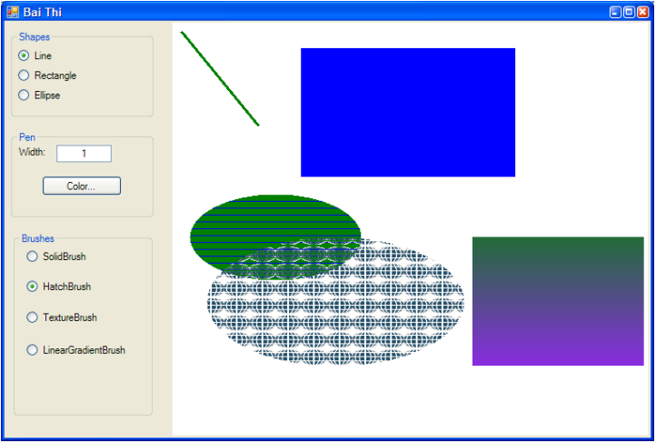

- Mô tả đầu vào và đầu ra của chương trình:
- Input: Người dùng có thể chọn các kiểu hình dạng, chọn kích thước và màu bút đối với dạng vẽ các đường thẳng (line), còn đối với kiểu vẽ hình chữ nhật và ellipse thì chọn các loại cọ vẽ.
- Output: Hiển thị các hình ảnh mà người dùng vẽ ra form, có Preview khi kéo chuột chọn kích thước hình.

Hình 6-2 GUI Bài 11
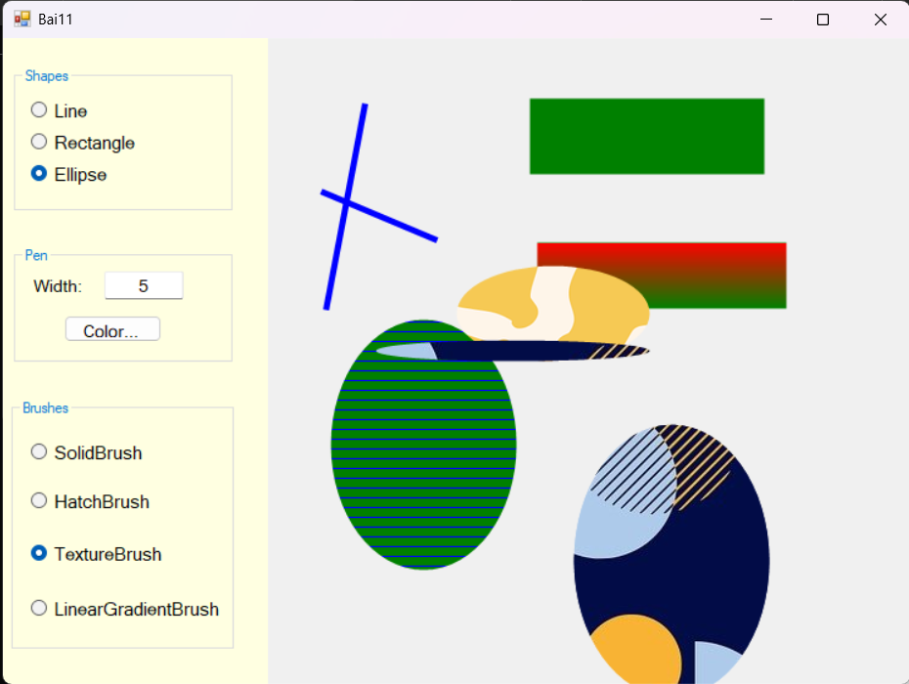

- Nội dung code Bài 11
Bảng 6.1 Bai11.Designer.cs
namespace BTTH5 {
partial class Bai11 {
/// <summary>
/// Required designer variable.
/// </summary>
private System.ComponentModel.IContainer components = null;

/// <summary>
/// Clean up any resources being used.
/// </summary>
/// <param name="disposing">true if managed resources should be disposed; otherwise, false.</param>
protected override void Dispose(bool disposing) {
if (disposing && (components != null)) {
components.Dispose();
}
base.Dispose(disposing);
}

#region Windows Form Designer generated code

/// <summary>
/// Required method for Designer support - do not modify
/// the contents of this method with the code editor.
/// </summary>
private void InitializeComponent() {
this.panel1 = new System.Windows.Forms.Panel();
this.gbBrushes = new System.Windows.Forms.GroupBox();
this.rbLinearGradientBrush = new System.Windows.Forms.RadioButton();
this.rbTextureBrush = new System.Windows.Forms.RadioButton();
this.rbHatchBrush = new System.Windows.Forms.RadioButton();
this.rbSolidBrush = new System.Windows.Forms.RadioButton();
this.gbPen = new System.Windows.Forms.GroupBox();
this.bPenColor = new System.Windows.Forms.Button();
this.tbWidthPen = new System.Windows.Forms.TextBox();
this.lWidthPen = new System.Windows.Forms.Label();
this.gbShapes = new System.Windows.Forms.GroupBox();
this.rbEllipse = new System.Windows.Forms.RadioButton();
this.rbRectangle = new System.Windows.Forms.RadioButton();
this.rbLine = new System.Windows.Forms.RadioButton();
this.colorDialog1 = new System.Windows.Forms.ColorDialog();
this.openFileDialog1 = new System.Windows.Forms.OpenFileDialog();
this.panel1.SuspendLayout();
this.gbBrushes.SuspendLayout();
this.gbPen.SuspendLayout();
this.gbShapes.SuspendLayout();
this.SuspendLayout();
//
// panel1
//
this.panel1.BackColor = System.Drawing.SystemColors.Info;
this.panel1.Controls.Add(this.gbBrushes);
this.panel1.Controls.Add(this.gbPen);
this.panel1.Controls.Add(this.gbShapes);
this.panel1.Dock = System.Windows.Forms.DockStyle.Left;
this.panel1.Location = new System.Drawing.Point(0, 0);
this.panel1.Name = "panel1";
this.panel1.Size = new System.Drawing.Size(289, 651);
this.panel1.TabIndex = 0;
//
// gbBrushes
//
this.gbBrushes.Controls.Add(this.rbLinearGradientBrush);
this.gbBrushes.Controls.Add(this.rbTextureBrush);
this.gbBrushes.Controls.Add(this.rbHatchBrush);
this.gbBrushes.Controls.Add(this.rbSolidBrush);
this.gbBrushes.ForeColor = System.Drawing.SystemColors.Highlight;
this.gbBrushes.Location = new System.Drawing.Point(9, 364);
this.gbBrushes.Name = "gbBrushes";
this.gbBrushes.Size = new System.Drawing.Size(242, 252);
this.gbBrushes.TabIndex = 4;
this.gbBrushes.TabStop = false;
this.gbBrushes.Text = "Brushes";
//
// rbLinearGradientBrush
//
this.rbLinearGradientBrush.AutoSize = true;
this.rbLinearGradientBrush.Font = new System.Drawing.Font("Microsoft Sans Serif", 10.8F, System.Drawing.FontStyle.Regular, System.Drawing.GraphicsUnit.Point, ((byte)(0)));
this.rbLinearGradientBrush.ForeColor = System.Drawing.SystemColors.ControlText;
this.rbLinearGradientBrush.Location = new System.Drawing.Point(21, 197);
this.rbLinearGradientBrush.Name = "rbLinearGradientBrush";
this.rbLinearGradientBrush.Size = new System.Drawing.Size(197, 26);
this.rbLinearGradientBrush.TabIndex = 3;
this.rbLinearGradientBrush.TabStop = true;
this.rbLinearGradientBrush.Text = "LinearGradientBrush";
this.rbLinearGradientBrush.UseVisualStyleBackColor = true;
this.rbLinearGradientBrush.CheckedChanged += new System.EventHandler(this.rbLinearGradientBrush_CheckedChanged);
//
// rbTextureBrush
//
this.rbTextureBrush.AutoSize = true;
this.rbTextureBrush.Font = new System.Drawing.Font("Microsoft Sans Serif", 10.8F, System.Drawing.FontStyle.Regular, System.Drawing.GraphicsUnit.Point, ((byte)(0)));
this.rbTextureBrush.ForeColor = System.Drawing.SystemColors.ControlText;
this.rbTextureBrush.Location = new System.Drawing.Point(21, 142);
this.rbTextureBrush.Name = "rbTextureBrush";
this.rbTextureBrush.Size = new System.Drawing.Size(140, 26);
this.rbTextureBrush.TabIndex = 2;
this.rbTextureBrush.TabStop = true;
this.rbTextureBrush.Text = "TextureBrush";
this.rbTextureBrush.UseVisualStyleBackColor = true;
this.rbTextureBrush.CheckedChanged += new System.EventHandler(this.rbTextureBrush_CheckedChanged);
//
// rbHatchBrush
//
this.rbHatchBrush.AutoSize = true;
this.rbHatchBrush.Font = new System.Drawing.Font("Microsoft Sans Serif", 10.8F, System.Drawing.FontStyle.Regular, System.Drawing.GraphicsUnit.Point, ((byte)(0)));
this.rbHatchBrush.ForeColor = System.Drawing.SystemColors.ControlText;
this.rbHatchBrush.Location = new System.Drawing.Point(21, 89);
this.rbHatchBrush.Name = "rbHatchBrush";
this.rbHatchBrush.Size = new System.Drawing.Size(125, 26);
this.rbHatchBrush.TabIndex = 1;
this.rbHatchBrush.TabStop = true;
this.rbHatchBrush.Text = "HatchBrush";
this.rbHatchBrush.UseVisualStyleBackColor = true;
this.rbHatchBrush.CheckedChanged += new System.EventHandler(this.rbHatchBrush_CheckedChanged);
//
// rbSolidBrush
//
this.rbSolidBrush.AutoSize = true;
this.rbSolidBrush.Font = new System.Drawing.Font("Microsoft Sans Serif", 10.8F, System.Drawing.FontStyle.Regular, System.Drawing.GraphicsUnit.Point, ((byte)(0)));
this.rbSolidBrush.ForeColor = System.Drawing.SystemColors.ControlText;
this.rbSolidBrush.Location = new System.Drawing.Point(21, 40);
this.rbSolidBrush.Name = "rbSolidBrush";
this.rbSolidBrush.Size = new System.Drawing.Size(118, 26);
this.rbSolidBrush.TabIndex = 0;
this.rbSolidBrush.TabStop = true;
this.rbSolidBrush.Text = "SolidBrush";
this.rbSolidBrush.UseVisualStyleBackColor = true;
this.rbSolidBrush.CheckedChanged += new System.EventHandler(this.rbSolidBrush_CheckedChanged);
//
// gbPen
//
this.gbPen.Controls.Add(this.bPenColor);
this.gbPen.Controls.Add(this.tbWidthPen);
this.gbPen.Controls.Add(this.lWidthPen);
this.gbPen.ForeColor = System.Drawing.SystemColors.Highlight;
this.gbPen.Location = new System.Drawing.Point(12, 211);
this.gbPen.Name = "gbPen";
this.gbPen.Size = new System.Drawing.Size(239, 117);
this.gbPen.TabIndex = 3;
this.gbPen.TabStop = false;
this.gbPen.Text = "Pen";
//
// bPenColor
//
this.bPenColor.Font = new System.Drawing.Font("Microsoft Sans Serif", 10.2F, System.Drawing.FontStyle.Regular, System.Drawing.GraphicsUnit.Point, ((byte)(0)));
this.bPenColor.ForeColor = System.Drawing.SystemColors.ControlText;
this.bPenColor.Location = new System.Drawing.Point(55, 69);
this.bPenColor.Name = "bPenColor";
this.bPenColor.Size = new System.Drawing.Size(106, 27);
this.bPenColor.TabIndex = 2;
this.bPenColor.Text = "Color...";
this.bPenColor.UseVisualStyleBackColor = true;
this.bPenColor.Click += new System.EventHandler(this.bPenColor_Click);
//
// tbWidthPen
//
this.tbWidthPen.Font = new System.Drawing.Font("Microsoft Sans Serif", 10.2F, System.Drawing.FontStyle.Regular, System.Drawing.GraphicsUnit.Point, ((byte)(0)));
this.tbWidthPen.Location = new System.Drawing.Point(99, 25);
this.tbWidthPen.Name = "tbWidthPen";
this.tbWidthPen.Size = new System.Drawing.Size(85, 27);
this.tbWidthPen.TabIndex = 1;
this.tbWidthPen.Text = "1";
this.tbWidthPen.TextAlign = System.Windows.Forms.HorizontalAlignment.Center;
this.tbWidthPen.TextChanged += new System.EventHandler(this.tbWidthPen_TextChanged);
//
// lWidthPen
//
this.lWidthPen.AutoSize = true;
this.lWidthPen.Font = new System.Drawing.Font("Microsoft Sans Serif", 10.2F, System.Drawing.FontStyle.Regular, System.Drawing.GraphicsUnit.Point, ((byte)(0)));
this.lWidthPen.ForeColor = System.Drawing.SystemColors.ControlText;
this.lWidthPen.Location = new System.Drawing.Point(17, 28);
this.lWidthPen.Name = "lWidthPen";
this.lWidthPen.Size = new System.Drawing.Size(57, 20);
this.lWidthPen.TabIndex = 0;
this.lWidthPen.Text = "Width:";
//
// gbShapes
//
this.gbShapes.Controls.Add(this.rbEllipse);
this.gbShapes.Controls.Add(this.rbRectangle);
this.gbShapes.Controls.Add(this.rbLine);
this.gbShapes.ForeColor = System.Drawing.SystemColors.Highlight;
this.gbShapes.Location = new System.Drawing.Point(12, 29);
this.gbShapes.Name = "gbShapes";
this.gbShapes.Size = new System.Drawing.Size(239, 145);
this.gbShapes.TabIndex = 2;
this.gbShapes.TabStop = false;
this.gbShapes.Text = "Shapes";
//
// rbEllipse
//
this.rbEllipse.AutoSize = true;
this.rbEllipse.Font = new System.Drawing.Font("Microsoft Sans Serif", 10.8F, System.Drawing.FontStyle.Regular, System.Drawing.GraphicsUnit.Point, ((byte)(0)));
this.rbEllipse.ForeColor = System.Drawing.SystemColors.ControlText;
this.rbEllipse.Location = new System.Drawing.Point(18, 94);
this.rbEllipse.Name = "rbEllipse";
this.rbEllipse.Size = new System.Drawing.Size(84, 26);
this.rbEllipse.TabIndex = 3;
this.rbEllipse.TabStop = true;
this.rbEllipse.Text = "Ellipse";
this.rbEllipse.UseVisualStyleBackColor = true;
this.rbEllipse.CheckedChanged += new System.EventHandler(this.rbEllipse_CheckedChanged);
//
// rbRectangle
//
this.rbRectangle.AutoSize = true;
this.rbRectangle.Font = new System.Drawing.Font("Microsoft Sans Serif", 10.8F, System.Drawing.FontStyle.Regular, System.Drawing.GraphicsUnit.Point, ((byte)(0)));
this.rbRectangle.ForeColor = System.Drawing.SystemColors.ControlText;
this.rbRectangle.Location = new System.Drawing.Point(18, 62);
this.rbRectangle.Name = "rbRectangle";
this.rbRectangle.Size = new System.Drawing.Size(112, 26);
this.rbRectangle.TabIndex = 2;
this.rbRectangle.TabStop = true;
this.rbRectangle.Text = "Rectangle";
this.rbRectangle.UseVisualStyleBackColor = true;
this.rbRectangle.CheckedChanged += new System.EventHandler(this.rbRectangle_CheckedChanged);
//
// rbLine
//
this.rbLine.AutoSize = true;
this.rbLine.Font = new System.Drawing.Font("Microsoft Sans Serif", 10.8F, System.Drawing.FontStyle.Regular, System.Drawing.GraphicsUnit.Point, ((byte)(0)));
this.rbLine.ForeColor = System.Drawing.SystemColors.ControlText;
this.rbLine.Location = new System.Drawing.Point(18, 30);
this.rbLine.Name = "rbLine";
this.rbLine.Size = new System.Drawing.Size(65, 26);
this.rbLine.TabIndex = 1;
this.rbLine.TabStop = true;
this.rbLine.Text = "Line";
this.rbLine.UseVisualStyleBackColor = true;
this.rbLine.CheckedChanged += new System.EventHandler(this.rbLine_CheckedChanged);
//
// openFileDialog1
//
this.openFileDialog1.FileName = "openFileDialog1";
//
// Bai11
//
this.AutoScaleDimensions = new System.Drawing.SizeF(8F, 16F);
this.AutoScaleMode = System.Windows.Forms.AutoScaleMode.Font;
this.ClientSize = new System.Drawing.Size(990, 651);
this.Controls.Add(this.panel1);
this.DoubleBuffered = true;
this.Name = "Bai11";
this.Text = "Bai11";
this.Paint += new System.Windows.Forms.PaintEventHandler(this.Bai11_Paint);
this.MouseDown += new System.Windows.Forms.MouseEventHandler(this.Bai11_MouseDown);
this.MouseMove += new System.Windows.Forms.MouseEventHandler(this.Bai11_MouseMove);
this.MouseUp += new System.Windows.Forms.MouseEventHandler(this.Bai11_MouseUp);
this.Resize += new System.EventHandler(this.Bai11_Resize);
this.panel1.ResumeLayout(false);
this.gbBrushes.ResumeLayout(false);
this.gbBrushes.PerformLayout();
this.gbPen.ResumeLayout(false);
this.gbPen.PerformLayout();
this.gbShapes.ResumeLayout(false);
this.gbShapes.PerformLayout();
this.ResumeLayout(false);

}

#endregion

private System.Windows.Forms.Panel panel1;
private System.Windows.Forms.GroupBox gbBrushes;
private System.Windows.Forms.RadioButton rbLinearGradientBrush;
private System.Windows.Forms.RadioButton rbTextureBrush;
private System.Windows.Forms.RadioButton rbHatchBrush;
private System.Windows.Forms.RadioButton rbSolidBrush;
private System.Windows.Forms.GroupBox gbPen;
private System.Windows.Forms.Button bPenColor;
private System.Windows.Forms.TextBox tbWidthPen;
private System.Windows.Forms.Label lWidthPen;
private System.Windows.Forms.GroupBox gbShapes;
private System.Windows.Forms.RadioButton rbEllipse;
private System.Windows.Forms.RadioButton rbRectangle;
private System.Windows.Forms.RadioButton rbLine;
private System.Windows.Forms.ColorDialog colorDialog1;
private System.Windows.Forms.OpenFileDialog openFileDialog1;
}
}

Bảng 6.2 Bai11.cs
using System;
using System.Collections.Generic;
using System.ComponentModel;
using System.Data;
using System.Drawing;
using System.Drawing.Drawing2D;
using System.Linq;
using System.Text;
using System.Threading.Tasks;
using System.Windows.Forms;

namespace BTTH5 {
public partial class Bai11 : Form {
Color color;
int PenWidth = 1;
Brush brush;
string shapes;
bool flag;

Bitmap image;
Graphics g;

Point Start;
Point End;

public Bai11() {
InitializeComponent();

color = Color.Black;
image = new Bitmap(ClientSize.Width, ClientSize.Height);
g = Graphics.FromImage(image);
g.SmoothingMode = SmoothingMode.AntiAlias;
}

private void bPenColor_Click(object sender, EventArgs e) {
DialogResult r = colorDialog1.ShowDialog();

if (r == DialogResult.OK) {
color = colorDialog1.Color;
}
}

private void rbSolidBrush_CheckedChanged(object sender, EventArgs e) {
if(brush != null)
brush.Dispose();
if (rbSolidBrush.Checked)
brush = new SolidBrush(Color.Green);
}

private void rbHatchBrush_CheckedChanged(object sender, EventArgs e) {
if(brush != null)
brush.Dispose();
if (rbHatchBrush.Checked)
brush = new HatchBrush(HatchStyle.Horizontal, Color.Blue, Color.Green);
}

private void rbTextureBrush_CheckedChanged(object sender, EventArgs e) {
if (brush != null)
brush.Dispose();

Image img;

if (rbTextureBrush.Checked) {
DialogResult r = MessageBox.Show("Sử dụng ảnh mặc định?", "Question", MessageBoxButtons.YesNo, MessageBoxIcon.Question);

if (r == DialogResult.No) {
openFileDialog1.Filter = "Bitmap (*.bmp)|*.bmp|PNG (*.png)|*.png";
DialogResult opf = openFileDialog1.ShowDialog();
if (opf == DialogResult.OK) {
img = Image.FromFile(openFileDialog1.FileName);
} else {
img = Properties.Resources.flower;
}
} else {
img = Properties.Resources.flower;
}

brush = new TextureBrush(img);
}

}

private void rbLinearGradientBrush_CheckedChanged(object sender, EventArgs e) {
if(brush != null)
brush.Dispose();
}

private void tbWidthPen_TextChanged(object sender, EventArgs e) {
if (string.IsNullOrEmpty(tbWidthPen.Text)) {
PenWidth = 0;
return;
}

if (!int.TryParse(tbWidthPen.Text, out PenWidth) || PenWidth < 0) {
MessageBox.Show("Pen Width phải là số nguyên lớn hơn 0", "ERROR", MessageBoxButtons.OK, MessageBoxIcon.Error);
tbWidthPen.Text = "1";
}
}

private void Disable_Brushes() {
rbSolidBrush.Checked = false;
rbLinearGradientBrush.Checked = false;
rbTextureBrush.Checked = false;
rbHatchBrush.Checked = false;
}

private void rbLine_CheckedChanged(object sender, EventArgs e) {
if (rbLine.Checked) {
shapes = "Line";
Disable_Brushes();
gbBrushes.Enabled = false;
} else {
rbSolidBrush.Checked = true;
gbBrushes.Enabled = true;
}
}

private void rbRectangle_CheckedChanged(object sender, EventArgs e) {
if (rbRectangle.Checked)
shapes = "Rectangle";
}

private void rbEllipse_CheckedChanged(object sender, EventArgs e) {
if (rbEllipse.Checked)
shapes = "Ellipse";
}

private void Bai11_MouseDown(object sender, MouseEventArgs e) {
Start = e.Location;
flag = true;
}

private void Bai11_MouseMove(object sender, MouseEventArgs e) {
if (flag) {
End = e.Location;

this.Invalidate();
}
}

private void Bai11_MouseUp(object sender, MouseEventArgs e) {
if (!flag)
return;

End = e.Location;
flag = false;

if (shapes == "Line") {
if (PenWidth == 0)
return;

g.DrawLine(new Pen(color, PenWidth), Start, End);
} else {
Rectangle rect = Create_Rect();

if (rbLinearGradientBrush.Checked) {
if (rect.Width > 0 && rect.Height > 0)
brush = new LinearGradientBrush(rect, Color.Red, Color.Green, LinearGradientMode.Vertical);
else
return;
}

if (shapes == "Rectangle")
g.FillRectangle(brush, rect);
else
g.FillEllipse(brush, rect);
}

this.Invalidate();
}

private Rectangle Create_Rect() {
int x = Math.Min(Start.X, End.X);
int y = Math.Min(Start.Y, End.Y);

int width = Math.Abs(Start.X - End.X);
int height = Math.Abs(Start.Y - End.Y);

return new Rectangle(x, y, width, height);
}

private void Bai11_Paint(object sender, PaintEventArgs e) {
Graphics graphics = e.Graphics;
graphics.SmoothingMode = SmoothingMode.AntiAlias;

graphics.DrawImage(image, 0, 0);

if (!flag)
return;

if(shapes == "Line") {
if (PenWidth == 0)
return;

graphics.DrawLine(new Pen(color, PenWidth), Start, End);
} else {
Rectangle rect = Create_Rect();

if (rbLinearGradientBrush.Checked) {
if (rect.Width > 0 && rect.Height > 0)
brush = new LinearGradientBrush(rect, Color.Red, Color.Green, LinearGradientMode.Vertical);
else
return;
}

if (shapes == "Rectangle")
graphics.FillRectangle(brush, rect);
else
graphics.FillEllipse(brush, rect);
}
}

private void Bai11_Resize(object sender, EventArgs e) {
if (ClientSize.Width <= 0 || ClientSize.Height <= 0 || image == null || g == null)
return;

Bitmap img = new Bitmap(ClientSize.Width, ClientSize.Height);
Graphics gNew = Graphics.FromImage(img);
gNew.SmoothingMode = SmoothingMode.AntiAlias;
gNew.DrawImage(image, 0, 0);

image.Dispose();
image = img;

g.Dispose();
g = gNew;

this.Invalidate();
}
}
}

- Các testcase của chương trình:
Đã được upload lên drive.

LinkCode Github: https://github.com/trungnha-uit/IT008/tree/main/BTTH5
LinkTestcase Drive:
https://drive.google.com/drive/folders/14gusMEKQ-AFHjl3Uu3hqsLsww9KxLRtO?hl=vi

