1.R

Toshiba

Mon Dec 01 16:46:42 2014

library(TSA)

## Loading required package: leaps  
## Loading required package: locfit  
## locfit 1.5-9.1 2013-03-22  
## Loading required package: mgcv  
## Loading required package: nlme  
## This is mgcv 1.8-0. For overview type 'help("mgcv-package")'.  
## Loading required package: tseries  
##   
## Attaching package: 'TSA'  
##   
## The following objects are masked from 'package:stats':  
##   
## acf, arima  
##   
## The following object is masked from 'package:utils':  
##   
## tar

library(tsDyn)

## Warning: package 'tsDyn' was built under R version 3.1.2

setwd("C:/Users/Toshiba/Desktop/vishal iit/5th sem/Applied time series analysis/assignments/project")  
load("projq1a.Rdata")  
  
plot(vk,type='l')

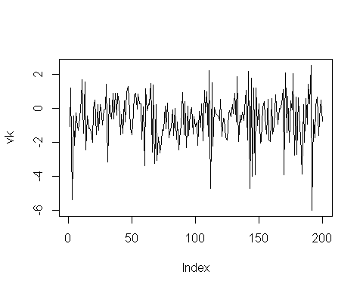

acf(vk)

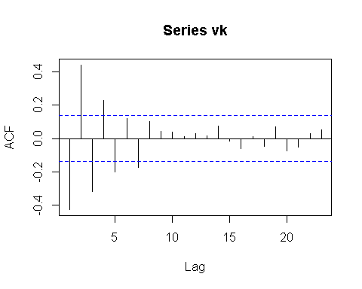

pacf(vk)

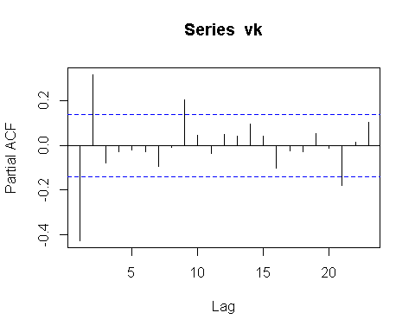

nonlinear_test=Tsay.test(vk,order=2)# non linear  
  
vk_guess=tar(vk,2,1,1,method="MAIC",estimate.thd=TRUE)  
vk_guess_residuals=vk_guess$residuals  
acf(vk_guess_residuals)

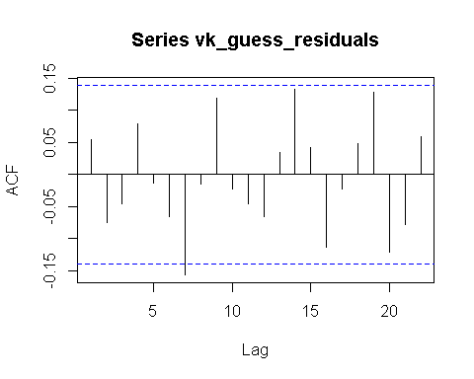

pacf(vk_guess_residuals)

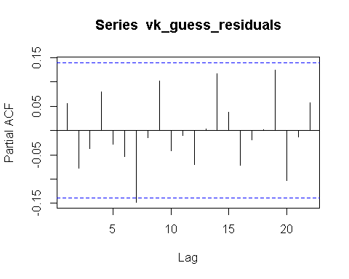

Threshold=vk_guess$n1 # Threshold  
vk_guess_1_coeff=vk_guess$qr1$coefficients # cofficients for first regime  
vk_guess_2_coeff=vk_guess$qr2$coefficients # cofficients for second regime  
  
phi_intercept_1=vk_guess_1_coeff[1]  
phi_1_1=vk_guess_1_coeff[2]  
phi_2_1=vk_guess_1_coeff[3]  
  
phi_intercept_2=vk_guess_2_coeff[1]  
phi_1_2=vk_guess_2_coeff[2]  
  
tsdiag.TAR(vk_guess)

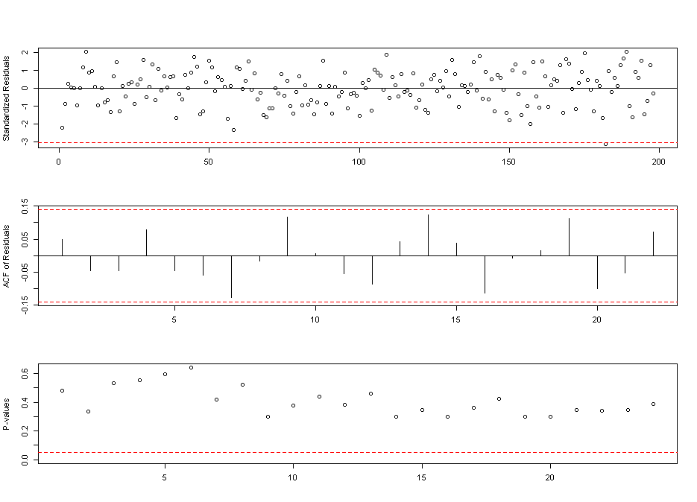

# part B  
  
epsk=vk_guess_residuals  
vk_guess_y=vk_guess$y  
  
Threshold_mod_store=0  
phi_mod_intercept_1_store=0  
phi_mod_1_1_store=0  
phi_mod_2_1_store=0  
  
phi_mod_intercept_2_store=0  
phi_mod_1_2_store=0  
j=1  
k=1  
l=1  
m=1  
n=1  
o=1  
for (i in 1:200)  
{  
  
epskr1<-sample(epsk,size=200,replace=T)  
vk_mod=vk_guess_y+epskr1  
vk_guess_mod=tar(vk_mod,2,1,1,method="MAIC",estimate.thd=TRUE)  
  
if(!is.na(vk_guess_mod$n1))  
{  
Threshold_mod_store[j]=vk_guess_mod$n1   
j=j+1  
}  
  
vk_guess_mod_1_coeff=vk_guess_mod$qr1$coefficients # cofficients for first regime  
vk_guess_mod_2_coeff=vk_guess_mod$qr2$coefficients # cofficients for second regime  
  
if(!is.na(vk_guess_mod_1_coeff[1]))  
{  
   
phi_mod_intercept_1_store[k]=vk_guess_mod_1_coeff[1]  
k=k+1  
}  
  
if(!is.na(vk_guess_mod_1_coeff[2]))  
{  
phi_mod_1_1_store[l]=vk_guess_mod_1_coeff[2]  
l=l+1  
}  
  
if(!is.na(vk_guess_mod_1_coeff[3]))  
{  
phi_mod_2_1_store[m]=vk_guess_mod_1_coeff[3]  
m=m+1  
}  
  
if(!is.na(vk_guess_mod_2_coeff[1]))  
{  
phi_mod_intercept_2_store[n]=vk_guess_mod_2_coeff[1]  
n=n+1  
}  
  
if(!is.na(vk_guess_mod_2_coeff[2]))  
{  
phi_mod_1_2_store[o]=vk_guess_mod_2_coeff[2]  
o=o+1  
}  
  
}  
  
Threshold_mod_mean=mean(Threshold_mod_store)  
Threshold_mod_var=var(Threshold_mod_store)  
Threshold_mod_den=dnorm(Threshold_mod_store,mean=Threshold_mod_mean,sd=sqrt(Threshold_mod_var))  
#plot(Threshold_mod_store,Threshold_mod_den,type="l")  
  
phi_mod_intercept_1_mean=mean(phi_mod_intercept_1_store)  
phi_mod_intercept_1_var=var(phi_mod_intercept_1_store)  
phi_mod_intercept_1_den=dnorm(phi_mod_intercept_1_store,mean=phi_mod_intercept_1_mean,sd=sqrt(phi_mod_intercept_1_var))  
#plot(phi_mod_intercept_1_store,phi_mod_intercept_1_den,type='l')  
  
  
phi_mod_1_1_mean=mean(phi_mod_1_1_store)  
phi_mod_1_1_var=var(phi_mod_1_1_store)  
phi_mod_1_1_den=dnorm(phi_mod_1_1_store,mean=phi_mod_1_1_mean,sd=sqrt(phi_mod_1_1_var))  
#plot(phi_mod_1_1_store,phi_mod_1_1_den,type='l')  
  
phi_mod_2_1_mean=mean(phi_mod_2_1_store)  
phi_mod_2_1_var=var(phi_mod_2_1_store)  
phi_mod_2_1_den=dnorm(phi_mod_2_1_store,mean=phi_mod_2_1_mean,sd=sqrt(phi_mod_2_1_var))  
#plot(phi_mod_2_1_store,phi_mod_2_1_den,type='l')  
  
phi_mod_intercept_2_mean=mean(phi_mod_intercept_2_store)  
phi_mod_intercept_2_var=var(phi_mod_intercept_2_store)  
phi_mod_intercept_2_den=dnorm(phi_mod_intercept_2_store,mean=phi_mod_intercept_2_mean,sd=sqrt(phi_mod_intercept_2_var))  
#plot(phi_mod_intercept_2_store,phi_mod_intercept_2_den,type='l')  
  
phi_mod_1_2_mean=mean(phi_mod_1_2_store)  
phi_mod_1_2_var=var(phi_mod_1_2_store)  
phi_mod_1_2_den=dnorm(phi_mod_1_2_store,mean=phi_mod_1_2_mean,sd=sqrt(phi_mod_1_2_var))  
#plot(phi_mod_1_2_store,phi_mod_1_2_den,type='l')

|  |  |  |
| --- | --- | --- |
| Variable | Actual | Mean |
| Threshold | 175 | 156.66 |
| Intercept1 | -0.165 | -0.419 |
| -d11 | -0.0248 | -0.107 |
| -d21 | 0.422 | 0.272 |
| Intercept2 | 0.366 | -0.13 |
| -d12 | -1.88 | -1.74 |