**CH5350: Applied Time Series Analysis**

**Project Report**

**By:**

**Vishal Subbiah**

**MM12B035**

**Declaration:**

I state that the following work has been done by me and only me without the assistance of any of the other students in this course (CH5350: Applied Time Series Analysis).

Sincerely,

Vishal Subbiah

(MM12B035)

1.R

library(TSA)

## Loading required package: leaps  
## Loading required package: locfit  
## locfit 1.5-9.1 2013-03-22  
## Loading required package: mgcv  
## Loading required package: nlme  
## This is mgcv 1.8-0. For overview type 'help("mgcv-package")'.  
## Loading required package: tseries  
##   
## Attaching package: 'TSA'  
##   
## The following objects are masked from 'package:stats':  
##   
## acf, arima  
##   
## The following object is masked from 'package:utils':  
##   
## tar

library(tsDyn)

## Warning: package 'tsDyn' was built under R version 3.1.2

setwd("C:/Users/Toshiba/Desktop/vishal iit/5th sem/Applied time series analysis/assignments/project")  
load("projq1a.Rdata")  
  
plot(vk,type='l')

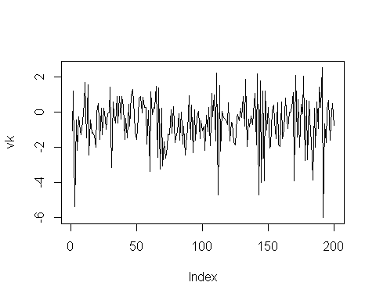

acf(vk)

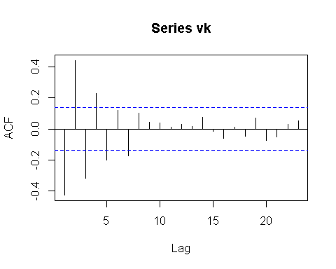

pacf(vk)

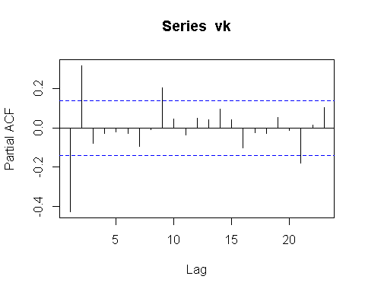

nonlinear_test=Tsay.test(vk,order=2)# non linear  
  
vk_guess=tar(vk,2,1,1,method="MAIC",estimate.thd=TRUE)  
vk_guess_residuals=vk_guess$residuals  
acf(vk_guess_residuals)

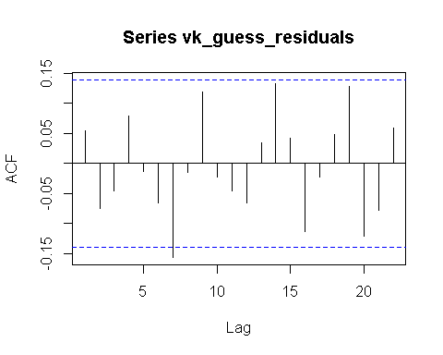

pacf(vk_guess_residuals)

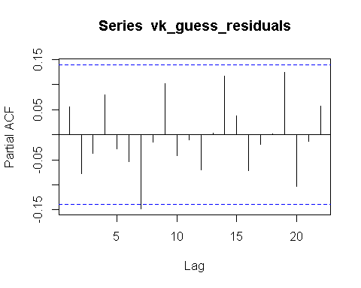

Threshold=vk_guess$n1 # Threshold  
vk_guess_1_coeff=vk_guess$qr1$coefficients # cofficients for first regime  
vk_guess_2_coeff=vk_guess$qr2$coefficients # cofficients for second regime  
  
phi_intercept_1=vk_guess_1_coeff[1]  
phi_1_1=vk_guess_1_coeff[2]  
phi_2_1=vk_guess_1_coeff[3]  
  
phi_intercept_2=vk_guess_2_coeff[1]  
phi_1_2=vk_guess_2_coeff[2]  
  
tsdiag.TAR(vk_guess)

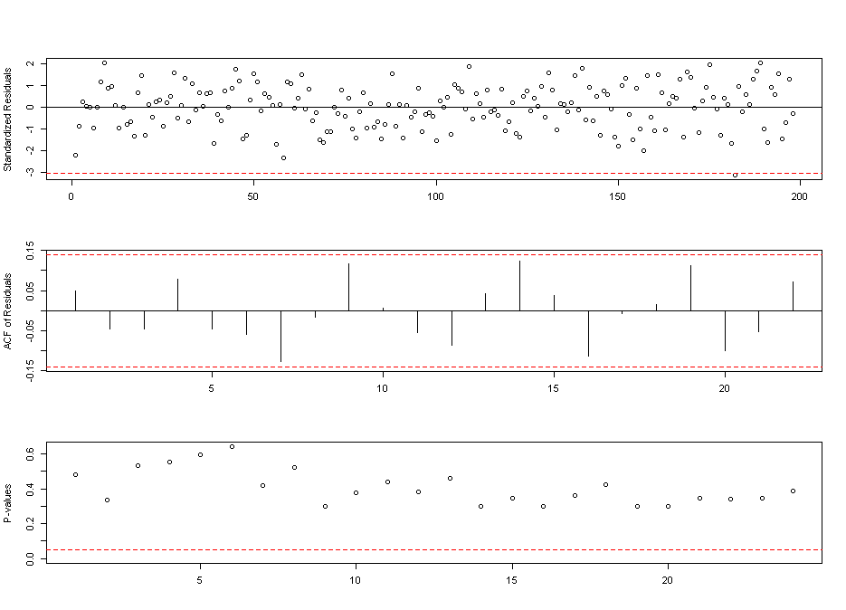

# part B  
  
epsk=vk_guess_residuals  
  
vk_guess_y=vk_guess$y  
  
Threshold_mod_store=0  
phi_mod_intercept_1_store=0  
phi_mod_1_1_store=0  
phi_mod_2_1_store=0  
  
phi_mod_intercept_2_store=0  
phi_mod_1_2_store=0  
j=1  
k=1  
l=1  
m=1  
n=1  
o=1  
for (i in 1:200)  
{  
  
epskr1<-sample(epsk,size=200,replace=T)  
vk_mod=vk_guess_y+epskr1  
vk_guess_mod=tar(vk_mod,2,1,1,method="MAIC",estimate.thd=TRUE)  
  
if(!is.na(vk_guess_mod$n1))  
{  
Threshold_mod_store[j]=vk_guess_mod$n1   
j=j+1  
}  
  
vk_guess_mod_1_coeff=vk_guess_mod$qr1$coefficients # cofficients for first regime  
vk_guess_mod_2_coeff=vk_guess_mod$qr2$coefficients # cofficients for second regime  
  
if(!is.na(vk_guess_mod_1_coeff[1]))  
{  
   
phi_mod_intercept_1_store[k]=vk_guess_mod_1_coeff[1]  
k=k+1  
}  
  
if(!is.na(vk_guess_mod_1_coeff[2]))  
{  
phi_mod_1_1_store[l]=vk_guess_mod_1_coeff[2]  
l=l+1  
}  
  
if(!is.na(vk_guess_mod_1_coeff[3]))  
{  
phi_mod_2_1_store[m]=vk_guess_mod_1_coeff[3]  
m=m+1  
}  
  
if(!is.na(vk_guess_mod_2_coeff[1]))  
{  
phi_mod_intercept_2_store[n]=vk_guess_mod_2_coeff[1]  
n=n+1  
}  
  
if(!is.na(vk_guess_mod_2_coeff[2]))  
{  
phi_mod_1_2_store[o]=vk_guess_mod_2_coeff[2]  
o=o+1  
}  
  
}  
  
Threshold_mod_mean=mean(Threshold_mod_store)  
Threshold_mod_var=var(Threshold_mod_store)  
Threshold_mod_den=dnorm(Threshold_mod_store,mean=Threshold_mod_mean,sd=sqrt(Threshold_mod_var))  
plot(Threshold_mod_store,Threshold_mod_den,type="l")

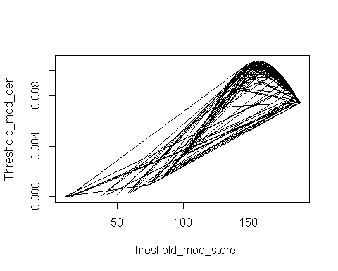

phi_mod_intercept_1_mean=mean(phi_mod_intercept_1_store)  
phi_mod_intercept_1_var=var(phi_mod_intercept_1_store)  
phi_mod_intercept_1_den=dnorm(phi_mod_intercept_1_store,mean=phi_mod_intercept_1_mean,sd=sqrt(phi_mod_intercept_1_var))  
plot(phi_mod_intercept_1_store,phi_mod_intercept_1_den,type='l')

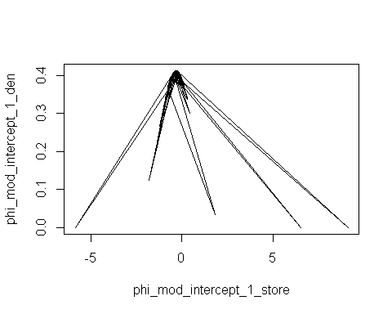

phi_mod_1_1_mean=mean(phi_mod_1_1_store)  
phi_mod_1_1_var=var(phi_mod_1_1_store)  
phi_mod_1_1_den=dnorm(phi_mod_1_1_store,mean=phi_mod_1_1_mean,sd=sqrt(phi_mod_1_1_var))  
plot(phi_mod_1_1_store,phi_mod_1_1_den,type='l')

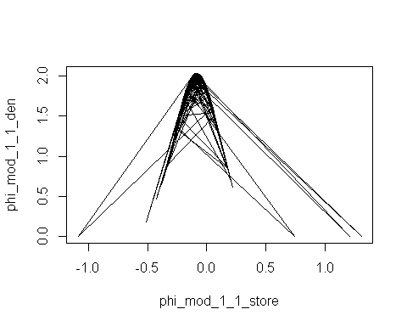

phi_mod_2_1_mean=mean(phi_mod_2_1_store)  
phi_mod_2_1_var=var(phi_mod_2_1_store)  
phi_mod_2_1_den=dnorm(phi_mod_2_1_store,mean=phi_mod_2_1_mean,sd=sqrt(phi_mod_2_1_var))  
plot(phi_mod_2_1_store,phi_mod_2_1_den,type='l')

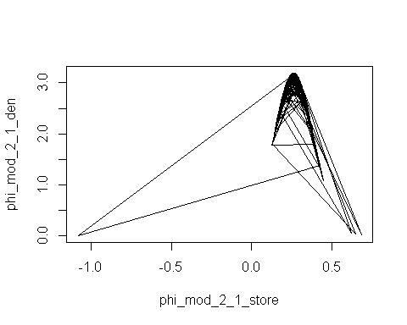

phi_mod_intercept_2_mean=mean(phi_mod_intercept_2_store)  
phi_mod_intercept_2_var=var(phi_mod_intercept_2_store)  
phi_mod_intercept_2_den=dnorm(phi_mod_intercept_2_store,mean=phi_mod_intercept_2_mean,sd=sqrt(phi_mod_intercept_2_var))  
plot(phi_mod_intercept_2_store,phi_mod_intercept_2_den,type='l')

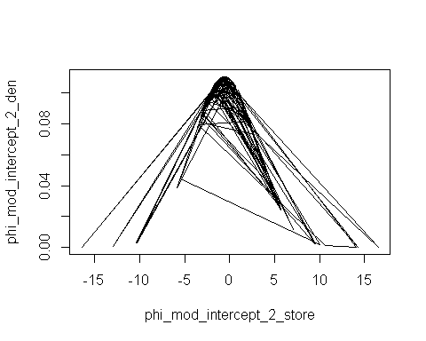

phi_mod_1_2_mean=mean(phi_mod_1_2_store)  
phi_mod_1_2_var=var(phi_mod_1_2_store)  
phi_mod_1_2_den=dnorm(phi_mod_1_2_store,mean=phi_mod_1_2_mean,sd=sqrt(phi_mod_1_2_var))  
plot(phi_mod_1_2_store,phi_mod_1_2_den,type='l')

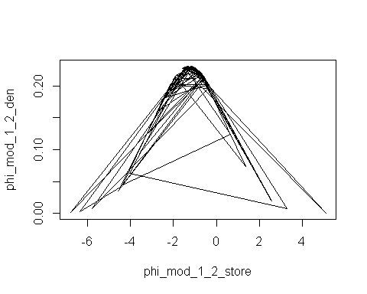

|  |  |  |  |
| --- | --- | --- | --- |
| Variable | From tar routine | Mean | Variance |
| Threshold | 175 | 156.66 | 1290.74 |
| Intercept1 | -0.165 | -0.419 | 0.3845 |
| -d11 | -0.0248 | -0.107 | 0.0262 |
| -d21 | 0.422 | 0.272 | 0.0042 |
| Intercept2 | 0.366 | -0.13 | 6.9465 |
| -d12 | -1.88 | -1.74 | 1.5018 |

The delay is 1.

This model satisfies since the residuals are white based on looking at the ACF and PACF and by running Box.test on the residuals.

2.R

library(TSA)

## Loading required package: leaps  
## Loading required package: locfit  
## locfit 1.5-9.1 2013-03-22  
## Loading required package: mgcv  
## Loading required package: nlme  
## This is mgcv 1.8-0. For overview type 'help("mgcv-package")'.  
## Loading required package: tseries  
##   
## Attaching package: 'TSA'  
##   
## The following objects are masked from 'package:stats':  
##   
## acf, arima  
##   
## The following object is masked from 'package:utils':  
##   
## tar

library(astsa)  
library(forecast)

## Loading required package: zoo  
##   
## Attaching package: 'zoo'  
##   
## The following objects are masked from 'package:base':  
##   
## as.Date, as.Date.numeric  
##   
## Loading required package: timeDate  
##   
## Attaching package: 'timeDate'  
##   
## The following objects are masked from 'package:TSA':  
##   
## kurtosis, skewness  
##   
## This is forecast 5.6   
##   
##   
## Attaching package: 'forecast'  
##   
## The following object is masked from 'package:astsa':  
##   
## gas  
##   
## The following object is masked from 'package:TSA':  
##   
## fitted.Arima  
##   
## The following object is masked from 'package:nlme':  
##   
## getResponse

data(retail)  
#retail_new=retail[1:255]  
plot(retail,type='l')

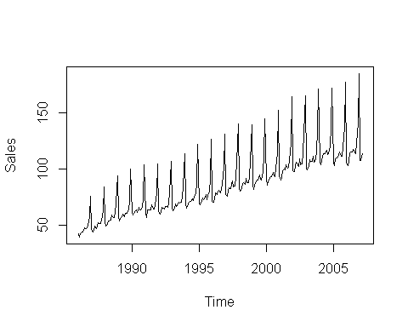

retail_diff=diff(retail)  
plot(retail_diff)# d=1, D=1

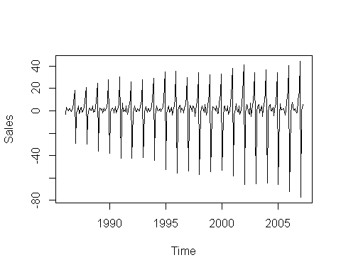

spectrum(retail)# S=12

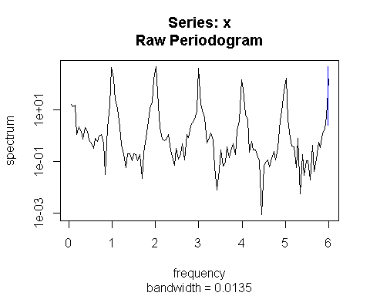

retail_acf=acf(retail,lag.max=50)#q=2,Q=1

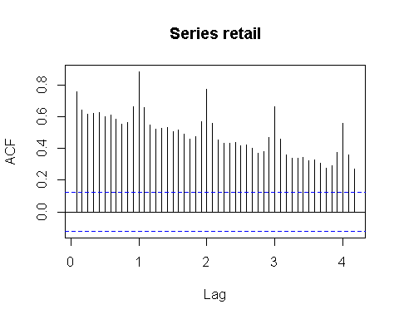

retail_pacf=pacf(retail,lag.max=50)#p=2,P=0

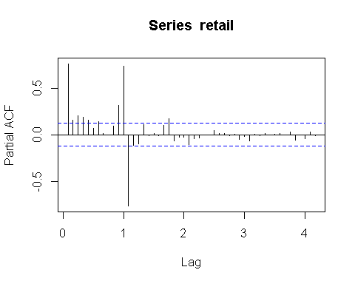

retail_test=sarima(retail,2,1,2,D=1,Q=1,S=12)

## initial value 0.840627   
## iter 2 value 0.685920  
## iter 3 value 0.645495  
## iter 4 value 0.645147  
## iter 5 value 0.644846  
## iter 6 value 0.644707  
## iter 7 value 0.644628  
## iter 8 value 0.644592  
## iter 9 value 0.644499  
## iter 10 value 0.644275  
## iter 11 value 0.643740  
## iter 12 value 0.642994  
## iter 13 value 0.642226  
## iter 14 value 0.641474  
## iter 15 value 0.641163  
## iter 16 value 0.641076  
## iter 17 value 0.641016  
## iter 18 value 0.640740  
## iter 19 value 0.640226  
## iter 20 value 0.639682  
## iter 21 value 0.639121  
## iter 22 value 0.638806  
## iter 23 value 0.638802  
## iter 24 value 0.638802  
## iter 25 value 0.638802  
## iter 26 value 0.638802  
## iter 27 value 0.638802  
## iter 28 value 0.638802  
## iter 29 value 0.638802  
## iter 30 value 0.638802  
## iter 31 value 0.638801  
## iter 32 value 0.638801  
## iter 32 value 0.638801  
## iter 32 value 0.638801  
## final value 0.638801   
## converged  
## initial value 0.632797   
## iter 2 value 0.632772  
## iter 3 value 0.632748  
## iter 4 value 0.632689  
## iter 5 value 0.632626  
## iter 6 value 0.632520  
## iter 7 value 0.632494  
## iter 8 value 0.632480  
## iter 9 value 0.632477  
## iter 10 value 0.632475  
## iter 11 value 0.632475  
## iter 11 value 0.632475  
## iter 11 value 0.632475  
## final value 0.632475   
## converged

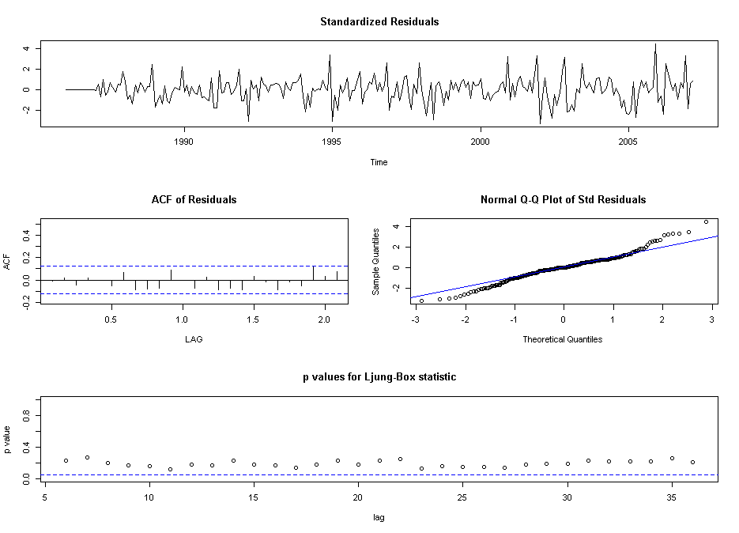

retail_residuals=retail_test$fit$residuals  
acf(retail_residuals)

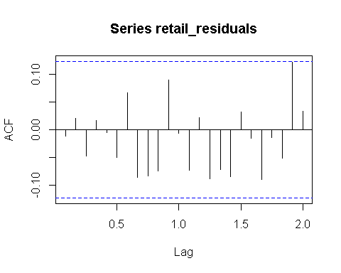

pacf(retail_residuals)

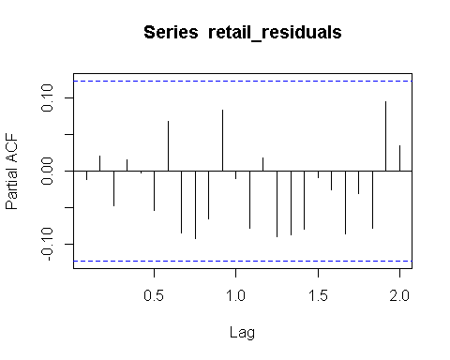

The Model is ARIMA(2,1,2) x (0,1,1)12 as seen based on the values and plots above.

This model satisfies since the residuals are white based on looking at the ACF and PACF and by running Box.test on the residuals.