2.R

Mon Dec 01 11:01:49 2014

library(TSA)

## Loading required package: leaps  
## Loading required package: locfit  
## locfit 1.5-9.1 2013-03-22  
## Loading required package: mgcv  
## Loading required package: nlme  
## This is mgcv 1.8-0. For overview type 'help("mgcv-package")'.  
## Loading required package: tseries  
##   
## Attaching package: 'TSA'  
##   
## The following objects are masked from 'package:stats':  
##   
## acf, arima  
##   
## The following object is masked from 'package:utils':  
##   
## tar

library(astsa)  
library(forecast)

## Loading required package: zoo  
##   
## Attaching package: 'zoo'  
##   
## The following objects are masked from 'package:base':  
##   
## as.Date, as.Date.numeric  
##   
## Loading required package: timeDate  
##   
## Attaching package: 'timeDate'  
##   
## The following objects are masked from 'package:TSA':  
##   
## kurtosis, skewness  
##   
## This is forecast 5.6   
##   
##   
## Attaching package: 'forecast'  
##   
## The following object is masked from 'package:astsa':  
##   
## gas  
##   
## The following object is masked from 'package:TSA':  
##   
## fitted.Arima  
##   
## The following object is masked from 'package:nlme':  
##   
## getResponse

data(retail)  
#retail_new=retail[1:255]  
plot(retail,type='l')

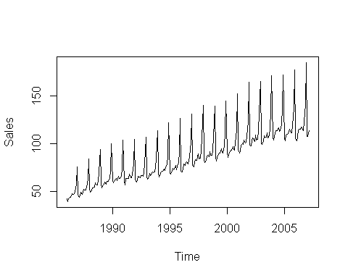

retail_diff=diff(retail)  
plot(retail_diff)#d=1, D=1

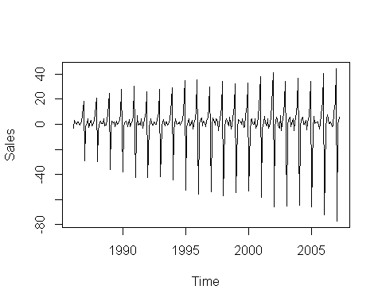

spectrum(retail)# S=12

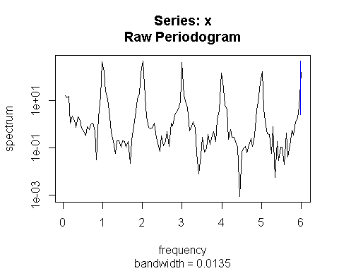

retail_acf=acf(retail,lag.max=50)#q=2,Q=1

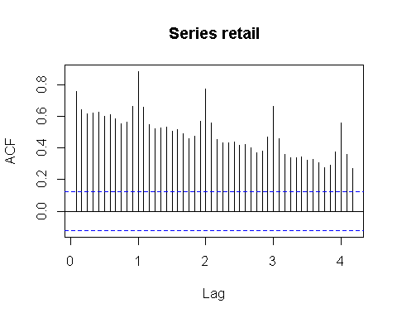

retail_pacf=pacf(retail,lag.max=50)#p=2,P=0

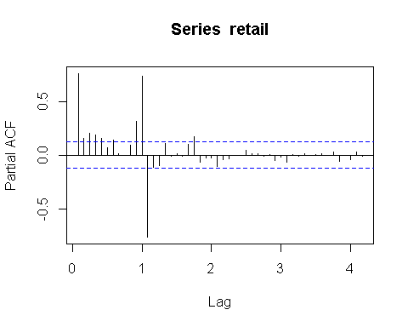

retail_test=sarima(retail,2,1,2,D=1,Q=1,S=12)

## initial value 0.840627   
## iter 2 value 0.685920  
## iter 3 value 0.645495  
## iter 4 value 0.645147  
## iter 5 value 0.644846  
## iter 6 value 0.644707  
## iter 7 value 0.644628  
## iter 8 value 0.644592  
## iter 9 value 0.644499  
## iter 10 value 0.644275  
## iter 11 value 0.643740  
## iter 12 value 0.642994  
## iter 13 value 0.642226  
## iter 14 value 0.641474  
## iter 15 value 0.641163  
## iter 16 value 0.641076  
## iter 17 value 0.641016  
## iter 18 value 0.640740  
## iter 19 value 0.640226  
## iter 20 value 0.639682  
## iter 21 value 0.639121  
## iter 22 value 0.638806  
## iter 23 value 0.638802  
## iter 24 value 0.638802  
## iter 25 value 0.638802  
## iter 26 value 0.638802  
## iter 27 value 0.638802  
## iter 28 value 0.638802  
## iter 29 value 0.638802  
## iter 30 value 0.638802  
## iter 31 value 0.638801  
## iter 32 value 0.638801  
## iter 32 value 0.638801  
## iter 32 value 0.638801  
## final value 0.638801   
## converged  
## initial value 0.632797   
## iter 2 value 0.632772  
## iter 3 value 0.632748  
## iter 4 value 0.632689  
## iter 5 value 0.632626  
## iter 6 value 0.632520  
## iter 7 value 0.632494  
## iter 8 value 0.632480  
## iter 9 value 0.632477  
## iter 10 value 0.632475  
## iter 11 value 0.632475  
## iter 11 value 0.632475  
## iter 11 value 0.632475  
## final value 0.632475   
## converged

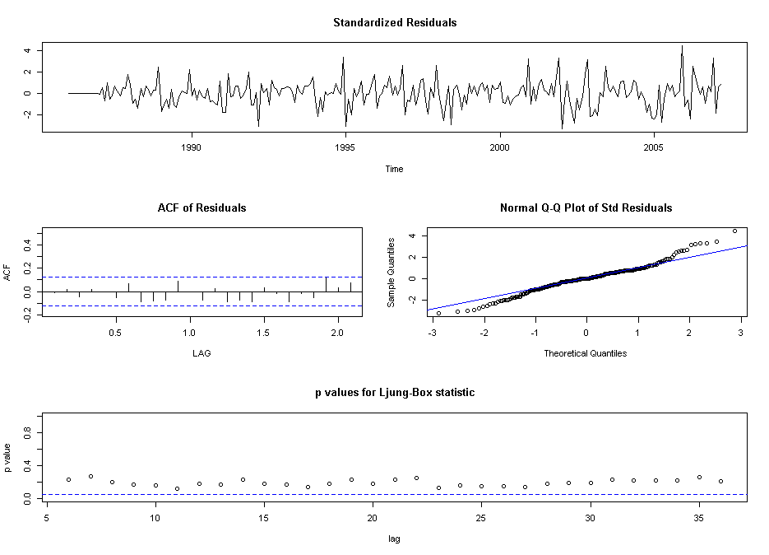

retail_residuals=retail_test$fit$residuals  
acf(retail_residuals)

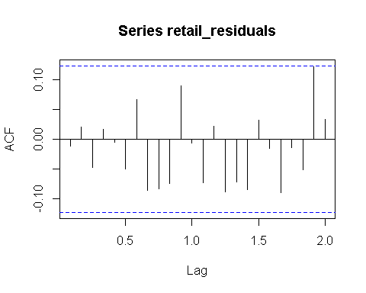

pacf(retail_residuals)

